2/17/2022

Jesse Hardy

6287

The king’s school

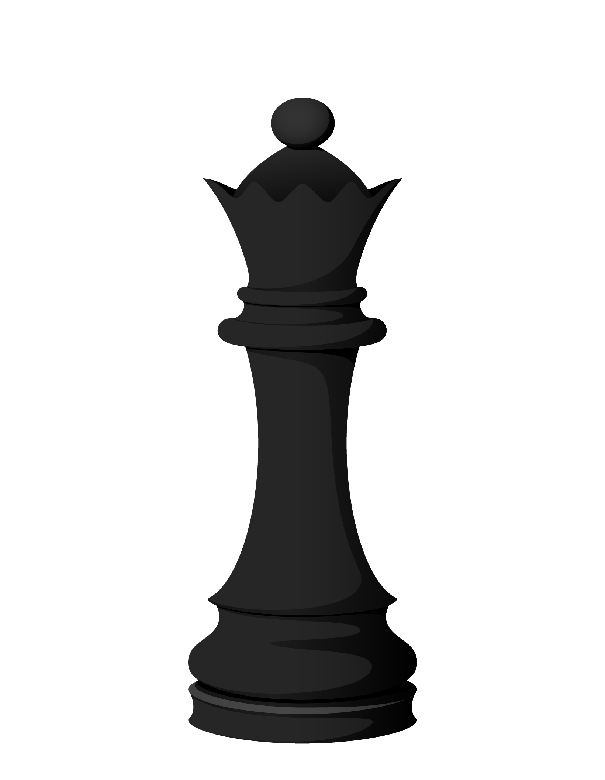**Chess Game**

OCR GCE A Computer science Project H446-03

[Document subtitle]

Project CONTENTS

Table of Contents

Analysis 4

An Outline of the Problem 4

StakeHolders 4

How the problem can be solved by computational methods 4

Thinking abstractly 5

Thinking ahead 5

Thinking procedurally 5

Thinking concurrently 7

Conclusion 7

Research 7

Interview plan (20/06/2021) 7

Interview script and answers (22/06/2021) 8

What would improve the chess experience for newer players and experienced players? 8

What visual effects should be in the game? 9

What sound effects should be in the game? 10

A review of the interview (23/06/2021) 10

Research into chess.com 11

Research Conclusion 20

Features that will be used for the game 20

Interview plan (13/07/21) 20

Interview Script and Answers (16/07/2021) 21

Visual Effects and Gameplay 21

Sound Effects 23

A Review of the Interview (17/07/2021) 24

If Orginial Features are Completed 25

Hardware and Software Requirements 26

Success Criteria 27

Design 30

Systems Diagram 30

Explanation of Each Module 31

Algorithms 33

Usability Features 46

Main Game 46

48

Main Menu 49

Class Diagram 51

Key Variables and Data Structures 52

Iterative Test data 56

Post development/Acceptance Test Table 59

Developing the Coded Solution 67

Drawing Chess Board & Pieces – Prototype 1 69

Creating the Main Class for Chess Rules & Setting up User Input – Prototype 1 70

Testing – Prototype 1 72

Errors Encountered – Prototype 1 73

Flowcharts used – Prototype 1 74

Interview & Review – Prototype 1 76

Generating ALL Possible Chess Moves, Starting with Pawns – Prototype 2 77

Generating All Bishop, Knight, Queen, Rook and King Moves – Prototype 2 78

Testing – Prototype 2 80

Errors Encountered – Prototype 2 87

Flowcharts Used – Prototype 2 88

Interview & Review – Prototype 2 94

Rules for Checks, Checkmates and Stalemates – Prototype 3 95

Rules for Pawn Promoting – Prototype 3 96

Rules for Castling – Prototype 3 97

Testing – Prototype 3 98

Errors Encountered – Prototype 3 101

Flowcharts Used – Prototype 3 102

Interview & Review – Prototype 3 103

Potential Moves Indicator – Prototype 4 104

Score Difference 105

Timer For Each Player 106

Username System 107

Prototype 4 Testing 109

Errors Encountered – Prototype 4 117

Flowcharts Used – Prototype 4 118

Interview & Review – Prototype 4 119

Database System – Prototype 5 121

Leaderboard System – Prototype 5 123

Testing – Prototype 5 126

Errors Encountered – Prototype 5 127

Flowcharts Used – Prototype 5 128

Interview & Review – Prototype 5 129

Summary of Validation 130

Evaluation 131

Usability Testing 131

Main Menu 131

Main Game 132

Leaderboard 133

Post Development TEsting & Success Criteria Evaluation 134

Maintenance 146

Current & Future Maintenance 146

Limitations and How They Could Be Approached 146

Project Source Code 148

Main Chess File 148

Chess Engine File 163

# Analysis

## An Outline of the Problem

For my project I am planning to re-create the classic board game of chess in python. This is a game between two players, where one player uses the white pieces and the other uses the black pieces. Each player takes turns to move one piece on the board and the aim of the game is to checkmate the opposition’s king. There are 6 different pieces on the board: Pawn, Bishop, Rook, Knight, King and Queen. Unlike the physical board game of chess, my program may: display potential moves that the players can make, which is extremely useful for newer players; display which pieces have been captured already and hence display the score of the pieces captured to show which player is currently winning in terms of material; and display when a king is in check or in checkmate to alert the players of this, which is again useful for newer players. Additionally, I will add a sound to alert the players when a piece has been captured or when a piece has been moved. This would improve the overall experience of the game. An extra addon to allow for more competitive players, I could add different lengths of time that the players have. The different timed modes for chess that I may add are Blitz, which is 3 or 5 minutes; Rapid, which is 10 or 30 minutes; and Bullet, which is 1 minute. This allows for a more competitive environment, therefore can be played by advanced players. Another helpful extension would be to add an Access database connected to the program to store each player’s name and the amount of wins they have collected, the number of games they have played and therefore a win-loss ratio for each player. This can then be displayed in a leader board system. The user would be then given an option to email a copy of the leader board if they would like.

## StakeHolders

The nature of the game is relatively simplistic, so my target audience would be for people aged around 4+, showing that I need to account for people of all ages and of all levels of skill. This is the reason I am including features, such as displaying potential moves for the players, which severely aids the less experienced players in learning what pieces can move where. One person that I have selected that personifies my target audience is Felix Williams of age 17, who is a keen, less experienced chess player himself, therefore knows what to expect when it comes to a chess game. As a less experienced chess player, he will also be able to properly assess whether the features that I am putting in place benefits newer players in their development of learning chess. The game will be played only using a mouse, so it is very easy to use and can be played on any computer.

## How the problem can be solved by computational methods

My chess game is suited to being solved by computational methods as playing chess on a traditional board can be very complex as there are a vast number of rules that players must remember, which is especially difficult for newer players, so algorithms would be used to break down the rules. Therefore, I must properly account for these as newer players are a part of my target audience and stakeholders. I have given the following examples to display why my problem can be solved using computational methods.

## Thinking abstractly

I need to decide what to include in the game/ what is necessary and what is not. Therefore, abstraction is perfect for this.

Abstraction for the Chess Game:

* Remove the third dimension and restrict the game to a two-dimensional user interface.
* Add a menu system to make it simple and easy for the user to switch through the timed modes and to the leader board.
* Add a score and images of pieces captured next to each player’s name to indicate which player has an advantage in terms of material.
* Display potential moves that the users can make to improve simplicity for newer players.
* Add a visual alert when the king is in check or has been checkmated, from which display clearly which player has emerged victorious.
* Remove unnecessary sounds to only those that occur when a piece has been moved or captured and when the king is in check or checkmated.
* The key objects in the game are the 6 different chess pieces (King, Queen, Bishop, Pawn, Rook, Knight) and the 64 square board that these pieces will be contained in.

## Thinking ahead

This is the process of giving your problem a plan and giving the solution to the problem, structure.

* I would plan to use python as I have used it frequently in the past and it has a suitable PyGame module that I would use to make the game and design the GUI.
* Most likely, I would write the game in the form of Object-Oriented Programming.
* The inputs for the game would be usernames of each player; using a mouse to navigate through the menus and drag pieces across squares on the board, then possibly their email address if they would like a copy of the leader board.
* The output screens would be menu system, containing leader boards, timed modes and then the actual chess board with the pieces.

## Thinking procedurally

This is the process of evaluating the most important conditions in the program that define the nature of the game, which will eventually develop into if statements in the program. The critical conditions in my chess game are whether a piece can capture other piece, whether a player is allowed to castle legally, whether the king is in check, whether a piece can be moved if it has been pinned.

The main game loop is checking where each piece on the board can move when it is clicked on and whether the king is in checkmate, which means that the game is concluded to be over.

**Breaking Down the Problem Procedurally**

## Thinking concurrently

This uses the logic of thinking of how to make the solution to the problem more efficient when in use. My chess game will be drawing images in the GUI (the chess board and pieces) whilst also updating material scores when pieces are captured.

## Conclusion

In conclusion, I have suggested and demonstrated a vast number of examples suggesting to why my problem is very much suited to being solved by computational methods, so being suited to the conversion into a computer program. The methods I have previously stated has given the problem at hand some clear structure, which will allow the final project to be more defined and detailed.

If the problem is successfully solved by the computer program, then my stakeholders will have a chess game that can be played by people of all ages and all levels of skill and people of less experience can learn how to play chess faster than someone learning using a traditional, physical chess board. Therefore, my stakeholders will be able use my program as a form of entertainment as first intended.

# Research

## Interview plan (20/06/2021)

The purpose of this interview is to find out the basic requirements of the game from my personified target audience member, Felix Williams.

The main points of the interview are to find out: What would improve the chess experience for newer players and experienced players; what visual effects should be in the game; and what sound effects should be in the game.

Question Layout:

What would improve the chess experience for newer players and experienced players?

* Should a potential move indicator be in the game?
* Would a window to the side be helpful for informing the user the value of each piece?
* Would the pieces captured under each player’s name be helpful?
* If yes, should the score difference between the players also be under each player’s name?
* Should there be a time control option?
* If yes, what timed control modes would you like to be included?
* If a piece is pinned (cannot legally move) should there be an indicator to let the players know this piece is pinned?
* If yes, should the square under the piece light up?
* As the game is two players, do you want online or local?

What visual effects should be in the game?

* Should there be a startup screen?
* Do you want a leaderboard system in the game?
* If yes, what facts and figures should be displayed on the leaderboard?
* If yes, should there be a menu system to allow the user to switch between the leaderboard and player vs player?
* If yes, should switching between the leaderboard and the player vs player be allowed in the middle of the game?
* If yes, should there be a limit to how many players are included on the leaderboard?
* Should there be a pause button in the game?
* Should there be a pop-up when the king is in check?
* Should there be a pop-up when the king is in checkmate?
* What should the theme of the appearances of the board and pieces be (e.g., Simplistic, modern, old style etc.)?
* Should the numbers and letters of each rank and file (rows and columns) be included?

What sound effects should be in the game?

* Should there be a sound when a piece is moved?
* Should there be a sound when the king is in check?
* Should there be a sound when the king is in checkmate?
* Should there be a sound when a piece is captured?
* Should there be a sound when a player attempts to make an illegal move?

## Interview script and answers (22/06/2021)

### What would improve the chess experience for newer players and experienced players?

Should a potential move indicator be in the game?

A potential move indicator would be nice if the person were taking a long time to move as they can quickly and easily see all potential moves, they can make.

Would a window to the side be helpful for informing the user the value of each piece?

This would be very nice for new players to learn how and which pieces to trade.

Would the pieces captured under each player’s name be helpful?

This would not be essential but would be a useful way for people to keep track of what they have taken.

If yes, should the score difference between the players also be under each player’s name?

Yes, the score difference should be displayed.

Should there be a time control option?

Yes, you should be able to set the time conditions of the game.

If yes, what timed control modes would you like to be included?

Bullet (1 minute), Blitz (3 or 5 minutes), Rapid (10 or 30 minutes) and a no time control option, as to not overwhelm the user with too many choices of timings, from which these are the fundamentals.

If a piece is pinned (cannot legally move) should there be an indicator to let the players know this piece is pinned?

Maybe an indicator such as a sound when that the user tries to move the pinned piece.

If yes, should the square under the piece light up?

Yes, that would be a good feature, but wouldn’t be essential.

As the game is two players, do you want online or local?

Local, as it is more convenient to set up and the environment would feel more like a traditional chess match, where you can see your opponent, so it is more authentic.

### What visual effects should be in the game?

Should there be a start-up screen?

Yes, there should be a start-up screen to introduce the game.

Do you want a leaderboard system in the game?

Yes, it would be useful to be able to keep track of the other players, but is not absolutely necessary.

If yes, what facts and figures should be displayed on the leader board?

The username, games played, wins and losses and their win percentage should be displayed.

If yes, should there be a menu system to allow the user to switch between the leaderboard and player vs player?

Yes, there should be a menu system to allow better fluidity in the program.

If yes, should switching between the leaderboard and the player vs player be allowed in the middle of the game?

Switching should not be allowed.

If yes, should there be a limit to how many players are included on the leader board?

There should be no limit to the number of players on the leader board.

Should there be a pause button in the game?

There is no need for a pause button as it is a time sensitive game that depends on thinking quickly to find moves that win the game.

Should there be a pop-up when the king is in check?

No pop-up, but maybe there should be a small message to the side or at the top indicating check and a sound should be played as well.

Should there be a pop-up when the king is in checkmate?

Yes, there should be a pop-up when the king is in checkmate.

What should the theme of the appearances of the board and pieces be (e.g., Simplistic, modern, old style etc.)?

Simplistic, as this means that more people will be able to recognise the pieces.

Should the numbers and letters of each rank and file (rows and columns) be included?

Yes, the board should be labelled on the sides.

### What sound effects should be in the game?

Should there be a sound when a piece is moved?

Yes, there should be a sound.

Should there be a sound when the king is in check?

Yes, there should be a sound.

Should there be a sound when the king is in checkmate?

Yes, there should be a sound.

Should there be a sound when a piece is captured?

Yes, there should be a sound.

Should there be a sound when a player attempts to make an illegal move?

Yes, there should be a sound, which should be the same one as if they try to move a pinned piece and all sounds should be clear, but not too loud.

## A review of the interview (23/06/2021)

The purpose of this interview was to see what potential features that my stakeholders and target audience would want from my game. Through this I think the interview was very successful as myself and the interviewee were able to conclude that exploring ways in which to help new players understand the game is vital, as most chess beginners face a roadblock in terms of growth when they have not understood the fundamentals of chess properly.

In particular, we concluded that a potential move indicator would drastically improve piece move time by the players as they would not have to think about which pieces move in which directions and ways. This means that the game would be more enjoyable for both players as there is less waiting time. Another features, such as indicators when a piece is pinned (cannot move) means that the players can learn and explore ways to exploit pinning pieces to gain advantages in future games to improve and become better chess players.

Additionally, we agreed that the visual effects of a menu system are very important to provide fluidity to the program, so that the user is able to smoothly switch between the leader board and the player vs player mode and so that they can pick which time control mode they want to play. In reference to the time controls, I have considered Felix’s point that the key, most important time controls should only be implemented as these are the most standard modes that are played by the professionals, so would be more relevant to the players.

In the sound effects section, it is clear that specific sound effects are wanted, such as when pieces are moved, captured, check occurring or checkmate occurring, which improve the gameplay experience as it would make the program feel more realistic like when playing chess on a traditional chess board. This means that the game would feel more authentic to play.

## Research into chess.com

Chess on Chess.com is very similar to the way Chess is played on a traditional chess board, as it follows all the same standard rules of chess. These are:

* White always moves first
* Each player takes alternate turns to move one piece only
* There are 6 different pieces on the board that must be arranged in a specific pattern

Different pieces can move in different ways (this will be shown in depth further on), with the likes of the special case of ‘En Passant’.

* When a piece appears like it can capture the King this is called ‘Check’ meaning that the king must move to a space that is not covered by the opponent’s pieces, the piece checking the king must be captured or a piece must block where the king is being checked from. But, when a knight checks the king, nothing can block the knight’s path, so it must either be captured, or the king must move.
* If the king is in double check (where the king is in the path of two of the opponent’s pieces), then it must move to a vacant space.
* If none of the previous rules can be carried out (i.e., the King has no legal moves, and nothing can block or capture the piece checking the King), then this is called Checkmate, meaning the game is over.
* If your piece is in front of your King in a way that moving that piece away from the king results in a check on your own king, then it means this move is called an illegal move and hence cannot be played. Therefore, the piece in front of the king is referred to as pinned.
* When the when the pieces in between one’s king and either rook are empty and none of the opponent’s pieces can move into any of those spaces then the king is able to ‘castle’, meaning the king moves 2 spaces towards the rook, then the rook moves to the centre either one space to the left or right of the king’s new position.
* When a pawn reaches the back rank it is given the ability to promote to either a Queen, Bishop, Knight or Rook.

However, on Chess.com all illegal moves cannot be played, whereas on a traditional chess board there is room for error when both players have not spotted that an illegal move has been played. For instance, this could be moving a piece that is pinned. These rules being enforced means that it is easier for new players.

Comparatively to a traditional chess board, Chess.com is a website that in nature allows people to play chess together online from all over the world in a variety of different modes. The main structure of it contains traditional chess that can be played in many different time controls, such as Blitz (3 minutes, 5 minutes, 3 minutes with 2 second of added time per move or 5 minutes with 5 seconds of added time per move), Bullet (1 minute, 1 minute with 1 second of added time per move or 2 minutes with 1 second of added time per move), Rapid (10 minute, 30 minute, 15 minute with 10 seconds of added time per move, 20 minute, 60 minute or 45 minute with 45 seconds of added time per move), Daily (1,2,3,5,6 or 14 days per move). These are the more standard modes of chess that each player on the website is assigned a separate skill rating for each time control modes, where if you win or lose you gain or lose a certain amount of skill rating according to an algorithm. Then, for each of these time control modes there is a leader board that displays the top players in terms of skill rating.

The other unorthodox chess modes can be played solo or with a friend. These are: 4 player chess, where 4 people play chess on one enlarged board; Doubles (Bughouse), where you can place your team mate’s captured pieces on your own board; Fog of war, where you can only see squares you can move to; Automate, where you set pieces up and let the computers fight it out; Atomic, where captures lead to an explosion that affects all surrounding pieces; Giveaway, where you give away all your pieces or get a stalemate to win and capturing is compulsory; Horde, where an army of pawns is against the black pieces; and finally, you can create a custom game to mix and match different modes.

Other functionality that the website provides are the professional learning platform from which there are video tutorials to learn how to play chess and the ability to practice against different levels of Artificial Intelligence from beginner level all the way up to Grand Master level. After each standard online match, the computer is also able to analyse the match, suggesting all the best moves throughout your game and analyses whether your moves were accurate. Additionally, chess.com provides a variety of chess puzzles that involve checkmating the opposition’s king is a certain position or winning high volumes of material which come in various difficulties in order to challenge the user into critical thinking.

Suited to more competitive players, there is a tournament system that allows users to create their own tournaments to specific requirements, such as only players under 1000 rating for Rapid are allowed to join. This introduces the competitive scene of chess to more inexperienced players. Also, the functionality of being able to view all your own past games and professional’s previous games in the archives system, allows aspiring players to review and evaluate a variety of positions that were played by professional players in order to improve their own gameplay. Then, you can view your progress using the in-built statistics system that provides graphs that show your skill rating progression in each time control mode, from which the success of players can be celebrated with friends through the messaging and friend system to add an additional social element.

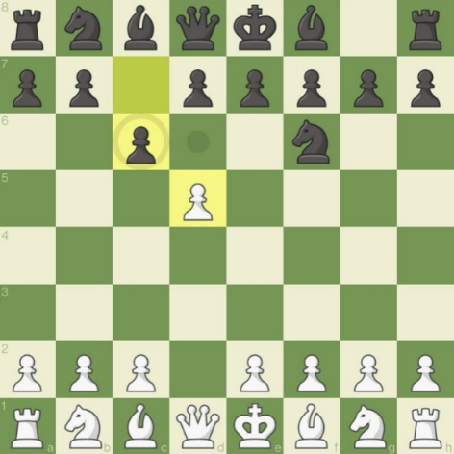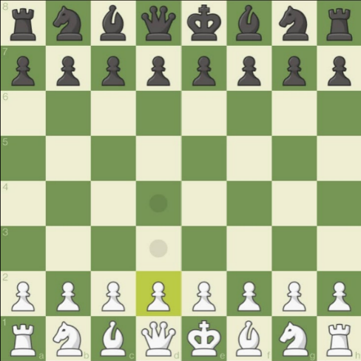**Piece Movement Rules**

The layout of the board is the same at the start of every game.

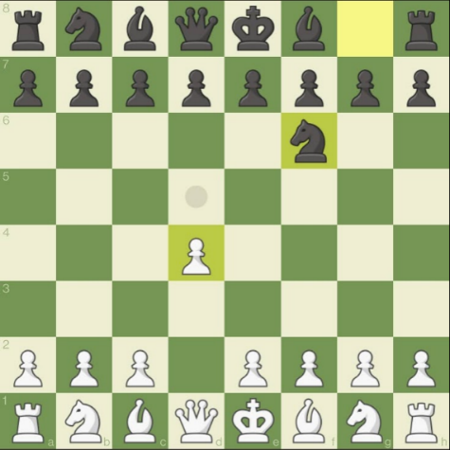

When the option is available the pawn is the only piece that captures in a different way that it moves, which is diagonally.

When the pawn has already been moved it can now only move one space at a time.

The **Pawn** can move two spaces when it has not previously been moved yet.

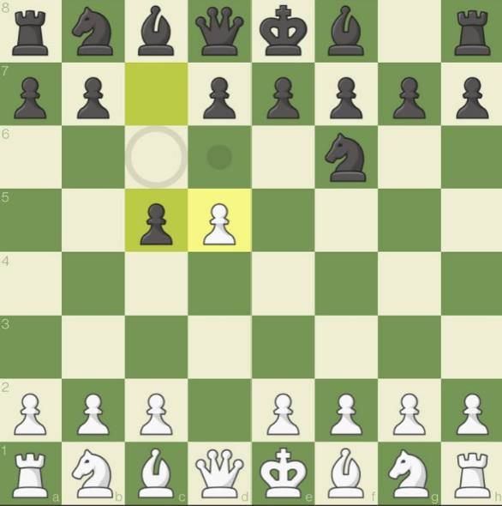

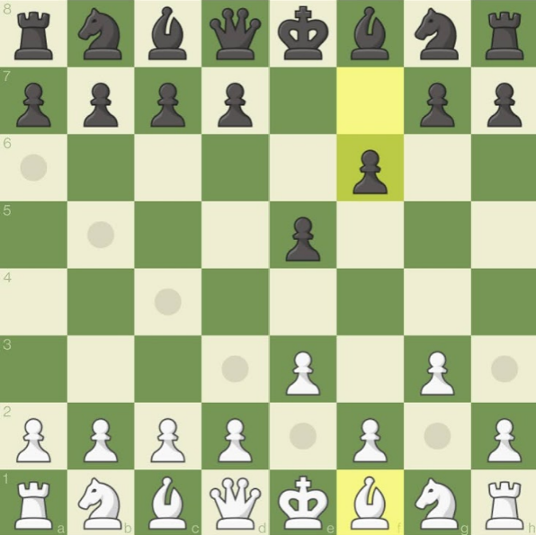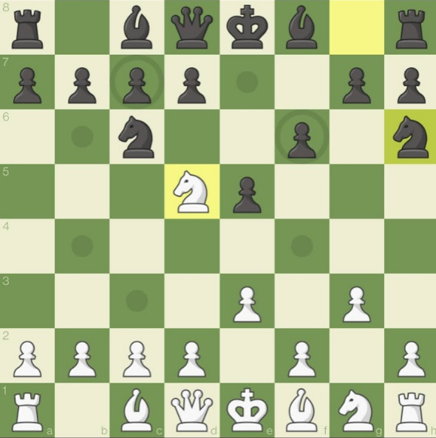

The **Knight** is able to move in an ‘L’ shaped direction and can jump over pieces in its way.

The **Bishop** is able to move diagonally any amount of spaces as long as no pieces are in the way of its path.

There is a special case called ‘En Passant’ where if the opponent moves a pawn two spaces causing both pawns to be on the same row/rank then the pawn is able to capture diagonally past the pawn.

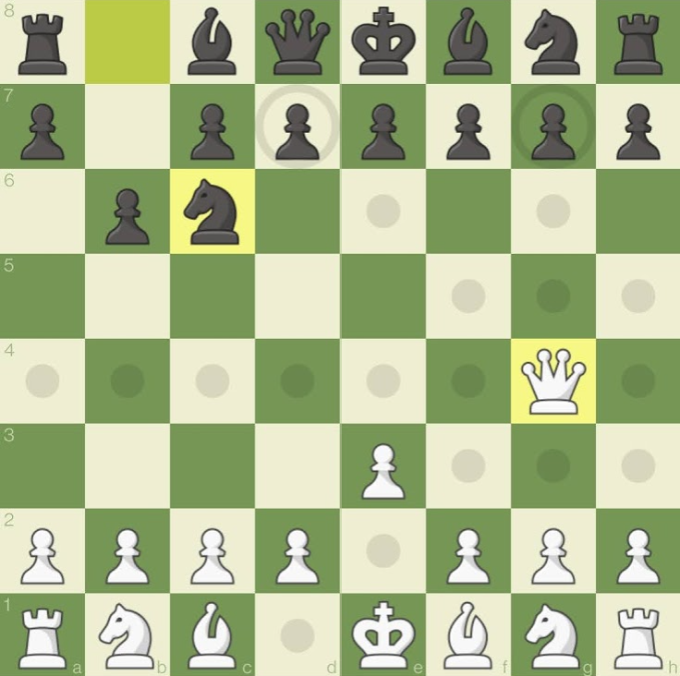

The **Queen** is a mixture of the Rook and the Bishop, as it is able to move any number of spaces vertically, horizontally or diagonally as long as there are no pieces in its path.

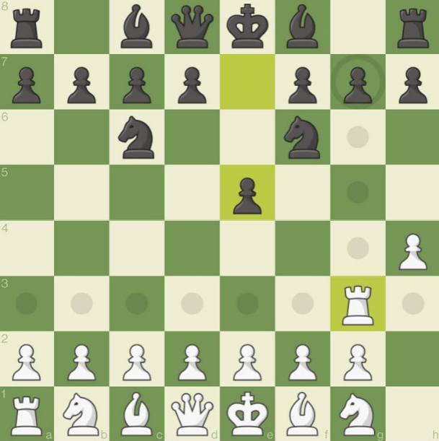

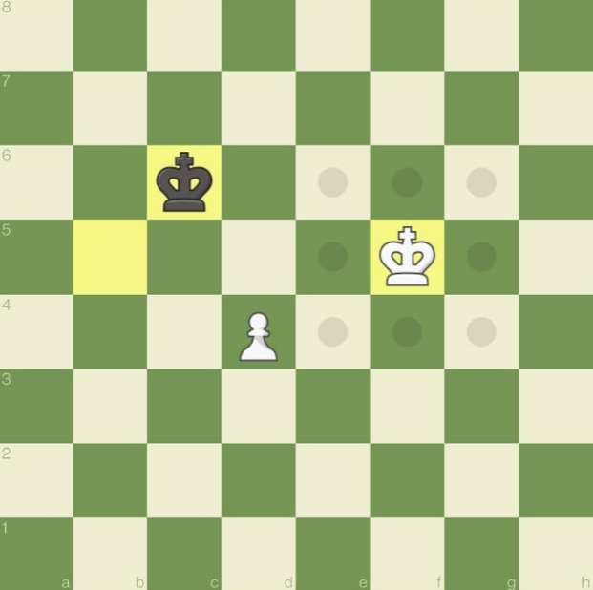**Pre-Online Match Screen**

The **King** is able to move to any space that is one distance away and is not covered by the path of a different piece.

The **Rook** is able to move any number of spaces vertically or horizontally as long as there are no pieces in its path.

King

Bishop

Knight

Rook

Queen

Black pieces

Opponent’s time control

Pawn

Different time control modes

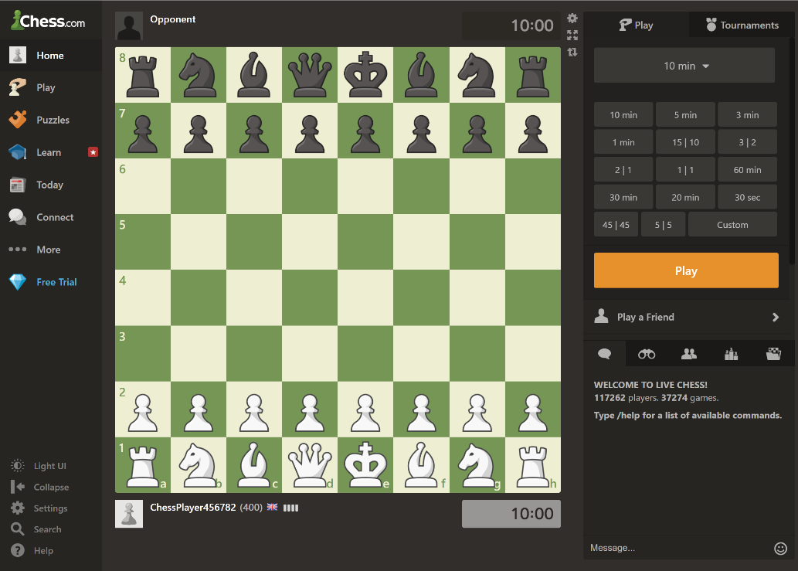

Menu system with sub-menus to access the different features.

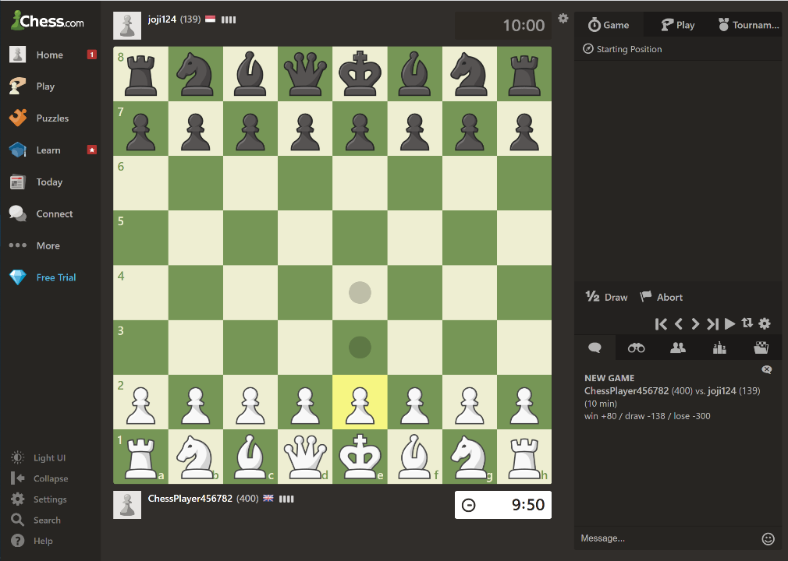 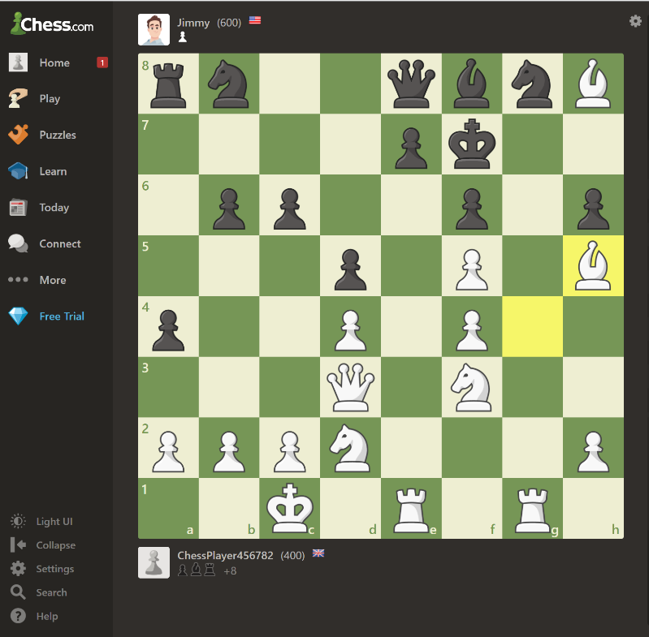 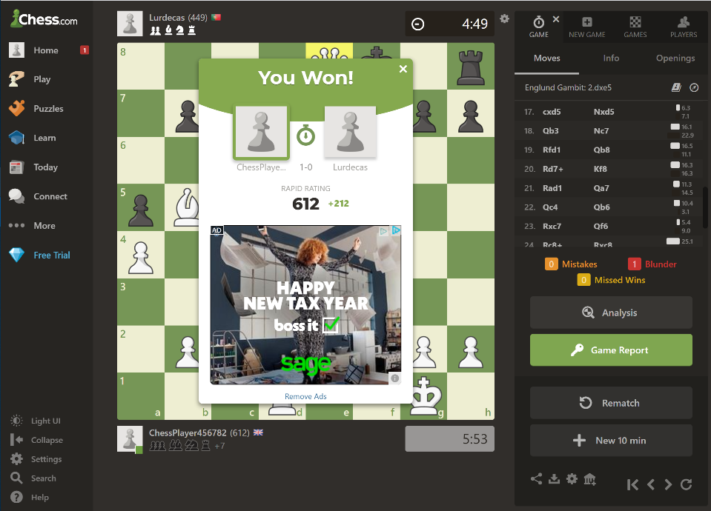 

When a piece is moved or captured there is a subtle sound, indicating these.

Potential move indicator, which appears when a piece is clicked on.

Buttons to view the previous moves in a current game or to play through the moves.

Abort or Resign button

Ask for a draw button

Play button to launch matchmaking against an online opponent.

Button to play against someone on your friend’s list.

Timer counts down as soon as the game starts for white.

**Player vs Player Online Match Screen for Rapid (10 minutes)**

Opponent’s Skill rating

Username

Opponent’s Username

Input box to allow messaging between players.

Skill rating, which changes according to wins or losses.

User’s time control, which only goes down when it is the user’s turn.

White pieces

The pieces black has captured, which is one pawn.

**In-Game Scoring System**

**Value of each piece:**

Queen = 9 points

Rook = 5 points

Bishop = 3 points

Knight = 3 points

Pawn = 1 point

King = Priceless

(As the king cannot be captured, only checkmated)

Display that shows white has captured black’s pawn, bishop and rook.

The yellow squares indicate the piece that was moved last.

The difference in score. Black has captured 1 point of material and white has captured 9 points of material. So, white has +8 more material than black.

**End Screen - Checkmate**

Displays at the top what the result of the game was.

The moves played throughout the game and the opening that was played. (Englund Gambit in this case)

New adjusted rating

Number of mistakes, blunders and missed wins.

Analysis button that measures whether your moves were accurate and suggests the best moves in each scenario.

Rematch or New game buttons

Amount of rating gained or lost from the match

Column, containing each player’s wins and losses and draws.

A drop-down menu to select the country or region of the leader board.

A drop-down menu to select the timed mode for the leader board.

**Leader board System**

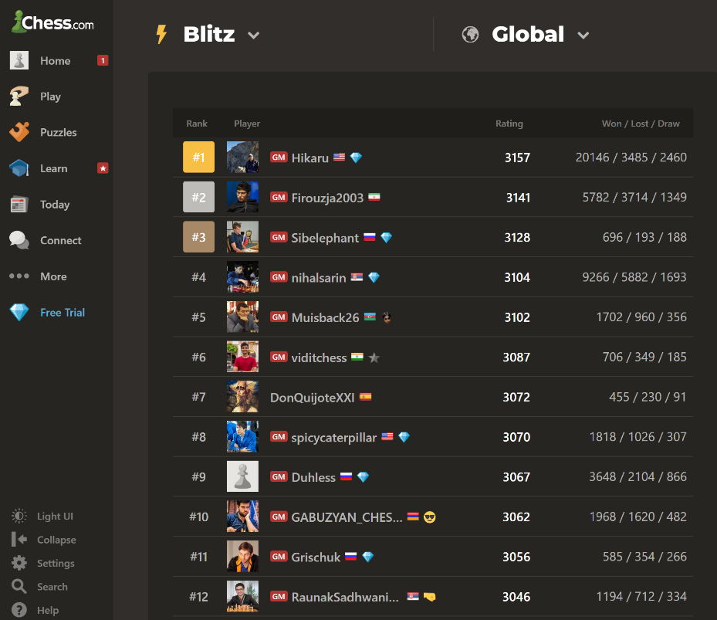

Column for the positions of each player according to their rating.

A menu system that displays all open lobbies that can be joined.

4-player chess board with colours yellow, blue, green and red. The normal piece movements are the same.

Button to create a new game, with sub-modes of 2v2 or Free for All.

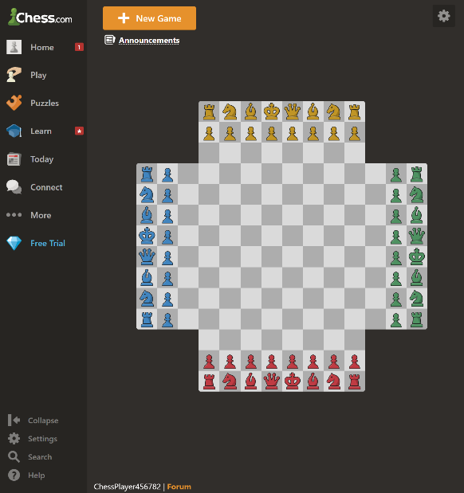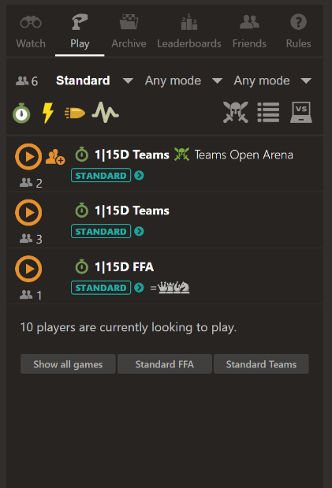

**Unorthodox Chess Mode Example: 4-Player Chess**

Each player’s username, nationality, and FIDE chess title. (GM stands for Grand Master, the highest title available).

Rating column, which estimates the player’s skill according to wins and losses against different opponents.

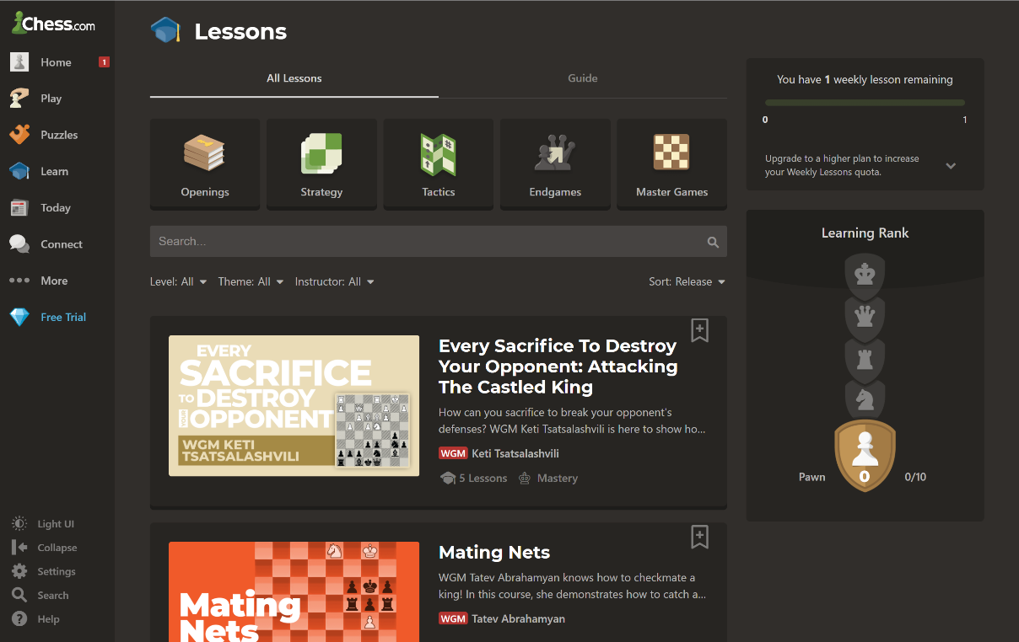

Button to watch videos about games played by previous Grand Masters.

Button to watch videos about end games and how to win.

Button to watch videos about tactics.

Button to watch videos about strategy.

Button to watch videos about different openings.

**Video Tutorials and Lessons**

Longer tournaments

Time until a particular tournament starts.

Number of players in the tournament

Names of the upcoming live tournaments, showing the type of chess and the time control.

Statistics for number of tournaments entered, points, 1st place finishes and withdrawals.

Join buttons

Videos

**Tournament System**

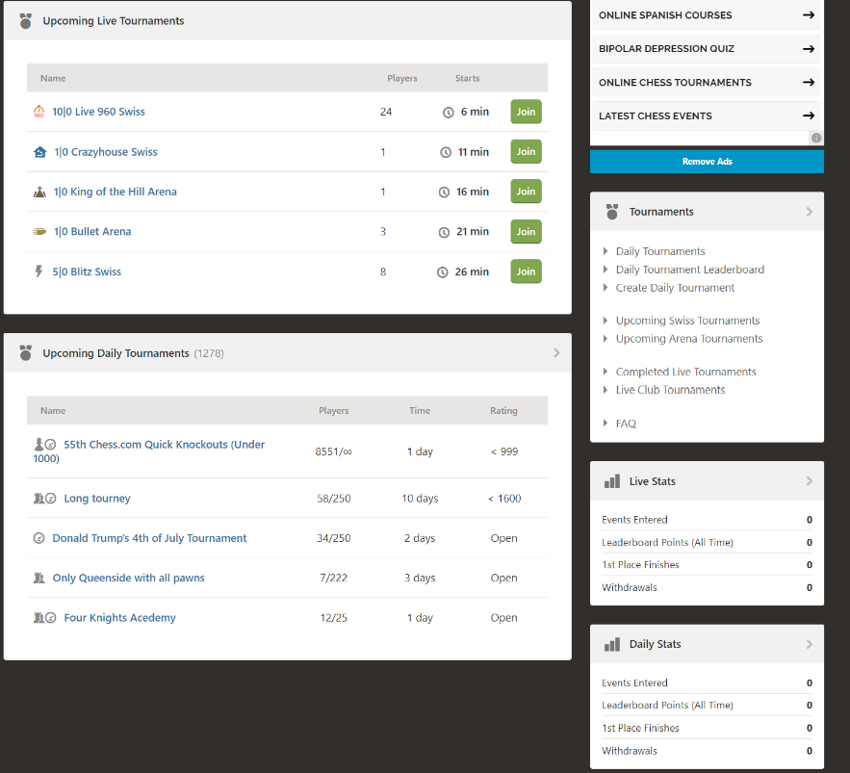

Search bar

Scroll menu with a variety of AI in each category, ranging from Beginner, Intermediate, Advanced and Master. (250 to 3200 rating)

The AI that has been selected and their description.

**Play against AI**

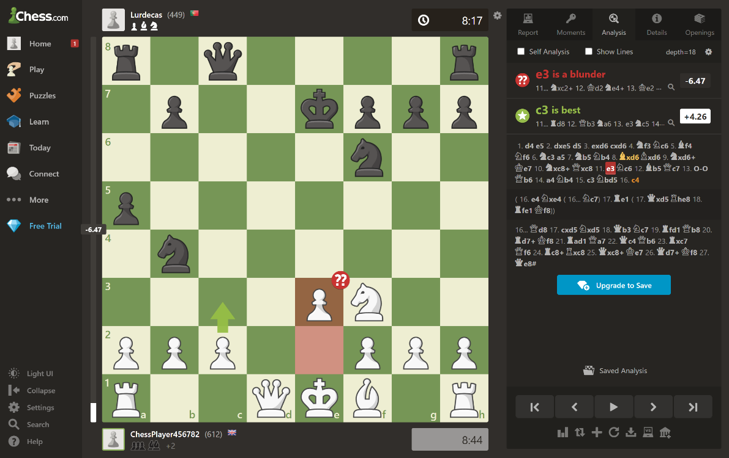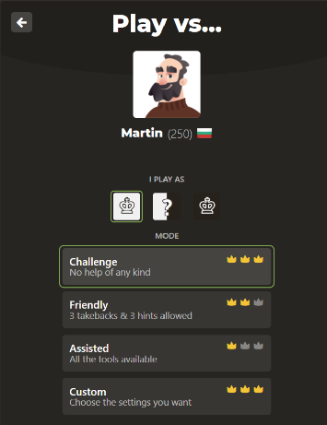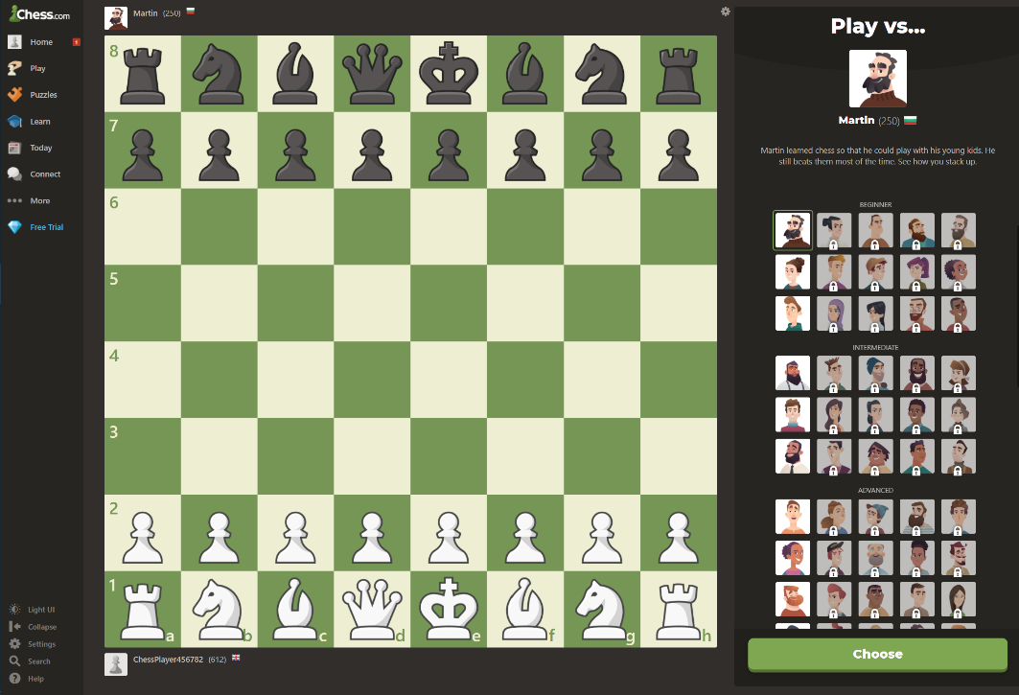

A number indicating how inaccurate/accurate your move was. The total accuracy score is displayed at the end of the game.

Displays whether your move was a blunder, inaccurate, good or the best move.

The move that was played and in this case the AI determines the move was a blunder.

Visual suggestion of what should have been played.

Buttons to go backwards or forwards in the game.

All the moves that were played in the game.

Displays what the best move was.

Choose button, which when pressed allows the user to select different levels of challenge with the chosen AI.

**Post-Match AI Analysis Feature**

The AI’s name, rating, and country.

### Research Conclusion

Through these screenshots and the introduction and the beginning, it is clear that Chess.com is a well-established website, packed full of features that cover every aspect that chess has to offer in an abundance of fun ways, and it covers ways in which to teach chess even to the core beginners. This is a common aim in which I wish to deliver my chess game, so that it can help teach newer players and offer a fun way to play chess with either friends or family without needing a physical chess board or an internet connection.

Aspects in particular that inspire me to add similar features are the possible piece movement area indicator; the in-game scoring system; leader board system; a clear and informative end screen; all the authentic different chess rules; and the ability to choose what time control the players would like to use. These are fundamental features that build the blocks of a complete chess game that is not too complicated for the user to use. The quantity of features in Chess.com is almost endless, so a large downside to the website is that it is difficult to use for younger or inexperienced players. Therefore, I believe that adding to many features would overload the game, making it quantity over quality, when in fact quality is more favoured to quantity.

Although features, such as creating an AI bot to play against would be a good addition, due to the time constraints of the project at hand. It would be difficult to add it in with all the other features that need to be implemented first as they are more important in order to achieve my aim.

# Features that will be used for the game

## Interview plan (13/07/21)

This interview with Felix Williams will be a more specific interview designed at giving more specific requirements about the game visuals, sounds, scoring and leader board. This will then allow me to create my first set of requirements for the game to start to solve the problem.

Question Layout:

Visual Effects and Gameplay

* What should the potential move indicator look like?
* What colour should the potential move indicator be?
* What should the animation of the potential move indicator look like?
* How should the user be able to move the pieces?
* What should the animation look like when the piece is being moved?
* What should the window containing the value of each piece look like?
* What should the pieces captured bar look like?
* What should the score difference look like?
* What should the start-up screen look like?
* When should the user be asked what timed control mode they want to play?
* What should the animation look like when a player tries to move a pinned piece?
* Should the board flip when a player makes a move?
* What font should the letters and numbers be in around the board?
* What colours should the board and pieces be?
* What should the layout of the leader board look like?
* Should there be a back and restart match button?
* What should the message look like when the king is in check/checkmate?
* Should there be an indicator for what the last piece was moved?

Sound Effects

* What should the sound be when a piece is moved?
* What should the sound be when the king is in check?
* What should the sound be when the king is in checkmate?
* What should the sound be when a piece is captured?
* What should the sound be when a player attempts to make an illegal move?

## Interview Script and Answers (16/07/2021)

### Visual Effects and Gameplay

What should the potential move indicator look like?

When a player clicks on one of their pieces using the mouse cursor, small white dots should appear on the squares that the piece can move to.

What colour should the potential move indicator be?

This should be either a grey or white colour or any colour that is not too bright that contrasts with the squares of the board.

What should the animation of the potential move indicator look like?

The animation should be almost instant as to not waste time in the game.

How should the user be able to move the pieces?

The pieces should be moved by left clicking on the piece with the mouse cursor then click again on the square where the player wants to move the piece. Possibly the pieces could also be moved by tapping on the screen, which would only work for touch screen devices.

What should the animation look like when the piece is being moved?

The piece should smoothly and quickly glide across the board to the desired square as not to waste time.

What should the window containing the value of each piece look like?

It should be a small window to the left or right side of the board, specifying the value of each piece in terms of score.

What should the pieces captured bar look like?

It should be a small bar under each player’s name, where it shows small images of the pieces that player has captured during the game.

What should the score difference look like?

It should be a small number on the right-hand side of the bar, where it shows how many points each player is up or down, such as -5 or +5.

What should the start-up screen and menu look like?

The start-up screen should introduce “Chess” with an appropriate background image, then open a window where there are two large buttons in the middle to either open PVP (Player vs Player) or the Leader board.

When should the user be asked what timed control mode they want to play?

When PVP is selected in the menu screen the players should be asked to type their usernames and select the timed control mode that they want to play.

What should the animation look like when a player tries to move a pinned piece?

When a player clicks on a piece that is pinned, the potential move indicator should not appear and there should be an error-like sound. The square underneath the pinned piece could also light up possibly in a red colour for a very short time.

Should the board flip when a player makes a move?

For some people this can be a very confusing feature as I have tried this on Chess.com, so for the game to fit for everyone I do not think this would be a useful feature.

What font should the letters and numbers be in around the board?

A modern and easy to read font.

What colours should the board and pieces be?

The pieces should be a clear black or white colour with black outlines, whereas the board should contrast to the black outlines of the pieces, so it could possibly be a blue/white or green/white board. The colour combination of the squares must have a darker and a lighter colour as to not confuse the players.

What should the layout of the leader board look like?

The leftmost column should contain the positions going down from 1, then moving right across the columns they should contain the usernames, games played, wins, losses then win percentage. The positions should be determined by the win percentage.

Should there be a back and restart match button?

There should be a back and restart match button in the corner of the window, which when pressed should bring up a confirmation message to ensure that the button was not clicked by mistake.

What should the message look like when the king is in check/checkmate?

Above the board there should be a small message that appears, exclaiming “Check!”, when the either king is in check. But, when a king is in checkmate then I think a small window should appear to the side of the board which exclaims “Checkmate!” and has buttons for a rematch, which would play the same time control, or a button for a new game, so that the players can select a new time control.

Should there be an indicator for what the last piece was moved?

There could be a window to the side that has an image of the piece that was last moved with the square coordinate, but this is not that necessary as both players would usually be heavily concentrated on the game.

### Sound Effects

What should the sound be when a piece is moved?

It should be a smooth almost wind-like sound to emulate the sound of a chess piece sliding across a real board.

What should the sound be when the king is in check?

It should be a ‘click’ sound like from a switch.

What should the sound be when the king is in checkmate?

It should be a ‘ding’ sound like a bell.

What should the sound be when a piece is captured?

It should be a ‘pop’ sound.

What should the sound be when a player attempts to make an illegal move?

It should be an error-like sound.

## A Review of the Interview (17/07/2021)

Due to this interview, the main features of the game have now been established.

**Menu System**

* The game will be introduced with a start-up screen.
* The user will then be asked whether they want to access the leader board or the Player vs Player mode.
* If the PVP mode is selected the players will be asked to enter their usernames and select the time control mode that they would like to play.
* If the leader board is selected, it would display the position, usernames, wins, losses, games played and win percentage in a table format. This leaderboard is local to that device, so would not cross over to other devices.
* There will be a back button on each screen to allow fluidity and a restart match button during gameplay.
* During matches, the back and restart button will have a confirmation message to ensure that the buttons were not clicked by accident.

**Match Gameplay**

* The players can move their pieces by left-clicking on them with the mouse cursor and then left-clicking on the square they would like to move it to.
* As soon as the player clicks on the piece, the potential moves indicator should appear.
* The game will follow the standard rules of chess which I have already explained in detail on pages 9-12 of my research.
* As soon as the user selects their time control, white’s timer will start to countdown, but when they have made their move, white’s timer will pause, and black’s timer will start to countdown. This is how the time control function works.
* When a piece has been pinned to the king (moving the piece results in a check on your own king, so it is illegal) and a player attempts to click on the piece to move it, the potential moves indicator would not appear.
* When a king is in check a small message will appear at the top of the board to notify the players. No other moves would be allowed to be played unless it deals with the check.
* When a king is in checkmate, a small box should appear, saying who won and giving the option for the two players to either start a new game with new time controls, start a new game with new usernames and time control or rematch with the same usernames and time controls.

**Score System**

* Images of the pieces captured by each player displayed under each player’s names.
* The score difference is also displayed next to this.
* The score difference is calculated by adding up the value of one’s captured pieces minus the opponent’s value of their pieces captured.
* Pawn is worth 1 score.
* Bishop is worth 3 score.
* Knight is worth 3 score.
* Rook is worth 5 score.
* Queen is worth 9 score.
* King is priceless as it can only be checkmated, not captured.

## If Orginial Features are Completed

**Time Limitations**

|  |  |  |
| --- | --- | --- |
| Requirement | Justification | Why is this a limitation? |
| Pawn can be promoted to a bishop, rook, knight, or queen when reaching the bank rank. | This would add extra realism to the game as this is possible in standard chess rules, but never usually desired. | This is a time limitation because I am taking other A-level subjects, and this is a feature that may not even be used in the program as most of the time a queen would be chosen. |
| When a piece is pinned, there could be an animation where the square beneath it lights up for a temporary time frame. | This would be beneficial for newer players, as sometimes there are too many things to keep track of during a match. | This is a time limitation because I am taking other A-level subjects, and this is not an essential feature, but adds extra usability for newer players. |
| An indicator for what the last move that was played during the game. | This would be a helpful usability feature that could help newer players. | This is a time limitation because I am taking other A-level subjects, and this is not an essential feature, as most of the time it would be obvious what the last move played was. |
| Add a different chess mode, such as chess 960. | This would be a great feature to ensure that the target audience is continued to be entertained and allows them to try different modes of chess. | This is a time limitation because I am taking other A-level subjects, and this is not an essential feature, as the most played mode of chess is standard chess. Therefore, this is where most of the target audience would spend their time. |
| Allow the user to choose the colour scheme and style of the board and pieces. | This feature would give the user some choice into the appearance of their chess experience, improving the usability. | This is a time limitation because I am taking other A-level subjects, and this is not an essential feature, as the appearance of the program is not essential as gameplay is more important. |

**Software Limitations**

|  |  |  |
| --- | --- | --- |
| Requirement | Justification | Why is this a limitation? |
| Add an online mode so that players can play against each other using different devices. | This would be a great feature to allow people to play against each other whilst using different devices even on a different network. | This is a software limitation because I would need to find extra software that can be used in linking players together through a peer-to-peer connection. |

**Hardware Limitations**

|  |  |  |
| --- | --- | --- |
| Requirement | Justification | Why is this a limitation? |
| Allow the use of two mice per computer with separate cursors. | This would make the game more competitive as this allows for faster gameplay as with one mouse the users must share it. | This is a hardware and software limitation because and extra mouse would bee needed, and another piece of software would be required to allow two cursors to be displayed at once. |

## Hardware and Software Requirements

|  |  |
| --- | --- |
| Hardware | Justification |
| Mouse | To allow the users to click on the pieces so that they can move them and to move through the menu system. |
| Keyboard | To allow the players to enter their usernames. |
| Monitor/Screen | To display the visuals of the menu system and the chess board. |
| Touch Screen (Optional) | To allow the users to interact with the game without needing a mouse. |
| Speakers/headphones | To output the sound effects produced from the game, such as when a piece is captured. |
| 1GB of secondary storage | The program will not be very large as the game is only 2D and does not have that many objects. |
| 2GB of RAM | Average computers usually have over 2GB of RAM, so this is not an issue for most. |
| Intel Atom or Intel core i3 Processor. | This is the minimum processor power to run python which also should not be an issue for most. |
| Software | Justification |
| Python version 3.6 or greater | To ensure the code runs smoothly without any errors. |
| Windows operating system later than 95 | This is the first operating system that runs Python. |

## Success Criteria

|  |  |  |  |
| --- | --- | --- | --- |
| No. | Requirements | Justification | Reference |
| 1. | A wind or hollow tap sound for when a piece is moved. | Creates a more authentic atmosphere. | Interview 16/07/2021 |
| 2. | A click sound like from a switch for when a king is in check. | Alerts the players to the fact that a king is in check. | Interview 16/07/2021 |
| 3. | A ‘ding’ sound like from a bell for when a king is in checkmate. | Alerts the players that someone has now won the game. | Interview 16/07/2021 |
| 4. | A ‘pop’ sound should be played when a piece is captured. | Alerts the players that a piece has been captured. | Interview 16/07/2021 |
| 5. | An error-like sound should be played when a player attempts to make an illegal move. | Gives players instant feedback about what moves are incorrect. | Interview 16/07/2021 |
| 6. | A potential moves indicator will appear when a player clicks on one of their pieces. This will be a circle appearing on the squares. | This shows all the possible places a piece can move. Allows the player to understand what each piece does. | A feature from the Chess.com website. |
| 7. | To move a piece, the player must click on one of their pieces and then click on a valid square to move it to. | Simplistic design makes it easy to understand for new players. | Interview 16/07/2021 |
| 8. | A start-up screen | Introduces the game and shows the players what they are about to play. | Interview 22/06/2021  Interview 16/07/2021 |
| 9. | Menu system will allow the user to pick between the Player vs Player mode or to access the leader board. | Gives a fluidity to the program and increases simplicity. | Interview 22/06/2021  Interview 16/07/2021 |
| 10. | The time control will need to be selected upon choosing the Player vs Player mode. Time control are: Bullet (1 minute), Blitz (3 or 5 minutes), Rapid (10 or 30 minutes), No time control option. The timer for each player stops when it is not their turn. | Time control is a feature for more competitive chess players as it adds an extra edge to the game because you cannot spend too long on your moves. | A feature from the Chess.com website and is used in competitive chess tournaments globally. |
| 11. | Usernames of both players will need to be inputted before a match can start. | This is needed to match the stats of a player to a username to be displayed on the leader board. | Interview 22/06/2021  Interview 16/07/2021 |
| 12. | The leader board will display the position numbers, usernames, games played, wins, losses, draws, and their win percentage. The table will be sorted by win percentage. | This is a useful tool for players to compare their rough skill with others on their device and to keep track of their wins. | Interview 22/06/2021  Interview 16/07/2021 |
| 13. | The style of the chess pieces and board will be modern and simplistic. | This is so that any chess player will be able to recognise the pieces and the board easily. | Interview 22/06/2021 |
|  | **Standard Rules of Chess**  All these rules have been explained in-depth in the Research section on pages 10-13. | These are essential to ensure that the game is as fair and as authentic as possible. | Rules that are used worldwide in chess and are used on chess.com |
| 14. | * White will always move first. | - | - |
| 15. | * Each player will take alternate turns to move one piece only. | - | - |
| 16. | * The six different pieces on the board that must be arranged in a specific pattern at the start of each match. | - | - |
| 17. | * Queen will move any number of spaces horizontally, diagonally, or vertically. | - | - |
| 18. | * King will move one space in any direction. | - | - |
| 19. | * Pawn will move two spaces on its first move then only one space afterwards. Captures one space diagonally with the exception being ‘En Passant’. | - | - |
| 20. | * Bishop will move any number of spaces diagonally. | - | - |
| 21. | * Rook will move any number of spaces horizontally or vertically. | - | - |
| 22. | * Knight will move in an ‘L’ shape. | - | - |
| 23. | * When a player’s king in in check they must deal with the check immediately. | - | - |
| 24. | * If the check cannot be dealt with it results in checkmate. | - | - |
| 25. | * If the king is in double check, the only way to resolve this is to move the king to a vacant square. | - | - |
| 26. | * Moving a piece that is pinned to the king is an illegal move. | - | - |
| 27. | * A player will be allowed to castle their king to the king’s side or queen’s side if the correct requirements are met. | - | - |
| 28. | * When a pawn reaches the back rank, it can promote to a Queen. | - | - |
| 29. | * When a player has no legal moves left and they are not in check, it results in a stalemate. | - | - |
| 30. | There will be a back button for each screen and a restart match button whilst in-game. | Allows the user to easily move through the menu system. | Interview 16/07/2021 |
| 31. | When a king is in check a small message should appear on top of the board indicating this. | Alerts the players that a check has occurred. | A feature that is used on the Chess.com website.  Interview 16/07/2021 |
| 32. | When a king is in checkmate a message should appear to indicate this with the name of the winner. | Alerts the players that the game has ended. | A feature that is used on the Chess.com website.  Interview 16/07/2021 |
| 33. | Images of the pieces captured by each player plus the score difference will be displayed under each player’s name. | Informs the players to who has an advantage in terms of material. | Interview 22/06/2021  Interview 16/07/2021  A feature that is used on the Chess.com website. |
| 34. | A window to the side of the board will display the values of each piece. Pawns are 1 score, Bishops are 3 score, Knights are 3 score, Rooks are 5 score, Queen is 9 score. | Informs the players generally what pieces are worth trading for other pieces. | Interview 16/07/2021 |

# Design

## Systems Diagram

Why am I using this approach to help structure the program?

This approach gives a clear overview as to what particular features need to be implemented in their respective categories of the game. Such categories are the ‘Main Game’, ‘Main Menu’ and ‘End Screen’. The problem being broken down then into input, outputs and buttons allows me to look at the problem at a more in-depth level. Using the computational skill of ‘Thinking Ahead’, I can plan out the procedures that need to be developed for each of these features.

## Explanation of Each Module

**Main Menu**

* Suitable background image
  + A suitable background image will be drawn to the screen when the program is run.
* Buttons
  + On the Main Menu there will be two buttons that allow the user to either play the ‘Player vs Player’ mode or to travel to the leaderboard where the wins, losses, games played and win loss percentage will be displayed.
* Inputs
  + The players will be asked to enter their usernames into boxes and a time control option will also need to be selected. The options are: Rapid (10 or 30 minutes), Blitz (3 or 5 minutes), Bullet (1 minute) or infinite time.

**Main Game**

* Inputs
  + The user moves the pieces on the board by clicking on one piece then clicking on the square they would like to move that piece to. The game will only allow the user to make valid chess moves, which include special rules, such as ‘En Passant’, castling and pawn promotion.
* Outputs
  + Upon entering the main game window, the board will be drawn to the centre of the window with each piece being drawn into its current starting position.
  + When a player clicks on their piece, the squares that the player can move that piece will be highlighted using the potential moves indicator.
  + The indicator will again only display valid chess moves. Pieces that are captured will disappear from the board and be transferred to the captured pieces list.
  + A timer for each player will run instantly when they make their first move. The timer only runs when it’s one’s turn. If the timer reaches 0 then the other player wins.
  + For each player above and below the board, their usernames will be displayed along with their pieces that they have captured and the score difference.
  + Score difference is calculated by adding up the values of each piece that a player has captured (Rook is 5, Queen is 9, Bishop is 3, Knight is 3 and Pawn is 1) minus the opposition’s total value of pieces captured.
* Sounds
  + Sounds should be executed for when a piece is captured or moved or when the king is in check or checkmate to alert the players of these rules.

**End Screen**

* When the game is finished, either via checkmate, stalemate or by running out of time, the winner will be displayed and in which fashion.
* The player’s statistics will now also be displayed, taken from the database. The statistics that will be displayed are the player’s wins, losses, games played and percentage win rate. This gives a basic idea to how skillful a player is.
* Buttons
  + There will be buttons that allow the players to complete a rematch, new game (with a new time control option) or to travel to the leaderboard to compare their new statistics with other players.

## Algorithms

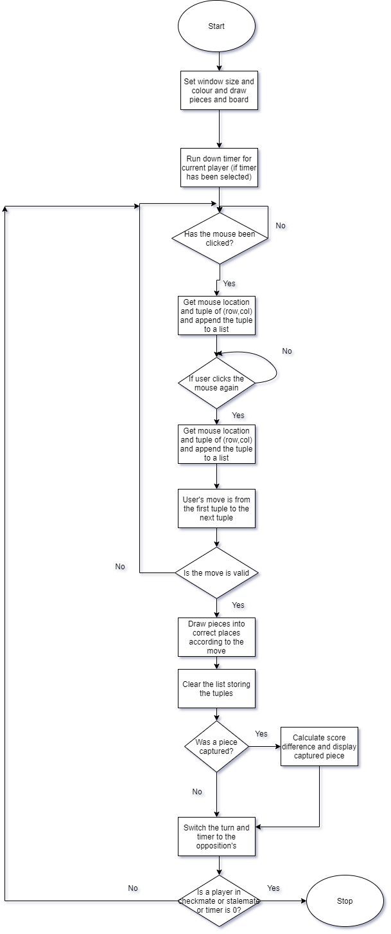**Main Game**

This algorithm is the main part of the program which calls each procedure that makes up the rules of chess and provides an authentic chess game to solve the problem.

**User Input**

This algorithm forms how the user can interact with the program and move their pieces.

User Input

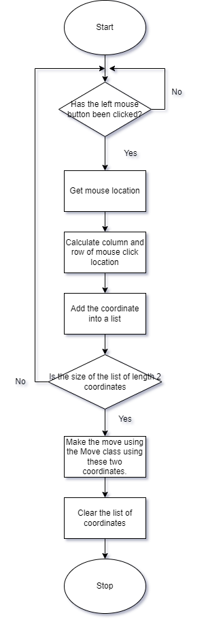

**Checking For Valid Moves**

This algorithm is responsible for the rules of where a pawn can move. This is needed to ensure that the user cannot make an illegal pawn move.

Pawn Movement

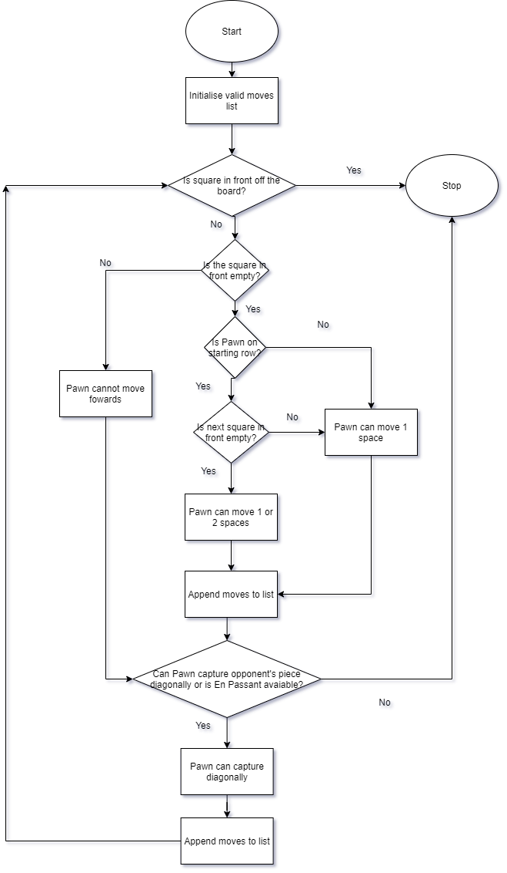

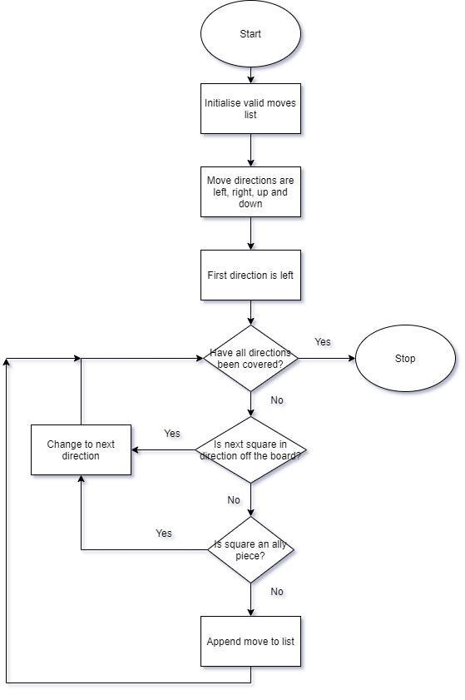

This algorithm is responsible for the rules of where a rook can move. This is needed to ensure that the user cannot make an illegal rook move.

Rook Movement

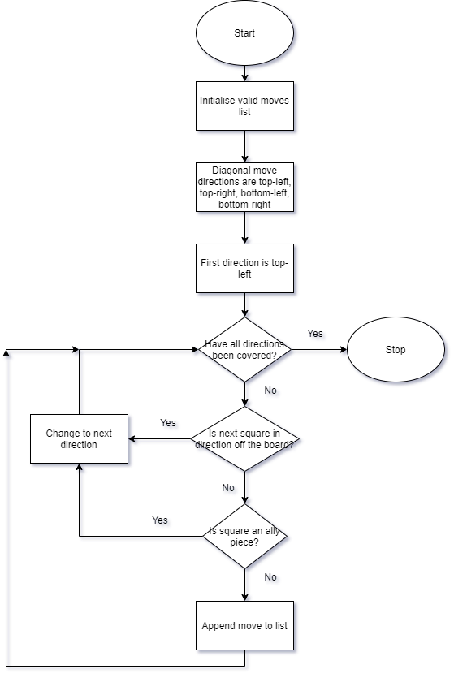

This algorithm is responsible for the rules of where a bishop can move. This is needed to ensure that the user cannot make an illegal bishop move.

Bishop Movement

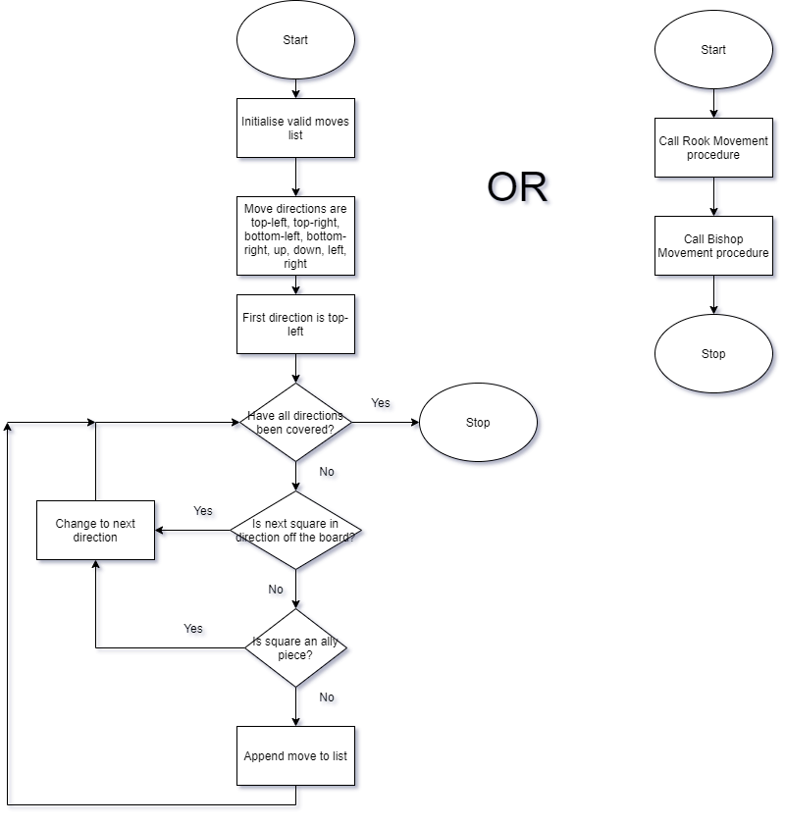

This algorithm is responsible for the rules of where a queen can move. This is needed to ensure that the user cannot make an illegal queen move.

Queen Movement

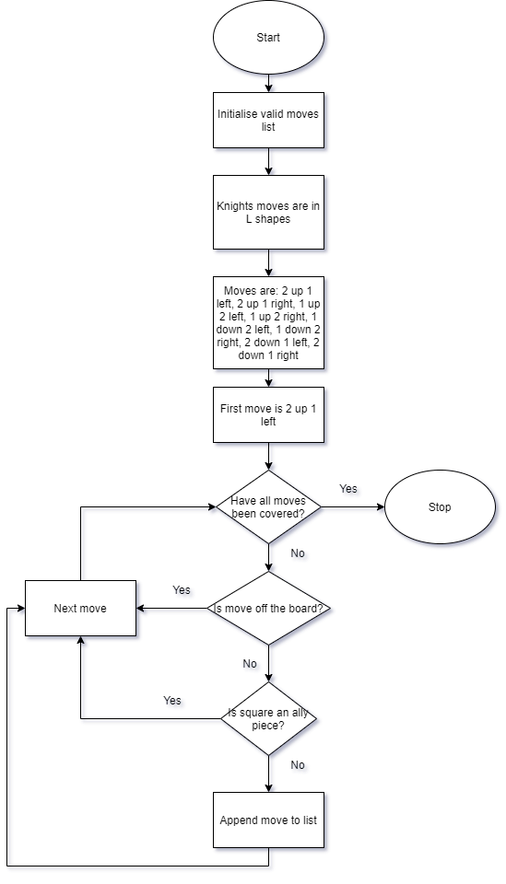

This algorithm is responsible for the rules of where a knight can move. This is needed to ensure that the user cannot make an illegal knight move.

Knight Movement

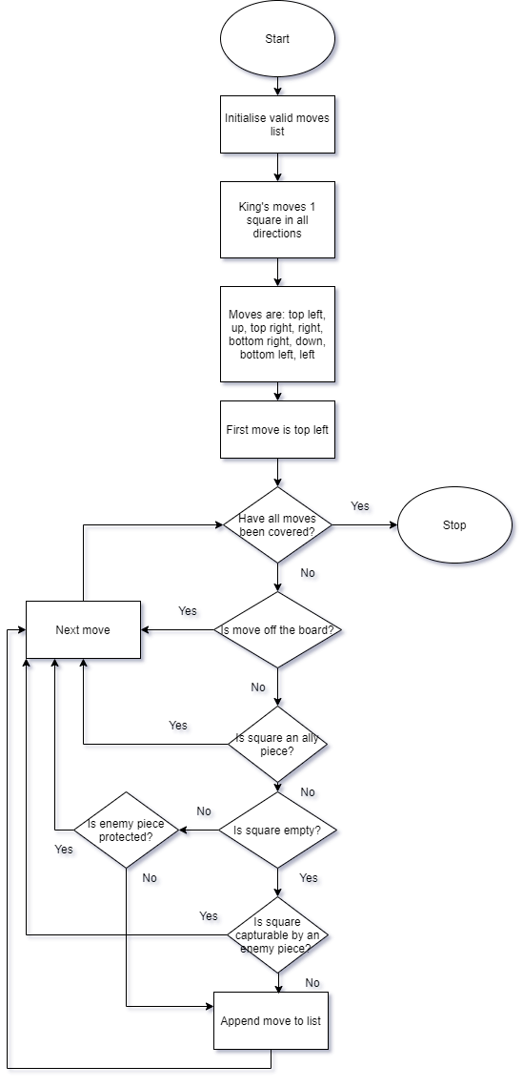

This algorithm is responsible for the rules of where a king can move. This is needed to ensure that the user cannot make an illegal king move.

King Movement

This algorithm is responsible for how checks, stalemates and stalemate messages are delivered.

Check, Checkmate & Stalemate

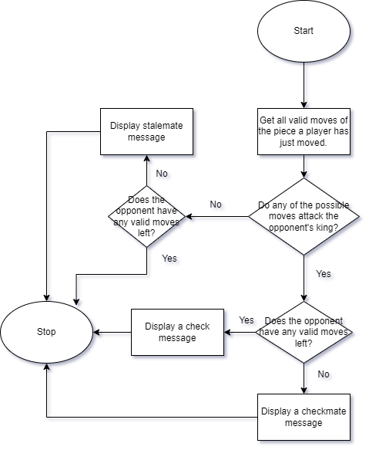

This algorithm is responsible for how squares are highlighted.

Potential Moves Indicator

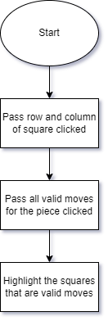

**Leader board & Database**

This algorithm is responsible for how the program interacts with the database and how the database can be converted into a table for the user.

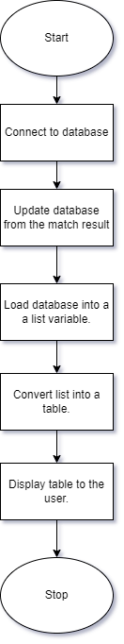

Leader board & Database

**Sounds**

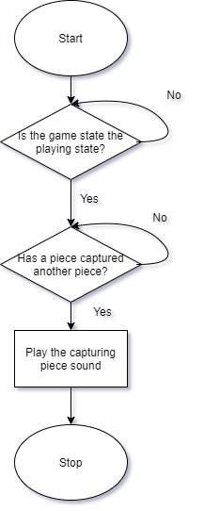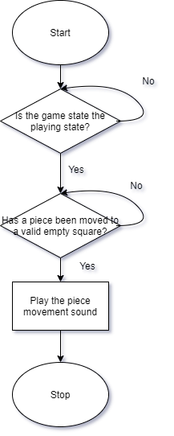

This algorithm is responsible for when the piece capturing sound should be played.

This algorithm is responsible for when the piece movement sound should be played.

Piece Capturing Sound

Piece Movement Sound

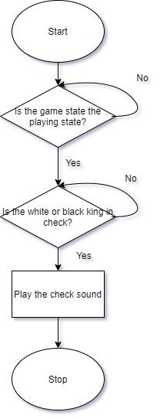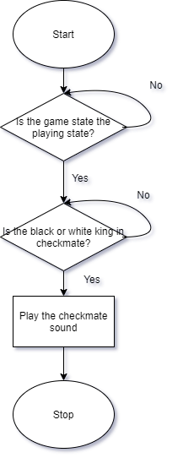

Checkmate Sound

Check Sound

This algorithm is responsible for when the checkmate sound should be played.

This algorithm is responsible for when the check sound should be played.

## Usability Features

### Main Game

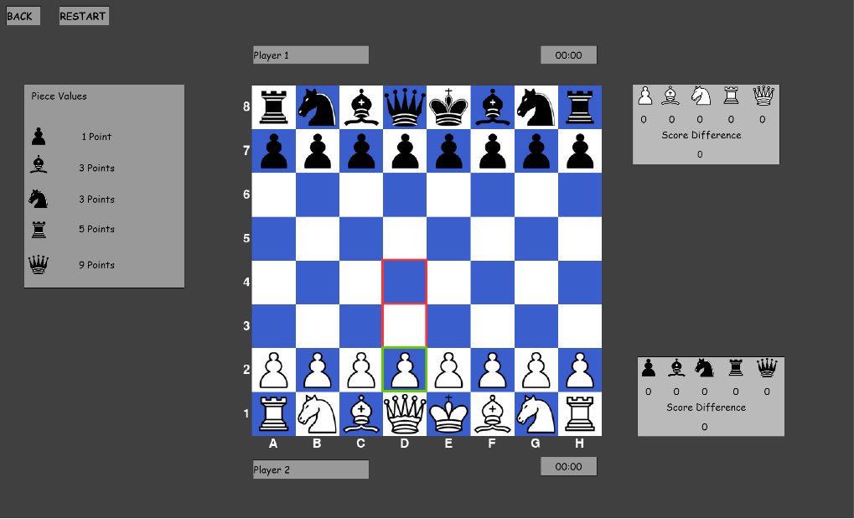**Functionality**

The simplicity of this means that the rules of chess can be learnt by anyone of any age

Highlighted squares indicate where a piece can be moved to or what piece has been selected by the user. The moves highlighted only show valid moves for that piece. Therefore, a piece cannot move outside the highlighted areas to teach the players the rules of each piece. To move a piece, the player must left click the piece using a mouse, then click on a highlighted square.

Player 2’s timer, which will count down whenever it is their turn and stop when it is player 1’s turn

Display player 1’s username so the players know which colour they are

Displays the file and rank notation on the side and bottom of the board, so that players can become familiar with this notation that is used globally.

Displays what white pieces player 1 has captured and displays the score difference between player 1 and player 2

Displays what black pieces player 2 has captured and displays the score difference between player 1 and player 2

Player 1’s timer, which will count down whenever it is their turn and stop when it is player 2’s turn

Display player 1’s username so the players know which colour they are

Restart button to reset the pieces to their original positions and reset the timer

Display piece values, so that the players can understand whether to trade pieces or not

Back button to return to the main menu

**Design and Colour Choices**

When a button is pressed, a red square should appear around the button to indicate that it has successfully been pressed by the user

The board colours have been selected to be dark blue and white to have a large contrast to the pieces and the highlighted squares from the potential moves indicator

The style of the piece images has been chosen as they are a simplistic style so any chess player can easily differentiate which chess piece is which



The font is Comic Sans, so is easily readable by people who suffer from reading difficulties, such as people that suffer with dyslexia

When a piece is clicked on the piece that has been selected will have a green square around it and the potential moves that the piece can make will be highlighted in red to contrast with the board and window colours

**Colour Blindness**

I have chosen these colours in my program because they can also be easily distinguished for people who have any colour blindness conditions. This means that people with colour blindness are not disadvantaged when using my game. Most common colour blindness conditions include:

Protanomaly/Red-Weak

Tritanomaly/Blue-Weak

Deuteranomaly/Green-Weak

### Main Menu

**Functionality and Design Choices**

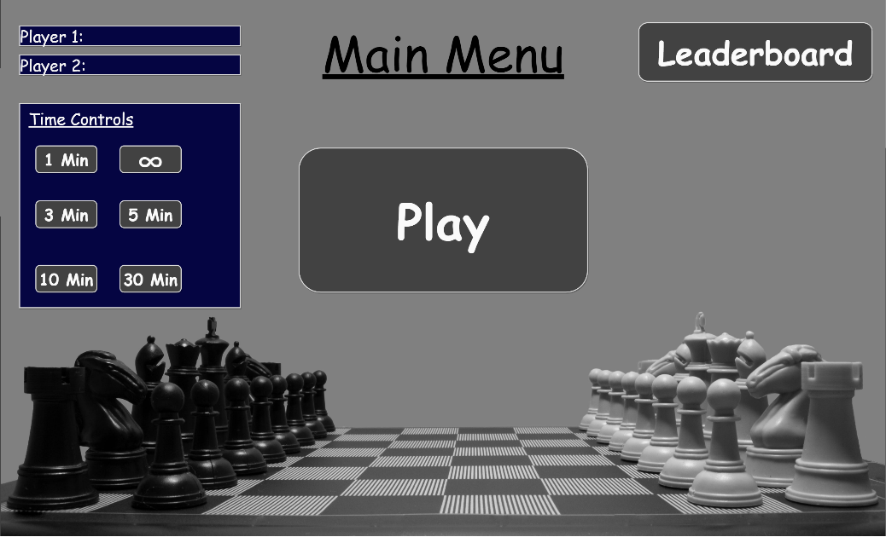

Clear title to inform the user which screen they are on

The font is again Comic Sans, so is easily readable by people who suffer from reading difficulties, such as people that suffer with dyslexia

The player username boxes must be filled out and a time control must be selected before the user can click the play button

Time control buttons, when clicked will make the in game timer count down from the time specified for each player

Play button, when clicked will take the players to the ‘Main Game’ window, where they will be able to play a chess match with. Will also have a red outline to show it has been clicked.

Leader board button, when clicked will take the user to a separate screen containing the wins, losses, games played and win percentage of each player using a database

Player 1 & 2 input boxes to enter the players’ usernames, so that the result can be stored into the leader board database after the match

**Colour Blindness**

I have chosen these colours in my program because they can also be easily distinguished for people who have any colour blindness conditions. This means that people with colour blindness can use the menu easily. Most common colour blindness conditions include:

Protanomaly/Red-Weak

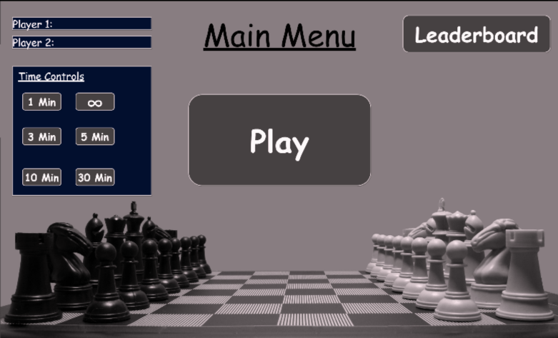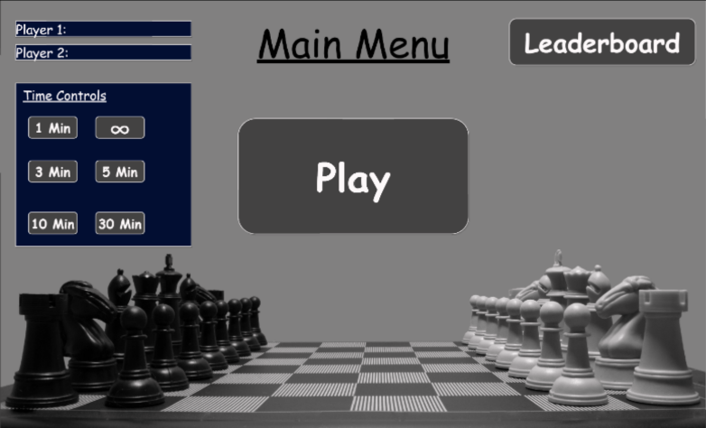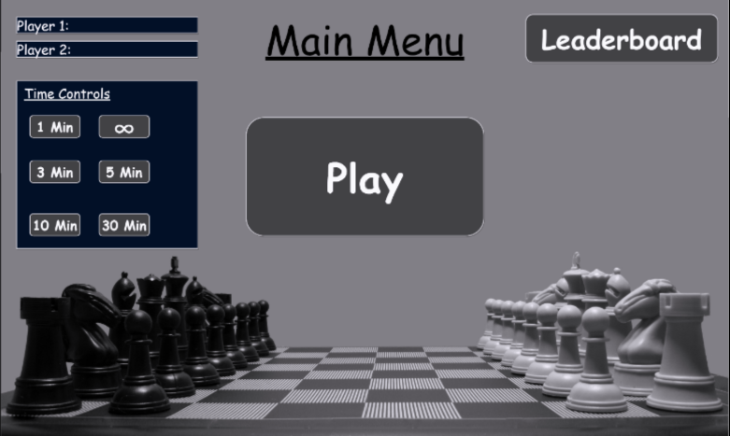

Tritanomaly/Blue-Weak

Deuteranomaly/Green-Weak

## Class Diagram

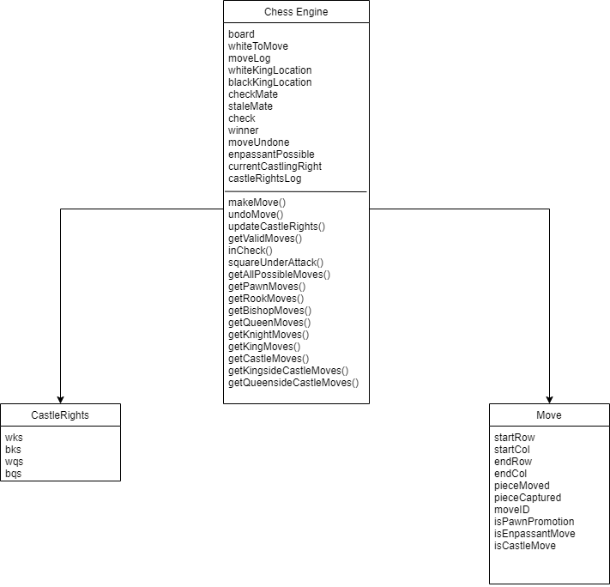

## Key Variables and Data Structures

|  |  |  |  |
| --- | --- | --- | --- |
| **Method** | **Name** | **Data Type** | **Explanation & Justification** |
| **Leader board** |  |  |  |
| Game State | Leader_board | N/A | This is the part of the game where the players can view the amount of games played, wins, losses and win percentage of each player. |
| Procedure | newStats | N/A | This is where new stats are added to the leader board after a match is completed, such as a new win is added to a player’s tally. |
| Variable | gamesPlayed | Integer | This stored the number of games by a player. |
| Variable | wins | Integer | This stores the number of wins by a player. |
| Variable | losses | Integer | This stores the number of losses by a player. |
| Variable | winPercentage | Float | This stores the win percentage of a player, calculated by doing the wins divided by the games played, multiplied by 100. |
| Database File | Leaderboard_database | .sql or .accdb | This database is going to be used to save all the statistics for each player’s username to allow them to be saved after the program is closed. |
| **Menu** |  |  |  |
| Game state | Menu | N/A | This is the part of the game where the user can choose to play the game or go to the leader board. |
| Procedure | Change_GameState | N/A | Depending on which button the player presses, it will take them to the main game or the leaderboard. |
| Variable | Player1 | String | This stores player 1’s username, so that it can be updated into the leader board after the match and with the correct result. |
| Variable | Player2 | String | This stores player 2’s username, so that it can be updated into the leader board after the match and with the correct result. |
| Procedure | usernameValidation | N/A | This is needed to ensure that the usernames that the players have picked are of the correct length. This will be limited to 20 characters. |
| Variable | timeControl | Integer | This stores the time control mode that has been selected. E.g. 5 minutes would be stored as the integer 5. |
| **Assets** |  |  |  |
| Sound file | Checkmate | .wav | This sound effect will play when one player checkmates the other. This is to alert both players that the game has now ended by this result. |
| Sound file | Check | .wav | This sound effect will be played when one player has checked the other player. This is to alert both players that this has occurred. |
| Sound file | pieceCaptured | .wav | This sound effect will play when one player captures the other player’s piece. This is to alert the second player that they lost a piece. |
| Sound file | pieceMoved | .wav | This sound effect will play when a player has moved their piece. This is to alert the other player that it is now their turn. |
| Field sprite | wP | .png | This image is for the white pawn to be displayed on the board |
| Field sprite | wR | .png | This image is for the white rook to be displayed on the board |
| Field sprite | wN | .png | This image is for the white knight to be displayed on the board |
| Field sprite | wB | .png | This image is for the white bishop to be displayed on the board |
| Field sprite | wQ | .png | This image is for the white queen to be displayed on the board |
| Field sprite | wK | .png | This image is for the white king to be displayed on the board |
| Field sprite | bP | .png | This image is for the black pawn to be displayed on the board |
| Field sprite | bR | .png | This image is for the black rook to be displayed on the board |
| Field sprite | bN | .png | This image is for the black knight to be displayed on the board |
| Field sprite | bB | .png | This image is for the black bishop to be displayed on the board |
| Field sprite | bQ | .png | This image is for the black queen to be displayed on the board |
| Field sprite | bK | .png | This image is for the black king to be displayed on the board |
| **Main Game** |  |  |  |
| Game State | ChessMain | N/A | This is the main state of the game where the two players carry out a game of chess. |
| Tuple | sqSelected | Integer | This tuple keeps track of the last square the user has clicked on. |
| Tuple Array | playerClicks | N/A | This array keeps track of the squares that have been clicked on. |
| Variable | row | Integer | This stores the row of the square that the user clicked on. |
| Variable | col | Integer | This stores the column of the square that the user clicked on. |
| 2D Array | board | N/A | This 2D array stores the board in its current position, where each square holds either a piece or an empty square. The board is 8x8 |
| Procedure | makeMove | N/A | This procedure takes a move as a parameter and executes it. |
| Procedure | updateCastleRights | N/A | This procedure updates the castling rights given the move. E.g. if the white king has already moved during the game, it cannot castle. |
| Procedure | getAllPossibleMoves | N/A | This procedure goes though all the squares on the board and retrieves all the possible moves that each piece can make at that point in the game without considering checks, according to the move rules of each piece. |
| Array | moves | N/A | This is a list of all possible moves that can be made by each piece at a given time in the game. |
| Procedure | getPawnMoves | N/A | This procedure gets all the pawn moves for the pawn located by “getAllPossibleMoves” and adds these valid moves to the array “moves” |
| Procedure | getRookMoves | N/A | This procedure gets all the rook moves for the rook located by “getAllPossibleMoves” and adds these valid moves to the array “moves” |
| Procedure | getBishopMoves | N/A | This procedure gets all the bishop moves for the bishop located by “getAllPossibleMoves” and adds these valid moves to the array “moves” |
| Procedure | getQueenMoves | N/A | This procedure gets all the queen moves for the queen located by “getAllPossibleMoves” and adds these valid moves to the array “moves” |
| Procedure | getKnightMoves | N/A | This procedure gets all the knight moves for the knight located by “getAllPossibleMoves” and adds these valid moves to the array “moves” |
| Procedure | getKingMoves | N/A | This procedure gets all the king moves for the king located by “getAllPossibleMoves” and adds these valid moves to the array “moves” |
| Procedure | getValidMoves | N/A | This procedure takes all the possible moves produced by “getAllPossibleMoves” and produces only valid moves taking checks into account. E.g., A piece pinned to the king cannot move. Also decides when a king is in checkmate/stalemate. |
| Procedure | squareUnderAttack | N/A | This procedure checks whether a square is under attack by the opponent. To then allow other procedures to be carried out, such as if the king is allowed to castle. |
| Procedure | getCastleMoves | N/A | Generates all the valid castling moves for the king |
| Procedure | getKingsideCastleMoves | N/A | Decides if the king is allowed to castle to the kingside (right side) |
| Procedure | getQueensideCastleMoves | N/A | Decides if the king is allowed to castle to the queenside (left side) |
| Procedure | drawboard | N/A | Draws the board to the screen |
| Procedure | drawPieces | N/A | Draws the pieces to the screen |
| Procedure | drawCoordinates | N/A | Draws the rank-and-file notation to the side and bottom of the board. To allow the players to become familiar with chess notation. |
| Procedure | drawResultText | N/A | Draws the result of the game at the top of the screen to alert the players that the game has ended. E.g. Checkmate may be displayed. |
| Procedure | loadImages | N/A | Loads the image files into python so that they can then be drawn onto the screen. |
| Procedure | timeControl | N/A | This procedure will reduce the timer for a player when it is their turn and stop when it isn’t. The number on the timer depends on what the user has selected in the main menu. |

## Iterative Test data

**Main Menu**

Username system

|  |  |
| --- | --- |
| **Test Data** | **Type** |
| JoeBloggs | Valid |
| Joebloggs1234 | Valid |
| Joebloggs12345 | Invalid |

Choosing time control system

|  |  |
| --- | --- |
| **Test Data** | **Type** |
| User clicks none of the buttons | Invalid |
| Clicks “1 min” button | Valid |
| Clicks “5 min” button | Valid |

**Main Game**

Pawn movement

|  |  |
| --- | --- |
| **Test Data** | **Type** |
| Moves pawn forward 1 space | Valid |
| Moves pawn forward 2 spaces on first move | Valid |
| Captures piece diagonally 1 space | Valid |
| Captures a piece using ‘en passant’ | Valid |
| Moves pawn forward 3 spaces | Invalid |

Bishop movement

|  |  |
| --- | --- |
| **Test Data** | **Type** |
| Moves bishop diagonally space | Valid |
| Moves bishop diagonally to capture a piece | Valid |
| Moves bishop horizontally | Invalid |

Rook movement

|  |  |
| --- | --- |
| **Test Data** | **Type** |
| Moves rook horizontally | Valid |
| Moves rook vertically to capture a piece | Valid |
| Moves rook diagonally | Invalid |

Queen movement

|  |  |
| --- | --- |
| **Test Data** | **Type** |
| Moves queen horizontally | Valid |
| Moves queen vertically | Valid |
| Moves queen diagonally to capture a piece | Valid |
| Moves queen in an ‘L’ shape | Invalid |

Knight movement

|  |  |
| --- | --- |
| **Test Data** | **Type** |
| Moves knight in an ‘L’ shape | Valid |
| Moves knight in an ‘L’ shape to capture a piece | Valid |
| Moves knight vertically | Invalid |

King movement

|  |  |
| --- | --- |
| **Test Data** | **Type** |
| Moves king within 1 space anywhere | Valid |
| King captures piece within 1 space | Valid |
| Moves king 2 spaces | Invalid |

Testing Check

|  |  |
| --- | --- |
| **Test Data** | **Type** |
| Moves bishop in line with enemy king | Valid |
| Moves bishop away from enemy king | Invalid |
| Moves a pinned piece | Invalid |
| Moves king into a space guarded by an enemy piece | Invalid |
| King captures a guarded piece | Invalid |

Testing Checkmate

|  |  |
| --- | --- |
| **Test Data** | **Type** |
| King is in check and cannot move or stop the check | Valid |
| King cannot move but is not in check | Invalid |

Testing Stalemate

|  |  |
| --- | --- |
| **Test Data** | **Type** |
| No legal moves left | Valid |
| One piece is still able to move | Invalid |

Potential moves indicator

|  |  |
| --- | --- |
| **Test Data** | **Type** |
| Valid squares are indicated when piece is clicked | Valid |
| Valid squares aren’t indicated when piece is clicked | Invalid |

Score difference

|  |  |
| --- | --- |
| **Test Data** | **Type** |
| Score difference increased by 1 when pawn is captured | Valid |
| Score difference increased by 5 when rook is captured | Valid |
| Number of pieces captured increased by 1 when a piece is captured | Valid |
| Capturing a queen increases score by 10 | Invalid |

Time control

|  |  |
| --- | --- |
| **Test Data** | **Type** |
| A player’s timer goes down during their turn | Valid |
| A player’s timer goes down during the opponent’s turn | Invalid |

**End screen**

|  |  |
| --- | --- |
| **Test Data** | **Type** |
| Press “L” (Loads up the leader board) | Valid |
| Press “R” (Resets the board) | Valid |
| Press “M” (Goes back to the main menu) | Valid |
| Press “J” | Invalid |

## Post development/Acceptance Test Table

|  |  |  |  |  |  |
| --- | --- | --- | --- | --- | --- |
| Test No. | Requirements to be tested | Input/Action | Expected Outcome | Has it been met? | Evaluate |
| 1. | White pawn movement on a two square pawn advance | **Valid:** A white pawn is clicked and the square two above is clicked with both squares above are empty and it is white’s first turn.  **Invalid:** A white pawn is clicked and the square two above is clicked with one of the two squares above being occupied by another piece. | **Valid:** The white pawn moves two spaces up the board.  **Invalid:** The white pawn does not move two spaces up and stays where it is. | n/a | n/a |
| 2. | White pawn movement on a one square pawn advance | **Valid:** A white pawn is clicked and the square above is clicked with the square above being empty.  **Invalid:** A white pawn is clicked and the square above is clicked with the square above being occupied by a piece. | **Valid:** The white pawn moves one space up the board.  **Invalid:** The white pawn does not move one space up the board and stays where it is. | n/a | n/a |
| 3. | White pawn capturing other pieces diagonally | **Valid:** A white pawn is clicked and the square above to the right is clicked with an opponent’s piece in that square.  **Invalid:** A white pawn is clicked and the square above to the right or left is clicked with an ally piece in that square. | **Valid:** The white pawn moves into the space where the piece was, and that piece is taken off the board.  **Invalid:** The white pawn does not move to that space and stays where it is. | n/a | n/a |
| 4. | White pawn ‘En Passant’ | **Valid:** Black pawn has moved two spaces down to meet white’s pawn on rank 5 and is now one square to the right of the white pawn. A white pawn is clicked on rank 5 (row 3) and the empty square up to the right is clicked.  **Invalid:** Instead, the black pawn only moves one space to meet the white pawn on the same rank. | **Valid:** The white pawn will move into that empty square and the black pawn would be removed from the board.  **Invalid:** The white pawn would not be able to capture diagonally by ‘En Passant’ | n/a | n/a |
| 5. | Black pawn movement on a two square pawn advance | **Valid:** A black pawn is clicked and the square two below is clicked with both squares below being empty and it is black’s first turn.  **Invalid:** A black pawn is clicked and the square two below is clicked with one of the two squares above being occupied by another piece. | **Valid:** The black pawn moves two spaces down the board.  **Invalid:** The black pawn does not move two spaces down the board and stays where it is. | n/a | n/a |
| 6. | Black pawn movement on a one square pawn advance | **Valid:** A black pawn is clicked, and the square below is clicked with the square below being empty.  **Invalid:** A black pawn is clicked, and the square below is clicked with the square below being occupied by a piece. | **Valid:** The black pawn moves one space down the board.  **Invalid:** The black pawn does not move one space down the board and stays where it is. | n/a | n/a |
| 7. | Black pawn capturing other pieces diagonally | **Valid:** A black pawn is clicked and the square above to the right is clicked with an opponent’s piece in that square.  **Invalid:** A black pawn is clicked and the square below to the right is clicked with an ally piece in that square. | **Valid:** The black pawn moves into the space where the piece was, and that piece is taken off the board.  **Invalid:** The black pawn does not move to that space and stays where it is. | n/a | n/a |
| 8. | Black pawn ‘En Passant’ | **Valid:** A white pawn has moved two spaces up to meet black’s pawn on rank 4 and is now one square to the right of the black pawn. The black pawn is clicked on rank 4 (row 4) and the empty square down to the right is clicked.  **Invalid:** Instead, the white pawn only moves one space to meet the black pawn on the same rank. | **Valid:** The black pawn will move into that empty square and the black pawn would be removed from the board.  **Invalid:** The black pawn would not be able to capture diagonally by ‘En Passant’ | n/a | n/a |
| 9. | Rook movement | **Valid:** A rook is clicked, and another square (empty) is clicked any number of spaces to the left, right, up, or down and in between the empty square that is clicked and the rook there is no pieces in the way.  **Invalid:** A rook is clicked, and another square is clicked any number of spaces to the left, right, up, or down and in between the empty square that is clicked and the rook there is a piece in the way. | **Valid:** The rook moves to that empty space.  **Invalid:** The rook does not move to that empty space. | n/a | n/a |
| 10. | Rook capturing other pieces | **Valid:** A rook is clicked, and another square is clicked (with an enemy piece in that square) any number of spaces to the left, right, up, or down and in between the occupied square that is clicked and the rook there is no pieces in the way.  **Invalid:** A rook is clicked, and another square is clicked (with an enemy piece in that square) any number of spaces to the left, right, up, or down and in between the occupied square that is clicked and the rook there is a piece in the way. | **Valid:** The rook moves into that square and the enemy piece is taken off the board.  **Invalid:** The rook does not move to that square and stays where it is. | n/a | n/a |
| 11. | Bishop Movement | **Valid:** A bishop is clicked, and another square (empty) is clicked any number of spaces diagonally to the top-left, top-right, bottom-left, or bottom-right and in between the empty square that is clicked and the bishop there is no pieces in the way.  **Invalid:** A bishop is clicked, and another square is clicked any number of spaces diagonally to the top-left, top-right, bottom-left, or bottom-right and in between the empty square that is clicked and the bishop there is a piece in the way. | **Valid:** The bishop moves to that empty space.  **Invalid:** The bishop does not move to that empty space. | n/a | n/a |
| 12. | Bishop capturing other pieces | **Valid:** A bishop is clicked, and another square is clicked (with an enemy piece in that square) any number of spaces diagonally to the top-left, top-right, bottom-left, or bottom-right and in between the occupied square that is clicked and the bishop there is no pieces in the way.  **Invalid:** A bishop is clicked, and another square is clicked (with an enemy piece in that square) any number of spaces diagonally to the top-left, top-right, bottom-left, or bottom-right and in between the occupied square that is clicked and the bishop there is a piece in the way. | **Valid:** The bishop moves into that square and the enemy piece is taken off the board.  **Invalid:** The bishop does not move to that square and stays where it is. | n/a | n/a |
| 13. | Queen movement | **Valid:** A queen is clicked, and another square (empty) is clicked any number of spaces diagonally, vertically, or horizontally and in between the empty square that is clicked and the queen there is no pieces in the way.  **Invalid:** A queen is clicked, and another square is clicked any number of spaces diagonally, vertically, or horizontally and in between the empty square that is clicked and the bishop there is a piece in the way. | **Valid:** The queen moves to that empty space.  **Invalid:** The queen does not move to that empty space. | n/a | n/a |
| 14. | Queen capturing other pieces | **Valid:** A queen is clicked, and another square is clicked (with an enemy piece in that square) any number of spaces diagonally, vertically, or horizontally and in between the occupied square that is clicked and the queen there is no pieces in the way.  **Invalid:** A queen is clicked, and another square is clicked (with an enemy piece in that square) any number of spaces diagonally, vertically, or horizontally and in between the occupied square that is clicked and the queen there is a piece in the way. | **Valid:** The queen moves into that square and the enemy piece is taken off the board.  **Invalid:** The queen does not move to that square and stays where it is. | n/a | n/a |
| 15. | Knight movement | **Valid:** A knight is clicked, and another square (empty) is clicked that forms an L shape with the knight.  **Invalid:** A knight is clicked, and another square is clicked that does not form an L shape with the knight. E.g., The square one above the knight. | **Valid:** The knight moves to that empty space.  **Invalid:** The knight does not move to that empty space. | n/a | n/a |
| 16. | Knight capturing other pieces | **Valid:** A knight is clicked, and another square (with an enemy piece in that square) is clicked that forms an L shape with the knight.  **Invalid:** A knight is clicked, and another square (with an ally piece) is clicked that forms an L shape with the knight. E.g., The square one above the knight. | **Valid:** The knight moves into that square and the enemy piece is taken off the board.  **Invalid:** The knight does not move to that empty space. | n/a | n/a |
| 17. | King movement | **Valid:** A king is clicked, and another square (empty) is clicked that is anywhere within one space of the king and there is no enemy pieces that are able to move to those squares.  **Invalid:** A square outside the radius of one square is attempted to be reached.  **Invalid:** The square the king is trying to get to is guarded by an enemy piece.  **Invalid:** The square the king is trying to get to has an ally piece already in that square. | **Valid:** The king moves to that empty space.  **Invalid:** The king does not move to that empty space. | n/a | n/a |
| 18. | King capturing other pieces | **Valid:** A king is clicked, and another square (with an enemy piece in it) is clicked anywhere within one space of the king and that piece is not guarded by another enemy piece.  **Invalid:** The piece the king is attempting to capture is guarded by another enemy piece. | **Valid:** The king moves into that square and the enemy piece is taken off the board.  **Invalid:** The king does not move to that square. | n/a | n/a |
| 19. | Checks | **Valid:** A piece is moved to a square where it can then capture the enemy king on the next turn. E.g. The bishop moves to a square that is on the same diagonal as the enemy king with no pieces in the way.  **Invalid:** When instead there is a piece in the way. | **Valid:** The screen displays “Check!” and now the enemy can only do moves that involve getting the king out of check. E.g. Moving the king off that diagonal.  **Invalid:** Nothing would be displayed. | n/a | n/a |
| 20. | Checkmate | **Valid:** When a check is carried out, but the king cannot move anywhere, and nothing can block or capture the piece that is checking the king.  **Invalid:** When a check is carried out and the king is able to get out of check. | **Valid:** The screen displays “Checkmate!” and now the game is over.  **Invalid:** Nothing is displayed. | n/a | n/a |
| 21. | Stalemate | **Valid:** When the king cannot move anywhere, and no other ally piece cannot be moved.  **Invalid:** When the king has no moves, but there are other moves that can be played. | **Valid:** The screen displays “Stalemate!” and now the game is a draw.  **Invalid:** Nothing is displayed. | n/a | n/a |
| 22. | Castling to the Queen’s side | **Valid:** The king is clicked and the square two to the left is clicked. For this to be valid castle, the squares in between the left rook and the king must all be empty and the two squares to the left of the king must not be guarded by any of the enemy’s pieces.  **Invalid:** The king is clicked and the square two to the left is clicked, but there is a knight between the king and the rook. | **Valid:** The king moves two spaces to the left and the left rook moves to the square on the right of the king’s new position.  **Invalid:** The king and the rook do not move anywhere. | n/a | n/a |
| 23. | Castling to the King’s side | **Valid:** The king is clicked and the square two to the left is clicked. For this to be valid castle, the squares in between the left rook and the king must all be empty and the two squares to the left of the king must not be guarded by any of the enemy’s pieces.  **Invalid:** The king is clicked and the square two to the left is clicked, but there is a knight between the king and the rook. | **Valid:** The king moves two spaces to the left and the left rook moves to the square on the right of the king’s new position.  **Invalid:** The king and the rook do not move anywhere. | n/a | n/a |
| 24. | Pawn promotion | **Valid:** A pawn that is on the second to last row is clicked and the square (empty) on the last row is clicked.  **Valid:** Instead of moving forwards to promote, the pawn can also capture diagonally to reach the last row.  **Invalid:** There is a piece in the way of the pawn, and it cannot capture anything. | **Valid:** The pawn can promote to a queen.  **Invalid:** The pawn cannot promote. | n/a | n/a |
| 25. | Main menu play button | **Valid:** The user left clicks the button.  **Invalid:** The user right clicks the button. | **Valid:** The button becomes no longer outlined in green and the user is taken to the main game window.  **Invalid:** Does not do anything. | n/a | n/a |
| 26. | Main menu leader board button | **Valid:** The user left clicks the button.  **Invalid:** The user right clicks the button. | **Valid:** The button becomes outlined in red and the user is taken to the leader board window.  **Invalid:** Does not do anything. | n/a | n/a |
| 27. | Main menu username input boxes | **Valid:** The user types in a username of maximum 13 characters.  **Invalid:** The user types in a username of over 13 characters. | **Valid:** When the play button is pressed the user is taken to the main game.  **Invalid:** Asks the user to type in a username of valid length. | n/a | n/a |
| 28. | Main menu time control buttons | **Valid:** The user left clicks the button.  **Invalid:** The user right clicks the button. | **Valid:** The button becomes outlined in red.  **Invalid:** Does not do anything. | n/a | n/a |
| 29. | Hovering over buttons | **Valid:** The user hovers the mouse cursor over a button. | **Valid:** The button becomes outlined in green. | n/a | n/a |
| 30. | User Input | **Valid:** The user clicks on any piece and moves it anywhere without movement rules.  **Invalid:** The user clicks off the board. | **Valid:** The piece moves to that square.  **Invalid:** Nothing should happen. | n/a | n/a |
| 31. | Piece movement sound | **Valid:** The user moves a piece. | **Valid:** Plays the piece movement sound. | n/a | n/a |
| 32. | Piece capturing sound | **Valid:** The user captures an enemy piece. | **Valid:** Plays the piece capturing sound. | n/a | n/a |
| 33. | Checkmate sound | **Valid:** One player checkmates the other. | **Valid:** Plays the checkmate sound. | n/a | n/a |
| 34. | Check sound | **Valid:** One player checks the other. | **Valid:** Plays the check sound. | n/a | n/a |
| 35. | Illegal move sound | **Valid:** The user attempts to make an illegal move. | **Valid:** Plays an error sound | n/a | n/a |
| 36. | Time controls | **Valid:** The user clicks on the 1-minute button in the main menu.  **Invalid:** Nothing is selected on the main menu. | **Valid:** The timers in the game are set to 1 minute and white’s starts counting down immediately.  **Invalid:** The user can’t progress into the game. | n/a | n/a |
| 37. | Score difference | **Valid:** Player 1 captures a pawn. | **Valid:** Player 1’s score difference increases by 1. | n/a | n/a |
| 38. | Potential moves indicator | **Valid:** Player 1 (white) clicks on a white pawn.  **Invalid:** Player 1 (white) clicks on a black pawn. | **Valid:** Highlights valid moves in red and highlights pawn in green.  **Invalid:** No highlighting should be displayed. | n/a | n/a |
| 39. | Leader board system | **Valid:** Player 1 won against player 2.  **Valid:** Player 1 drew against player 2. | **Valid:** Player 1’s games played, and wins are increased by 1. Player 2’s games played, and losses are increased by 1. Updated leader board is displayed with position, username, games played, wins, losses, draws and win percentage as columns.  **Valid:** Player 1’s and player 2’s games played, and draws are increased by 1. Updated leader board is displayed with position, username, games played, wins, losses, draws and win percentage as columns. | n/a | n/a |
| 40. | Back and restart match buttons | **Valid:** User clicks the back button whilst playing.  **Valid:** User clicks the restart match button whilst playing. | **Valid:** The user must confirm their action again.  **Valid:** The board resets to its starting form. | n/a |  |

# Developing the Coded Solution

**Agile Development**

Move to next problem

Test solution

Review solution

Code solution

Design solution

Initial Problem

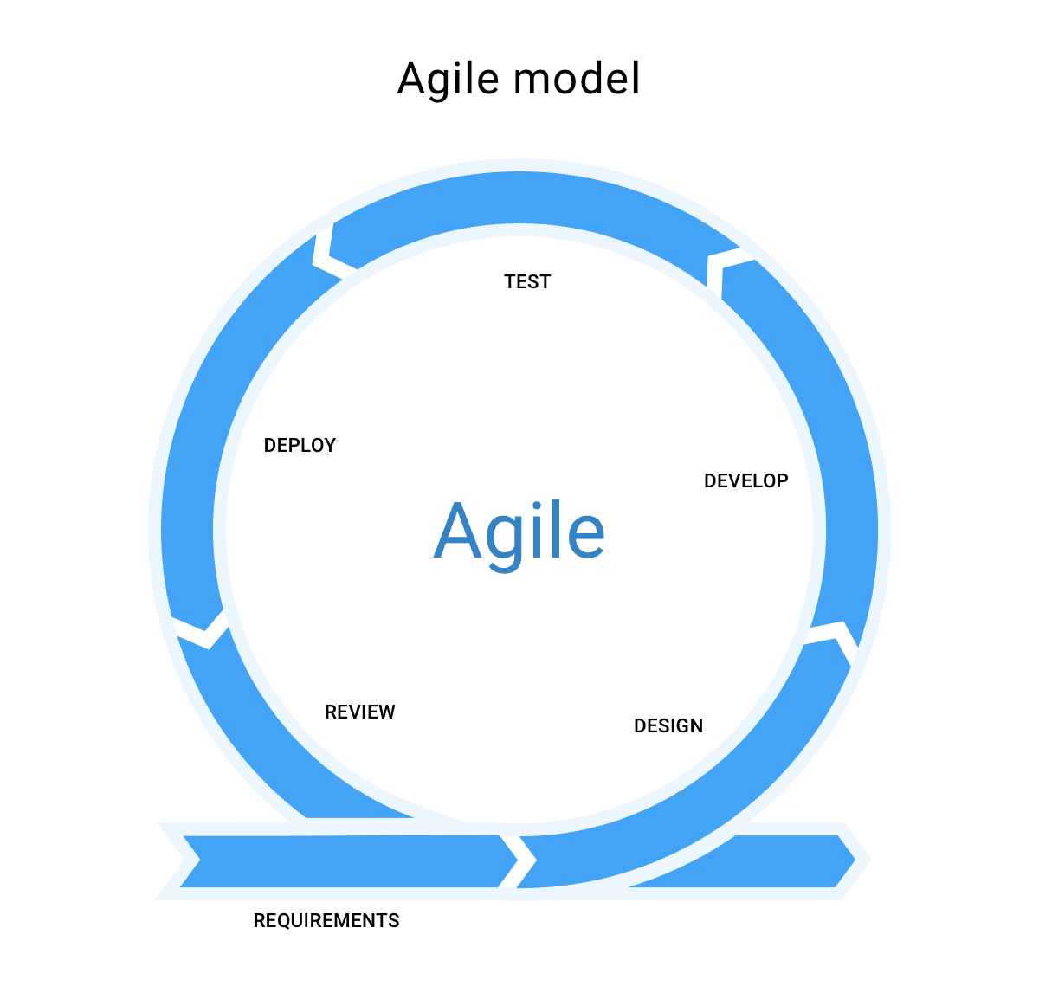

The agile model is where rapid incremental cycles are used to solve a given problem and then move to the next problem, where this repeats until all of the success criteria has been met and the stakeholders are satisfied. I have chosen to use this model because it allows me to focus on one problem at a time whilst working on my chess program.

**Development Plan**

After the period of development, I expect to have completed most/all my success criteria.

I have split the period of development up into 6 prototypes:

* Prototype 1 – Aimed to complete drawing the main objects that are displayed in the game and setting up user input.
* Prototype 2 – Aimed to only allow the user to only play valid chess moves without considering checks.
* Prototype 3 – Aimed to add the rules of check, checkmate, and stalemate to give the game an end result and to add extra features, such as pawn promoting and castling.
* Prototype 4 - Aimed to add extra visual features to enhance game quality and authenticity for beginners, such as time controls, score difference, potential moves indicator, and a username system.
* Prototype 5 – Aimed to add a database system into the game to store the leaderboard values. The leaderboard will be able to be accessed from the main menu.
* Prototype 6 – Aimed to add sounds into the game for different situations for increased authenticity.

## Drawing Chess Board & Pieces – Prototype 1

**10/09/21**





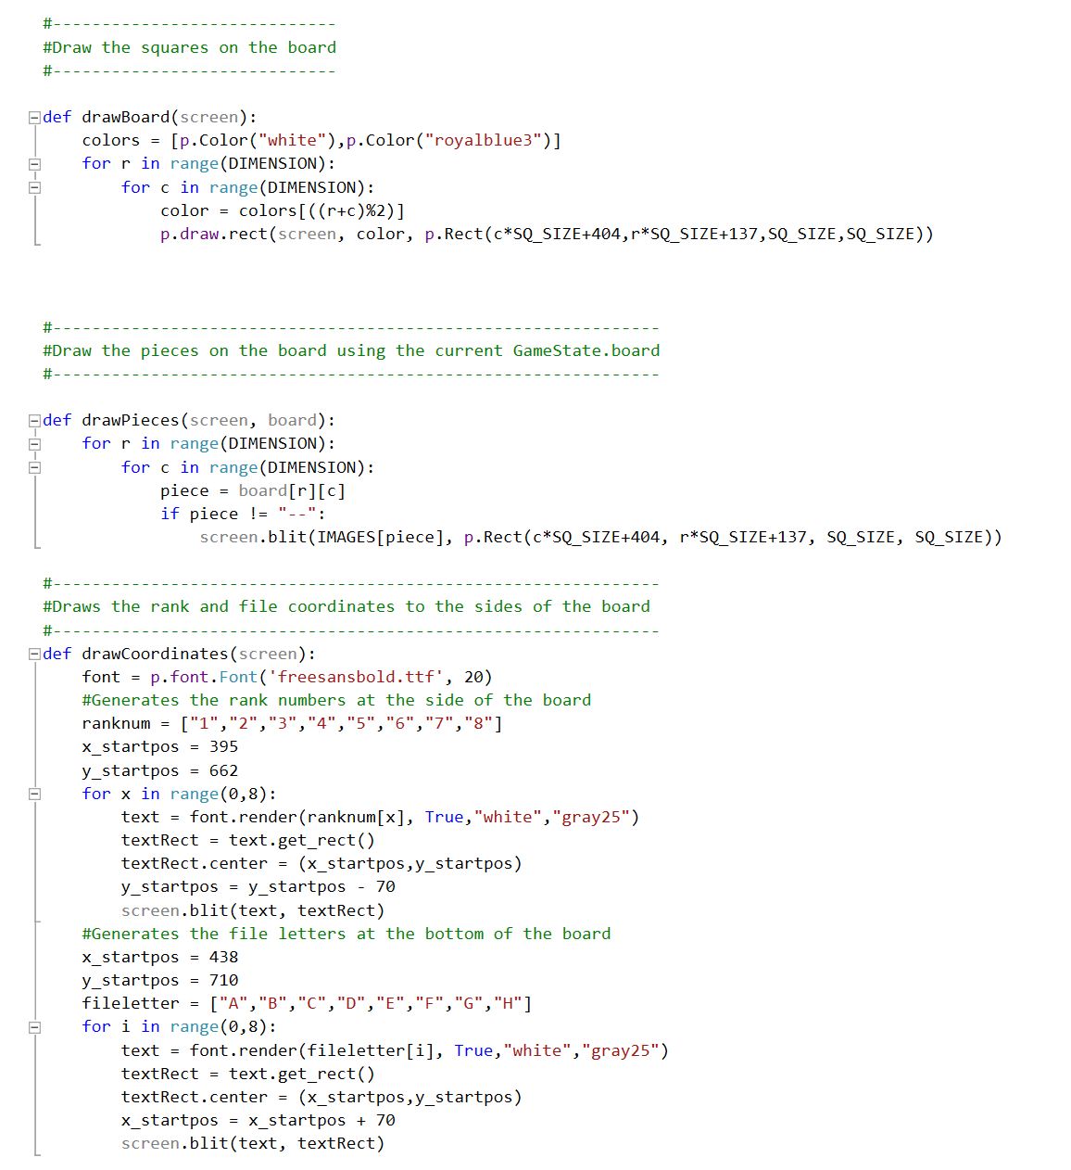

When drawPieces() is called, the program draws all the pieces to the board.

When drawBoard() is called, the program draws a chequered blue and white board to the screen.

When drawCoordinates() is called, the program draws all the rank and file notation to the sides of the board.

When loadImages() is called, the program loads all the images that are above, into the program.

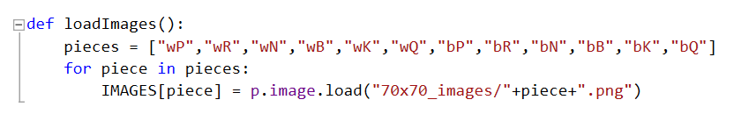

Before starting to code this section, I first did some research about the piece images that I needed to be able to draw the pieces on top of the board. I found these images above by doing a google search about “clip art chess pieces”, from which I found some suitable copyright-free images, which I resized to be 70x70 images to fit the board perfectly. Then, I needed to do some research about how to implement the module of PyGame, and specifically how to draw things to the screen. Once I found this out, I began to start creating my code to solve this first problem. This produced the solution of:

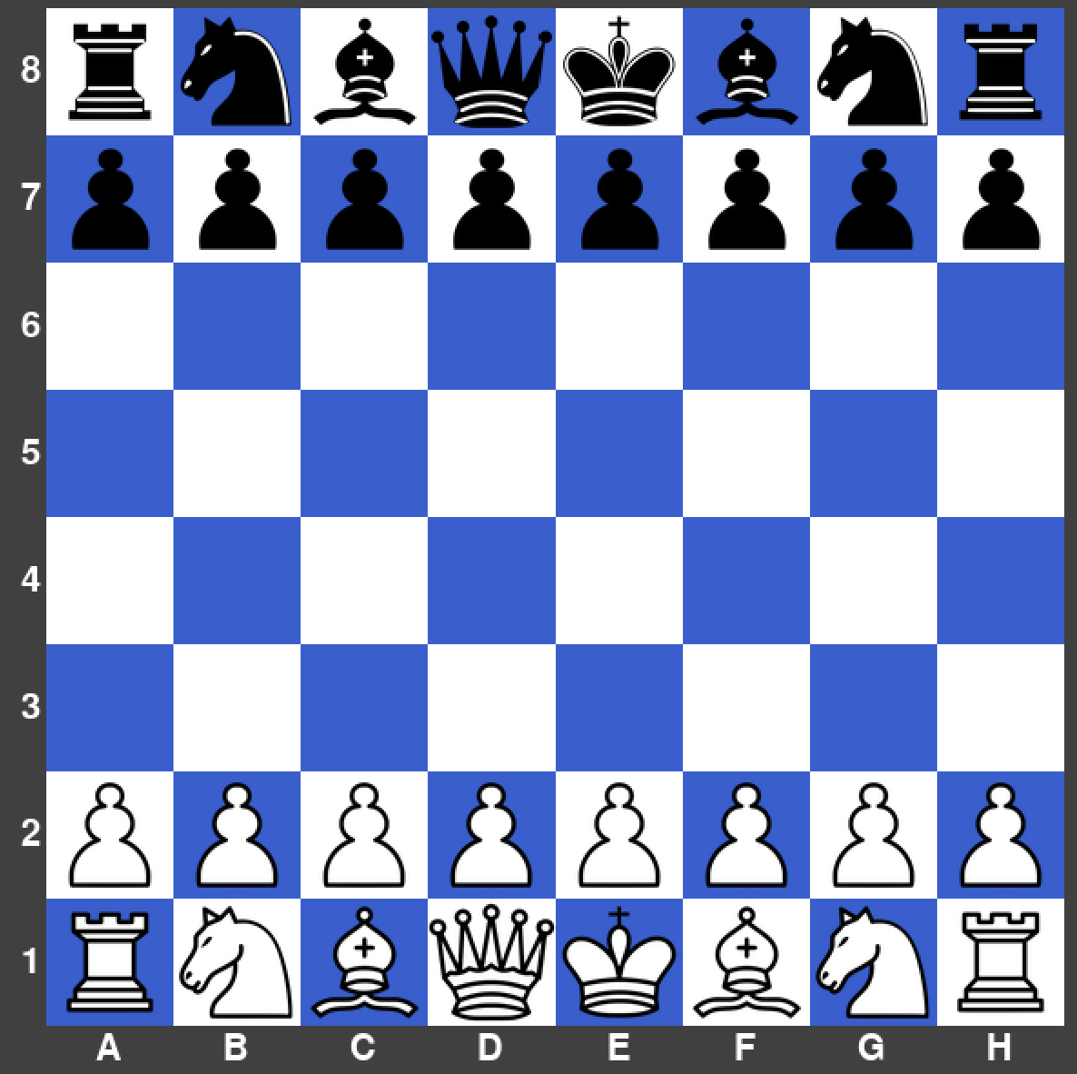

### Creating the Main Class for Chess Rules & Setting up User Input – Prototype 1

**17/09/21**

In this section I created a 2D array which stores the locations of every piece and empty square on the board. This will then change as the players move their pieces around the board, then the board screen can be updated. The turn indication is created by a single Boolean variable whiteToMove, which switches from True to False. Then, I needed to figure out how the user would be able to interact with the pieces and how the main game loop would be created. I decided to split each square into a tuple of (row,col), so when a user clicks on a specific square it would be stored as a tuple. For example, (4,3) indicates row 4, column 3. Then, each move the user attempts to make is made up of a starting tuple and an end tuple. The solution that I have produced is below.

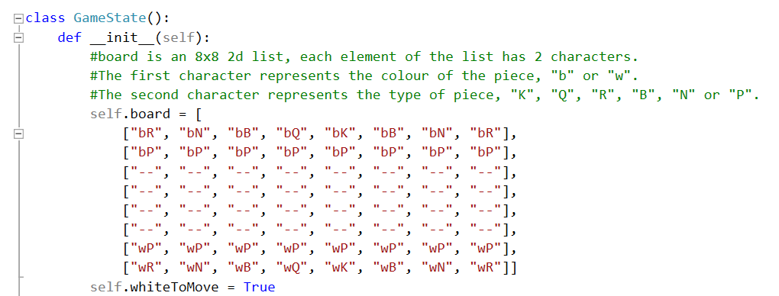

Attribute to declare that the first move is to be made by white.

2D Array of the board

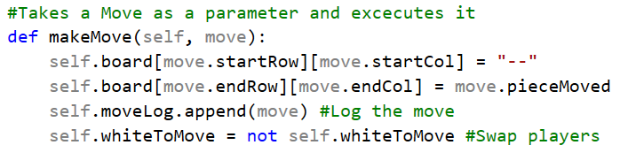

When called, it changes the board layout decided by where the user click which is passed as a parameter. Then, swaps the turn at the end.

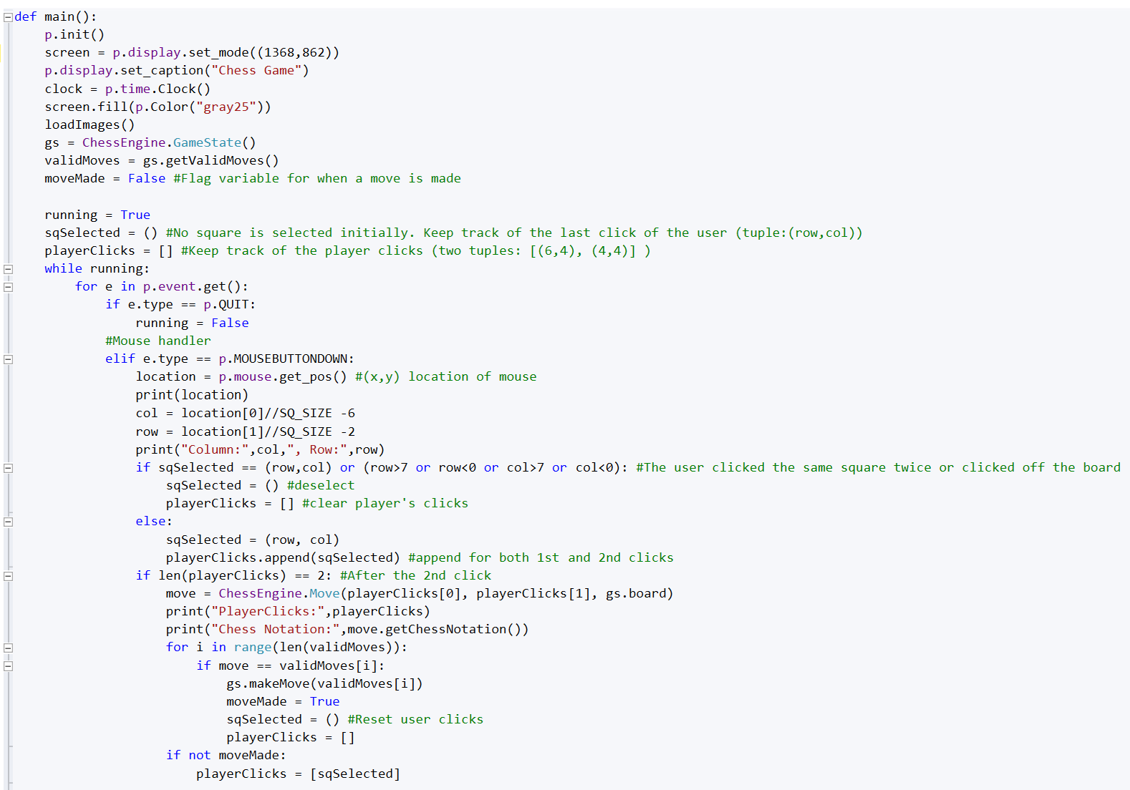

Validation to ensure the user doesn’t click the same square twice or off the board.

Calls another procedure to then decide whether the move is valid or not. This will be shown later.

Retrieves the location of the mouse

Initialises the list that stores the tuples of each player’s click

Sets up the display window

### Testing – Prototype 1

|  |  |  |  |  |
| --- | --- | --- | --- | --- |
| What’s being tested? | Input | Justification | Expected Outcome | Actual Outcome |
| User input for movement of pieces. | Click on the square E2. Then, click on the square F4. | To allow the user to move their pieces on the board. | The pawn disappears from E2 and travels to F4. | The pawn moves from E2 to F4. |
| Invalid test for movement | Click on the square E2. Then, click outside the board’s bounds. | To ensure that there is validation in place. | Nothing should happen. | Caused a ‘list index out of range’ error |

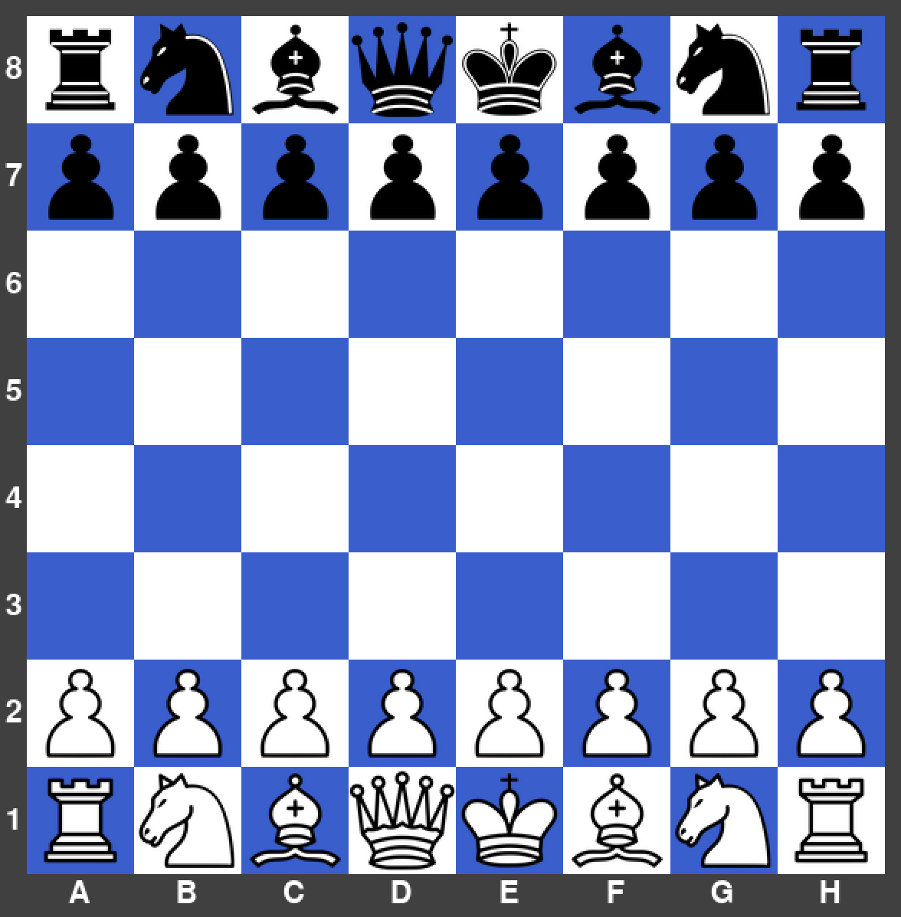

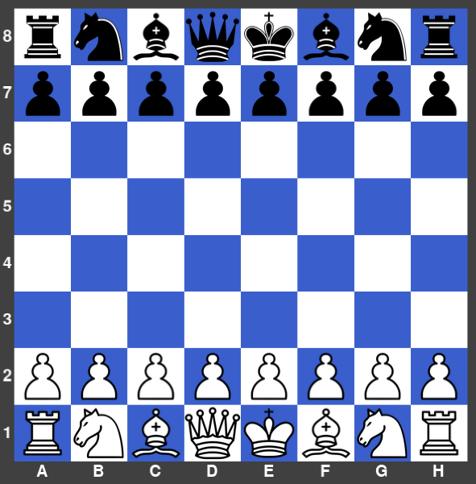



### Errors Encountered – Prototype 1

**List index error**

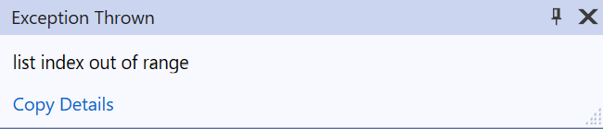

I found this error whilst testing my program, where I noticed that if the user where to click outside the boards area, this would throw a list index out of range error.

**Remedial Action**

To fix this I added some validation in place so that no columns or rows outside of the board would be passed into the algorithm using an if statement. This meant that there were no more errors for this prototype.



### Flowcharts used – Prototype 1

User Input



Main Game



### Interview & Review – Prototype 1

|  |  |  |
| --- | --- | --- |
| No. | Requirements | Justification |
| 7. | To move a piece, the player must click on one of their pieces and then click on a valid square to move it to. | Simplistic design makes it easy to understand for new players. |
| 13. | The style of the chess pieces and the board will be modern and simplistic. | This is so that any chess player will be able to recognise the pieces and the board easily. |
| 14. | White will always move first. | To ensure the rules are realistic. |
| 15. | Each player will take alternate turns to move one piece only. | To ensure the rules are realistic. |
| 16. | The six different pieces on the board that must be arranged in a specific pattern at the start of each match. | To ensure the rules are realistic. |

**Interview**

Me: What do you think about the appearance of the program at this stage?

Felix Williams: I am very pleased with the look of the board and pieces. I think the blue and white style is unique and the pieces look clear and modern.

Me: What do you think about the way the user can move the pieces?

Felix Williams: The way that the user can easily click twice to move a piece is perfect, as it’s user friendly and very responsive.

Me: What do you think about the rules that I have implemented so far?

Felix Williams: The rules, such as white moving first; each player taking alternate moves; and the board being put into the correct starting position, makes the game feel authentic already.

Me: Overall, how do you feel with the progress I have made?

Felix Williams: I am happy with how this first prototype is looking and functions, but I would like to see the pieces given restricted movement, where they can only move to squares and capture other pieces where the proper chess rules apply.

**Next steps**

After discussing with Felix about this prototype, I need to ensure that all the pieces on the board are given their unique movement rules. For example, rooks can only move vertically and horizontally any number of empty squares around them, but not over other pieces.

## Generating ALL Possible Chess Moves, Starting with Pawns – Prototype 2

**24/09/21**

In this section, I needed a way of finding all the moves each piece on the board can go to that is valid, without considering checks for now. What I came up with was, after a move is made and at the start of the game, every square on the board is scanned, if a piece is it that square, then another procedure is called to determine where that piece can go to. Then, the squares that the piece can go to are saved in an array, which means that the player can only move that piece to the tuples that are saved within that array. The tuples that are saved in the array are in a form called from another class to give clear information of the start and end square. Firstly, I decided to start with the pawns, which I figured out, need different if statements depending on whether they are white or black as they move differently up and down the board. This made the code slightly longer than I had expected.

Main procedure for getting valid moves, starting with only pawns.

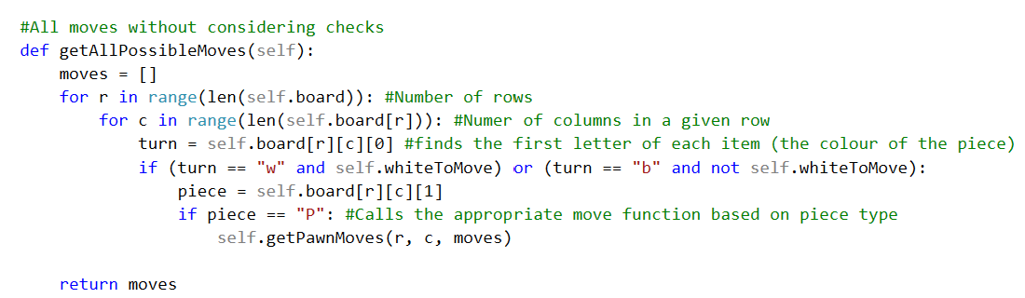

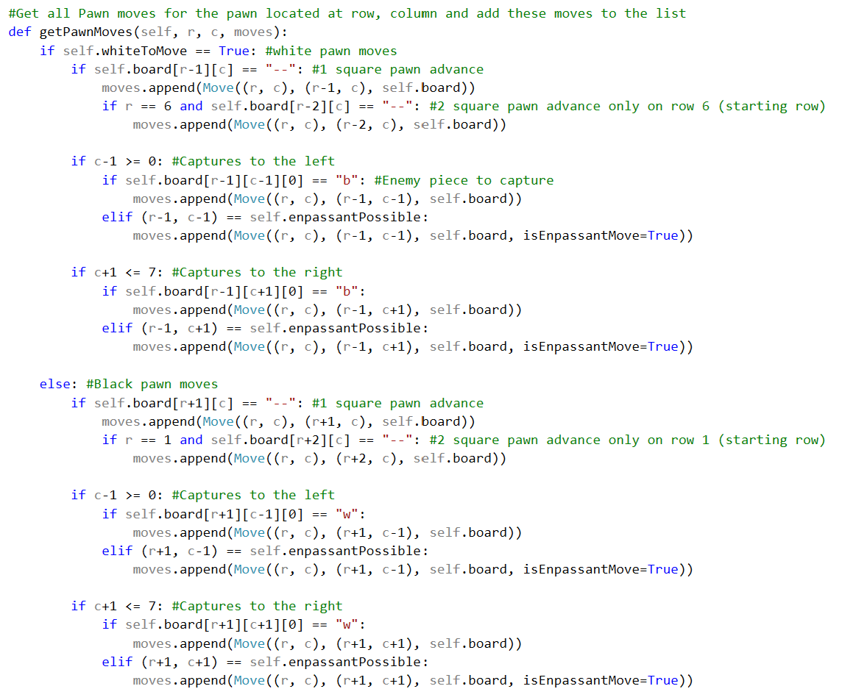

All white pawn moves

Validation to ensure that the column is not off the board.

All black pawn moves

All black pawn moves capturing to the right, including en passant conditions

All black pawn moves capturing to the left, including en passant conditions

All white pawn moves capturing to the right, including en passant conditions

All white pawn moves capturing to the left, including en passant conditions

Procedure to get all valid pawn moves

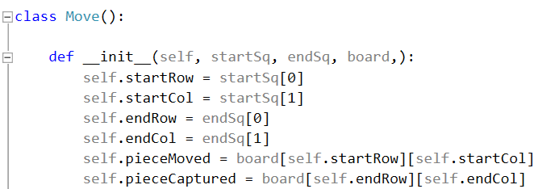

The class defining the logic behind the moves that are made and registered.

### Generating All Bishop, Knight, Queen, Rook and King Moves – Prototype 2

**01/10/21**

In this section, I finally created all the movement rules for each chess piece on the board. The form that I ended up using for most was assigning each piece with directions that they can move in, then seeing how far that piece could move before reaching another piece or the edge of the board. So, if the square was an ally piece or the square is out of bounds, the loop would stop. But, if the square contained an enemy piece or it was empty, that move is added to the moves array. When I reached the Queen moves, I did begin to structure it like the rook or bishop procedure before realising it would be easier to just call those procedures directly to save time, as a queen is essentially a rook and bishop combined into one piece.

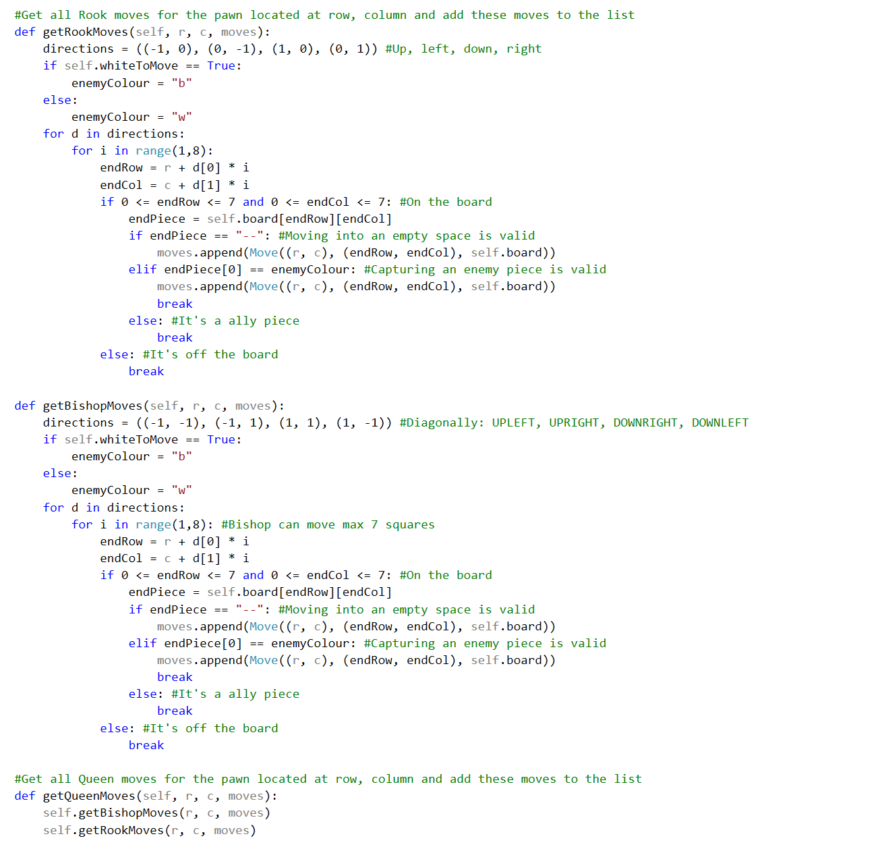

Validation to ensure that the move is on the board.

Validation to ensure that the move is on the board.

If it’s white’s turn then the enemy colour is black, if not the enemy colour is white.

If it’s white’s turn then the enemy colour is black, if not the enemy colour is white.

Retrieves all the valid bishop moves

Retrieves all the valid queen moves

Retrieves all the valid rook moves

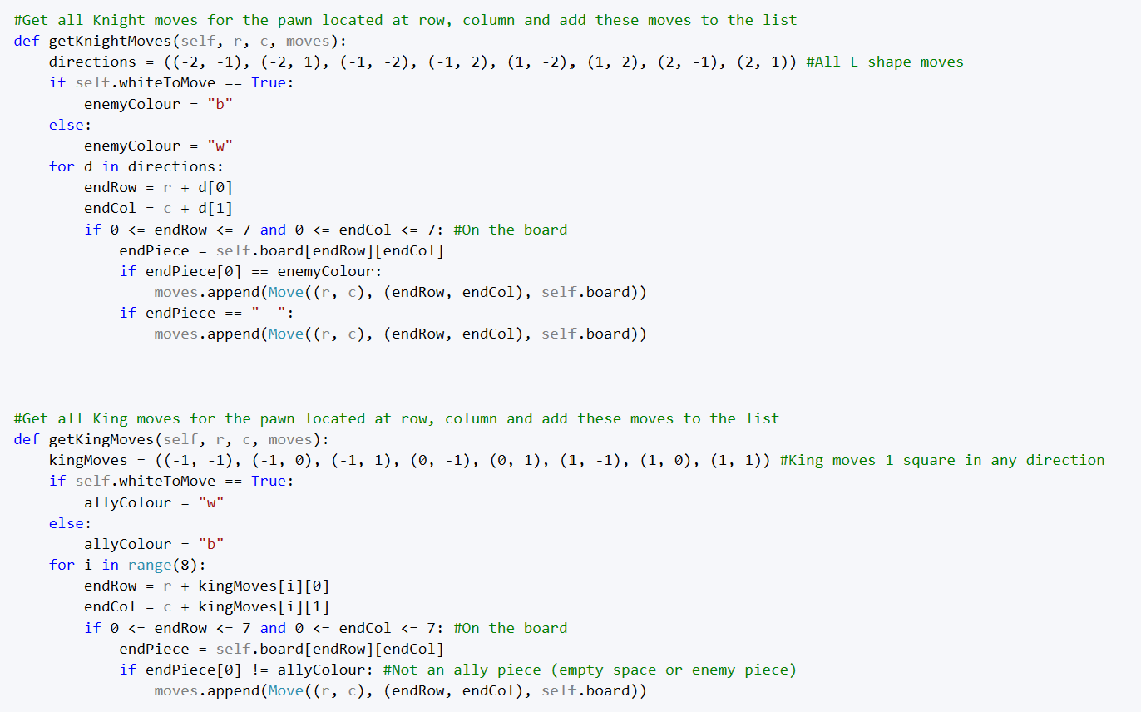

Validation to ensure that the move is on the board.

Validation to ensure that the move is on the board.

Retrieves all the valid knight moves

Retrieves all the valid king moves

### Testing – Prototype 2

|  |  |  |  |  |
| --- | --- | --- | --- | --- |
| What’s being tested? | Input | Justification | Expected Outcome | Actual Outcome |
| Pawn movement on a one square advance | Pawn is clicked on D2, then D3 is clicked. | To allow the user to move their pawn one square. | The pawn disappears from its current square and moves to D3. | The pawn moved to the correct place. |

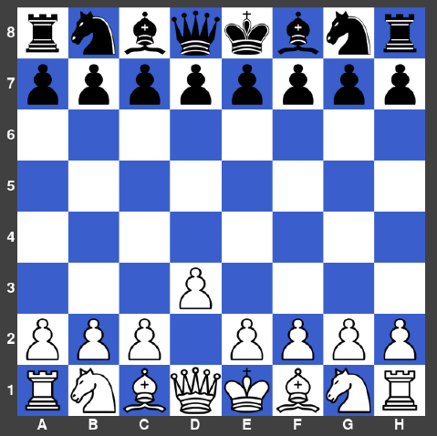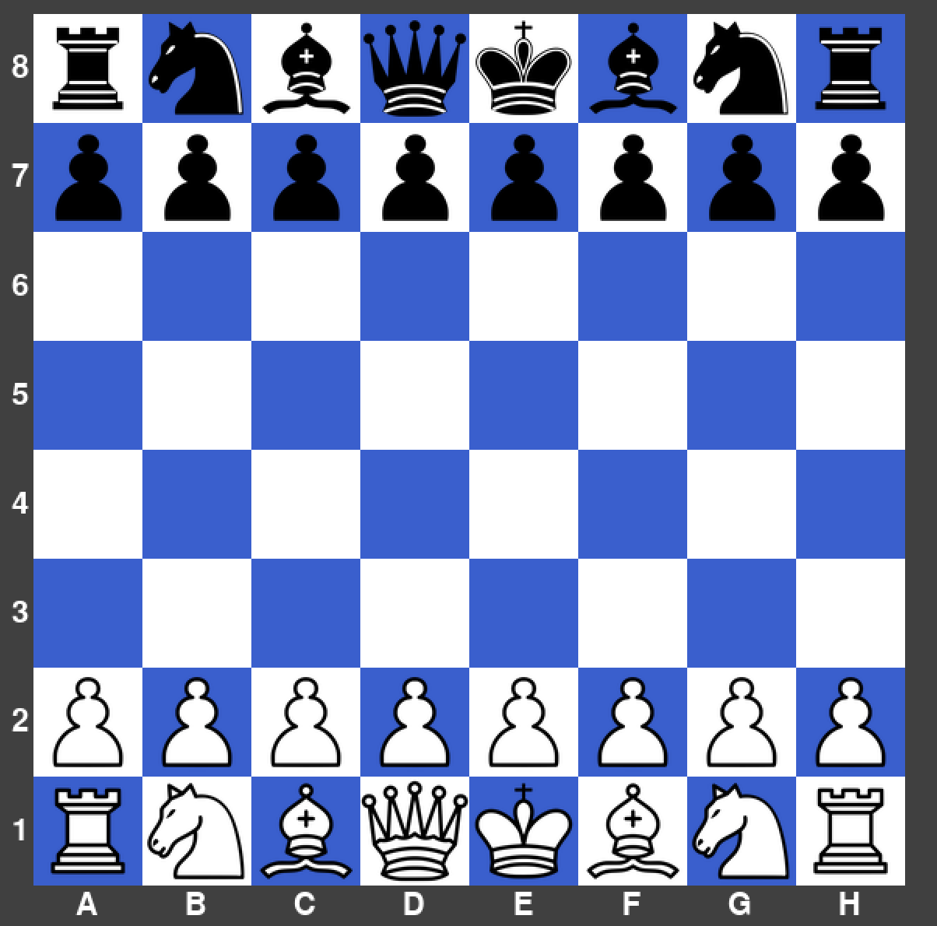

|  |  |  |  |  |
| --- | --- | --- | --- | --- |
| What’s being tested? | Input | Justification | Expected Outcome | Actual Outcome |
| Pawn movement on a two square advance | Pawn is clicked on C2, then C3 is clicked. | To allow the user to move their pawn two squares. | The pawn disappears from its current square and moves to C3. | The pawn moved to the correct place. |

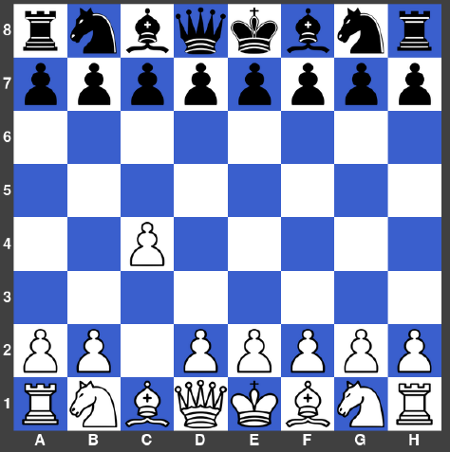

|  |  |  |  |  |
| --- | --- | --- | --- | --- |
| What’s being tested? | Input | Justification | Expected Outcome | Actual Outcome |
| Pawn capturing enemy pieces diagonally. | Pawn is clicked on D4, then E5 is clicked. | To allow the user to capture enemy pieces with pawns. | The pawn disappears from its current square and moves to E5 replacing the black pawn. | The pawn moved to the correct place and black pawn disappeared. |

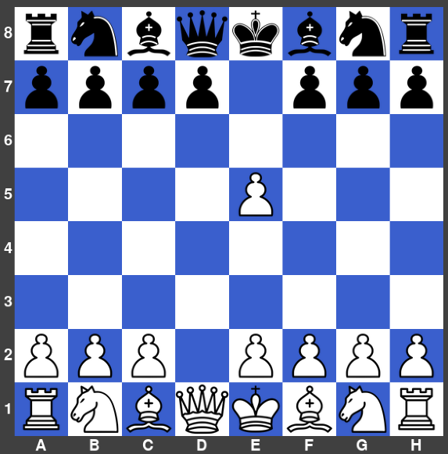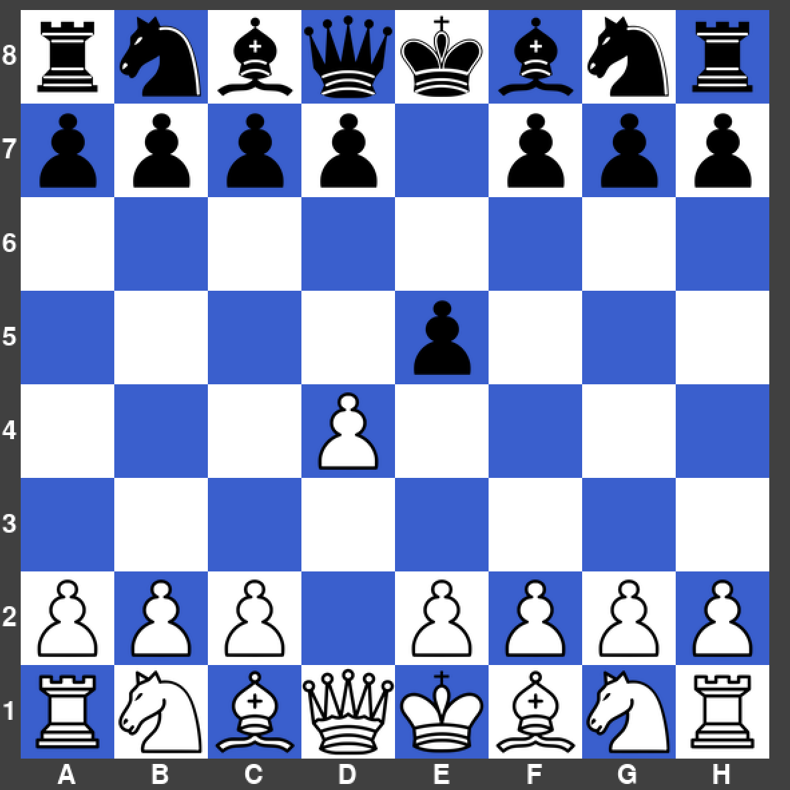

|  |  |  |  |  |
| --- | --- | --- | --- | --- |
| What’s being tested? | Input | Justification | Expected Outcome | Actual Outcome |
| Pawn ‘En Passant’ | Pawn is clicked on D4, then E5 is clicked. | To allow the user to capture enemy pieces with pawns. | The pawn disappears from its current square and moves to E5 replacing the black pawn. | The pawn moved to the correct place and black pawn disappeared. |

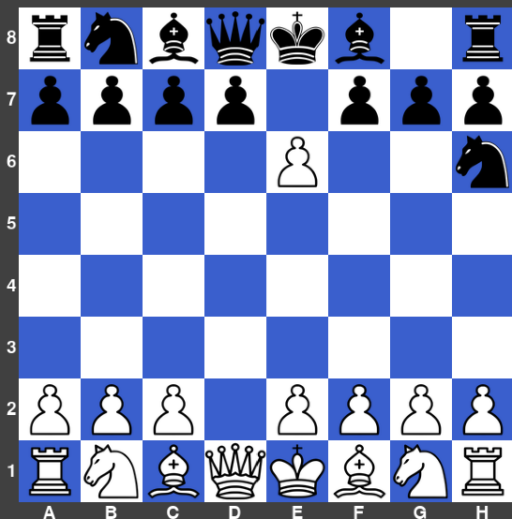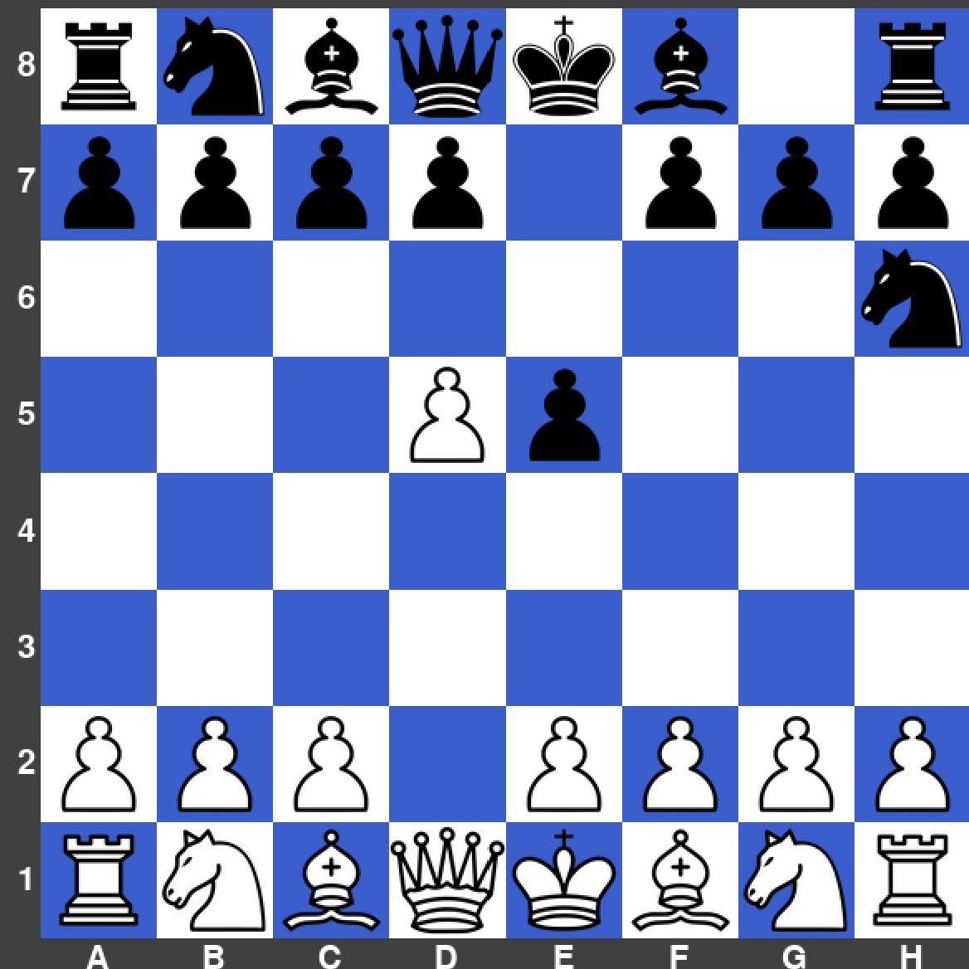

|  |  |  |  |  |
| --- | --- | --- | --- | --- |
| What’s being tested? | Input | Justification | Expected Outcome | Actual Outcome |
| Rook movement | Rook is clicked on H3, then A3 is clicked. | To allow the user to move their rook to any empty squares horizontally or vertically. | The rook disappears from its current square and moves to A3. | The rook didn’t move and stayed on H3 (incorrect outcome). |

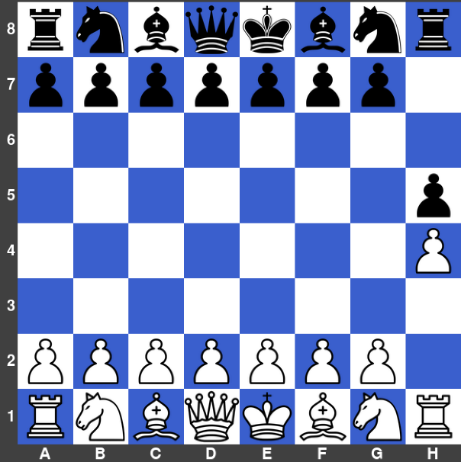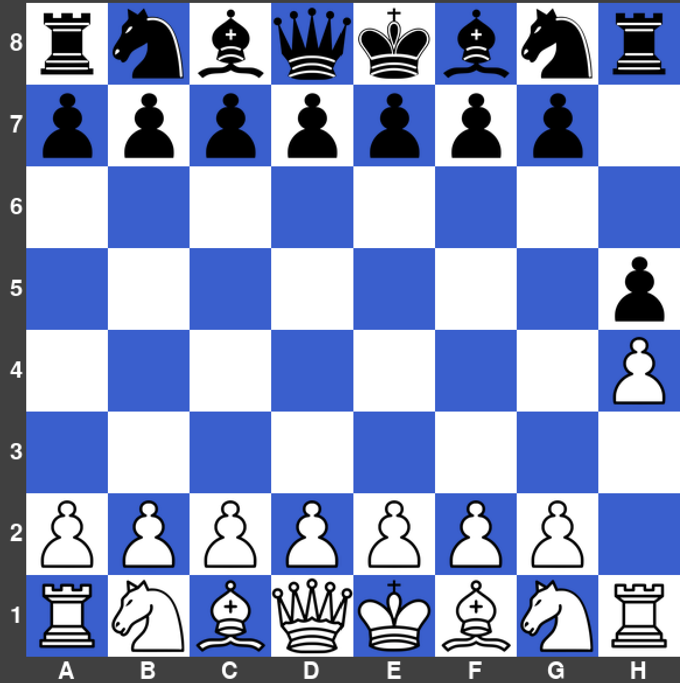

|  |  |  |  |  |
| --- | --- | --- | --- | --- |
| What’s being tested? | Input | Justification | Expected Outcome | Actual Outcome |
| Rook capturing other pieces | Rook is clicked on A3, then A7 is clicked. | To allow the user to capture enemy pieces using their rook. | The rook disappears from its current square and moves to A7, replacing the black pawn. | The rook moved to the correct place and the black pawn disappeared. |

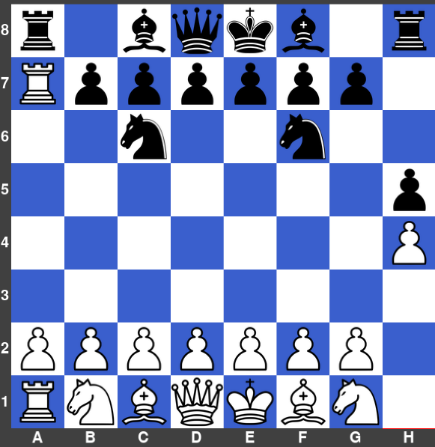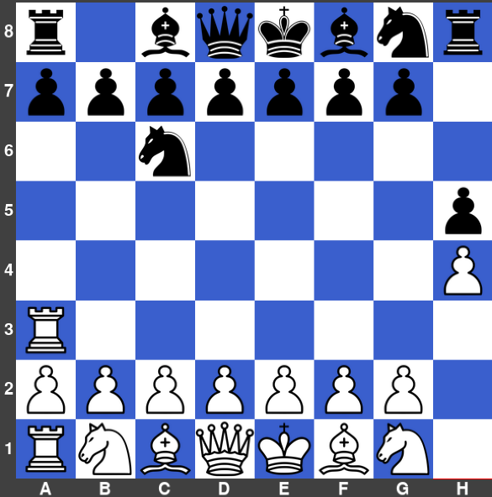

|  |  |  |  |  |
| --- | --- | --- | --- | --- |
| What’s being tested? | Input | Justification | Expected Outcome | Actual Outcome |
| Bishop movement | Bishop is clicked on F1, then A6 is clicked. | To allow the user to move their bishop to only valid empty spaces. | The bishop disappears from its current square and moves to A6. | The bishop moved to the correct place. |

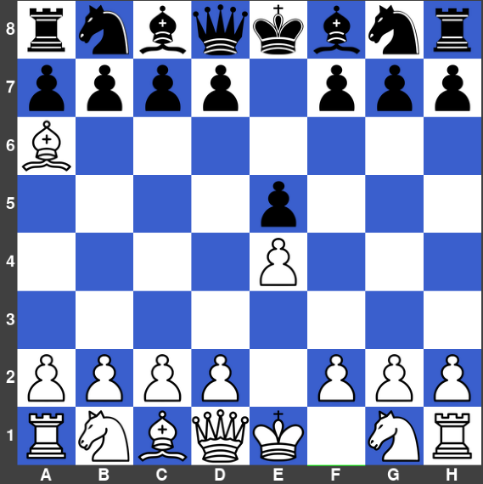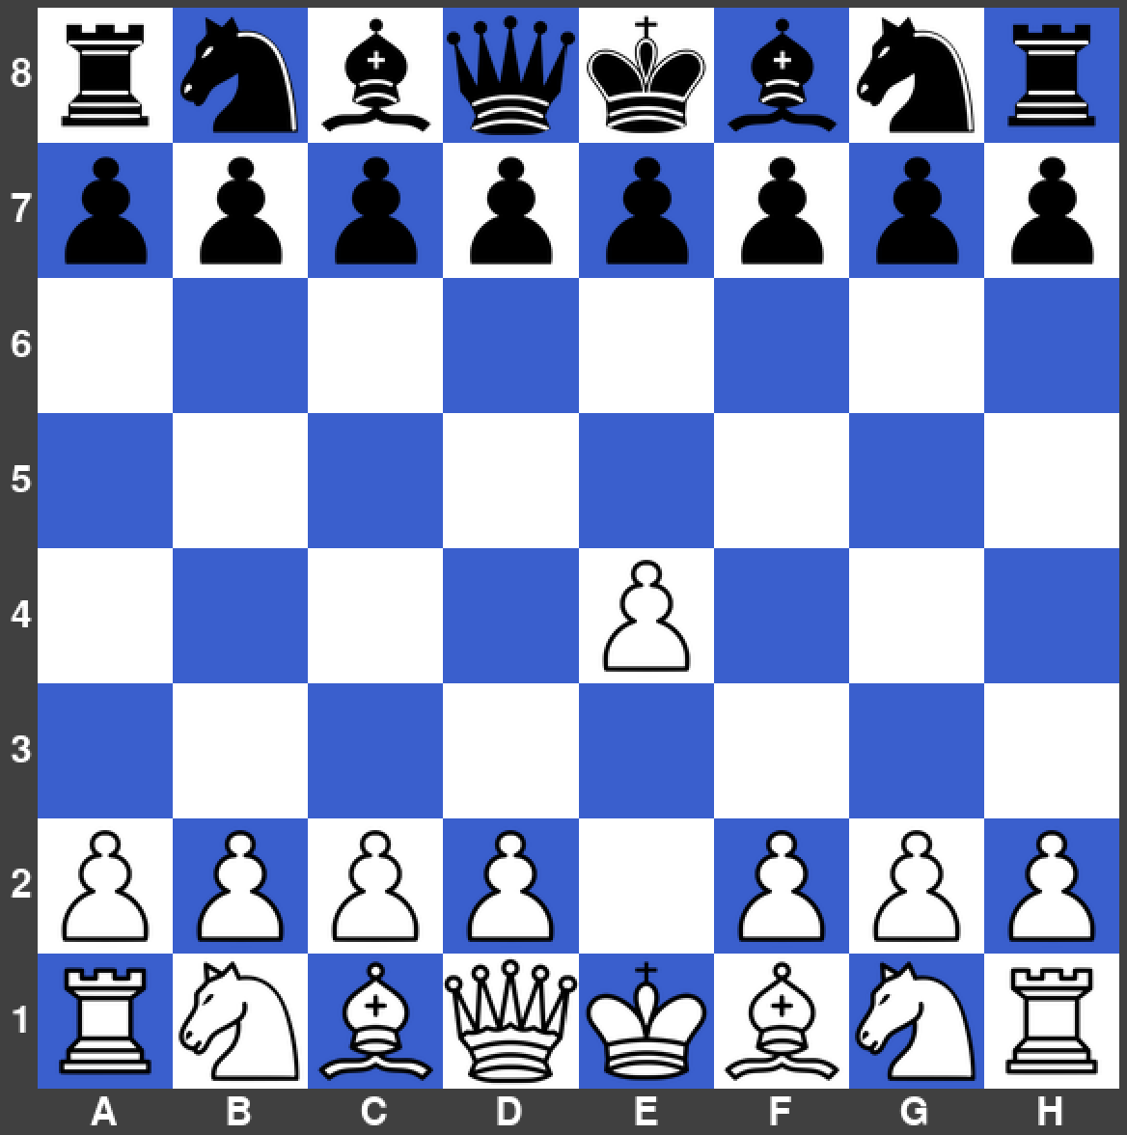

|  |  |  |  |  |
| --- | --- | --- | --- | --- |
| What’s being tested? | Input | Justification | Expected Outcome | Actual Outcome |
| Bishop capturing other pieces | Bishop is clicked on A6, then B7 is clicked. | To allow the user to capture enemy pieces using their bishop only using the diagonal squares. | The bishop disappears from its current square and moves to B7, replacing the black pawn. | The bishop moved to the correct place and the black pawn disappeared. |

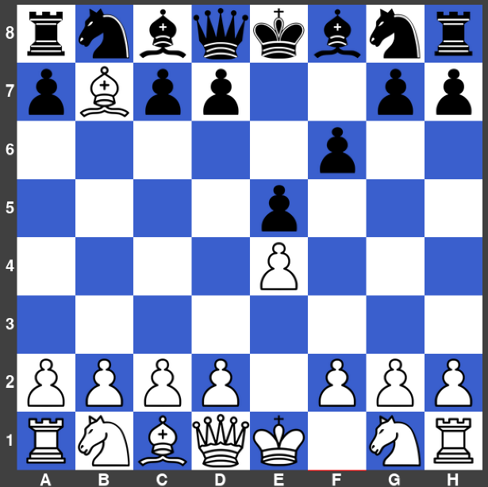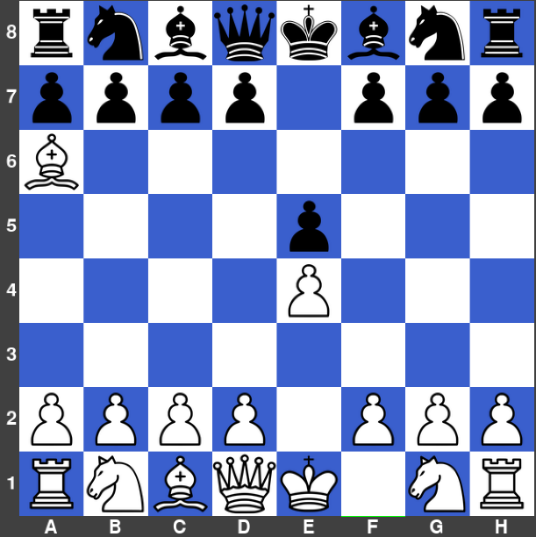

|  |  |  |  |  |
| --- | --- | --- | --- | --- |
| What’s being tested? | Input | Justification | Expected Outcome | Actual Outcome |
| Queen diagonal movement | Bishop is clicked on D1, then F3 is clicked. | To allow the user to move their queen diagonally. | The queen disappears from its current square and moves to F3. | The queen moved to the correct place. |

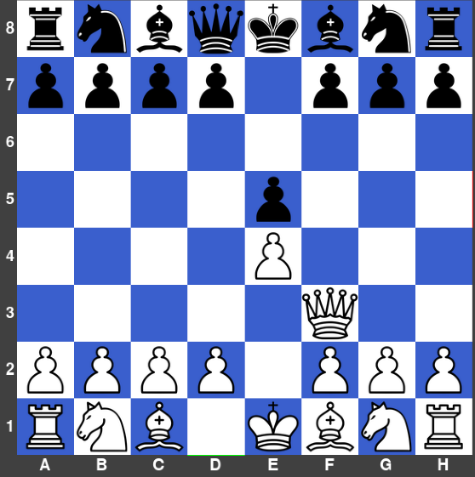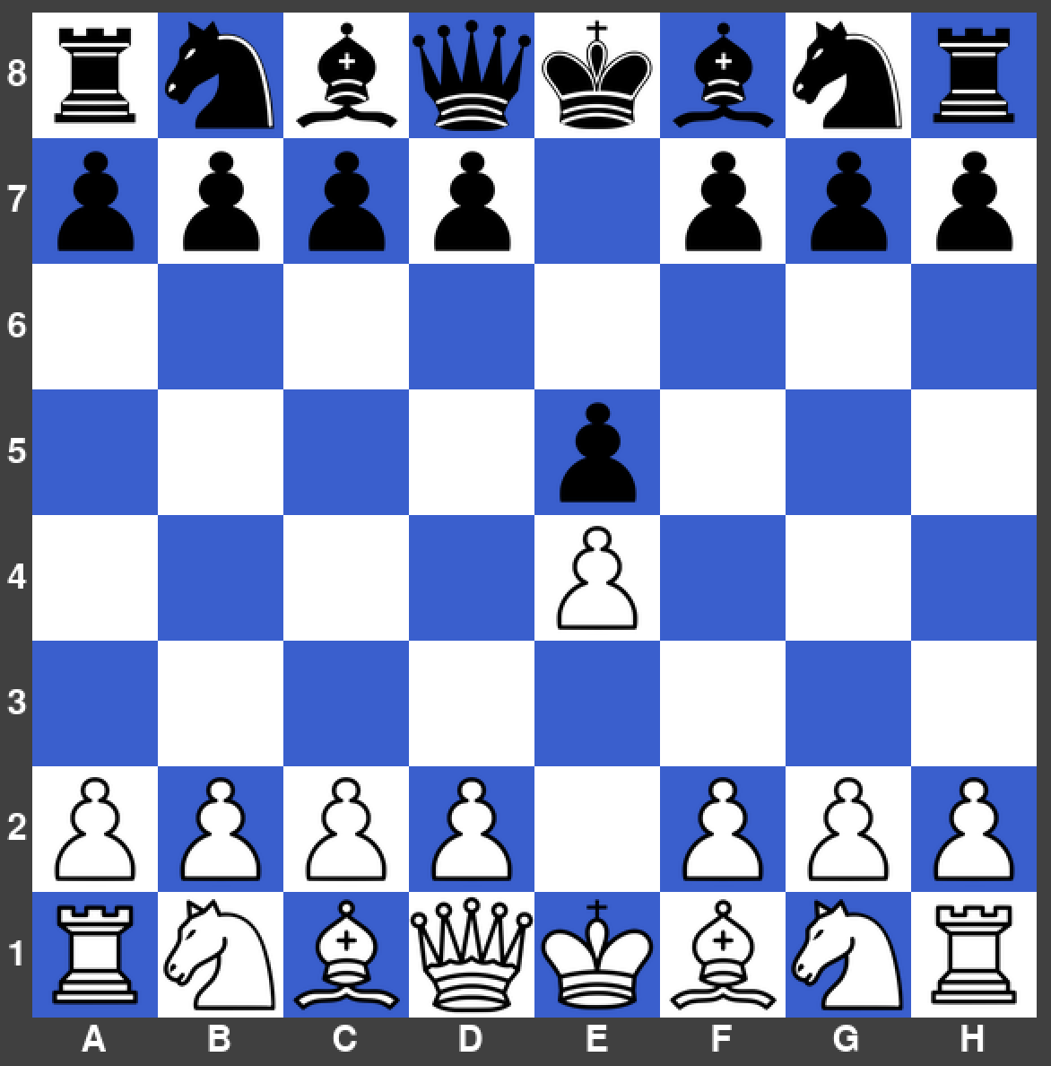

|  |  |  |  |  |
| --- | --- | --- | --- | --- |
| What’s being tested? | Input | Justification | Expected Outcome | Actual Outcome |
| Queen movement in a straight line and capturing a piece. | Queen is clicked on F3, then F7 is clicked. | To allow the user to move their queen in a straight line like a rook. | The queen disappears from its current square and moves to F7. | The queen moved to the correct place and the black pawn disappeared. |

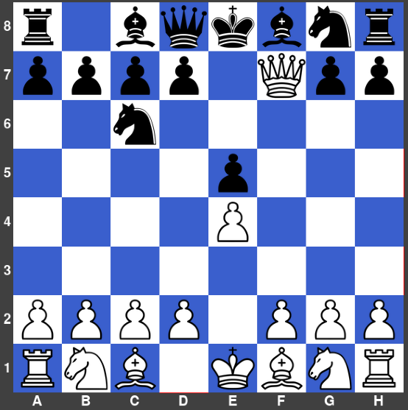

|  |  |  |  |  |
| --- | --- | --- | --- | --- |
| What’s being tested? | Input | Justification | Expected Outcome | Actual Outcome |
| King movement | King is clicked on E1, then E2 is clicked. | To allow the user to move their king 1 space. | The king disappears from its current square and moves to E2. | The king moved to the correct place. |

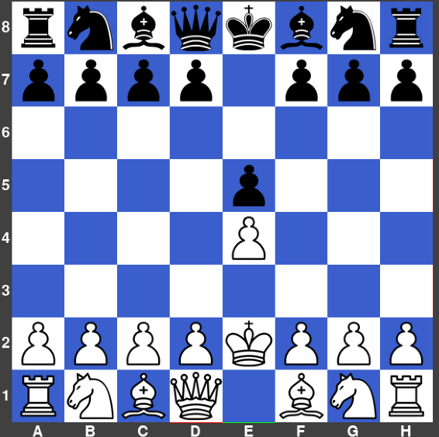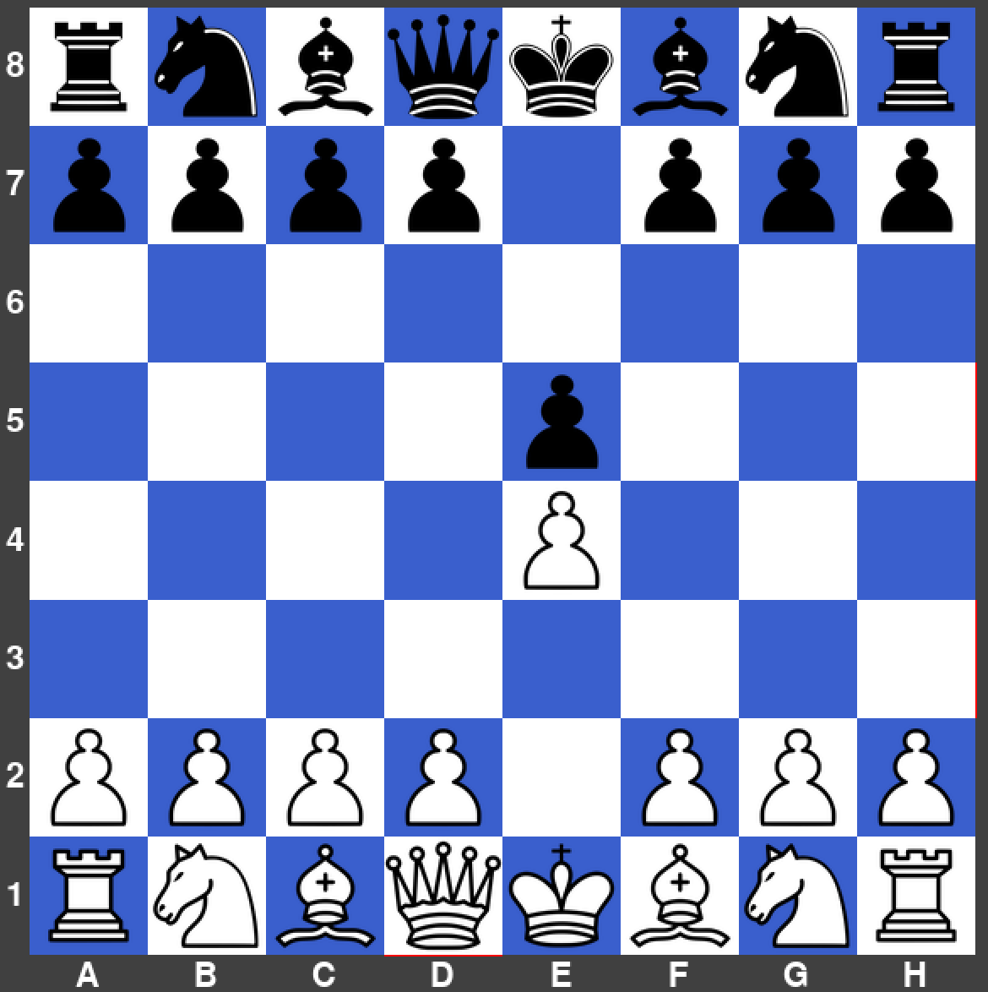

|  |  |  |  |  |
| --- | --- | --- | --- | --- |
| What’s being tested? | Input | Justification | Expected Outcome | Actual Outcome |
| King capturing other pieces | King is clicked on E1, then F2 is clicked. | To allow the user to capture pieces with their king, without considering checks at this point (this move is an illegal move using the official chess rules). | The king disappears from its current square and moves to F2. | The king moved to the correct place, but this move will not be allowed later. |

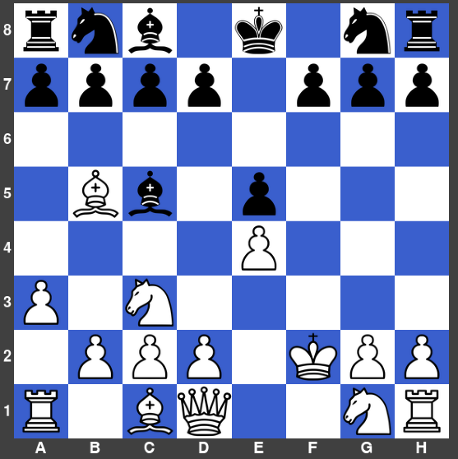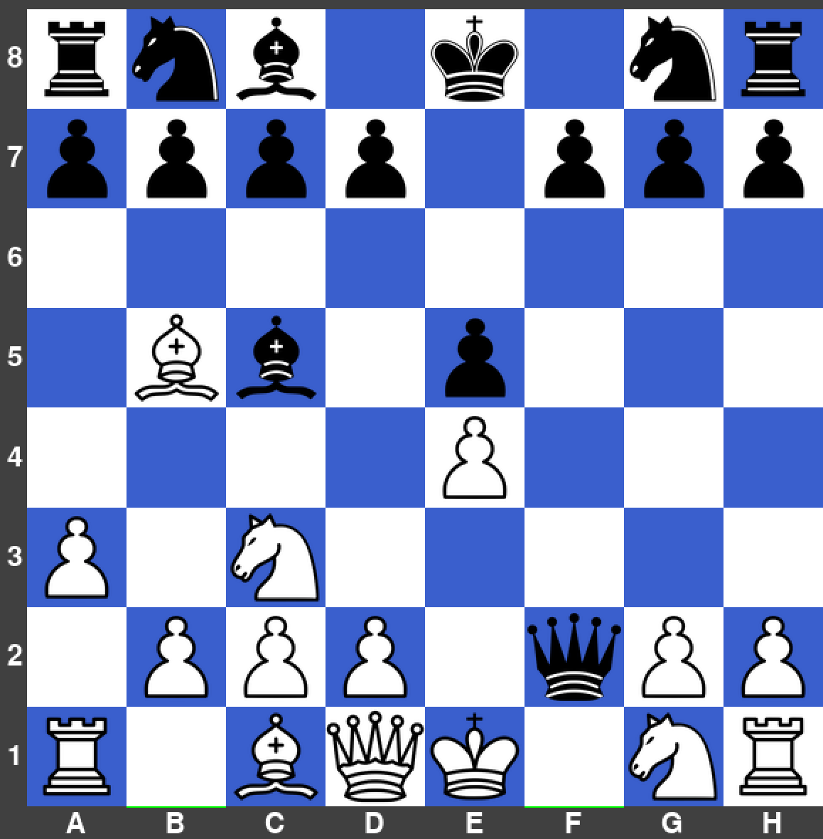

|  |  |  |  |  |
| --- | --- | --- | --- | --- |
| What’s being tested? | Input | Justification | Expected Outcome | Actual Outcome |
| Knight movement | Knight is clicked on G1, then F3 is clicked. | To allow the user to move their knight in an ‘L’ shape. | The knight disappears from its current square and moves to F3. | The knight moved to the correct place. |

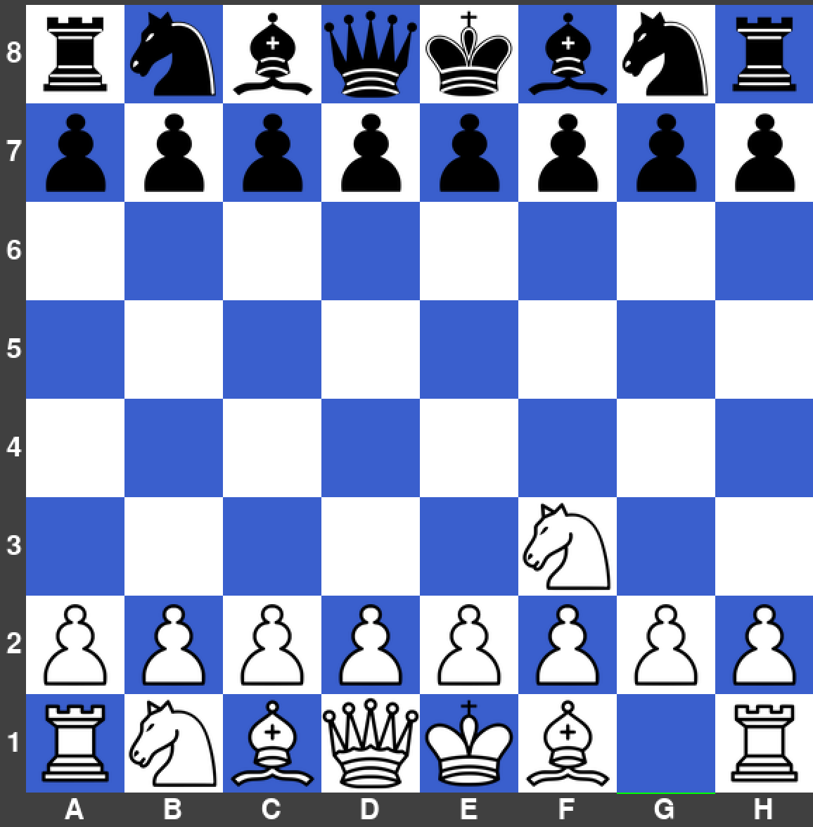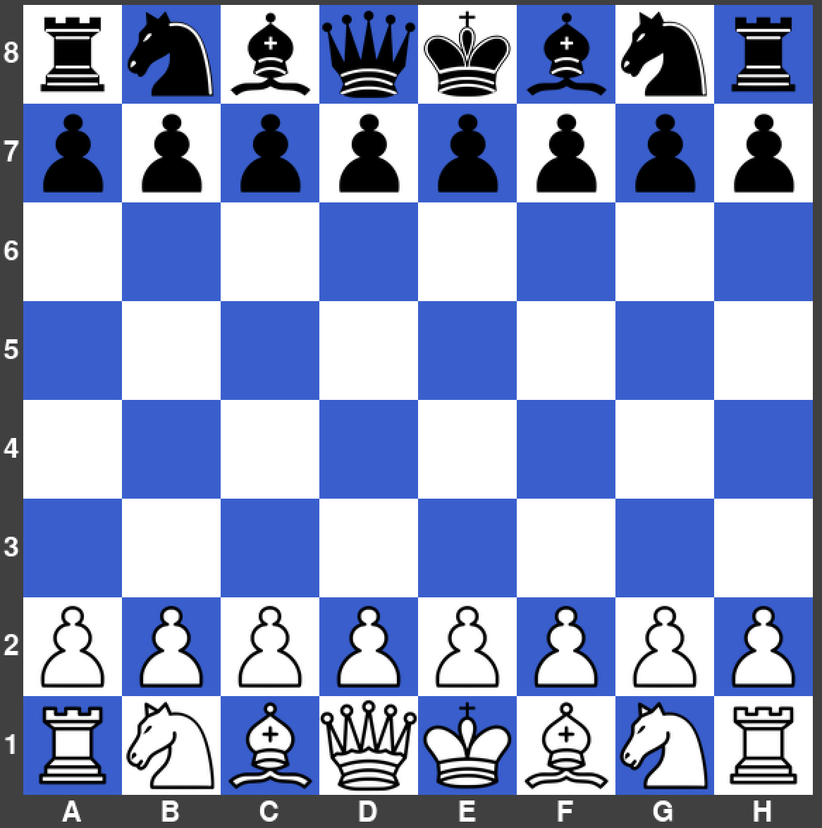

|  |  |  |  |  |
| --- | --- | --- | --- | --- |
| What’s being tested? | Input | Justification | Expected Outcome | Actual Outcome |
| Knight capturing other pieces | Knight is clicked on F3, then E5 is clicked. | To allow the user to move their knight in an ‘L’ shape whilst capturing enemy pieces. | The knight disappears from its current square and moves to E5. | The knight moved to the correct place. |

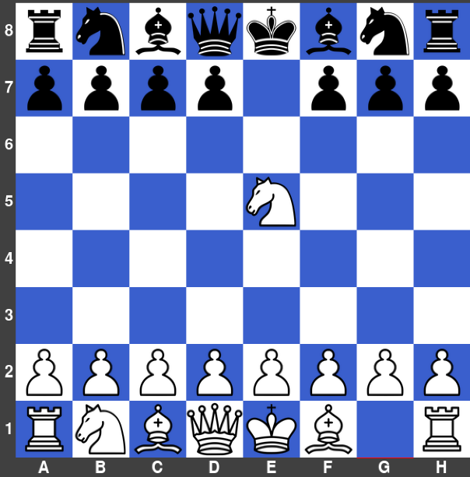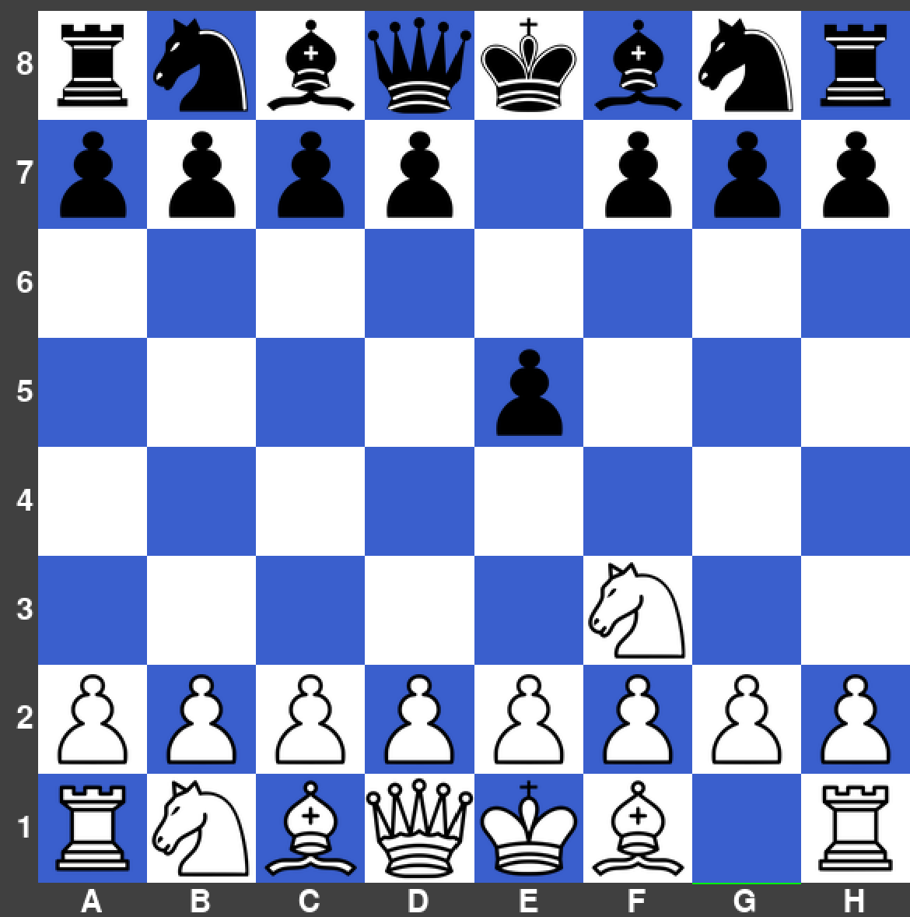

### Errors Encountered – Prototype 2

**Rook Movement Logic Error**

Whilst testing the movement of the rook, I realised that it was not able to move up the board like it was supposed to do. The interpreter did not throw an error; hence it must have been a logic error within my procedure for rook movement.

Before:

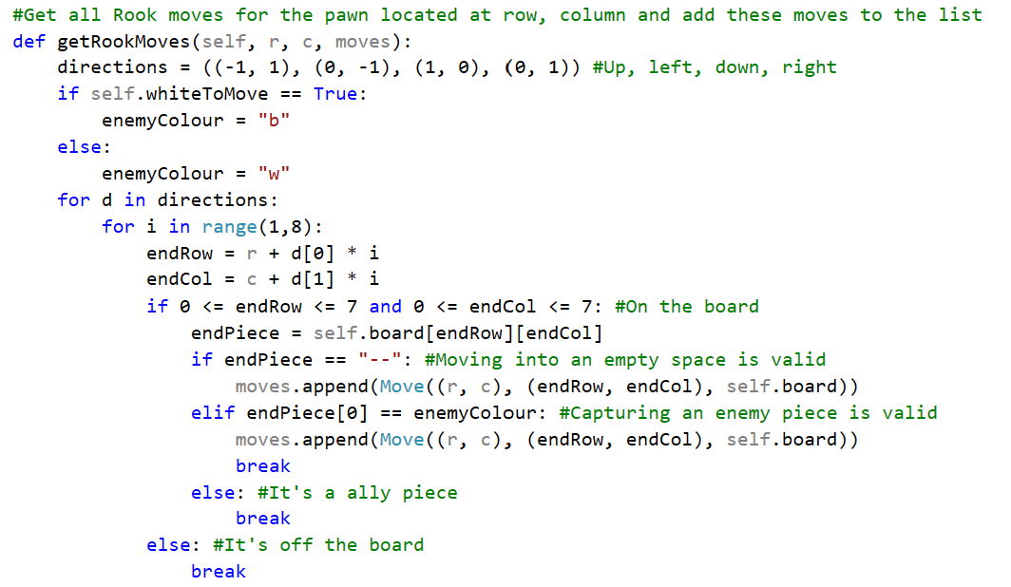

**Remedial Action**

After carefully going through my code, I realised that there was an incorrect direction on the 3rd line of the code above. (-1,1) would allow the rook to move up and to the right like a bishop, where it should’ve been (-1,0). This now allows the rook to move vertically upwards as it should.

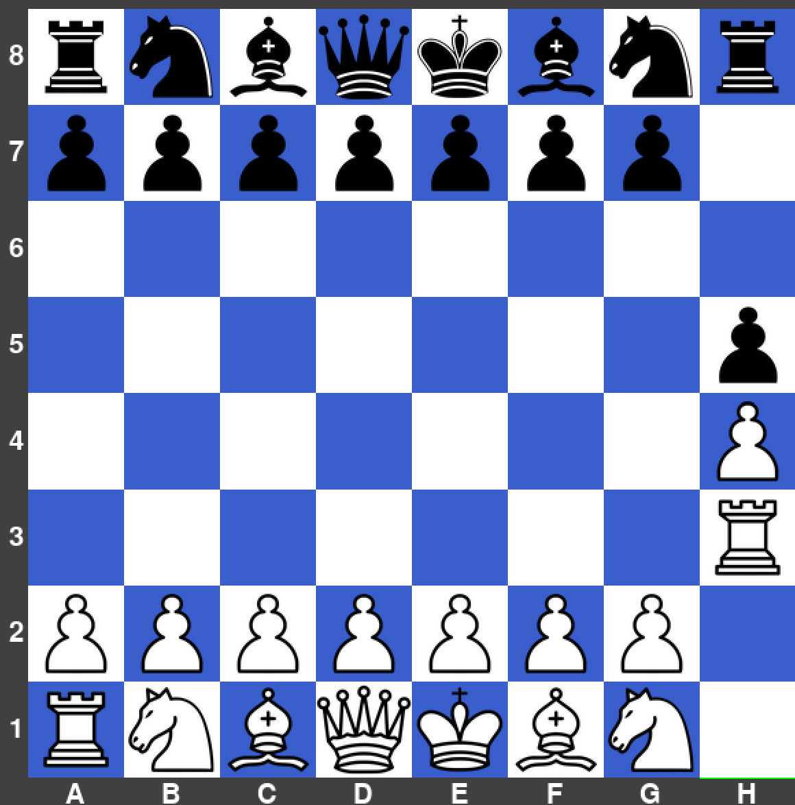After:

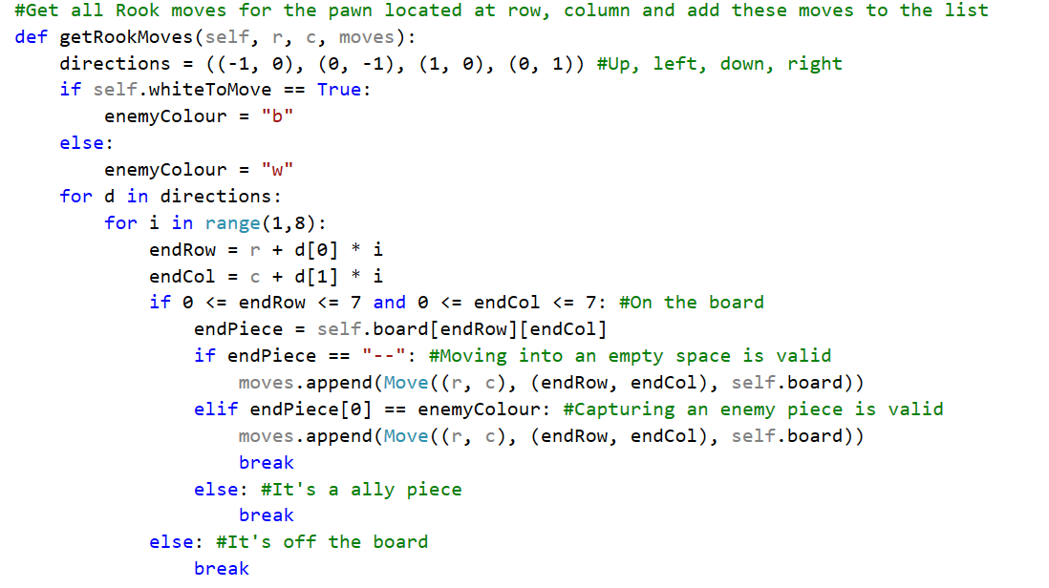

### Flowcharts Used – Prototype 2

Pawn Movement





Rook Movement



This algorithm is responsible for the rules of where a bishop can move. This is needed to ensure that the user cannot make an illegal bishop move.

Bishop Movement



This algorithm is responsible for the rules of where a queen can move. This is needed to ensure that the user cannot make an illegal queen move.

Queen Movement



This algorithm is responsible for the rules of where a knight can move. This is needed to ensure that the user cannot make an illegal knight move.

Knight Movement



This algorithm is responsible for the rules of where a king can move. This is needed to ensure that the user cannot make an illegal king move.

King Movement

### Interview & Review – Prototype 2

|  |  |  |
| --- | --- | --- |
| No. | Requirements | Justification |
| 17. | Queen will move any number of spaces horizontally, diagonally, or vertically. | To ensure the rules are realistic. |
| 18. | King will move one space in any direction. | To ensure the rules are realistic. |
| 19. | Pawn will move two spaces on its first move, then only one space afterwards. Captures one space diagonally with the exception being ‘En Passant’. | To ensure the rules are realistic. |
| 20. | Bishop will move any number of spaces diagonally. | To ensure the rules are realistic. |
| 21. | Rook will move any number of spaces horizontally or vertically. | To ensure the rules are realistic. |
| 22. | Knight will move in an ‘L’ shape. | To ensure the rules are realistic. |

**Interview**

Me: What do you think about the rules of the program at this stage?

Felix Williams: I am quite happy with how each piece can move only where they are supposed to go in most cases.

Me: Is there anything that needs improving within this prototype?

Felix Williams: Whilst playing the game, I have noticed that some pieces are able to do some moves that are classed as illegal. Such as, the king can capture a protected piece.

Me: Overall, how do you feel with the progress I have made?

Felix Williams: I love seeing how this game is progressing and the new rules and features you are implementing, so I am happy with the progress so far. As I have said already, the most important thing to implement next is full making sure all chess rules are applied in this game.

**Next steps**

After discussing with Felix about this prototype, I need to ensure that I implement checks, checkmates, stalemates, pawn promotion, and castling. This would fix the logic error talking about previously, where the king can capture a protected piece, plus adding lots more rules that make the game feel more authentic to the players.

## Rules for Checks, Checkmates and Stalemates – Prototype 3

**08/10/21**

In this section, I figured out how to integrate checks, checkmates, and stalemates to ensure that the game has an end result. To implement this, I needed to create some new procedures that finds out when a certain square is under attack (useful for the check function), when a piece is pinned (so cannot move), and when a player has no moves left, so is in checkmate or stalemate. To achieve finding a pin, looking at a single moment of the game, the main logic that I used was to generate all possible moves (without considering checks), then make those moves, then generate all the opponent’s possible moves and see whether any of their moves attack your king (using the square under attack function). If any of them do, then the original move was invalid and is removed from the moves array because that piece is pinned to the king.

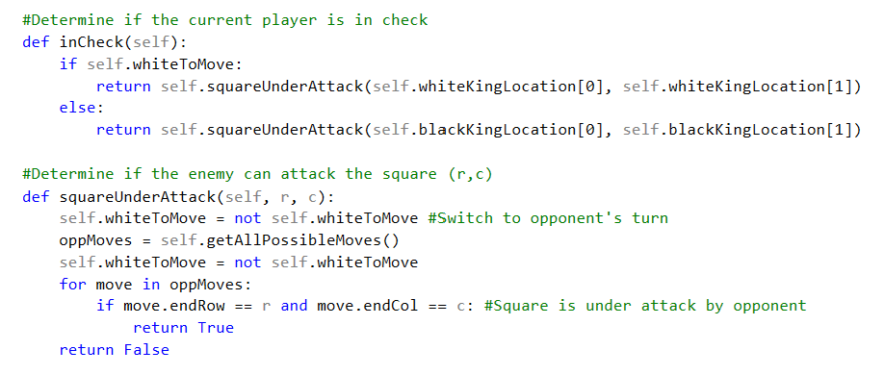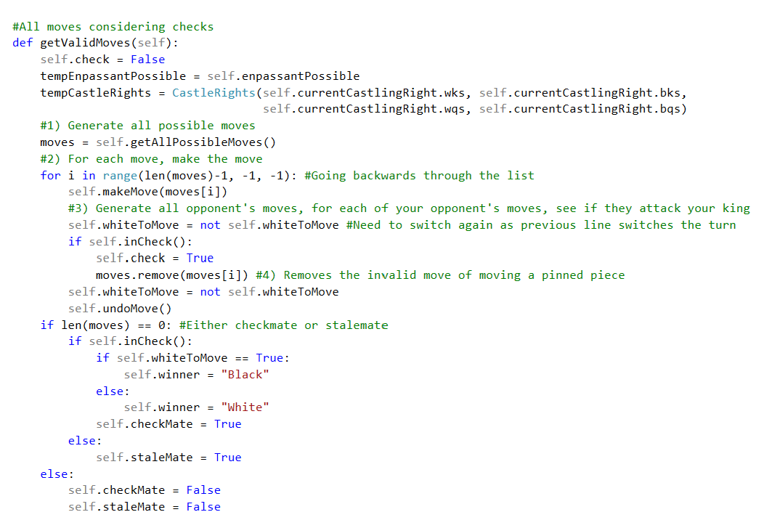

This is needed to collect all the possible moves generated from the getAllPossibleMoves() function and then determine which are not possible because that piece is pinned, so cannot be moved. Then, it determines when a player cannot play any more moves, so it means it’s the end of the game by checkmate or stalemate.

This is needed to determine whether a piece is attacking a specific square, which is used within the inCheck() function.

This is needed to determine if the player is in check, then if the player is in checkmate later.

### Rules for Pawn Promoting – Prototype 3

**18/10/21**

In this section, I discovered that in almost all cases, promoting to a queen compared to a knight, rook or bishop is essential. Therefore, I have decided that it is easier for beginners if they are not given this choice, so to simplify the game of chess a bit further. I have spoken to my stakeholder Felix, and he agrees as well that this does not need to be implemented. The main logic for pawn promoting is that if a pawn reaches the last row that it can reach, it will instantly turn into a queen.



Logic for whether the black or white pawn has reached the last row that they can reach.

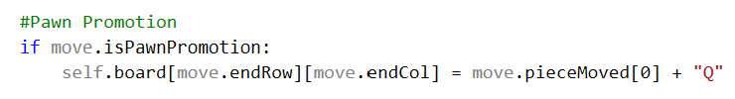

Changes the piece to a queen from a pawn in the 2D board array, which is then later updated to draw the queen on the board.

### Rules for Castling – Prototype 3

**25/10/21**

In this section, I needed to give the players the ability to castle to the king’s side or the queen’s side, as this is an essential rule in chess that can cause a player to win or lose because of it. Approaching this problem, first I needed to create a set of circumstances when castling is acceptable and when it is not. Such circumstances could be if the king or rook has already been moved that game, or if there are pieces in the way of the king and a rook, or if an enemy piece is attacking the squares where the king moves in the motion of castling (the two squares to the left/right of the king). This means that, I have made a procedure that updates when queen or king side castling is acceptable through a Boolean variable.

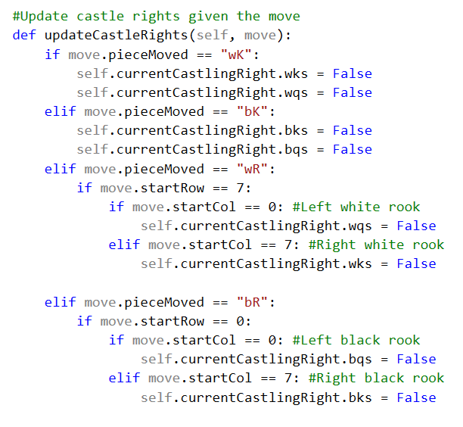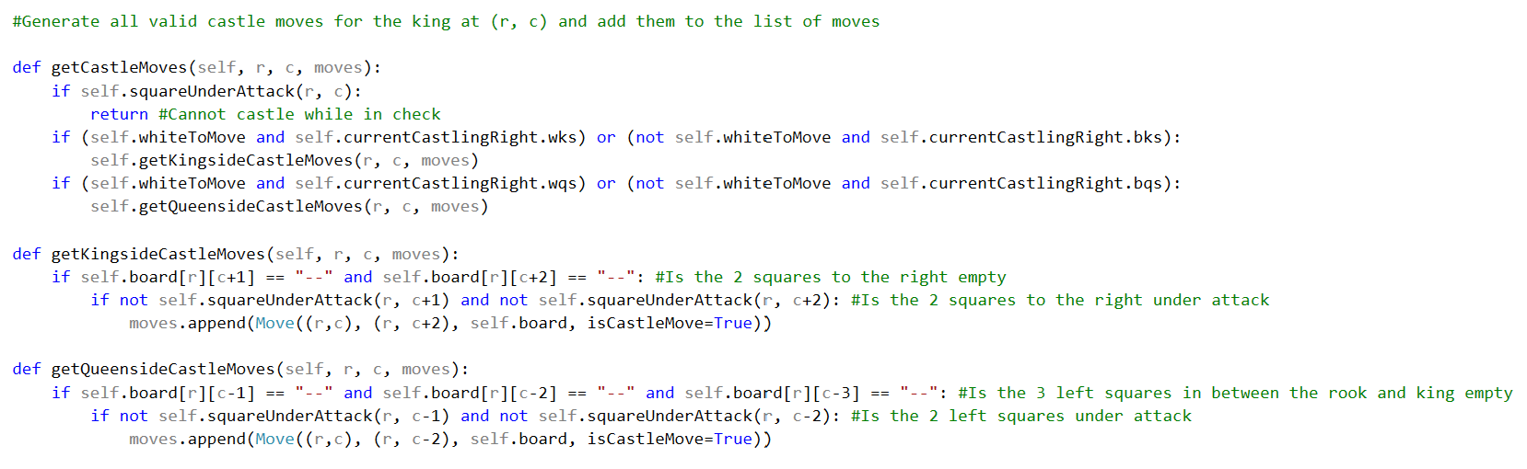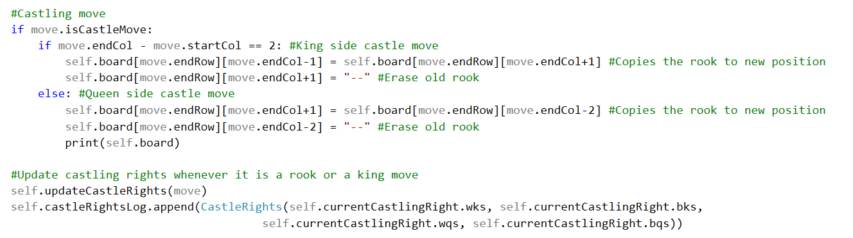

This is needed to move the king and rook into their new locations after a player has performed a castling move and update new castling rights.

This is needed to determine whether a king can castle with further rules, like the king is not allowed to castle whilst in check.

This is needed to determine whether a king can castle, depending on if the rook or king has been moved that game, which is then used in the next procedure.

### Testing – Prototype 3

|  |  |  |  |  |
| --- | --- | --- | --- | --- |
| What’s being tested? | Input | Justification | Expected Outcome | Actual Outcome |
| Checks | Bishop is clicked on F1, then B5 is clicked. | To allow a player to perform checks on the enemy king. | The check message appears at the top, where black is forced to only make moves to get out of the check. | The check message did appear and black can only make moves dealing with the check. |

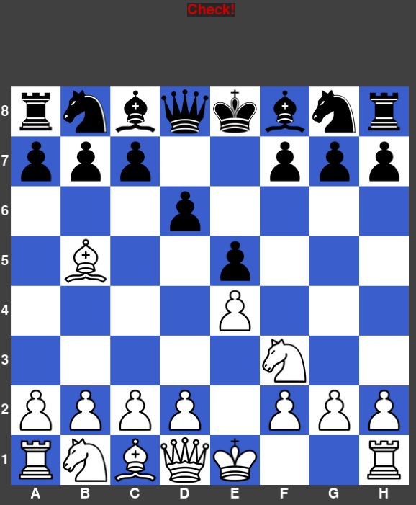 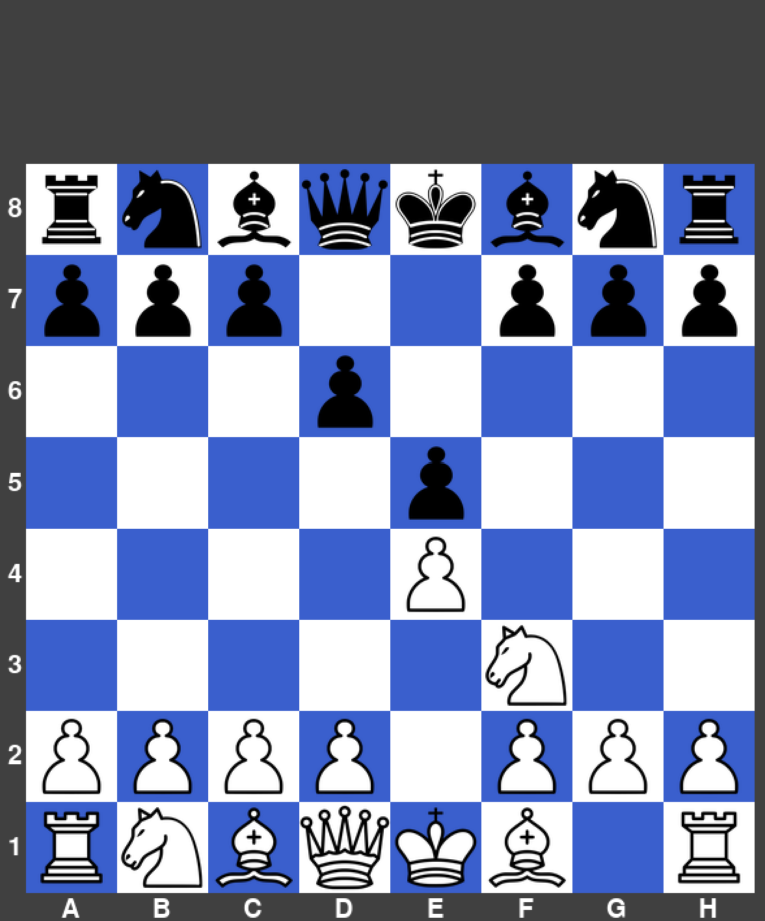

|  |  |  |  |  |
| --- | --- | --- | --- | --- |
| What’s being tested? | Input | Justification | Expected Outcome | Actual Outcome |
| Checkmate | Queen is clicked on F3, then F7 is clicked. | To allow a player to perform a checkmate on the enemy player. | The checkmate message appears at the top, where the game ends. | The checkmate message did appear. |

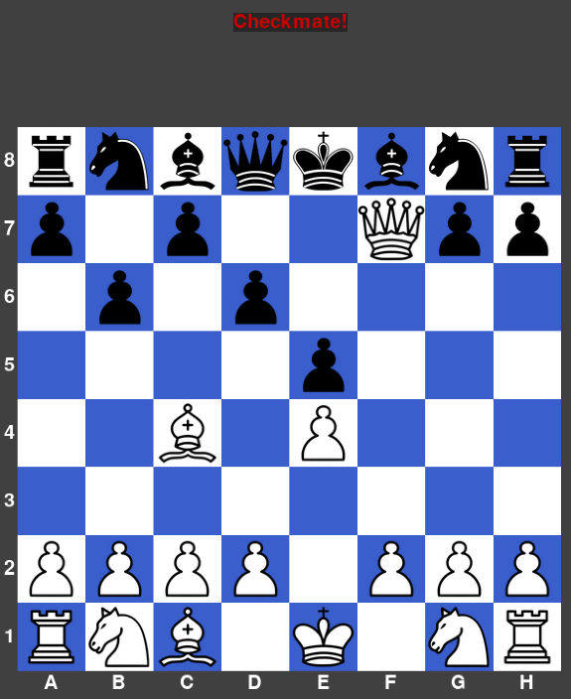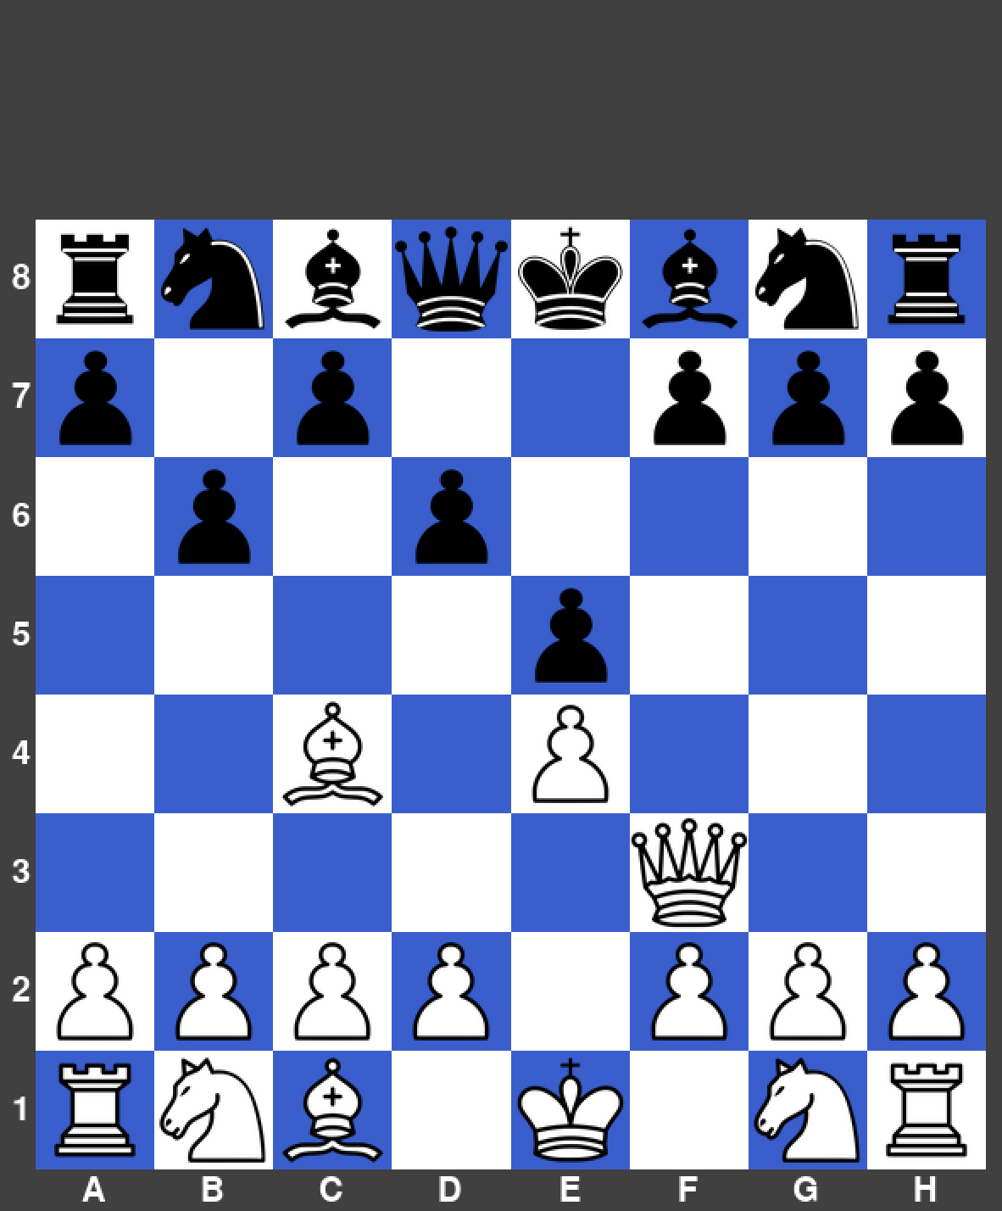

|  |  |  |  |  |
| --- | --- | --- | --- | --- |
| What’s being tested? | Input | Justification | Expected Outcome | Actual Outcome |
| Stalemate | Queen is clicked on G6, then F7 is clicked. | To allow a stalemate to be performed. | The stalemate message appears at the top of the screen and the games ends. | The stalemate message did appear. |

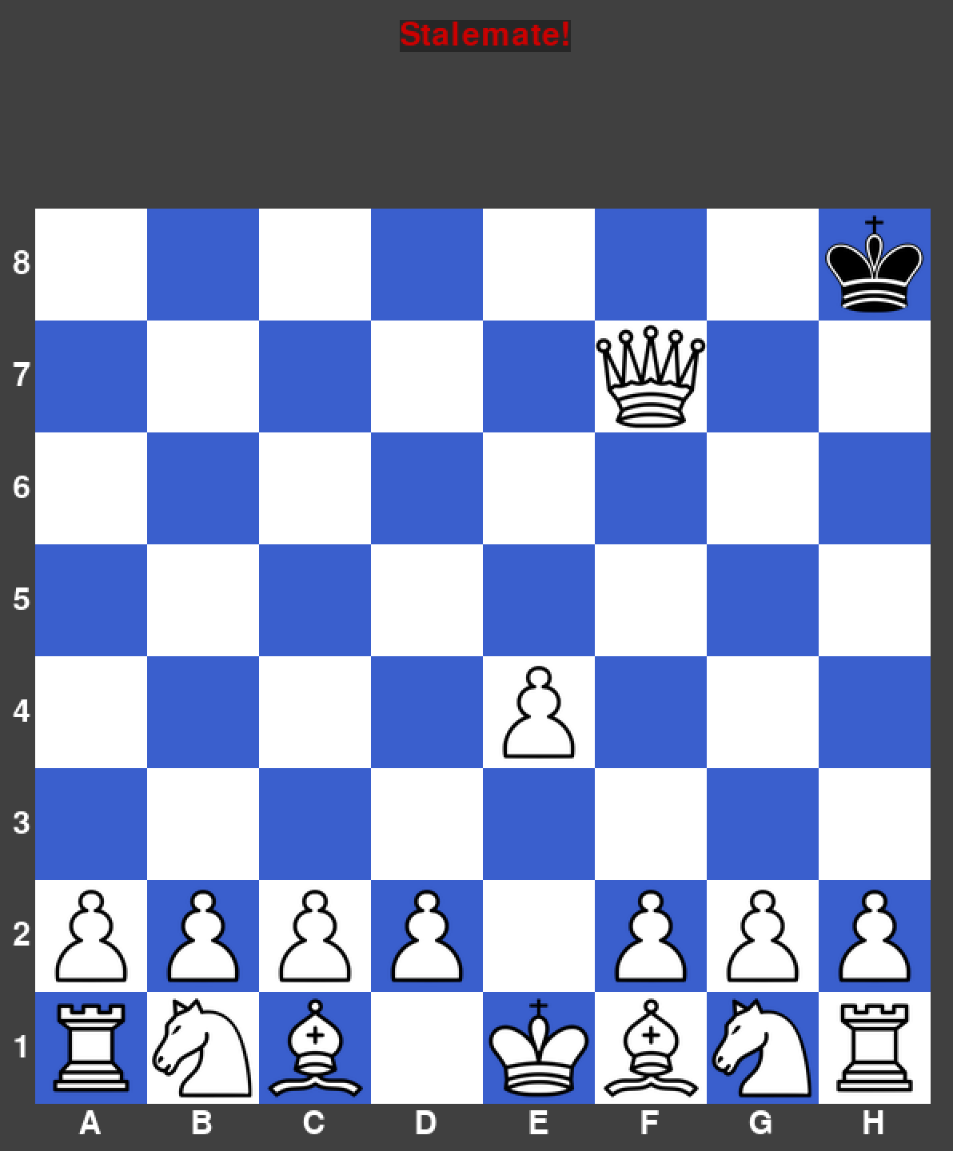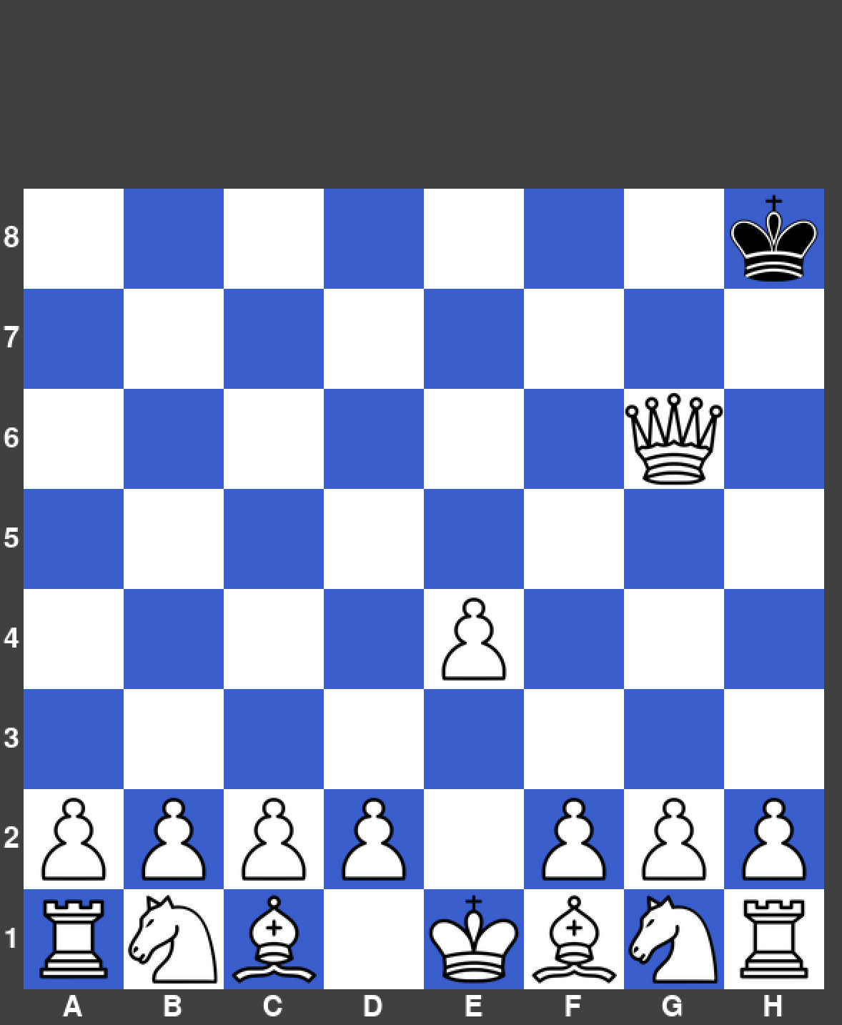

|  |  |  |  |  |
| --- | --- | --- | --- | --- |
| What’s being tested? | Input | Justification | Expected Outcome | Actual Outcome |
| Castling to the queen’s side | King is clicked on E1, then C1 is clicked. | To allow a queen’s side castling to occur only in the correct circumstances. | The king moves two spaces to the left and the rook moves 3 spaces to the right. | The king did move two spaces to the left and the rook moved 3 spaces to the right, but the original rook was still there (Logic error). |

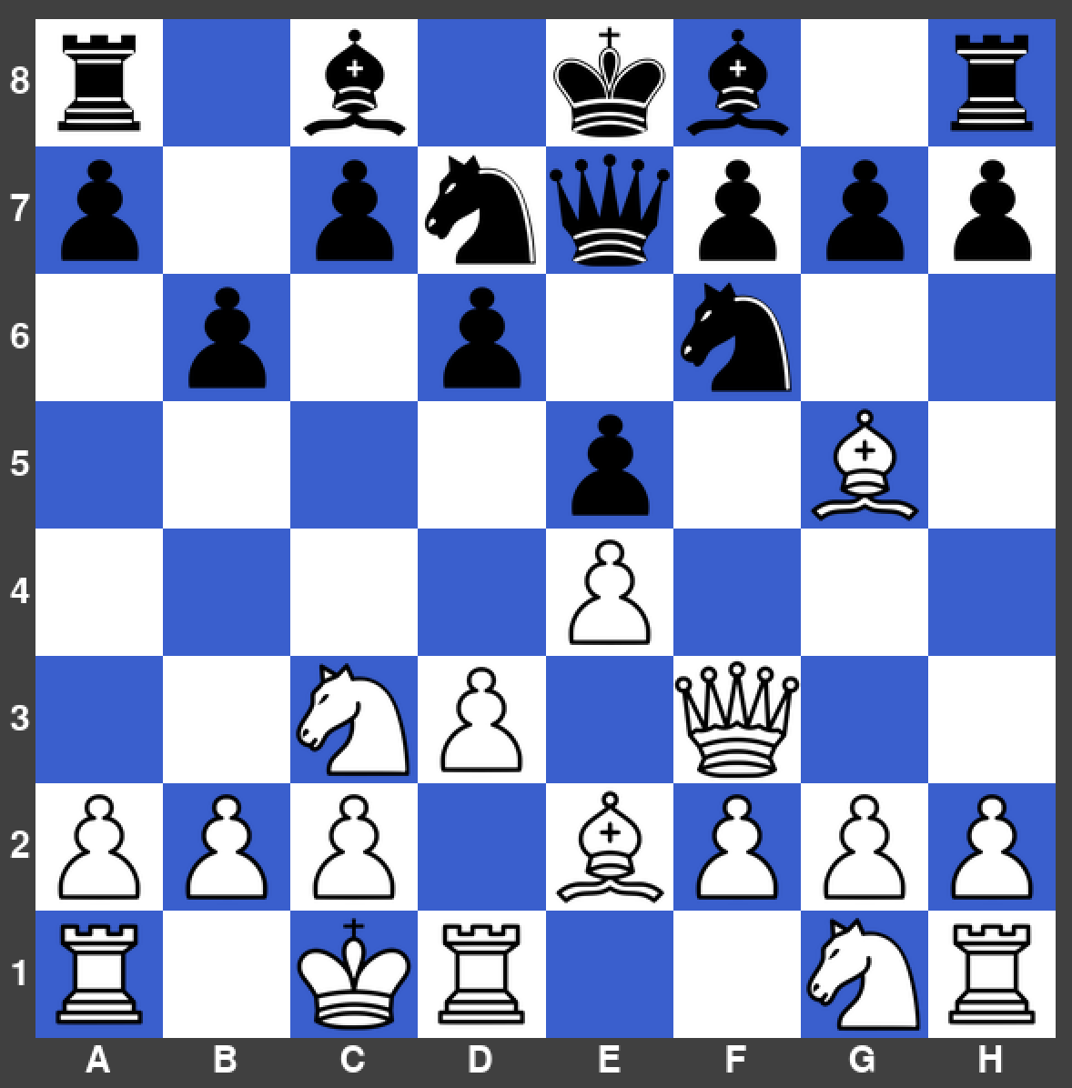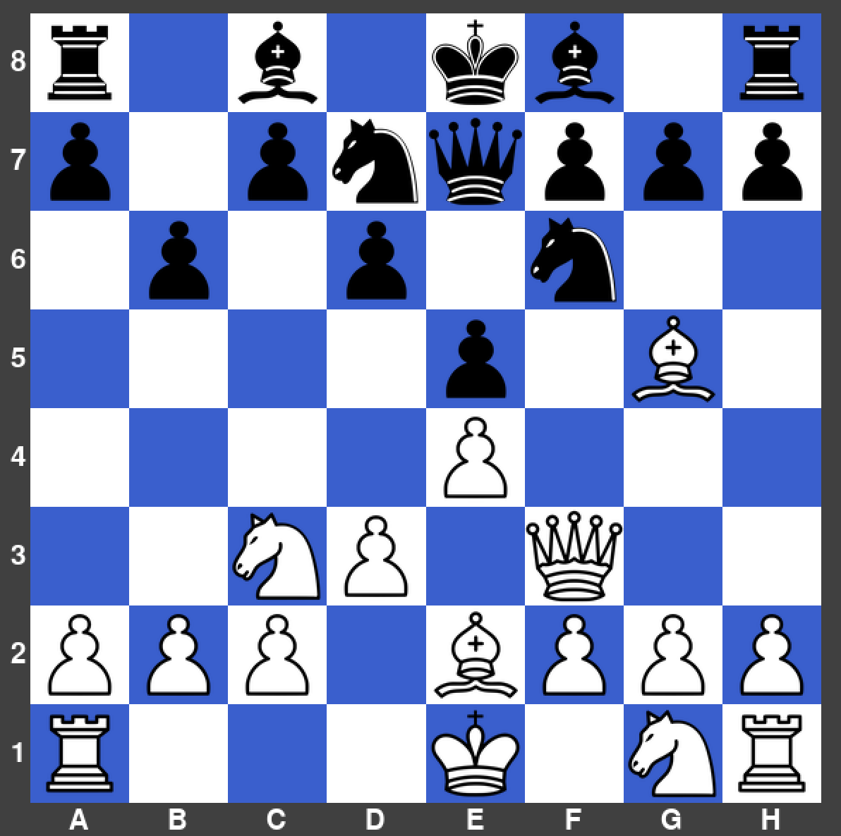

|  |  |  |  |  |
| --- | --- | --- | --- | --- |
| What’s being tested? | Input | Justification | Expected Outcome | Actual Outcome |
| Castling to the king’s side | Queen is clicked on G6, then F7 is clicked. | To allow a stalemate to be performed. | The stalemate message appears at the top of the screen and the games ends. | The stalemate message did appear. |

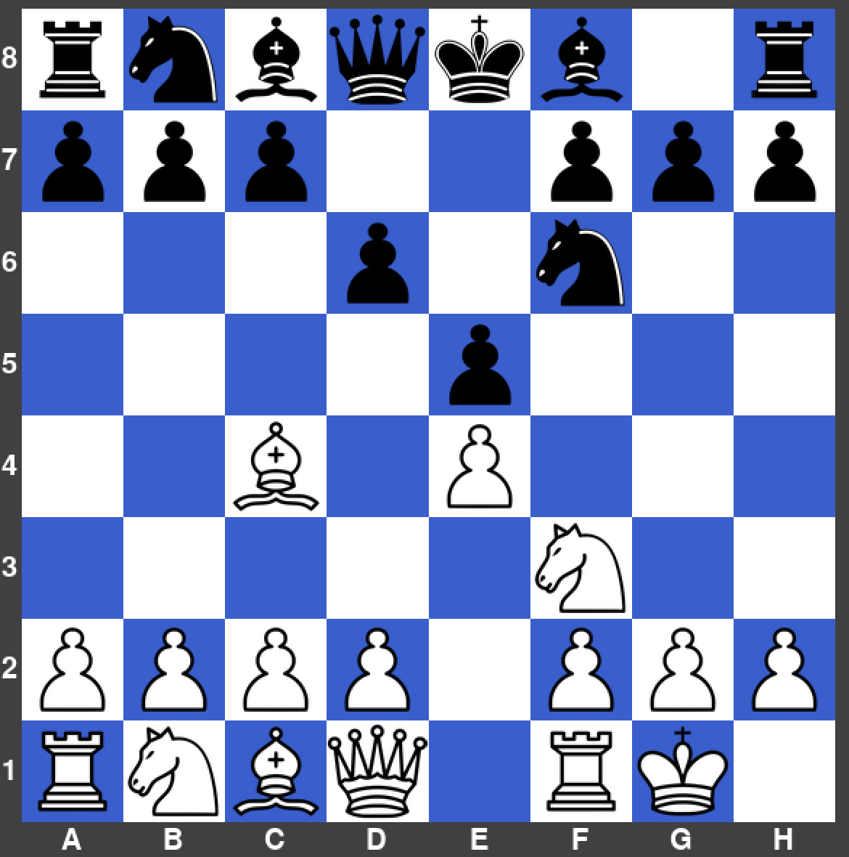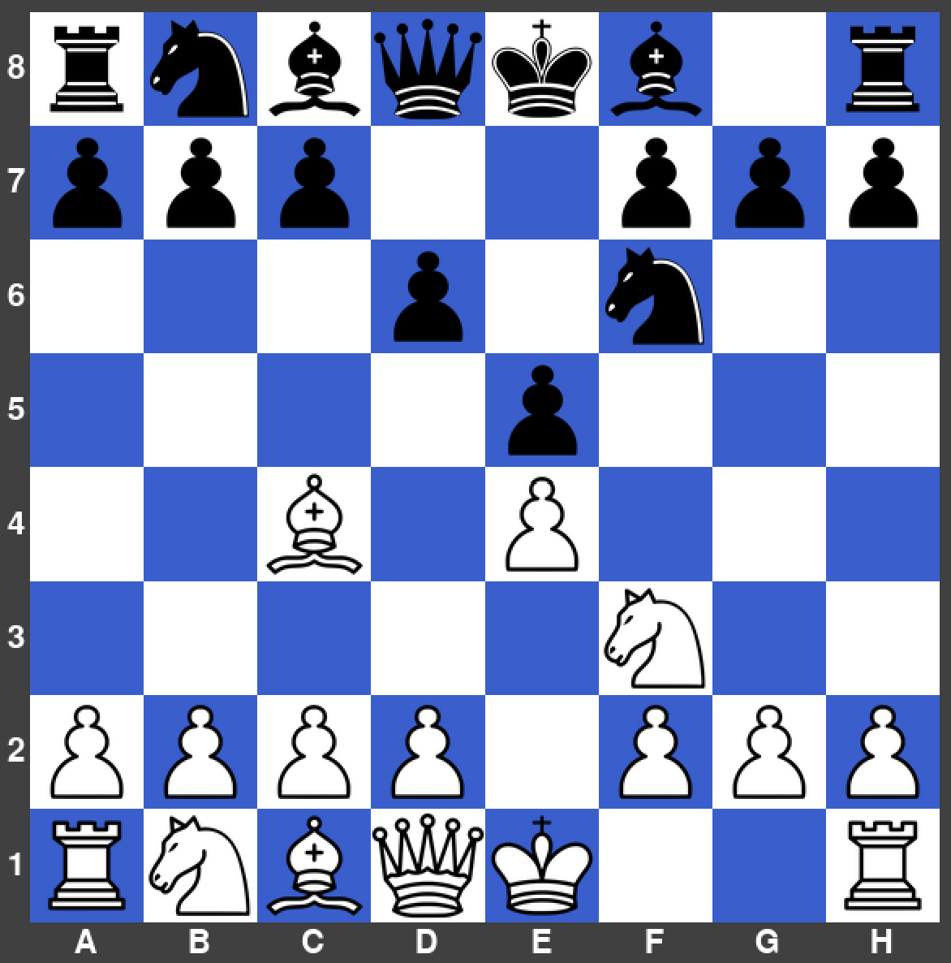

|  |  |  |  |  |
| --- | --- | --- | --- | --- |
| What’s being tested? | Input | Justification | Expected Outcome | Actual Outcome |
| Pawn promotion | Pawn is clicked on A7, then A8 is clicked. | To allow a pawn promotion to be completed. | The pawn becomes a queen when entering the back rank. | The pawn did become a queen. |

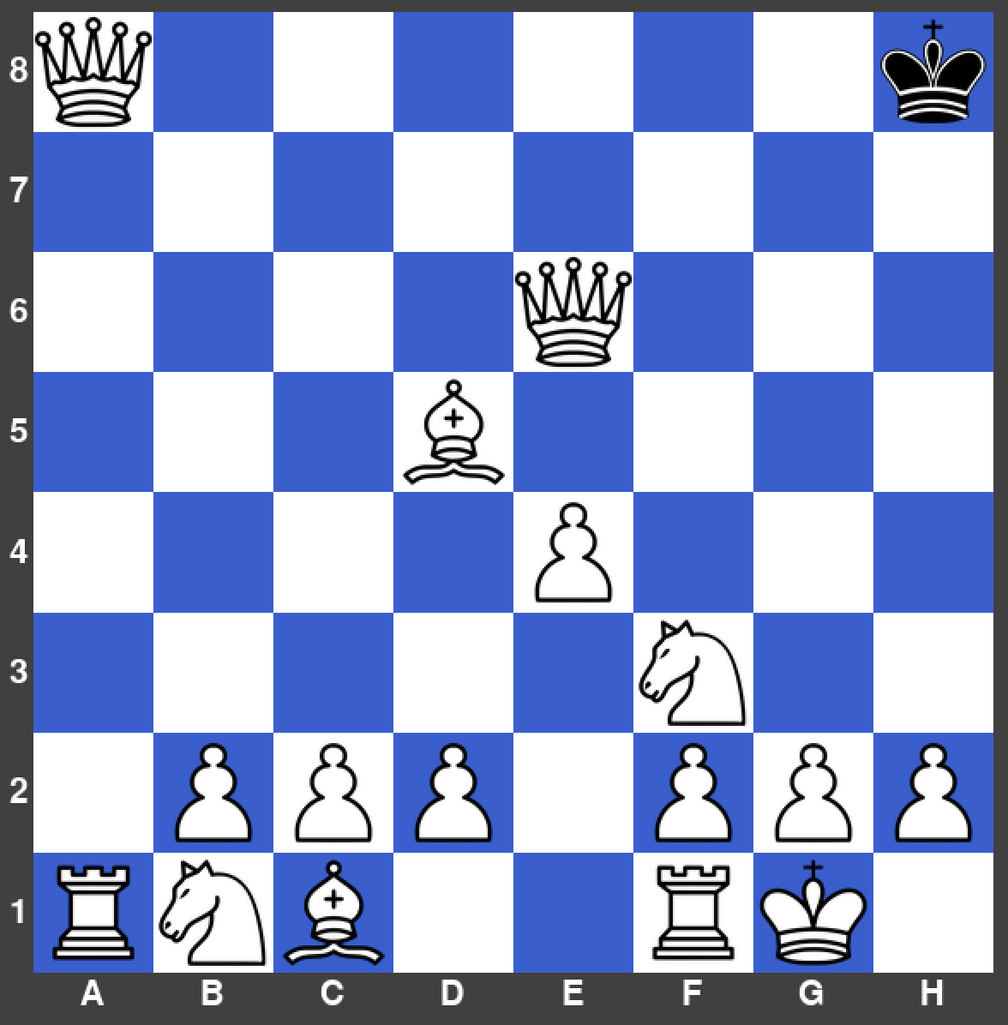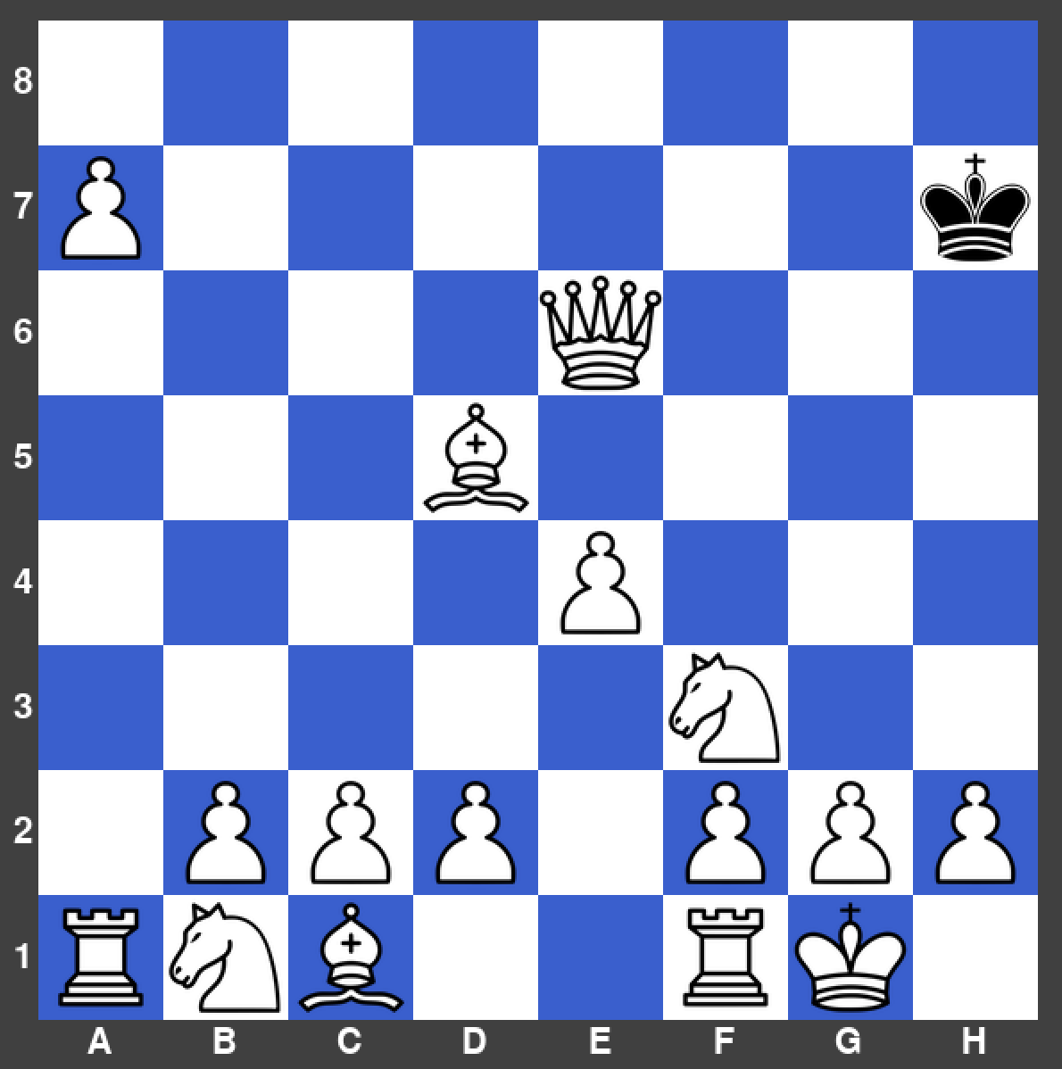

### Errors Encountered – Prototype 3

**Queen’s Side Castling Logic Error**

Whilst testing the queen’s side castling, I found that it was not working as it’s supposed to. As the rook moved to the correct space, but was also still in its original space, meaning that the rook had duplicated.

Before:

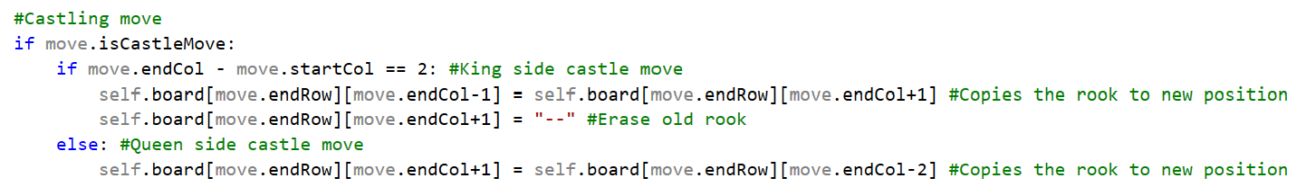

**Remedial Action**

After going through my code, I realised I had made the small mistake of forgetting to type in the line to erase the original rook.

After:

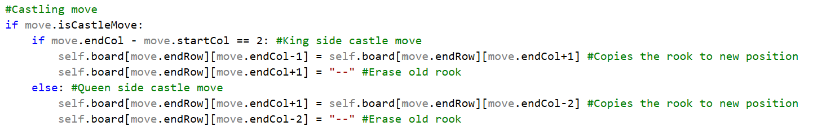

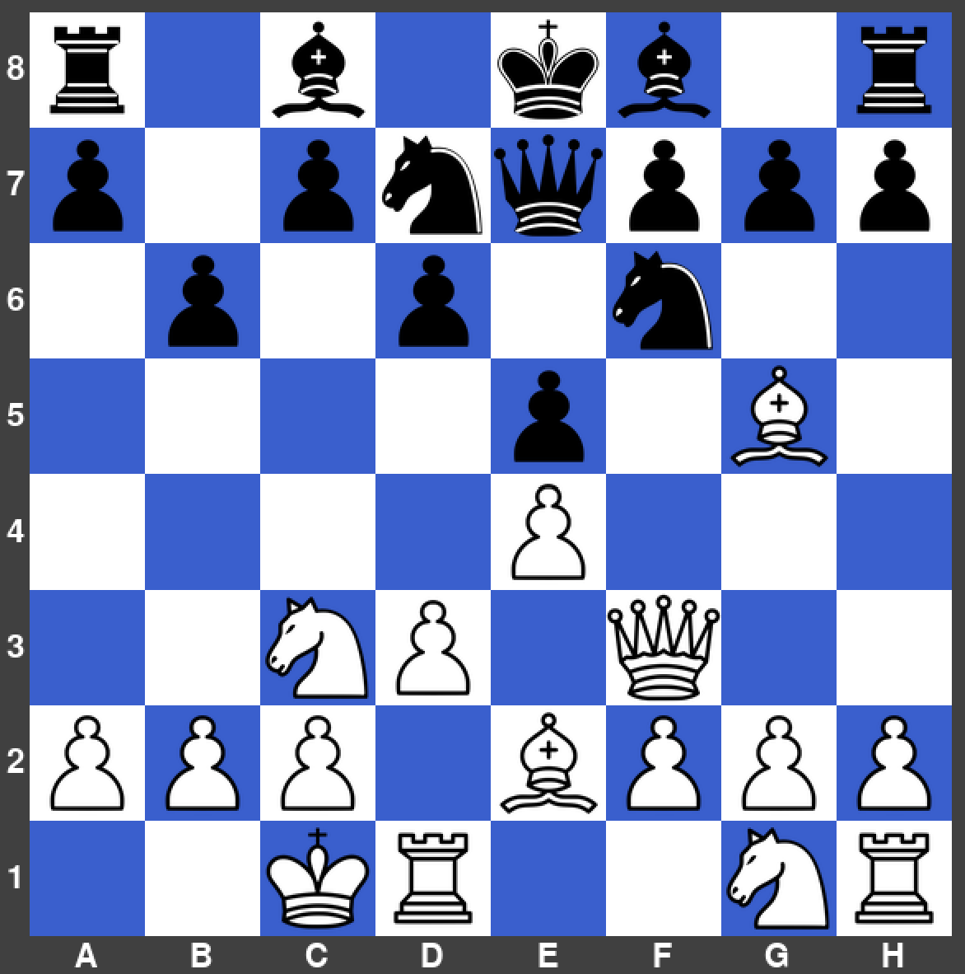

### Flowcharts Used – Prototype 3

Check, Checkmate & Stalemate



### Interview & Review – Prototype 3

|  |  |  |
| --- | --- | --- |
| No. | Requirements | Justification |
| 23. | When a player’s king is in check, they must deal with the check immediately. | To ensure the rules are realistic. |
| 24. | If the check cannot be dealt with it results in a checkmate. | To ensure the rules are realistic. |
| 25. | If the king is in double check, the only way to resolve this is to move the king to a vacant square. | To ensure the rules are realistic. |
| 26. | Moving a piece that is pined to the king is an illegal move. | To ensure the rules are realistic. |
| 27. | A player will be allowed to castle their king to the king’s side or queen’s side if the correct requirements are met. | To ensure the rules are realistic. |
| 28. | When a pawn the back rank, it can promote to a Queen. | To ensure the rules are realistic. |
| 29. | When a player has no legal moves left and they are not in check, it results in a stalemate. | To ensure the rules are realistic. |
| 31. | When a king is in check a small message should appear on top of the board indicating this. | To ensure the rules are realistic. |
| 32. | When a king is in checkmate a message should appear to indicate this with the name of the winner. | To ensure the rules are realistic. |

**Interview**

Me: What do you think about the rules of the program at this stage?

Felix Williams: I am very happy with how I can give checks and checkmates, so that now there is a goal of the playing the game. The fact that the players are given messages at the top when in check, checkmate and stalemate is nice from a usability standpoint.

Me: Is there anything that needs improving within this prototype?

Felix Williams: At the end of a game, I noticed that it does not display which user gave the checkmate or won. So, when you eventually implement the username system, I think this would be the perfect point to put in the username that won the game.

Me: Overall, how do you feel with the progress I have made?

Felix Williams: Overall, it is great seeing more rules being implemented perfectly like the official chess rules. Whilst testing the game, I tried making lots of illegal moves, all of which did not work. So, this is a nice improvement from the previous prototype.

**Next steps**

After discussing with Felix about this prototype, for the next one I need to implement a username system, so that the winner’s name can be displayed at the end of each game. This feature will also be used in the database so identify different players on the system.

## Potential Moves Indicator – Prototype 4

**01/11/21**

In this section, the aim was to create an indicator that gives a square a red outline when that square can be moved to by a piece in a valid way and a green outline when the square holds the piece currently selected. The main concept for this was when a player clicks on a square, all end squares from the valid moves array that have the same starting square as the square that has just been clicked on are outlined in red. This means that the players can see where each piece can go. I did a bit of trial and error to find what were the best shades of red and green to use and the thickness of the outlines themselves. I managed to find a good middle ground on this, where the outlines are clearly visible, but also not too distracting.

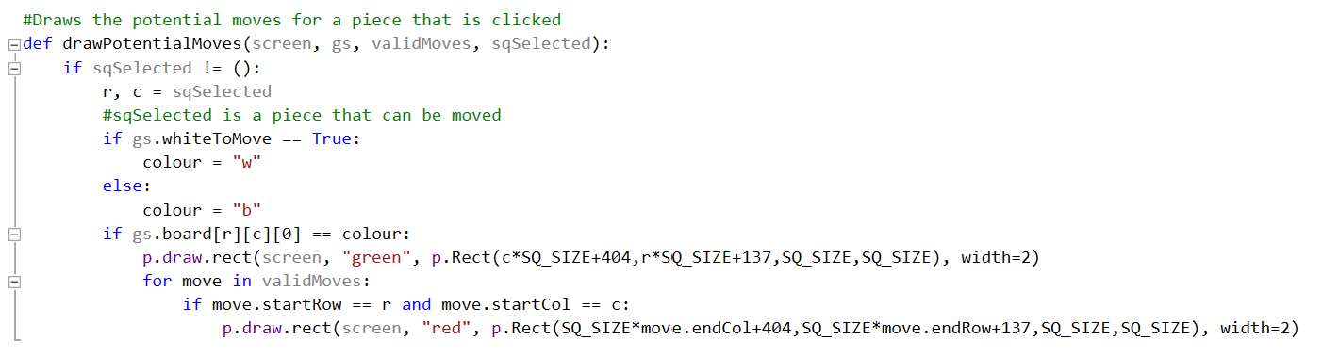

This is needed to draw boxes around the squares that can be moved to by the current selected piece.

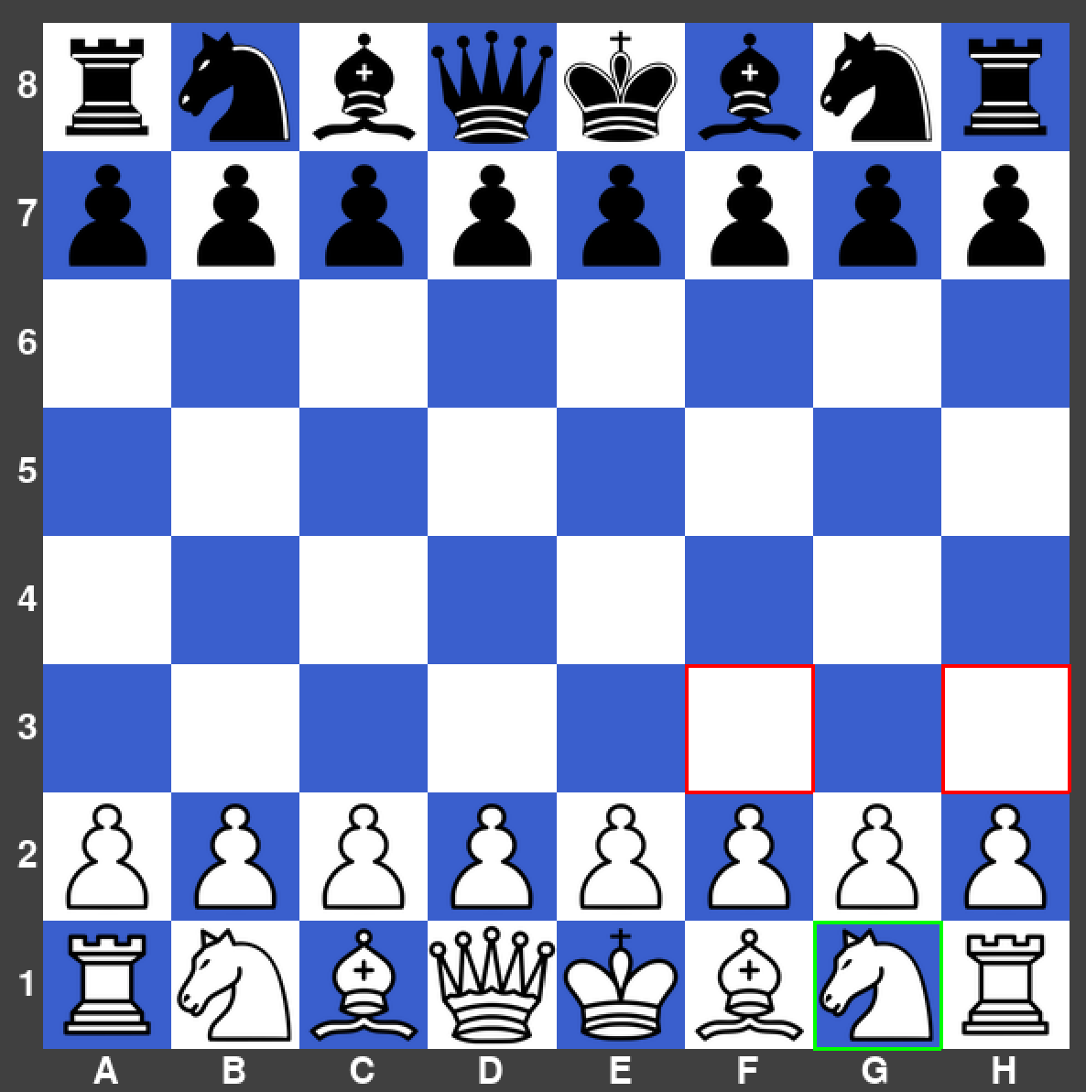

This is an example of what the board looks like when the white knight on G1 is selected. White is given the option to move the knight to F3 or H3, which are the knight’s only valid moves at that moment in time.

### Score Difference

**08/11/21**

In this section, the aim was to create a box at each side of the player’s pieces which tells each player what pieces of the opponent’s they have captured during that game and the score difference between them. I accomplished this by creating a captured pieces list, which is updated every time a piece is moved, and any pieces captured are added to the list. Then, I created some IF statements like the ones below for the black and white pieces to update the quantity of each piece in the list, which is then drawn to the board in the correct place. Then, the score difference is also calculated and drawn at the side of the board.

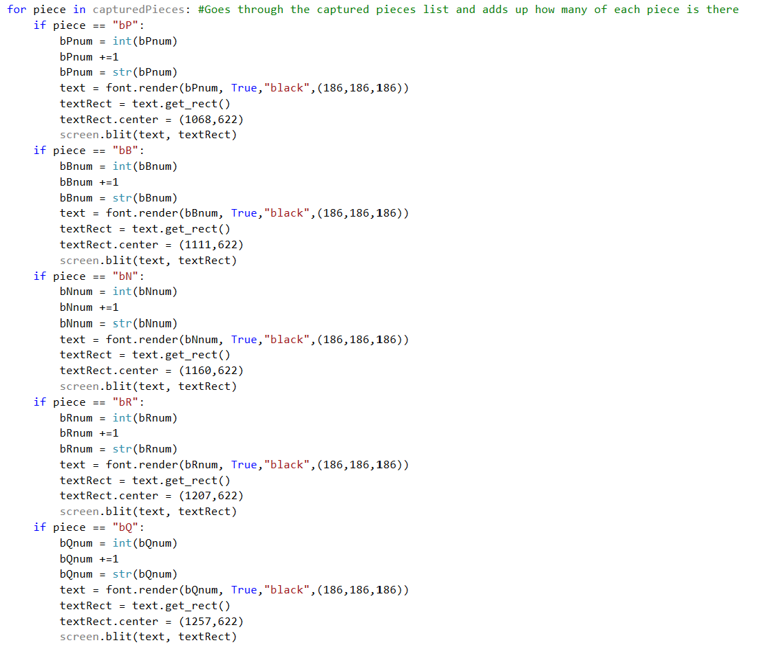

This loop is needed to ensure that the number of each piece is updated whenever there is a change. (This snippet of code is only for the black pieces).

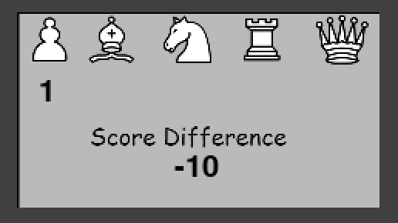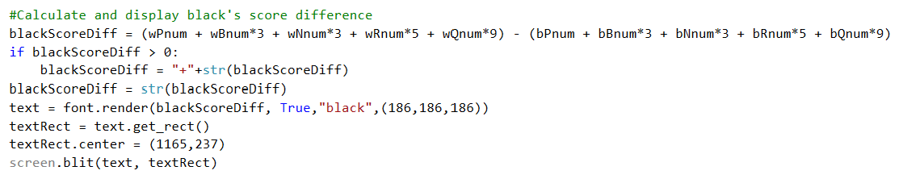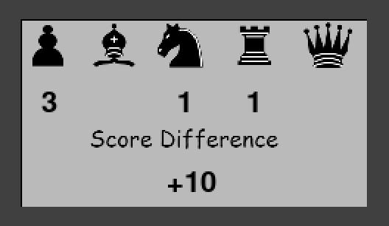

These are examples of what the code above does when certain pieces are captured. As you can see from the image, black is +10, so would be considered to have an advantage.

This snippet is needed to calculate and draw the score difference value into the correct place. (This snippet of code is only for the black pieces).

### Timer For Each Player

**15/11/21**

In this section, the aim was to create a countdown timer for each player and a player’s timer only goes down when it is a player’s turn. Then, if a player’s timer reaches zero, then the other player wins. I achieved this by creating two separate timers that rely on PyGame’s set timer and clock functions. An example of the code used, and the user interface is below.

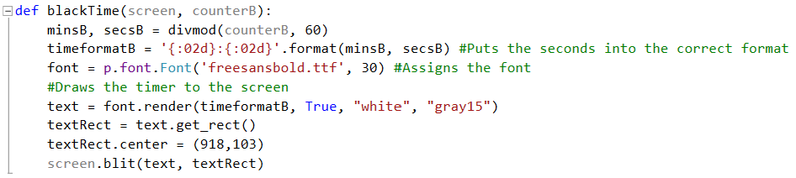

This code is needed to ensure that the timer is I the correct format and the timer is drawn into the correct position.

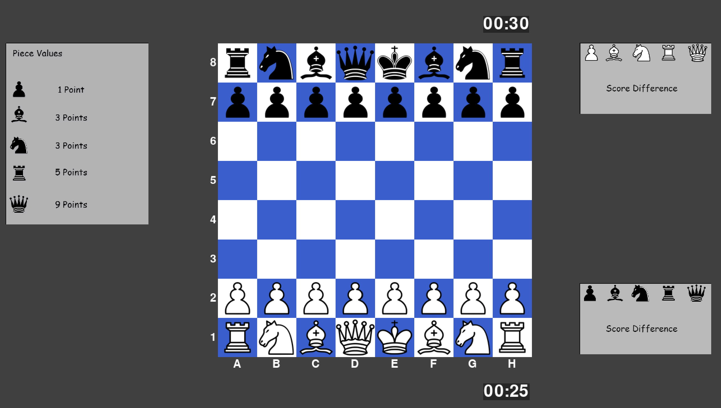

White’s timer goes down as soon as the game begins then stops when it is not white’s move.

### Username System

**22/11/21**

In this section, I implemented the feature for the players to enter their usernames on the main menu, so that they can be displayed in the game and be used in the leader board window. This means that the results from matches can be stored in a database and then used by the players to see who the best players on the local device are. To achieve this feature, I created a rectangle using the PyGame module, which when collides with the mouse and clicked on would change the colour of the rectangle. This indicates that now the player can type in their username into that box, where the text is stored into a variable. When backspace is pressed, the last character is removed from the variable. When the play button is clicked, the text from both boxes is then passed into the main program, where it is then drawn to the screen at the top and bottom of the board.

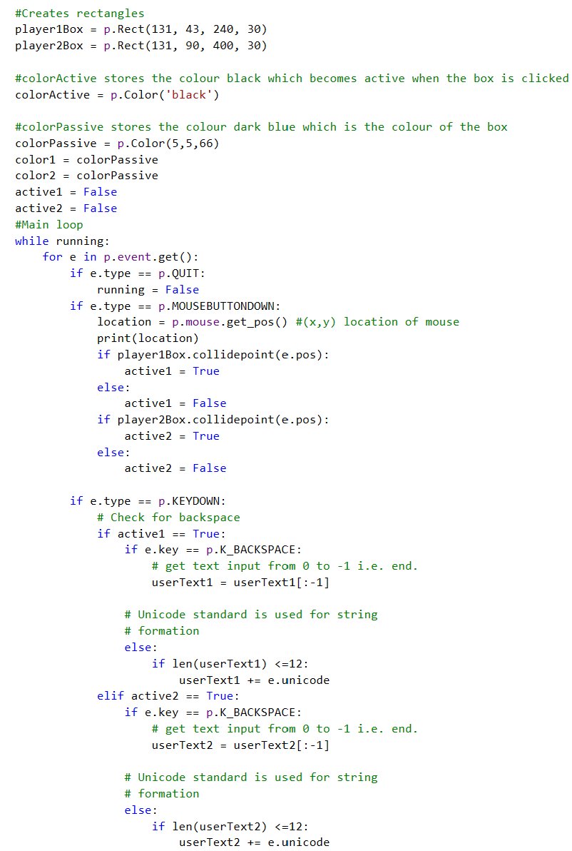

Validation to ensure that the max characters is 13.

Backspace Detection

Collision Detection

Main Menu Loop

Player 2 box has been typed and is still currently selected.

Player 1 box has been typed and deselected.

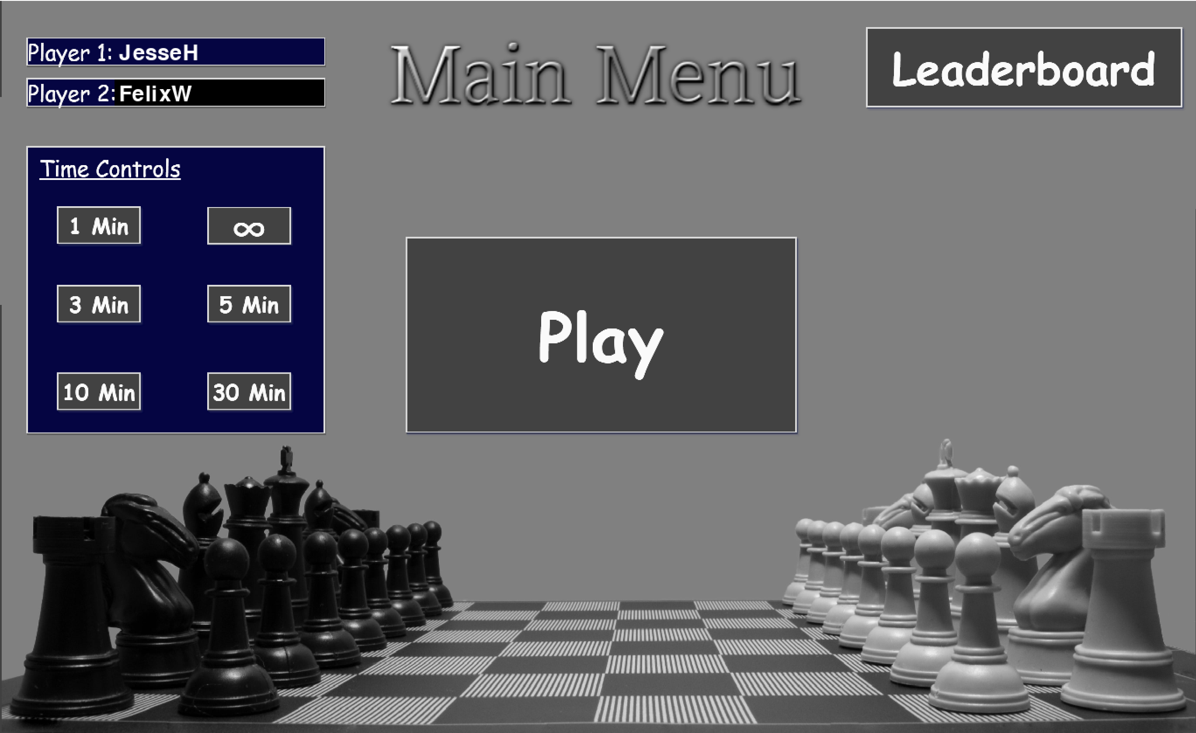

Player 2 is automatically assigned to black and drawn to this side.

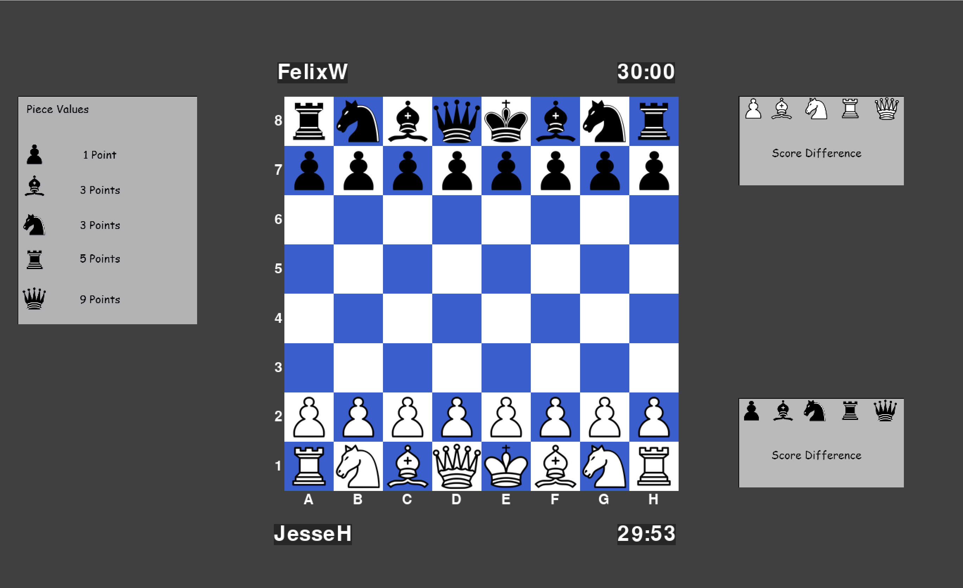

Player 1 is automatically assigned to white and drawn to this side.

### Prototype 4 Testing

|  |  |  |  |  |
| --- | --- | --- | --- | --- |
| What’s being tested? | Input | Justification | Expected Outcome | Actual Outcome |
| Pawn moves using the potential moves indicator. | Pawn is clicked on E2. | To show all possible valid pawn moves at a certain point in time. | Two squares in front of the pawn are highlighted in red and E2 pawn is highlighted in green. | Squares were highlighted off the board (logic error). |

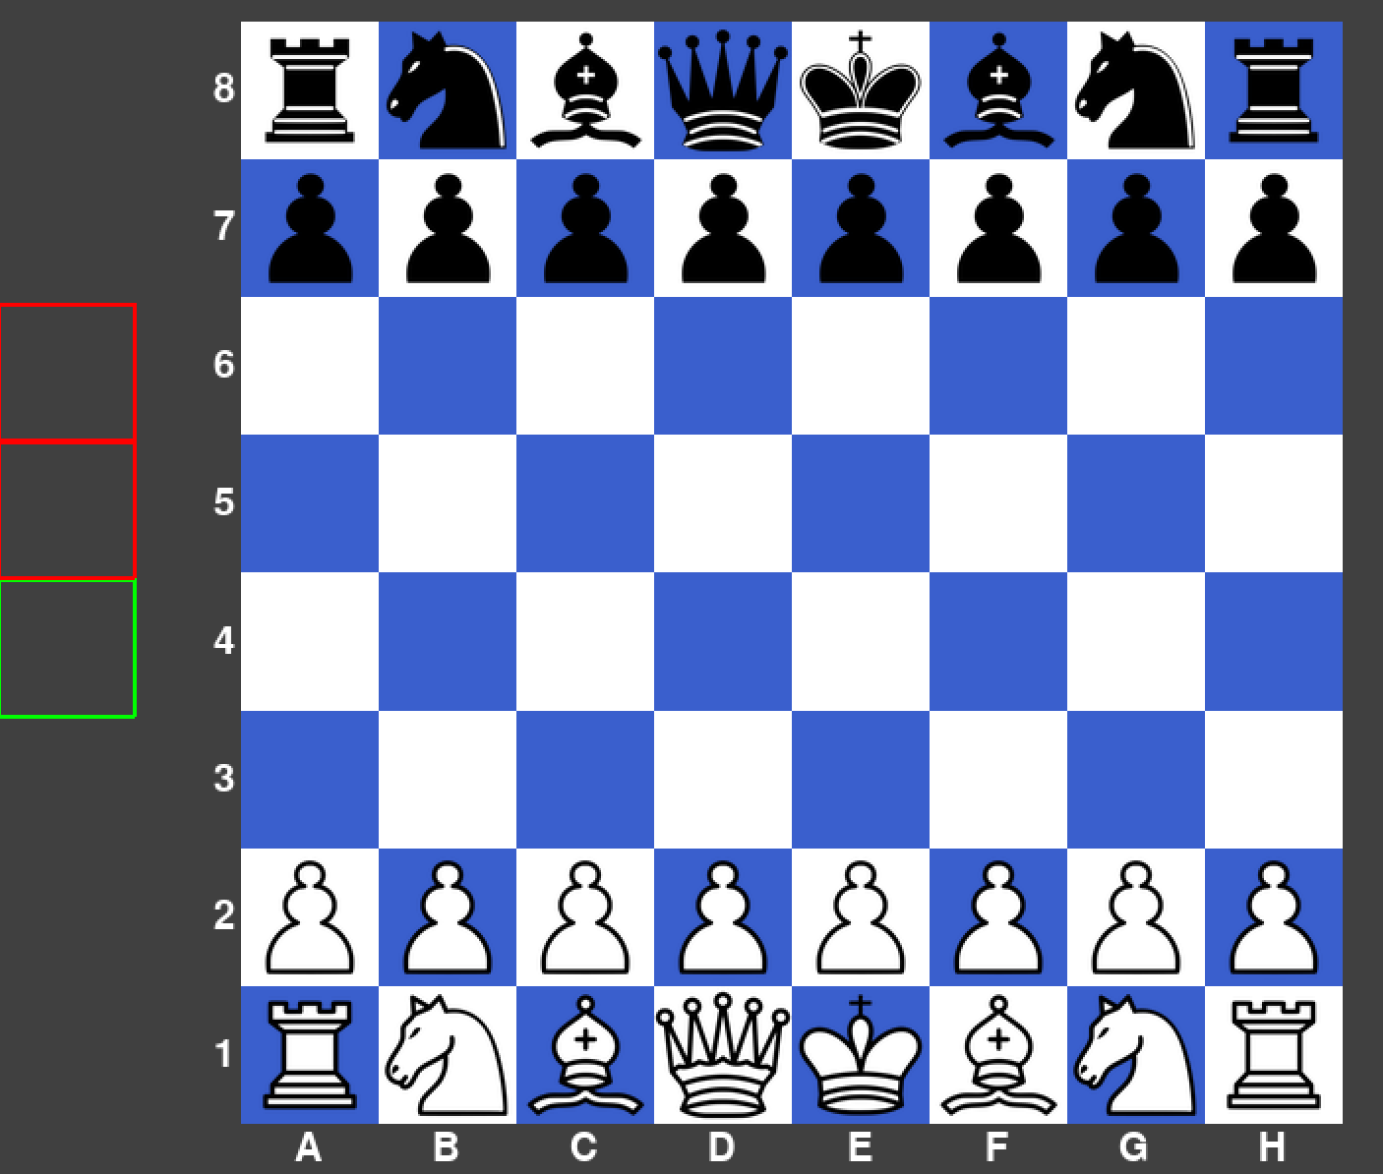

|  |  |  |  |  |
| --- | --- | --- | --- | --- |
| What’s being tested? | Input | Justification | Expected Outcome | Actual Outcome |
| Rook moves using the potential moves indicator. | Rook is clicked H1. | To show all possible valid rook moves at a certain point in time. | Two squares in front of the rook are highlighted in red and H1 rook is highlighted in green. | Squares were highlighted as expected. |

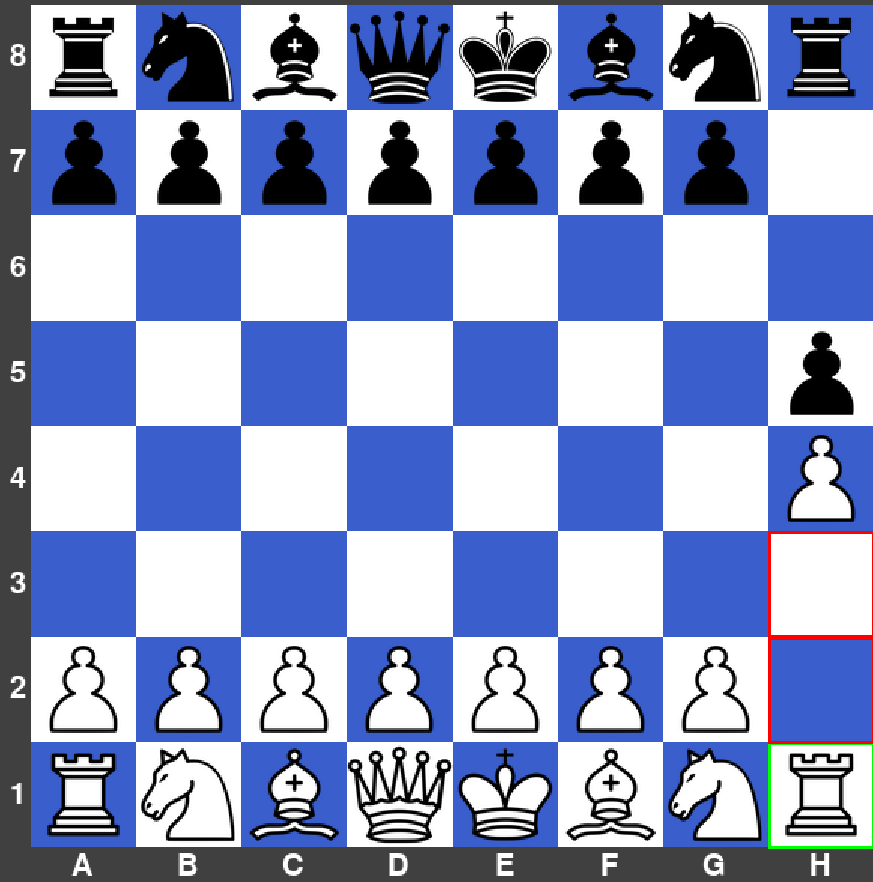

|  |  |  |  |  |
| --- | --- | --- | --- | --- |
| What’s being tested? | Input | Justification | Expected Outcome | Actual Outcome |
| Bishop moves using the potential moves indicator. | Bishop is clicked on C1. | To show all possible valid bishop moves at a certain point in time. | Top right diagonal squares are highlighted in red and C1 bishop is highlighted in green. | Squares were highlighted as expected. |

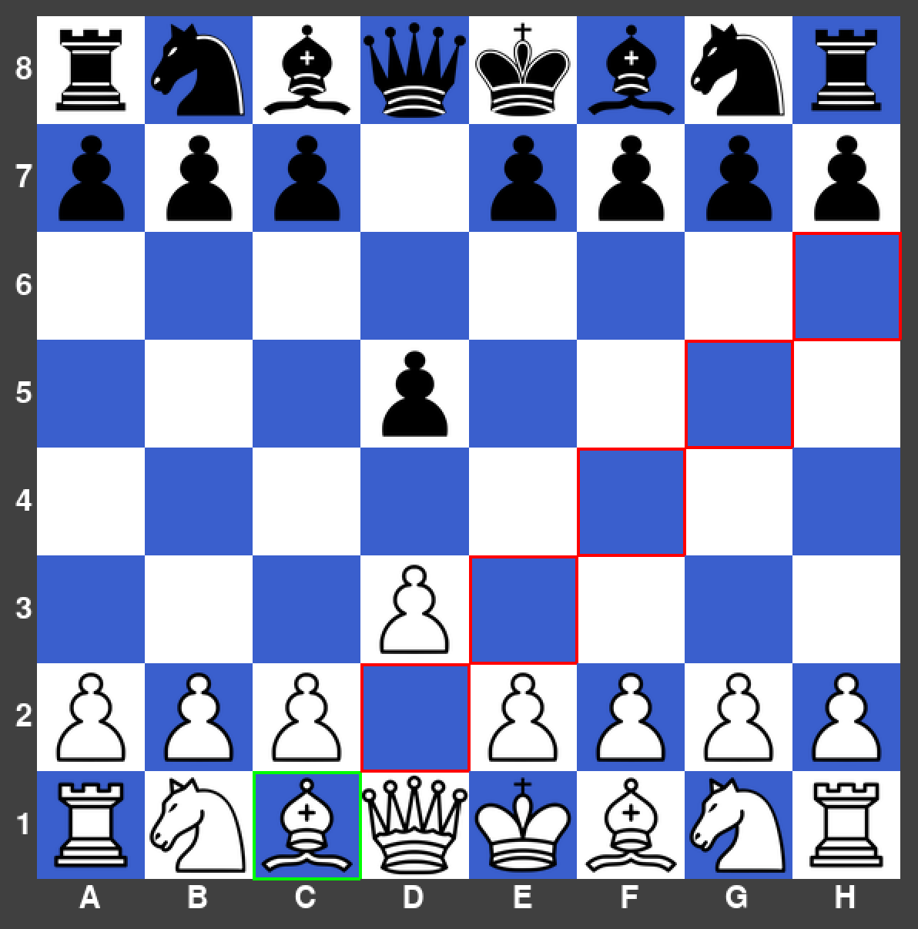

|  |  |  |  |  |
| --- | --- | --- | --- | --- |
| What’s being tested? | Input | Justification | Expected Outcome | Actual Outcome |
| Queen moves using the potential moves indicator. | Queen is clicked on G4. | To show all possible valid queen moves at a certain point in time. | All possible bishop and rook moves are highlighted in red and G4 is highlighted in green. | Squares were highlighted as expected. |

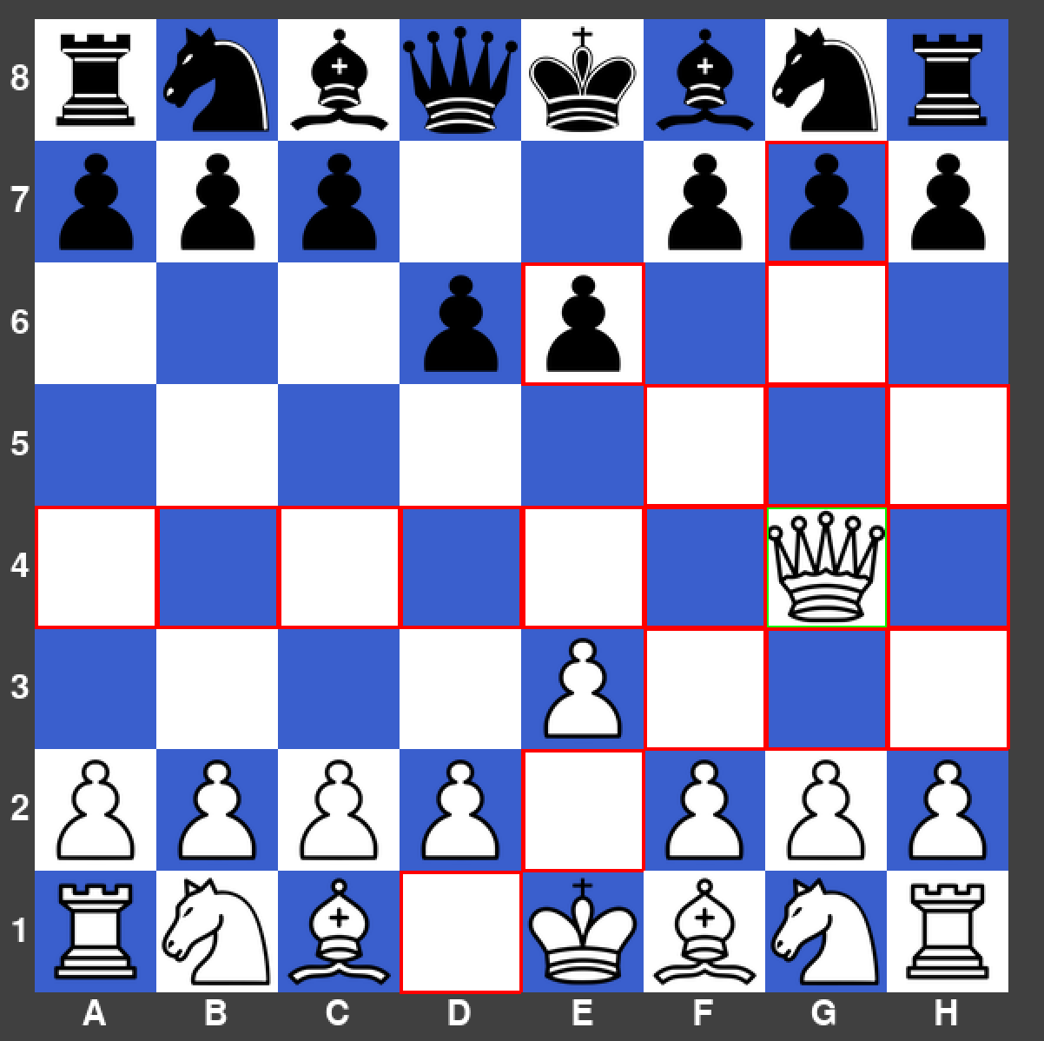

|  |  |  |  |  |
| --- | --- | --- | --- | --- |
| What’s being tested? | Input | Justification | Expected Outcome | Actual Outcome |
| King moves using the potential moves indicator. | King is clicked on E4. | To show all possible valid king moves at a certain point in time. | All possible king moves are highlighted in red and E4 is highlighted in green. | Squares were highlighted as expected. |

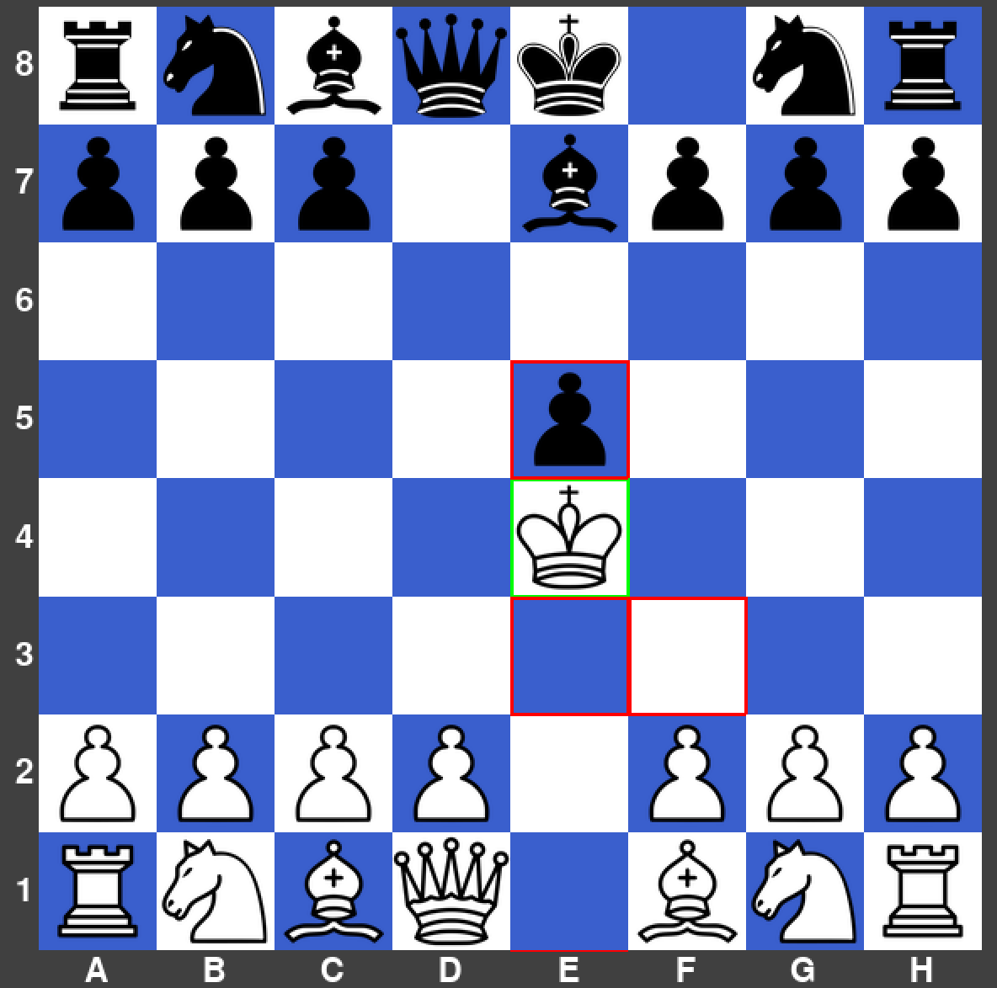

|  |  |  |  |  |
| --- | --- | --- | --- | --- |
| What’s being tested? | Input | Justification | Expected Outcome | Actual Outcome |
| Knight moves using the potential moves indicator. | Knight is clicked on G1. | To show all possible valid knight moves at a certain point in time. | All possible knight moves are highlighted in red and G1 is highlighted in green. | Squares were highlighted as expected. |

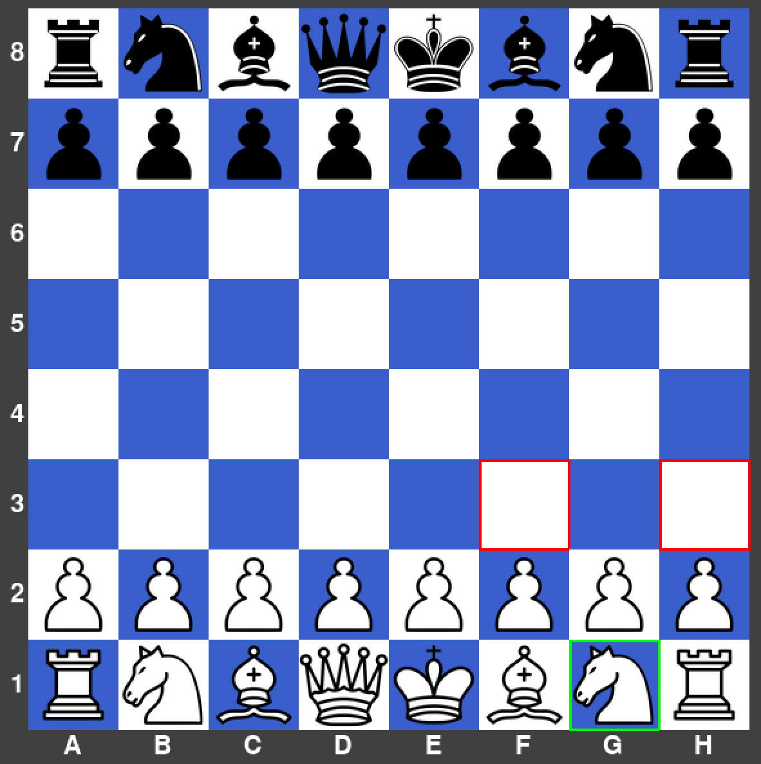

|  |  |  |  |  |
| --- | --- | --- | --- | --- |
| What’s being tested? | Input | Justification | Expected Outcome | Actual Outcome |
| Score difference and captured pieces tracker | One black pawn, bishop, knight, rook, and queen is captured. | To show what pieces have been captured during the game and the score difference between the two players. | 1’s appear under each black piece and the score difference is 21. | The actual outcome did match the expected outcome |

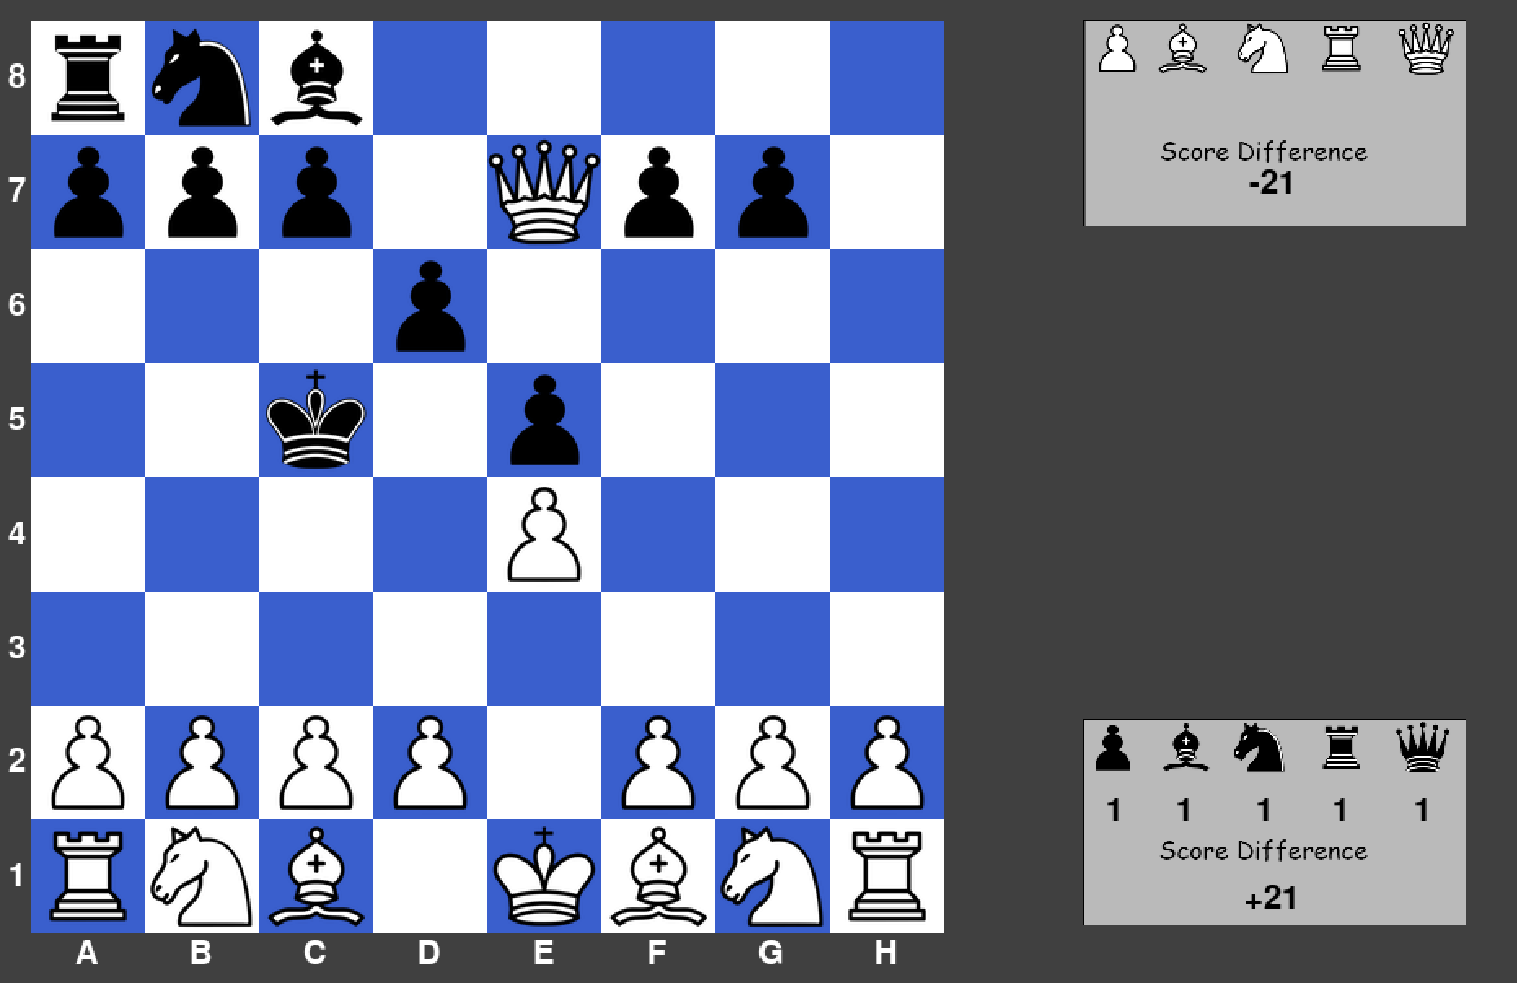

|  |  |  |  |  |
| --- | --- | --- | --- | --- |
| What’s being tested? | Input | Justification | Expected Outcome | Actual Outcome |
| Timer for 1 minute | 1 minute button is selected on the main menu | To allow the match to be determined in a specific amount of time. | The timer starts at 1 minute and begins counting down immediately for white. | The actual outcome did match the expected outcome. |

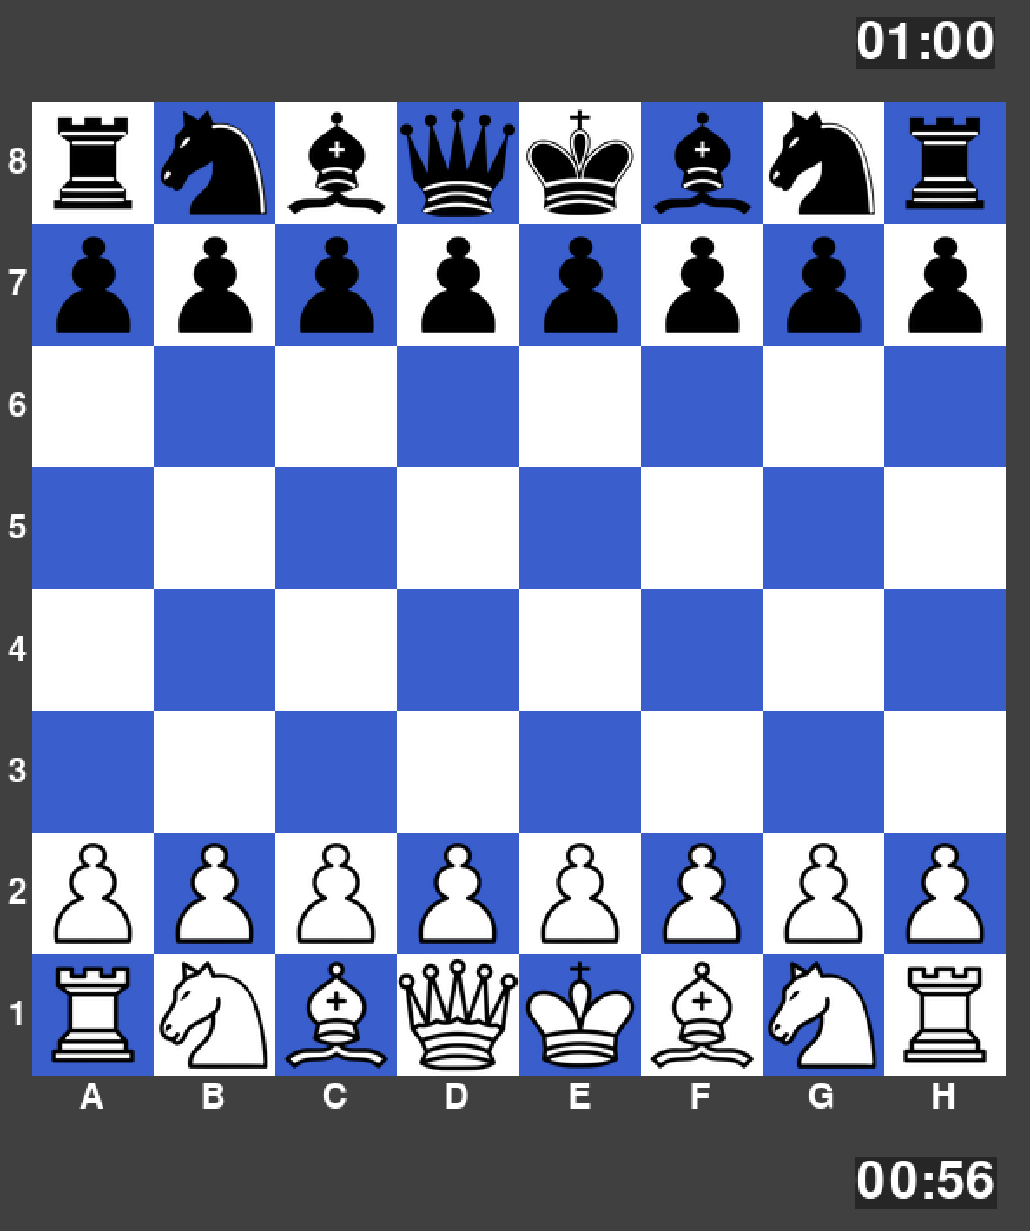

|  |  |  |  |  |
| --- | --- | --- | --- | --- |
| What’s being tested? | Input | Justification | Expected Outcome | Actual Outcome |
| Timer for 3 minutes | 3-minute button is selected on the main menu | To allow the match to be determined in a specific amount of time. | The timer starts at 3 minutes and begins counting down immediately for white. | The actual outcome did match the expected outcome. |

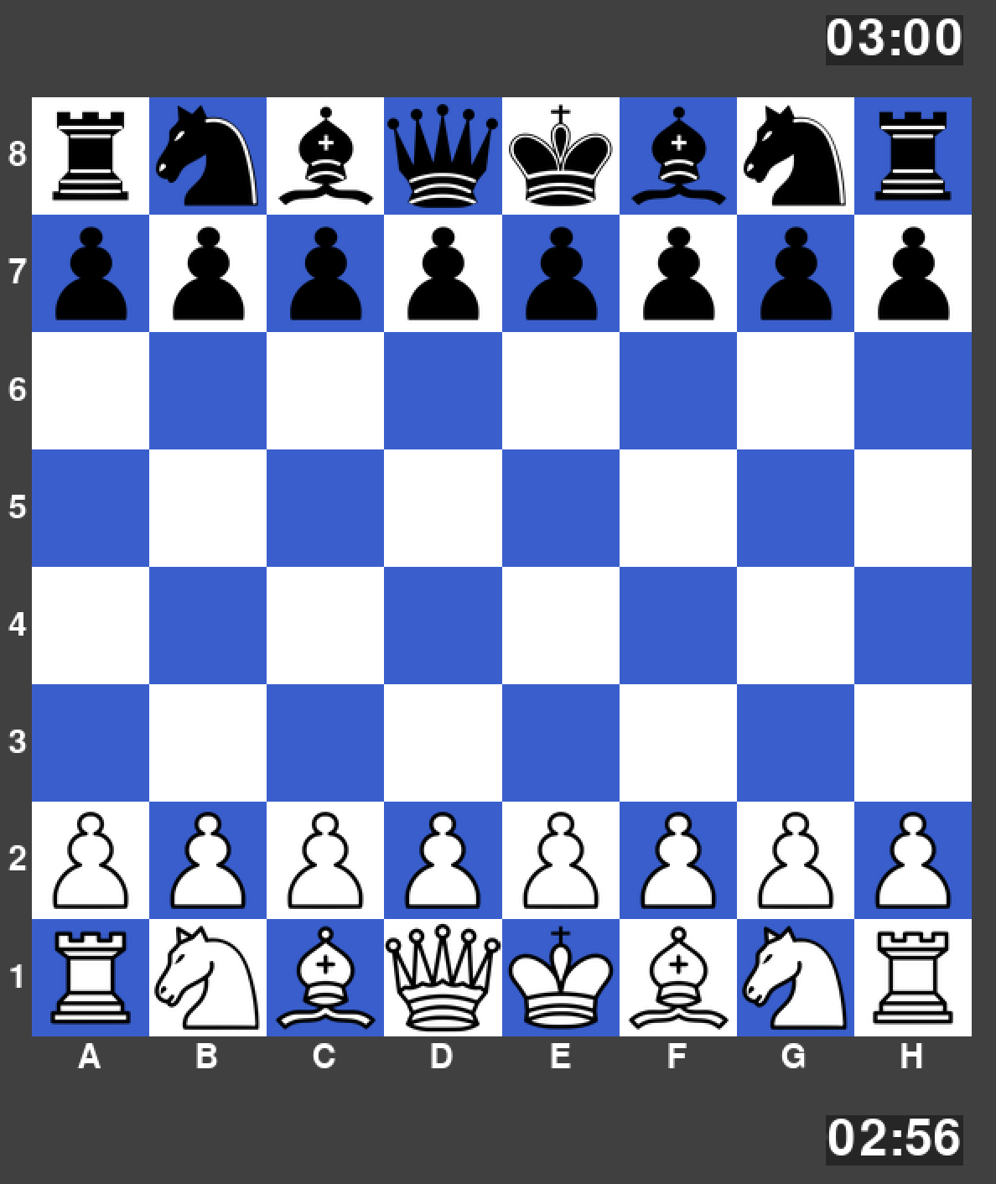

|  |  |  |  |  |
| --- | --- | --- | --- | --- |
| What’s being tested? | Input | Justification | Expected Outcome | Actual Outcome |
| Timer for 5 minutes | 5-minute button is selected on the main menu | To allow the match to be determined in a specific amount of time. | The timer starts at 5 minutes and begins counting down immediately for white. | The actual outcome did match the expected outcome. |

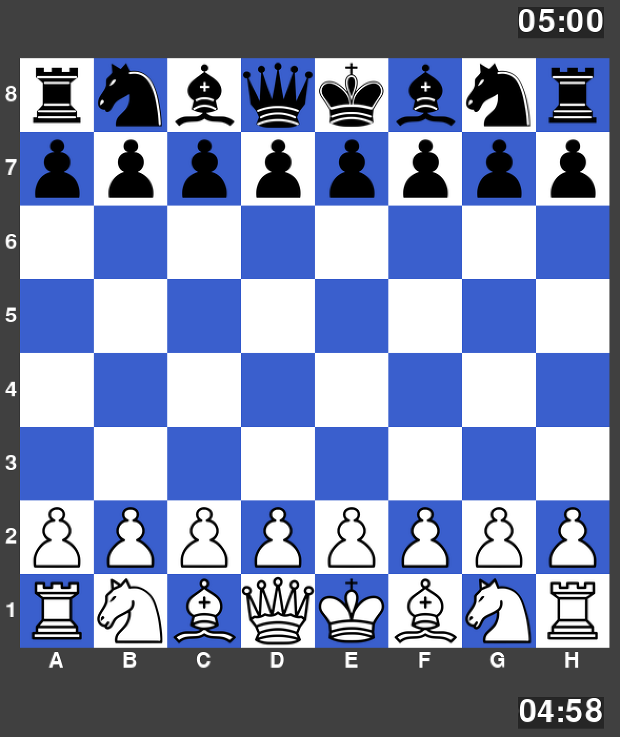

|  |  |  |  |  |
| --- | --- | --- | --- | --- |
| What’s being tested? | Input | Justification | Expected Outcome | Actual Outcome |
| Timer for 10 minutes | 10-minute button is selected on the main menu | To allow the match to be determined in a specific amount of time. | The timer starts at 10 minutes and begins counting down immediately for white. | The actual outcome did match the expected outcome. |

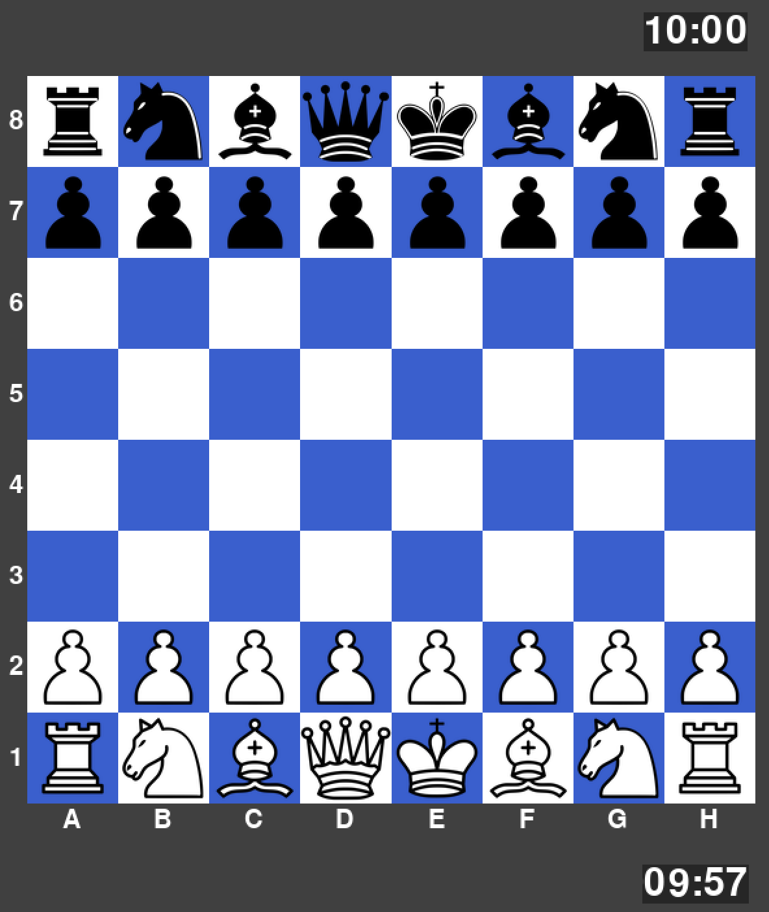

|  |  |  |  |  |
| --- | --- | --- | --- | --- |
| What’s being tested? | Input | Justification | Expected Outcome | Actual Outcome |
| No timer selected | Infinity button is selected on the main menu | To allow the match to be played without the worry about the timer. | The timer does not display any numbers. | The actual outcome did match the expected outcome. |

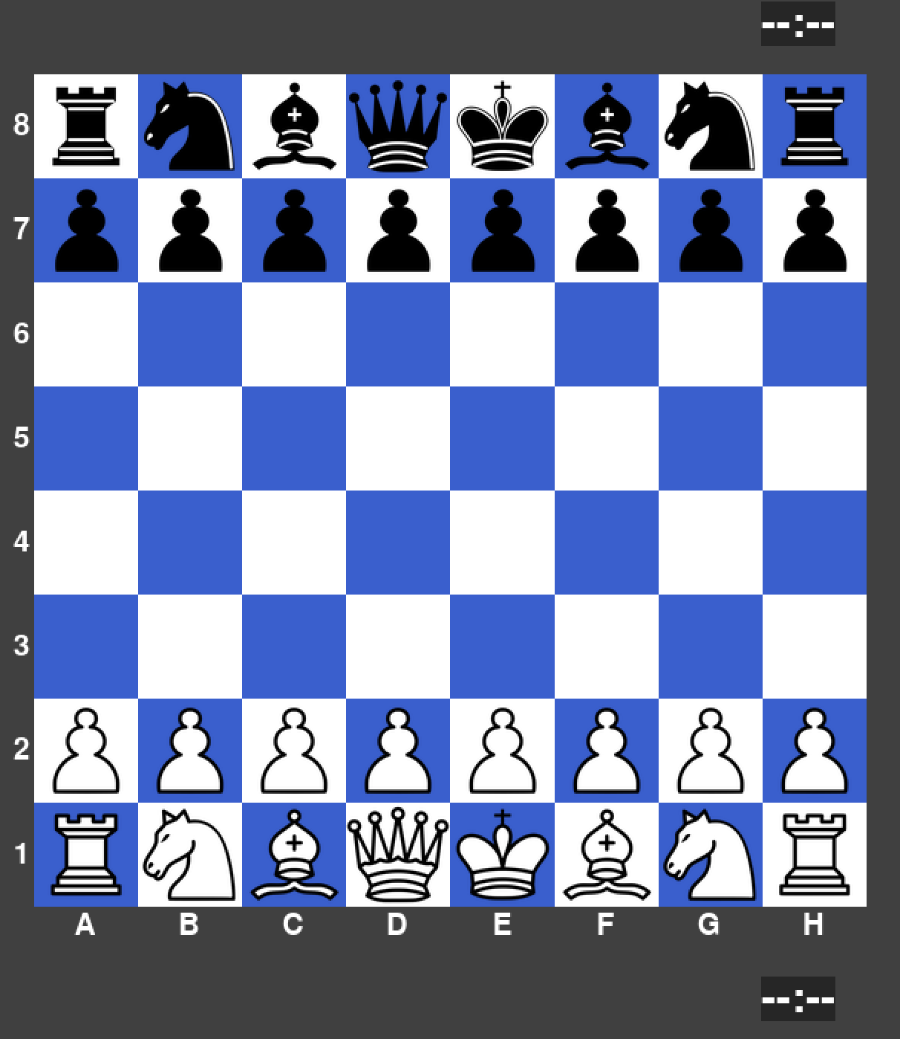

|  |  |  |  |  |
| --- | --- | --- | --- | --- |
| What’s being tested? | Input | Justification | Expected Outcome | Actual Outcome |
| Timer for 30 minutes | 30-minute button is selected on the main menu | To allow the match to be determined in a specific amount of time. | The timer starts at 30 minutes and begins counting down immediately for white. | The actual outcome did match the expected outcome. |

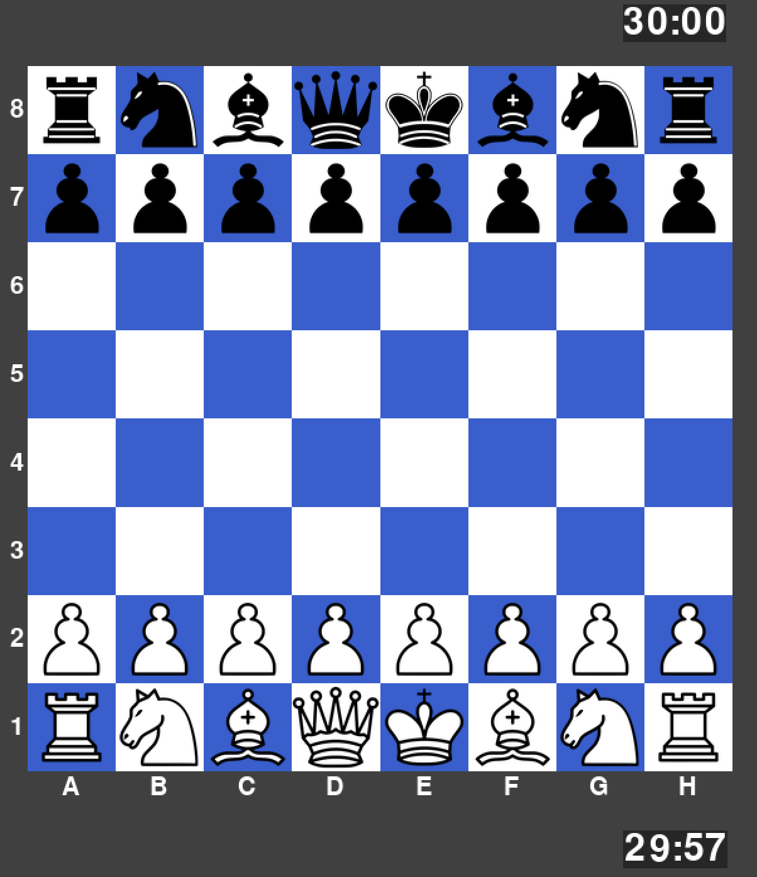

|  |  |  |  |  |
| --- | --- | --- | --- | --- |
| What’s being tested? | Input | Justification | Expected Outcome | Actual Outcome |
| Username system | Player 1 = “JesseH”  Player 2 = “FelixW” | To show which player is on which side of the board and this can then be used in other parts of the program. | “JesseH” is displayed below the board and “FelixW” is displayed above the board. | The actual outcome did match the expected outcome. |

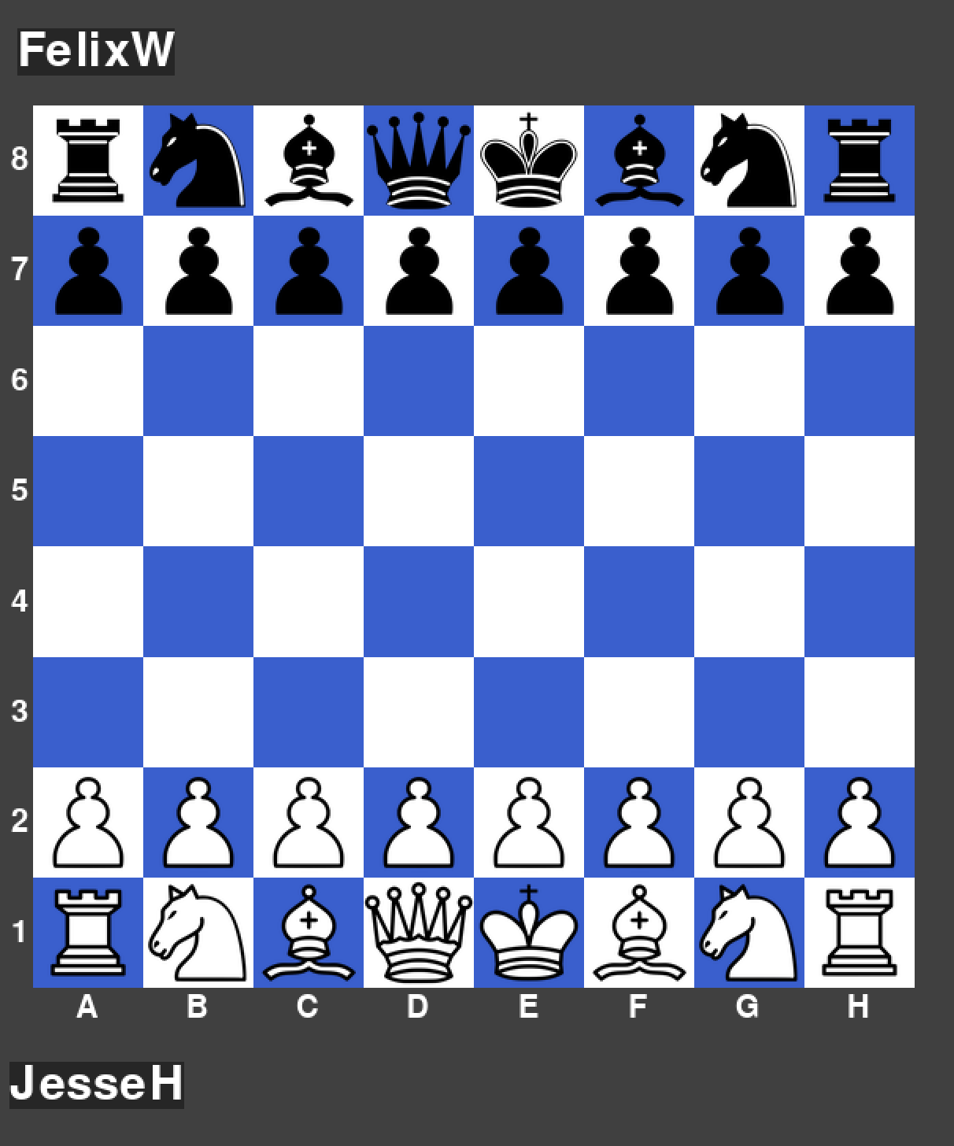

### Errors Encountered – Prototype 4

**Potential Moves Indicator Error**

Whilst testing my potential moves indicator with pawns, I realised there was a small error in my code that did not adjust the coordinates to place the highlighted boxes in the correct places.

Before:

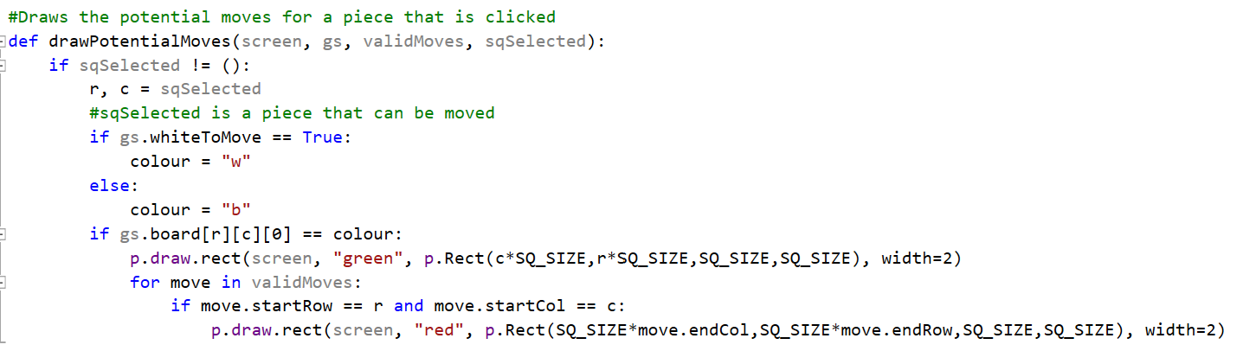

**Remedial Action**

To fix this issue I just needed to transform each rectangle drawn by vector (404,137). This means that it now overlaps the board in the correct place.

After:

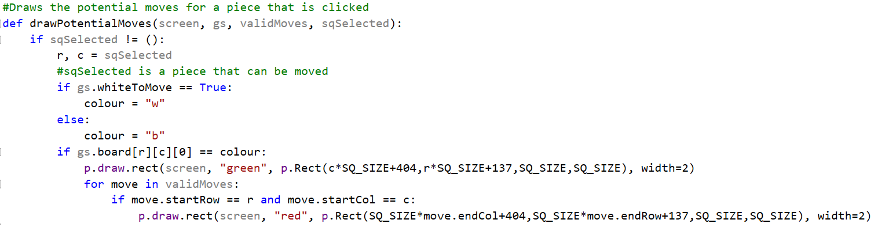

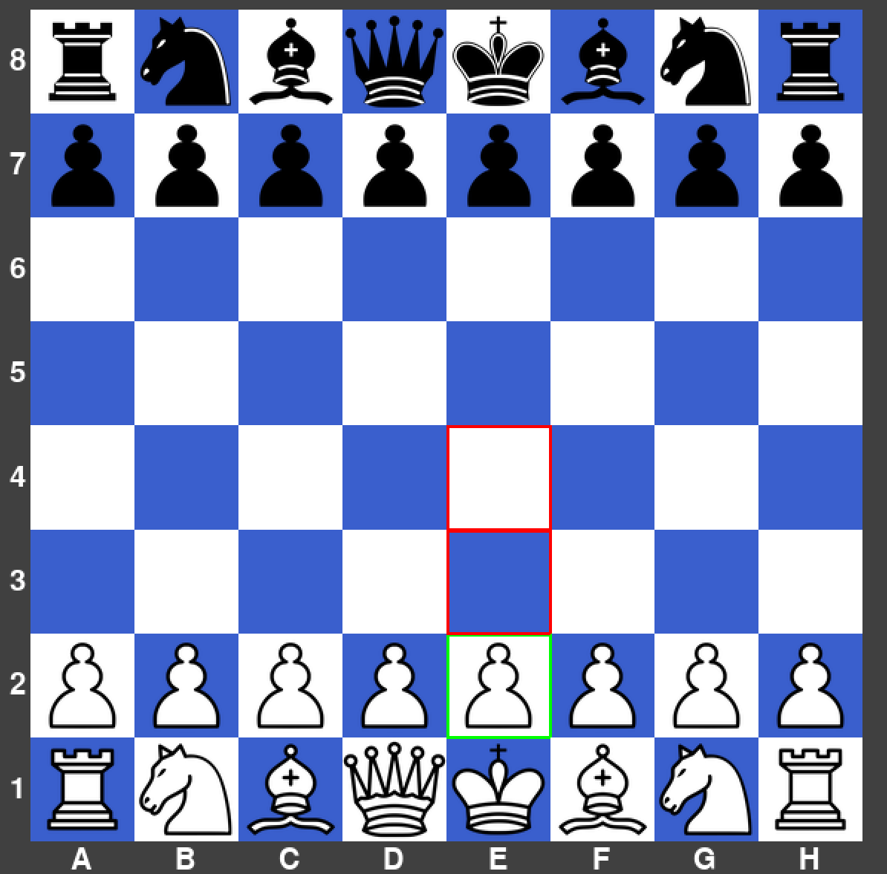

### Flowcharts Used – Prototype 4

Potential Moves Indicator



### Interview & Review – Prototype 4

|  |  |  |
| --- | --- | --- |
| No. | Requirements | Justification |
| 6. | A potential moves indicator will appear when a player clicks on one of their pieces. This will be a circle appearing on the squares. | This shows all the possible places a piece can move. Allows the player to understand what each piece does. |
| 8. | A start-up screen | Introduces the game and shows the players what they are about to play. |
| 9. | Menu system will allow the user to pick between the Player vs Player mode or to access the leader board. | Gives a fluidity to the program and increases simplicity. |
| 10. | The time control will need to be selected upon choosing the Player vs Player mode. Time controls are: Bullet (1 minute), Blitz (3 or 5 minutes), Rapid (10 or 30 minutes), no time control option. The timer for each player stops when it is not their turn. | Time control is a feature for more competitive players as it adds an extra edge to the game because you cannot spend too long on your moves. |
| 11. | Usernames of both players will need to be inputted before a match can start. | This is needed to match the stats of a player to a username to be displayed on the leader board. |
| 33. | Images of the pieces captured by each player plus the score difference will be displayed under each player’s name. | Informs the players to who has an advantage in terms of material. |
| 34. | A window to the side of the board will display the values of each piece. Pawns are 1 score, Bishops are 3 score, Knights are 3 score, Rooks are 5 score, Queen is 9 score. | Informs the players generally what pieces are worth trading for other pieces. |

**Interview**

Me: What do you think about the appearance of the main menu?

Felix Williams: It looks very smart. It has all the necessary aspects on the main menu that we have talked about previously. I like the feature when you hover over the buttons it lights up in green, which is helpful.

Me: What do you think about the timer control system?

Felix Williams: It functions perfectly as it’s supposed to – stopping for each player when it’s not their turn and being able to pick which duration of timer in the main menu.

Me: Is there anything that needs improving within this prototype?

Felix Williams: Whilst testing the potential moves indicator I noticed that sometimes the green and red boxes would stay visible on the boundaries of the board. This may need another look at but is not harmful to the program in any way.

Me: Overall, how do you feel with the progress I have made?

Felix Williams: Overall, the amount of usability features implemented in this protype is great to see. The fact that many of the features are aimed at newer players to help them progress is brilliant, fitting perfectly with what this program was set out to do. I am excited to see how the database and leader board system is implemented next using the username system used in this current prototype.

**Next steps**

After discussing with Felix about this prototype, in the next prototype I need to implement the database and leader board system to store the results of matches after each game. This leader board will be accessible after each match or in the main menu.

## Database System – Prototype 5

**29/11/2021**

In this section, I implemented the feature of creating and linking a database to my python game file. For this I used the Microsoft Access Database. I achieved this by fetching all the data from the data base and I converted them into local variables, so that I could perform operations on them. For example, if player 1 won the match, their win counter would be increased by one. Then, the values would be updated into the database. The stats that are used in the database are games played, wins, losses, username, win percentage, and draws. This data can then be displayed in the leader board interface later.

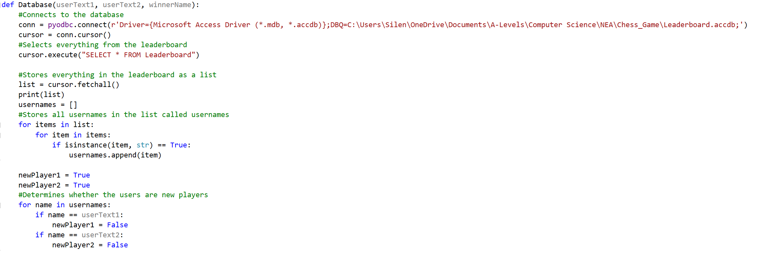

Database procedure is needed to process all the data from the database, then output it back into the database with updates values.

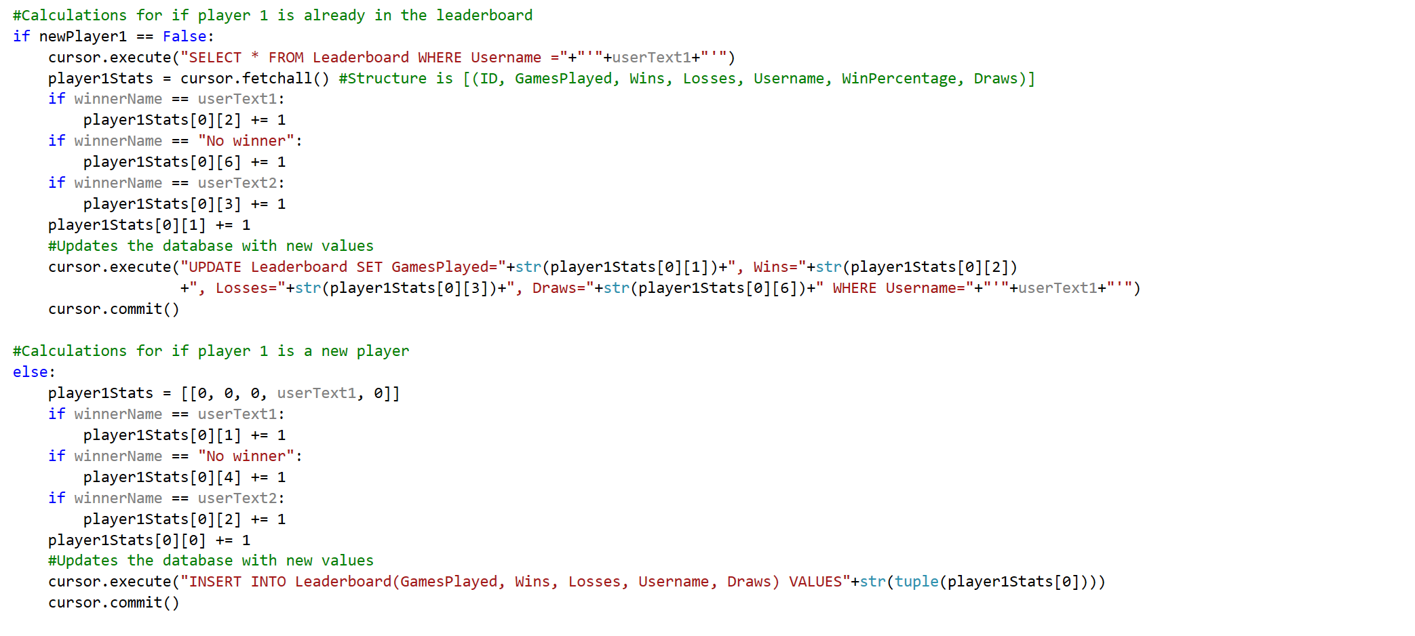

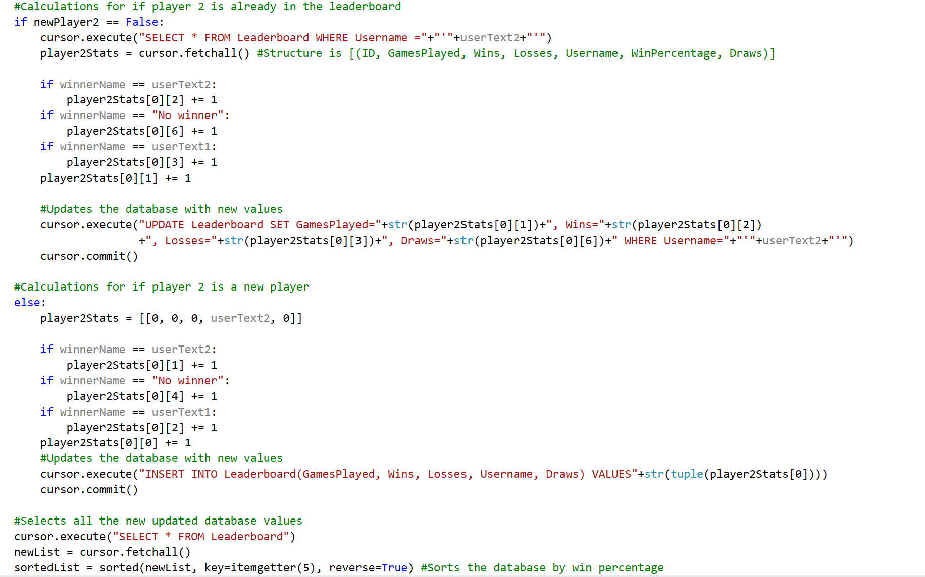

### Leaderboard System – Prototype 5

**06/12/2021**

In this section, I implemented an entire leader board interface which can be accessed using the “L” key after a match or using the leader button in the main menu. I achieved this by using the tkinter library to create a table which I could import the database data into. This means that, all the data from the database can be seen by the players in a fully up to date table format that has an infinite number of rows, utilising a scrollable slider. The leader board displays the position, username, games played, wins, losses, draws and win percentage. The leader board is sorted in terms of win percentage in descending order. An example of this can be seen below:

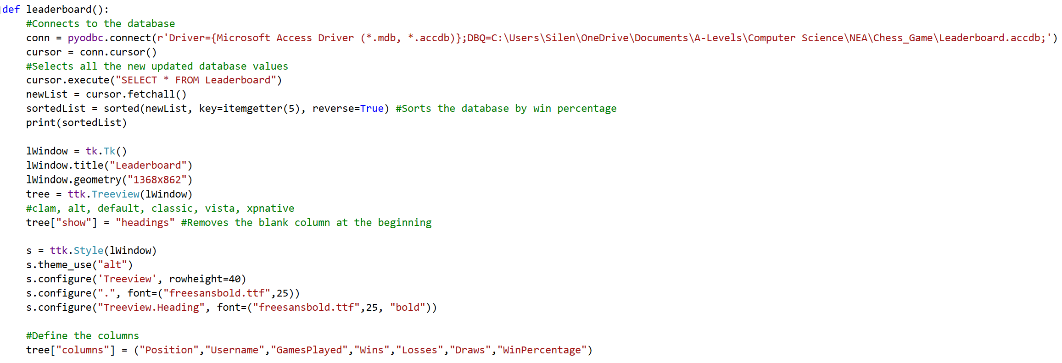

Leader board procedure is needed to structure all the data from the database into a table that can be seen by the user in a easy to read format.

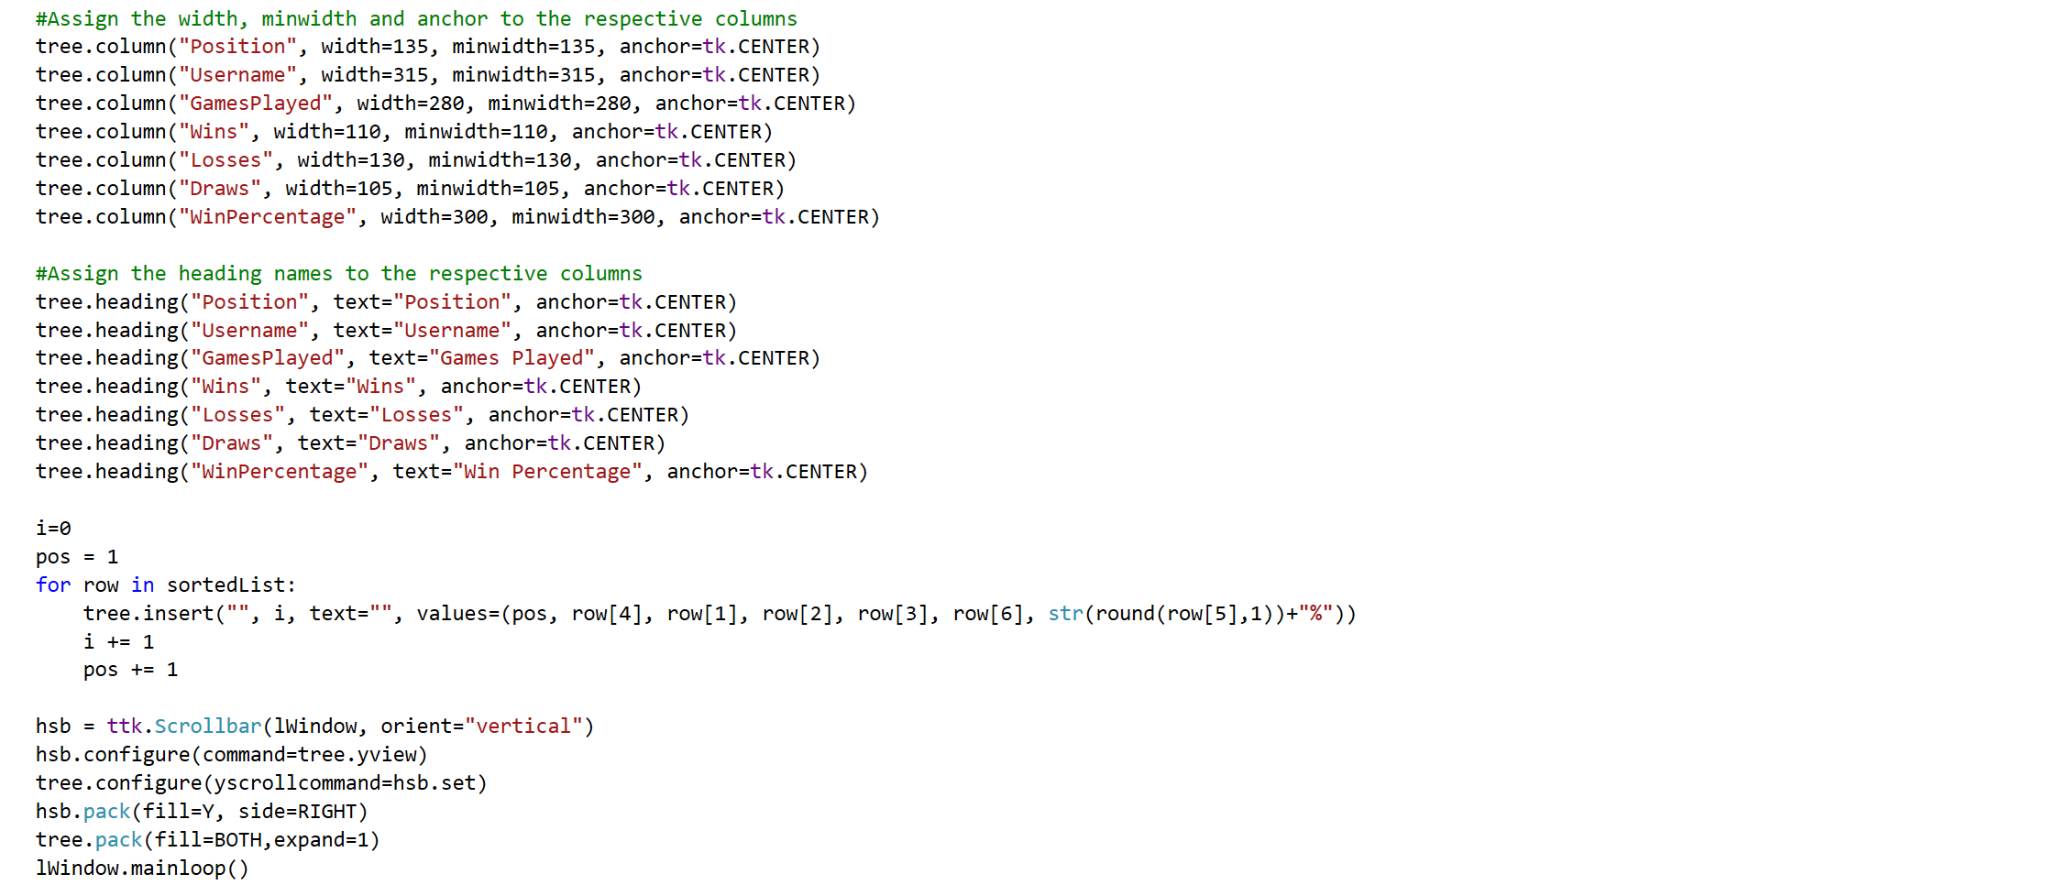

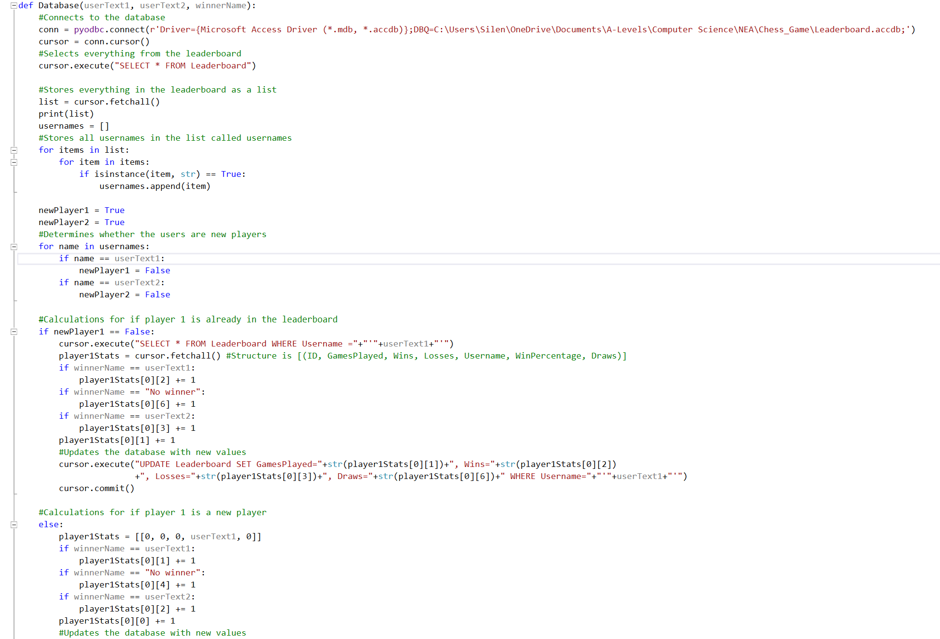

Database procedure is needed to take all data from the database and convert it into a local list variable. Then, the appropriate data is updated using the match result. Then, the database is updated.

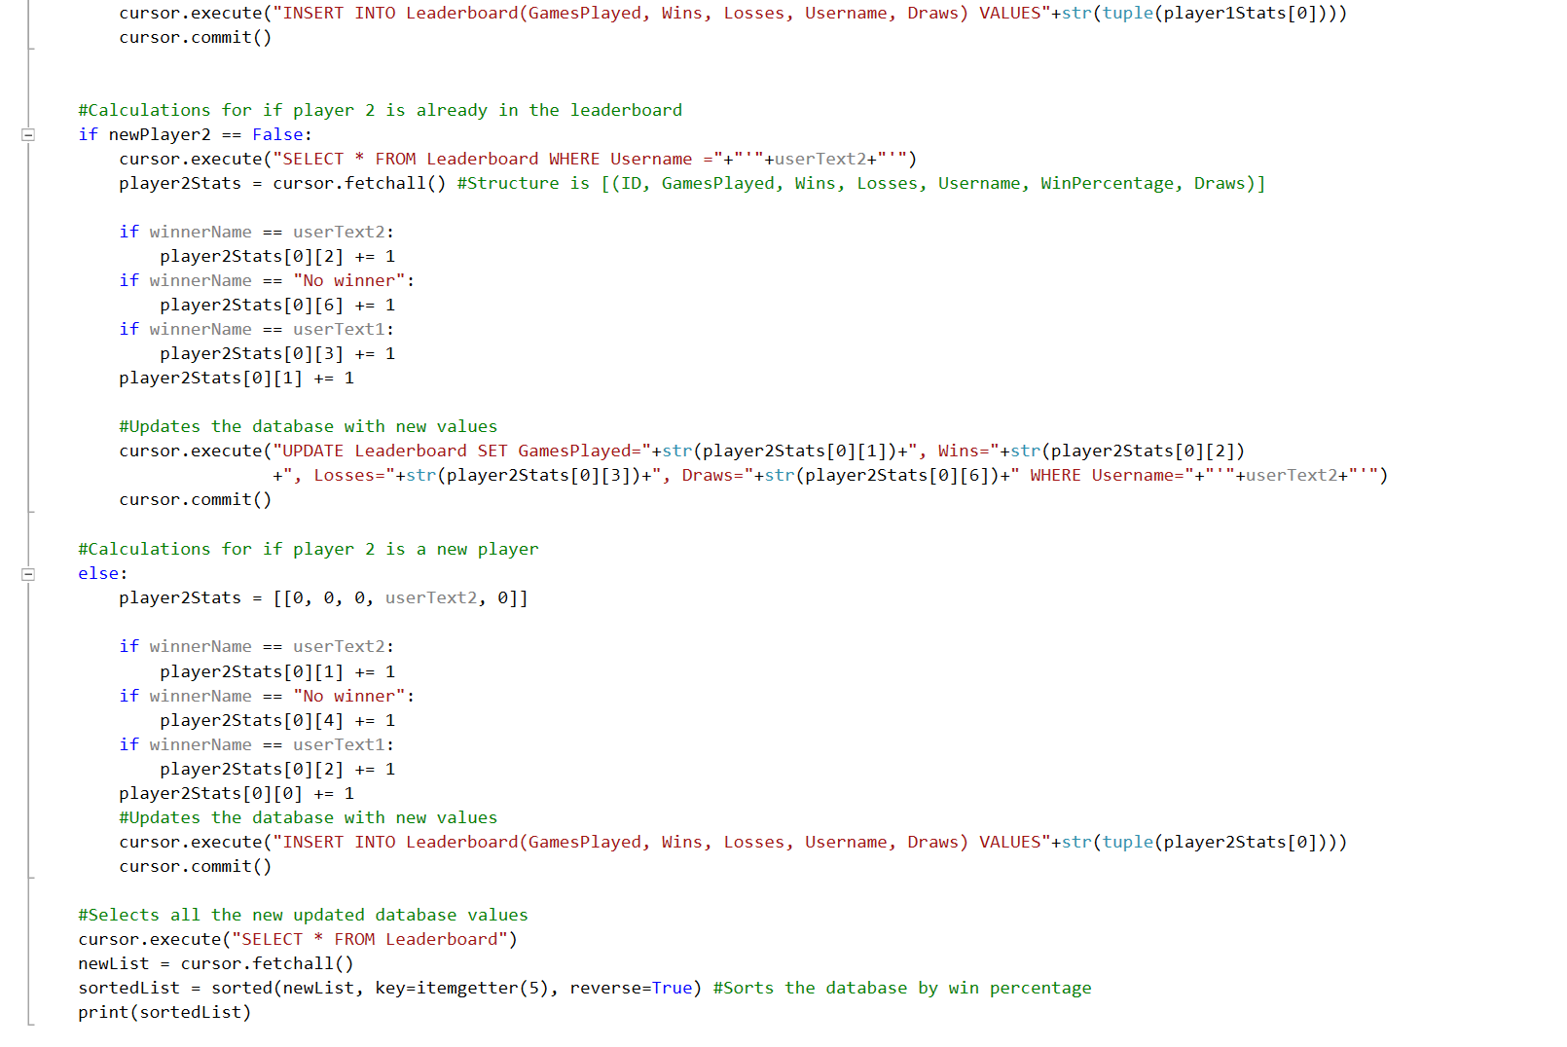

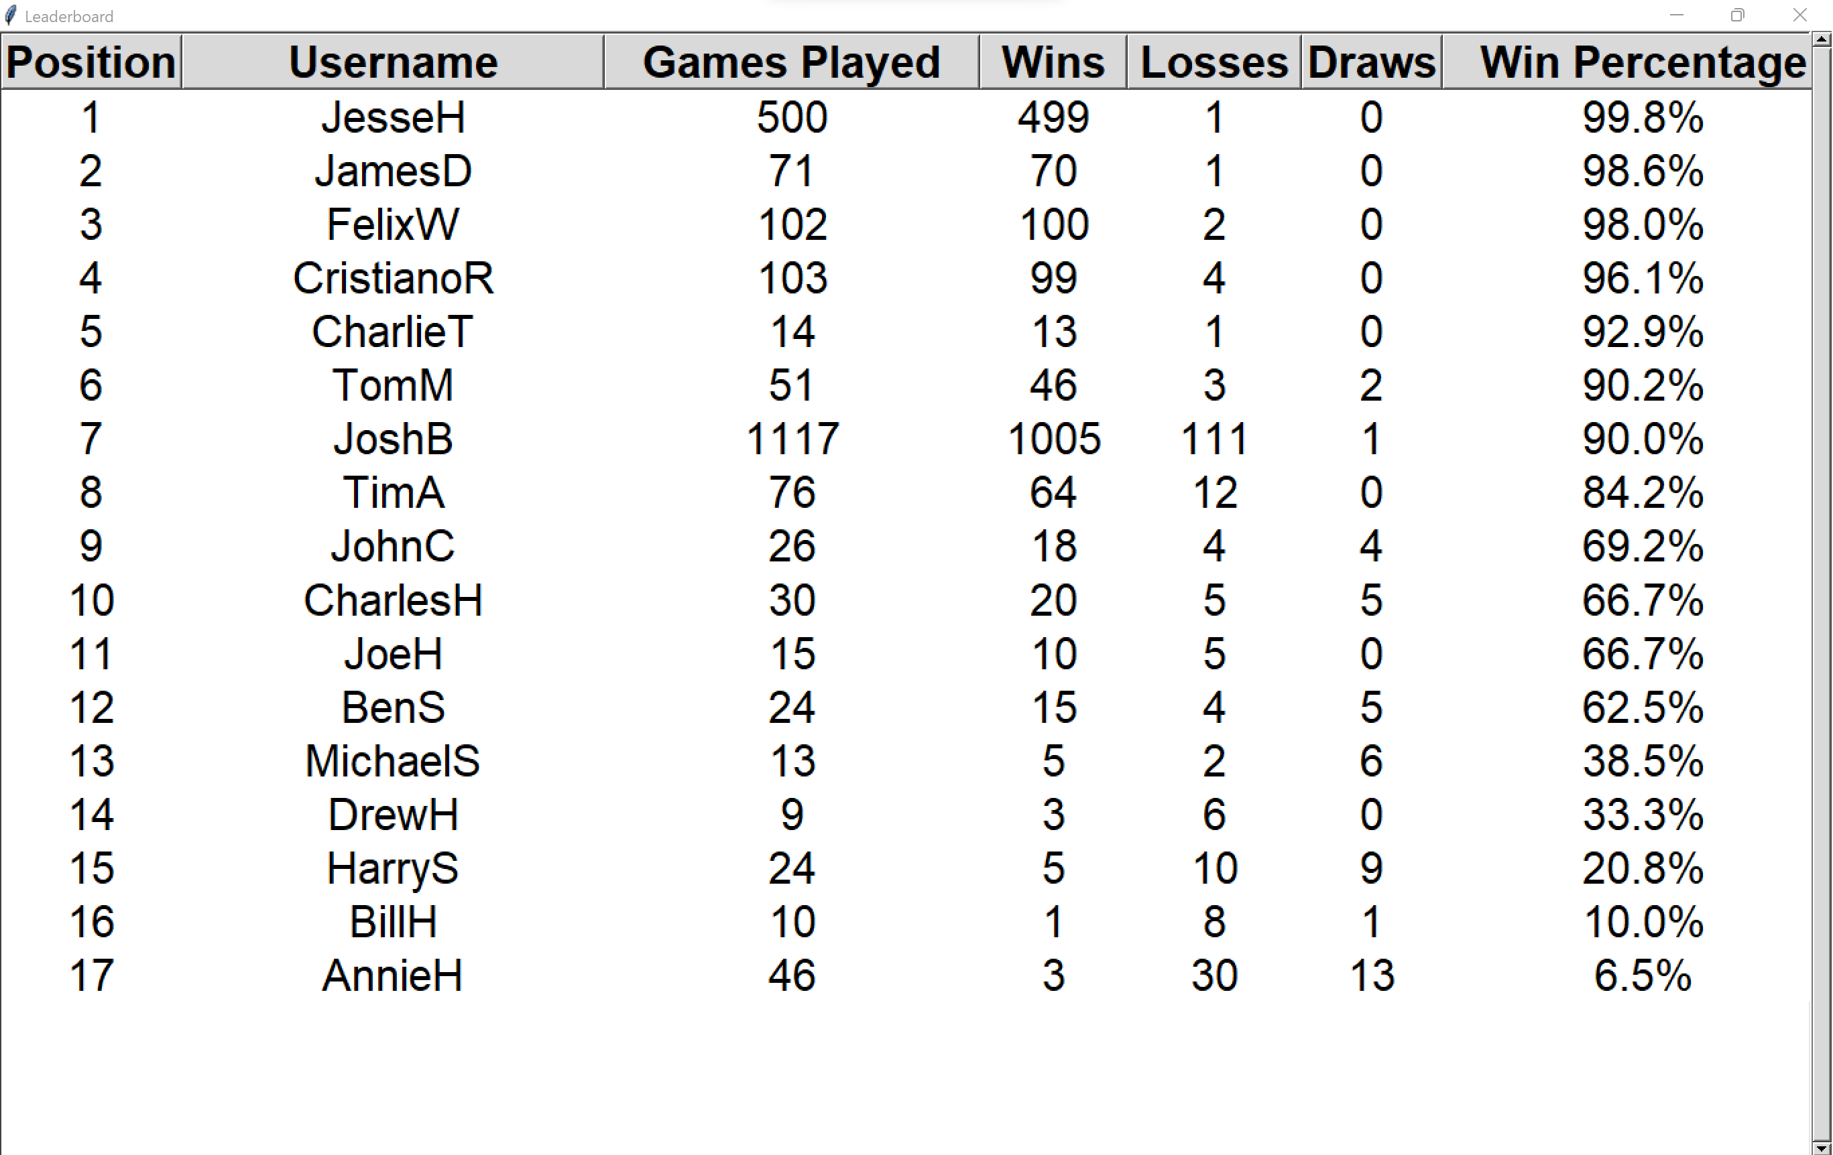

### Testing – Prototype 5

|  |  |  |  |  |
| --- | --- | --- | --- | --- |
| What’s being tested? | Input | Justification | Expected Outcome | Actual Outcome |
| New player being put into the leader board. | Player 1 (SammyM) won against player 2 (SophieH). | To allow a new player to be entered into the leader board with the correct position. | SammyM should enter the leaderboard at the top spot with 1 games played and 1 win. SophieH should enter the leaderboard in 19th with 1 games played and 1 loss. | The actual outcome did match the expected outcome. |

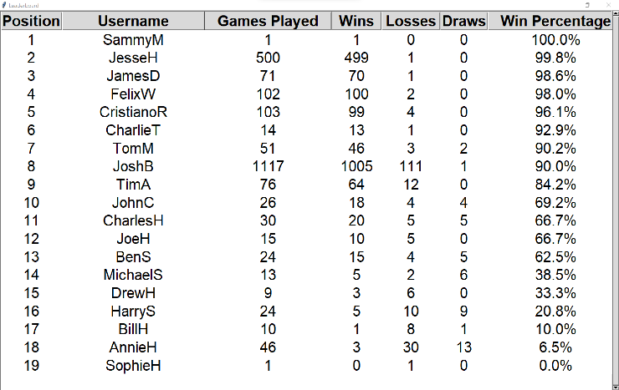

|  |  |  |  |  |
| --- | --- | --- | --- | --- |
| What’s being tested? | Input | Justification | Expected Outcome | Actual Outcome |
| Updating a player’s stats when already in the leaderboard | Player 1 (SammyM) lost against player 2 (JoeH). | To allow existing players to move up and down the leader board with up-to-date stats. | SammyM should move down to 13th place with 2 games played, 1 win and 1 loss. JoeH should move up to 10th place with 16 games played, 11 wins and 5 losses. | The actual outcome did match the expected outcome. |

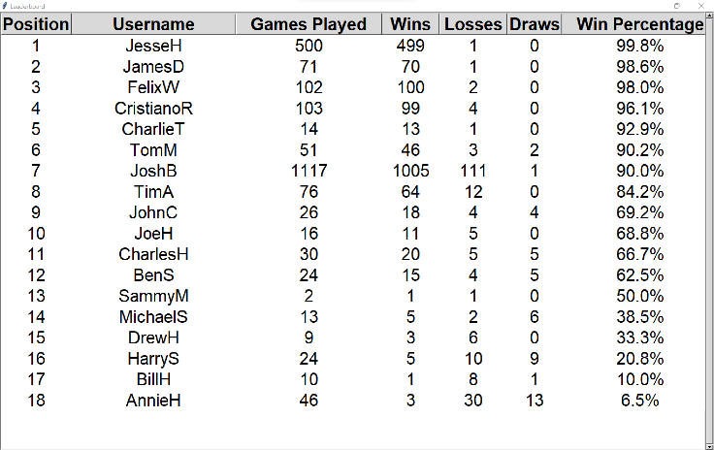

### Errors Encountered – Prototype 5

One of the main issues that I had in this prototype was when I tried to execute any SQL statement in early development. The code below just shows myself trying to access a Microsoft Access Database file that I had created.

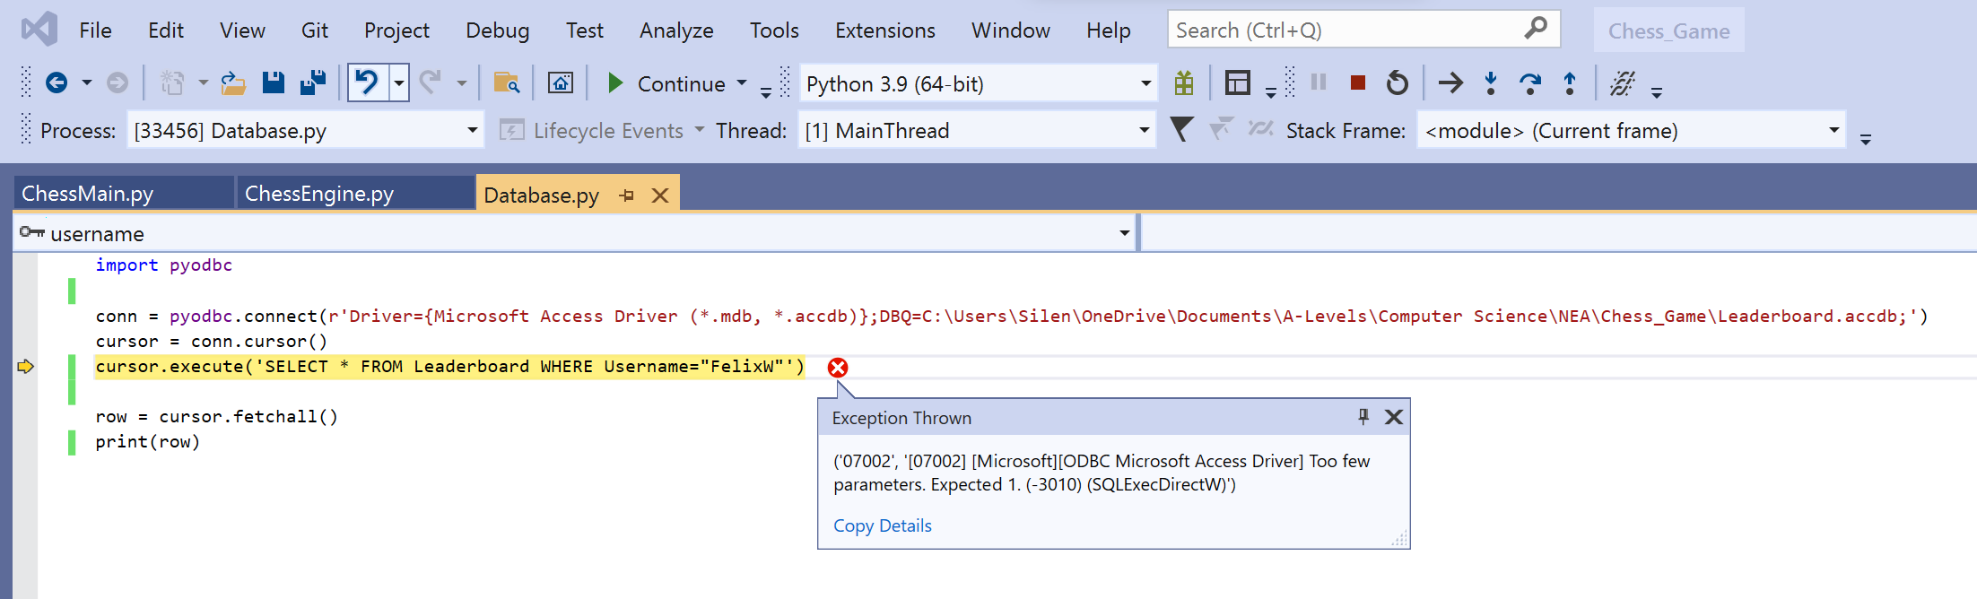

**Remedial Action**

I figured out that the solution to the problem below was to just swap the instances of the apostrophes and the speech marks.

### Flowcharts Used – Prototype 5



Leader board & Database

### Interview & Review – Prototype 5

|  |  |  |
| --- | --- | --- |
| No. | Requirements | Justification |
| 12. | The leader board will display the position numbers, usernames, games played, wins, losses, draws, and their win percentage. The table will be sorted by win percentage. | This is a useful tool for players to compare their rough skill with others on their device and to keep track of their wins. |

**Interview**

Me: What do you think about the appearance and function of the leader board?

Felix Williams: The layout is very clear and professional, and all the necessary data is presented in the leader board, which is great. The fact that the leader board can be accessed be pressing the letter “L” after a match is a great addition and the use of the scroll bar at the side of the screen is brilliant for when there are lots of users.

Me: Is there anything that needs improving within this prototype?

Felix Williams: From what I have tested and seen from this prototype; I don’t think anything needs to be changed.

Me: Overall, how do you feel with the progress I have made?

Felix Williams: Overall, I am incredibly happy with everything with this prototype and the entire game has really come together following this prototype.

## Summary of Validation

**Prototype 1**

There wasn’t any validation for drawing the main user interface of the game, but when I added the user input, there was validation needed to ensure that the user doesn’t click the same square twice, or a square that is off the board.

**Prototype 2**

There was lots of validation needed in this prototype as this made of the main rules for piece movement. Every piece has validation for ensuring that valid moves are not off the board, or a valid move cannot be capturing another ally piece. Then, only valid moves are added to the list, where the players can only play moves that are in this list.

**Prototype 3**

There was lots of validation needed in this prototype as this creates the rules for checks, checkmates, castling, and pawn promotion. Validation is important for these to ensure that the correct scenario is given when a check or checkmate occurs. Also, for castling and pawn promotion because these have specific rules for when this can be carried out. Then, only these valid moves are added to the list, where the players can only play moves that are in this list.

**Prototype 4**

Validation was needed in this section to ensure that only moves in the valid moves list with the same starting row and column as the square the user clicks on is drawn to the board for the potential moves indicator. Validation was also needed in the username system to ensure that the max characters the user could type in is 13.

**Prototype 5**

No validation needed as this prototype involved a lot of data processing using match results and drawing the leader board interface onto the screen.

# Evaluation

## Usability Testing

In this section, I will be annotating different freeze frames of the game, stating their usability features and how they could have been improved given more time or if I did more development cycles.

### Main Menu

Hovering over any of the buttons makes the outline turn green.

Username boxes allows the users to type in their usernames

Leader board button, which when clicked opens the leader board window.

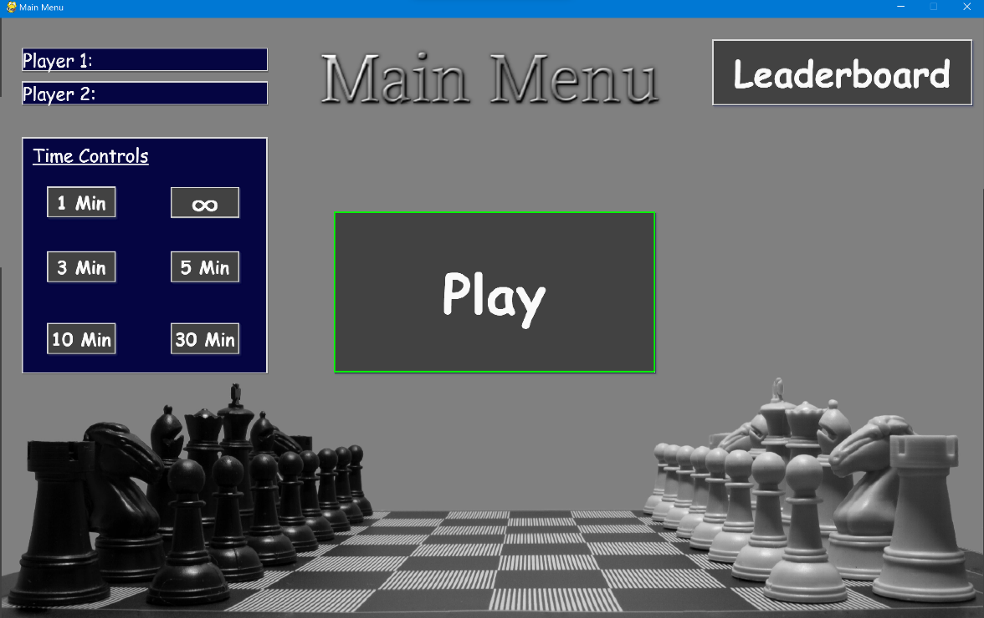

To click the play button the user must first enter two usernames and click on a time control.



Background image introduces the game that is about to be played.

Time control buttons allows the user to select one of the time control modes.

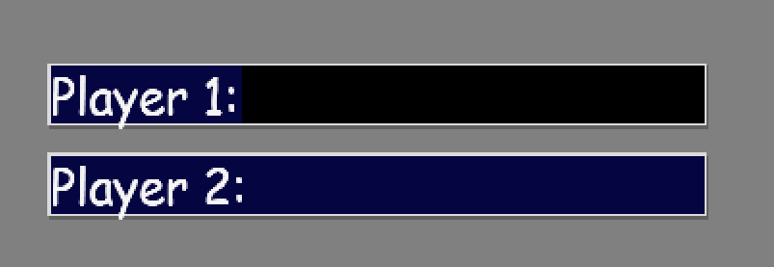

When a box is clicked, the box turns black to indicate it is selected and now it can be typed into.



**Usability Improvements**

To improve the usability of this screen, I could have included a dropdown list for the time controls instead of the buttons to make it clear which time control the users selected. Additionally, when a button is clicked it may have been better to change the colour to indicate this or designate and animation for this action.

### Main Game

Black’s time remaining is displayed, depending on the mode selected.

Black’s pieces captured and score difference is displayed.

Black’s username is displayed.

The value of each piece is displayed at the side of the board.

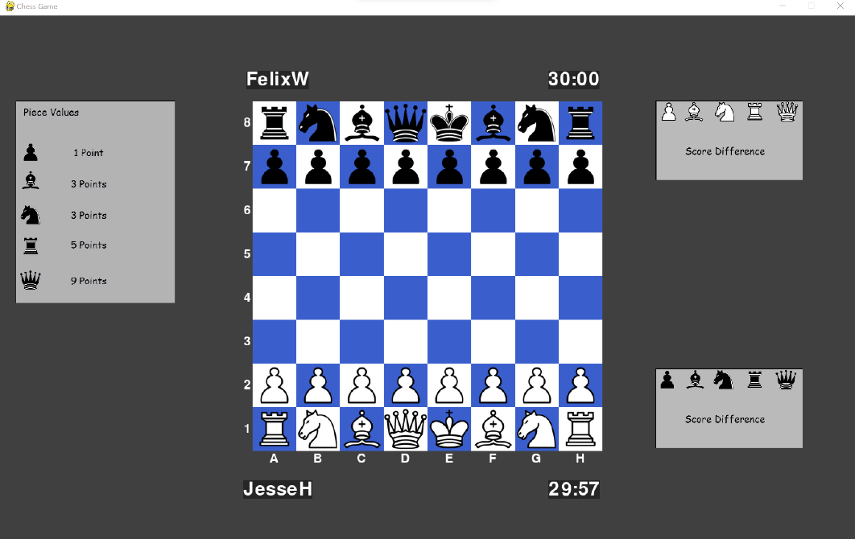

Board notation is displayed.

White’s pieces captured and score difference is displayed.

White’s time remaining is displayed, depending on the mode selected.

White’s username is displayed.

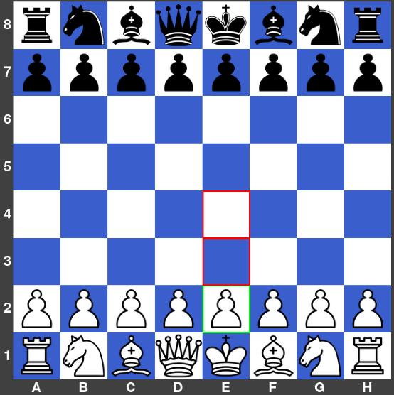

Potential moves indicator is displayed when a player clicks on one of their pieces.

**Usability Improvements**

To improve the usability of this screen, possibly the images of pieces captured should be displayed under the usernames of each player, where only the images are displayed, not the numbers. So, when more pieces are captured, they are added in order under each username. I think this would create a more professional appearance and add better function, so that the players can see what order the pieces were captured in. Additionally, the score difference could be displayed only for the person that has more combined piece value captured. For example, when a player is +5 up, the -5 wouldn’t be displayed next to the other player’s username.

### Leaderboard

Username, Games Played, Wins, Losses, Draws, and Win Percentage columns are determined by the outcome of matches played.

Position column is determined by win percentage, sorted by descending order.

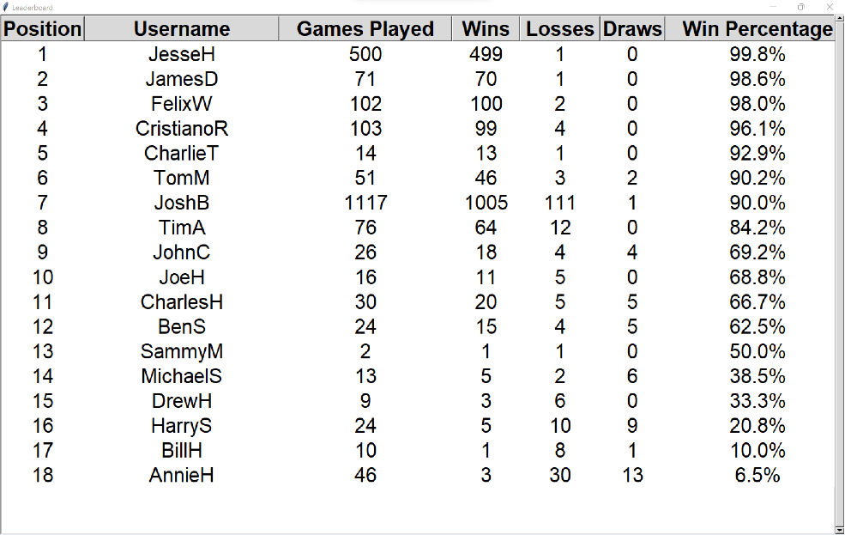

Scroll bar is attached to the side of the screen, where if there are more than 19 players, the user can scroll down to view all players statistics. There is no limit on the number of players than can be stored here.

Examples of a leader board with test data.

**Usability Improvements**

To access the leader board after a match is completed the user must press the ‘L’ button on their keyboard. A message should be displayed to the user that this can be done after a match is completed.

## Post Development TEsting & Success Criteria Evaluation

|  |  |  |  |  |  |
| --- | --- | --- | --- | --- | --- |
| Test No. | Requirements to be tested | Input/Action | Expected Outcome | Has it been met? | Evaluate/Justify |
| 1. | White pawn movement on a two square pawn advance | **Valid:** A white pawn is clicked and the square two above is clicked with both squares above are empty and it is white’s first turn.  **Invalid:** A white pawn is clicked and the square two above is clicked with one of the two squares above being occupied by another piece. | **Valid:** The white pawn moves two spaces up the board.  **Invalid:** The white pawn does not move two spaces up and stays where it is. | Requirement has been fully met. | This allows the white pawn to complete a two square advance on its first move. |
| 2. | White pawn movement on a one square pawn advance | **Valid:** A white pawn is clicked and the square above is clicked with the square above being empty.  **Invalid:** A white pawn is clicked and the square above is clicked with the square above being occupied by a piece. | **Valid:** The white pawn moves one space up the board.  **Invalid:** The white pawn does not move one space up the board and stays where it is. | Requirement has been fully met. | This allows the white pawn to complete a one square pawn advance. |
| 3. | White pawn capturing other pieces diagonally | **Valid:** A white pawn is clicked and the square above to the right is clicked with an opponent’s piece in that square.  **Invalid:** A white pawn is clicked and the square above to the right or left is clicked with an ally piece in that square. | **Valid:** The white pawn moves into the space where the piece was, and that piece is taken off the board.  **Invalid:** The white pawn does not move to that space and stays where it is. | Requirement has been fully met. | This allows the white pawn to capture other pieces through its diagonal motion. |
| 4. | White pawn ‘En Passant’ | **Valid:** Black pawn has moved two spaces down to meet white’s pawn on rank 5 and is now one square to the right of the white pawn. A white pawn is clicked on rank 5 (row 3) and the empty square up to the right is clicked.  **Invalid:** Instead, the black pawn only moves one space to meet the white pawn on the same rank. | **Valid:** The white pawn will move into that empty square and the black pawn would be removed from the board.  **Invalid:** The white pawn would not be able to capture diagonally by ‘En Passant’ | Requirement has been fully met. | This allows the white pawn to complete the ‘En passant’ rule. |
| 5. | Black pawn movement on a two square pawn advance | **Valid:** A black pawn is clicked and the square two below is clicked with both squares below being empty and it is black’s first turn.  **Invalid:** A black pawn is clicked and the square two below is clicked with one of the two squares above being occupied by another piece. | **Valid:** The black pawn moves two spaces down the board.  **Invalid:** The black pawn does not move two spaces down the board and stays where it is. | Requirement has been fully met. | This allows the black pawn to complete a two square advance on its first move. |
| 6. | Black pawn movement on a one square pawn advance | **Valid:** A black pawn is clicked, and the square below is clicked with the square below being empty.  **Invalid:** A black pawn is clicked, and the square below is clicked with the square below being occupied by a piece. | **Valid:** The black pawn moves one space down the board.  **Invalid:** The black pawn does not move one space down the board and stays where it is. | Requirement has been fully met. | This allows the black pawn to complete a one square pawn advance. |
| 7. | Black pawn capturing other pieces diagonally | **Valid:** A black pawn is clicked and the square above to the right is clicked with an opponent’s piece in that square.  **Invalid:** A black pawn is clicked and the square below to the right is clicked with an ally piece in that square. | **Valid:** The black pawn moves into the space where the piece was, and that piece is taken off the board.  **Invalid:** The black pawn does not move to that space and stays where it is. | Requirement has been fully met. | This allows the black pawn to capture other pieces through its diagonal motion. |
| 8. | Black pawn ‘En Passant’ | **Valid:** A white pawn has moved two spaces up to meet black’s pawn on rank 4 and is now one square to the right of the black pawn. The black pawn is clicked on rank 4 (row 4) and the empty square down to the right is clicked.  **Invalid:** Instead, the white pawn only moves one space to meet the black pawn on the same rank. | **Valid:** The black pawn will move into that empty square and the black pawn would be removed from the board.  **Invalid:** The black pawn would not be able to capture diagonally by ‘En Passant’ | Requirement has been fully met. | This allows the black pawn to complete the ‘En passant’ rule. |
| 9. | Rook movement | **Valid:** A rook is clicked, and another square (empty) is clicked any number of spaces to the left, right, up, or down and in between the empty square that is clicked and the rook there is no pieces in the way.  **Invalid:** A rook is clicked, and another square is clicked any number of spaces to the left, right, up, or down and in between the empty square that is clicked and the rook there is a piece in the way. | **Valid:** The rook moves to that empty space.  **Invalid:** The rook does not move to that empty space. | Requirement has been fully met. | This allows the rook to move around the board using its horizontal and vertical directions. |
| 10. | Rook capturing other pieces | **Valid:** A rook is clicked, and another square is clicked (with an enemy piece in that square) any number of spaces to the left, right, up, or down and in between the occupied square that is clicked and the rook there is no pieces in the way.  **Invalid:** A rook is clicked, and another square is clicked (with an enemy piece in that square) any number of spaces to the left, right, up, or down and in between the occupied square that is clicked and the rook there is a piece in the way. | **Valid:** The rook moves into that square and the enemy piece is taken off the board.  **Invalid:** The rook does not move to that square and stays where it is. | Requirement has been fully met. | This allows the rook to capture enemy pieces using its horizontal and vertical directions. |
| 11. | Bishop Movement | **Valid:** A bishop is clicked, and another square (empty) is clicked any number of spaces diagonally to the top-left, top-right, bottom-left, or bottom-right and in between the empty square that is clicked and the bishop there is no pieces in the way.  **Invalid:** A bishop is clicked, and another square is clicked any number of spaces diagonally to the top-left, top-right, bottom-left, or bottom-right and in between the empty square that is clicked and the bishop there is a piece in the way. | **Valid:** The bishop moves to that empty space.  **Invalid:** The bishop does not move to that empty space. | Requirement has been fully met. | This allows the bishop to move around the board using its diagonal directions. |
| 12. | Bishop capturing other pieces | **Valid:** A bishop is clicked, and another square is clicked (with an enemy piece in that square) any number of spaces diagonally to the top-left, top-right, bottom-left, or bottom-right and in between the occupied square that is clicked and the bishop there is no pieces in the way.  **Invalid:** A bishop is clicked, and another square is clicked (with an enemy piece in that square) any number of spaces diagonally to the top-left, top-right, bottom-left, or bottom-right and in between the occupied square that is clicked and the bishop there is a piece in the way. | **Valid:** The bishop moves into that square and the enemy piece is taken off the board.  **Invalid:** The bishop does not move to that square and stays where it is. | Requirement has been fully met. | This allows the bishop to capture other pieces using its diagonal directions. |
| 13. | Queen movement | **Valid:** A queen is clicked, and another square (empty) is clicked any number of spaces diagonally, vertically, or horizontally and in between the empty square that is clicked and the queen there is no pieces in the way.  **Invalid:** A queen is clicked, and another square is clicked any number of spaces diagonally, vertically, or horizontally and in between the empty square that is clicked and the bishop there is a piece in the way. | **Valid:** The queen moves to that empty space.  **Invalid:** The queen does not move to that empty space. | Requirement has been fully met. | This allows the queen to move around the board using its horizontal, vertical, and diagonal directions. |
| 14. | Queen capturing other pieces | **Valid:** A queen is clicked, and another square is clicked (with an enemy piece in that square) any number of spaces diagonally, vertically, or horizontally and in between the occupied square that is clicked and the queen there is no pieces in the way.  **Invalid:** A queen is clicked, and another square is clicked (with an enemy piece in that square) any number of spaces diagonally, vertically, or horizontally and in between the occupied square that is clicked and the queen there is a piece in the way. | **Valid:** The queen moves into that square and the enemy piece is taken off the board.  **Invalid:** The queen does not move to that square and stays where it is. | Requirement has been fully met. | This allows the queen to capture other pieces using its horizontal, vertical, and diagonal directions. |
| 15. | Knight movement | **Valid:** A knight is clicked, and another square (empty) is clicked that forms an L shape with the knight.  **Invalid:** A knight is clicked, and another square is clicked that does not form an L shape with the knight. E.g., The square one above the knight. | **Valid:** The knight moves to that empty space.  **Invalid:** The knight does not move to that empty space. | Requirement has been fully met. | This allows the knight to move around the board in an ‘L’ shape. |
| 16. | Knight capturing other pieces | **Valid:** A knight is clicked, and another square (with an enemy piece in that square) is clicked that forms an L shape with the knight.  **Invalid:** A knight is clicked, and another square (with an ally piece) is clicked that forms an L shape with the knight. E.g., The square one above the knight. | **Valid:** The knight moves into that square and the enemy piece is taken off the board.  **Invalid:** The knight does not move to that empty space. | Requirement has been fully met. | This allows the knight to capture other pieces using its ‘L’ shape movement. |
| 17. | King movement | **Valid:** A king is clicked, and another square (empty) is clicked that is anywhere within one space of the king and there is no enemy pieces that are able to move to those squares.  **Invalid:** A square outside the radius of one square is attempted to be reached.  **Invalid:** The square the king is trying to get to is guarded by an enemy piece.  **Invalid:** The square the king is trying to get to has an ally piece already in that square. | **Valid:** The king moves to that empty space.  **Invalid:** The king does not move to that empty space. | Requirement has been fully met. | This allows the king to move around the board within one square. |
| 18. | King capturing other pieces | **Valid:** A king is clicked, and another square (with an enemy piece in it) is clicked anywhere within one space of the king and that piece is not guarded by another enemy piece.  **Invalid:** The piece the king is attempting to capture is guarded by another enemy piece. | **Valid:** The king moves into that square and the enemy piece is taken off the board.  **Invalid:** The king does not move to that square. | Requirement has been fully met. | This allows the king to capture other pieces that are within one square. |
| 19. | Checks | **Valid:** A piece is moved to a square where it can then capture the enemy king on the next turn. E.g. The bishop moves to a square that is on the same diagonal as the enemy king with no pieces in the way.  **Invalid:** When instead there is a piece in the way. | **Valid:** The screen displays “Check!” and now the enemy can only do moves that involve getting the king out of check. E.g. Moving the king off that diagonal.  **Invalid:** Nothing would be displayed. | Requirement has been fully met. | This allows checks to be carried out on each player. |
| 20. | Checkmate | **Valid:** When a check is carried out, but the king cannot move anywhere, and nothing can block or capture the piece that is checking the king.  **Invalid:** When a check is carried out and the king is able to get out of check. | **Valid:** The screen displays “Checkmate!” and now the game is over.  **Invalid:** Nothing is displayed. | Requirement has been fully met. | This allows checkmates to be carried out on each player to give a goal for the game. |
| 21. | Stalemate | **Valid:** When the king cannot move anywhere, and no other ally piece cannot be moved.  **Invalid:** When the king has no moves, but there are other moves that can be played. | **Valid:** The screen displays “Stalemate!” and now the game is a draw.  **Invalid:** Nothing is displayed. | Requirement has been fully met. | This allows a stalemate to be performed where the game end in a draw. |
| 22. | Castling to the Queen’s side | **Valid:** The king is clicked and the square two to the left is clicked. For this to be valid castle, the squares in between the left rook and the king must all be empty and the two squares to the left of the king must not be guarded by any of the enemy’s pieces.  **Invalid:** The king is clicked and the square two to the left is clicked, but there is a knight between the king and the rook. | **Valid:** The king moves two spaces to the left and the left rook moves to the square on the right of the king’s new position.  **Invalid:** The king and the rook do not move anywhere. | Requirement has been fully met. | This allows the players to utilise castling towards the queen’s side. |
| 23. | Castling to the King’s side | **Valid:** The king is clicked and the square two to the left is clicked. For this to be valid castle, the squares in between the left rook and the king must all be empty and the two squares to the left of the king must not be guarded by any of the enemy’s pieces.  **Invalid:** The king is clicked and the square two to the left is clicked, but there is a knight between the king and the rook. | **Valid:** The king moves two spaces to the left and the left rook moves to the square on the right of the king’s new position.  **Invalid:** The king and the rook do not move anywhere. | Requirement has been fully met. | This allows the players to utilise castling towards the king’s side. |
| 24. | Pawn promotion | **Valid:** A pawn that is on the second to last row is clicked and the square (empty) on the last row is clicked.  **Valid:** Instead of moving forwards to promote, the pawn can also capture diagonally to reach the last row.  **Invalid:** There is a piece in the way of the pawn, and it cannot capture anything. | **Valid:** The pawn can promote to a queen.  **Invalid:** The pawn cannot promote. | Requirement has been fully met. | This allows the players to promote their pawns to a queen when one reaches the back rank. |
| 25. | Main menu play button | **Valid:** The user left clicks the button.  **Invalid:** The user right clicks the button. | **Valid:** The button becomes no longer outlined in green and the user is taken to the main game window.  **Invalid:** Does not do anything. | Requirement has been fully met. | This allows the user to travel to the main game window. |
| 26. | Main menu leader board button | **Valid:** The user left clicks the button.  **Invalid:** The user right clicks the button. | **Valid:** The button becomes outlined in red and the user is taken to the leader board window.  **Invalid:** Does not do anything. | Requirement has been fully met. | This allows the user to travel to the leader board window. |
| 27. | Main menu username input boxes | **Valid:** The user types in a username of maximum 13 characters.  **Invalid:** The user types in a username of over 13 characters. | **Valid:** When the play button is pressed the user is taken to the main game.  **Invalid:** Asks the user to type in a username of valid length. | Requirement has been fully met. | This allows the users to type in their usernames which is validated to only allow up to 13 characters. |
| 28. | Main menu time control buttons | **Valid:** The user left clicks the button.  **Invalid:** The user right clicks the button. | **Valid:** The button becomes outlined in red.  **Invalid:** Does not do anything. | Requirement has been fully met. | This allows the users to select a time control mode that they would like to play. |
| 29. | Hovering over buttons | **Valid:** The user hovers the mouse cursor over a button. | **Valid:** The button becomes outlined in green. | Requirement has been fully met. | This gives a visual indicator of what the mouse is selecting. |
| 30. | User Input | **Valid:** The user clicks on any piece and moves it anywhere without considering movement rules.  **Invalid:** The user clicks off the board. | **Valid:** The piece moves to that square.  **Invalid:** Nothing should happen. | Requirement has been fully met. | This forms the basis of how the users move their pieces, which is then validated depending on the piece selected later. |
| 31. | Piece movement sound | **Valid:** The user moves a piece. | **Valid:** Plays the piece movement sound. | Requirement has not been met. | This was not implemented purely due to the time constraints on the project, where if I did another development cycle, this could have been implemented. I would have done this by finding a sound file that matches my requirements and then play this sound every time that the user moves a piece. |
| 32. | Piece capturing sound | **Valid:** The user captures an enemy piece. | **Valid:** Plays the piece capturing sound. | Requirement has not been met. | This was not implemented purely due to the time constraints on the project, where if I did another development cycle, this could have been implemented. I would have done this by finding a sound file that matches my requirements and then play this sound every time that the user captures an enemy piece. |
| 33. | Checkmate sound | **Valid:** One player checkmates the other. | **Valid:** Plays the checkmate sound. | Requirement has not been met. | This was not implemented purely due to the time constraints on the project, where if I did another development cycle, this could have been implemented. I would have done this by finding a sound file that matches my requirements and then play this sound when a checkmate occurs. |
| 34. | Check sound | **Valid:** One player checks the other. | **Valid:** Plays the check sound. | Requirement has not been met. | This was not implemented purely due to the time constraints on the project, where if I did another development cycle, this could have been implemented. I would have done this by finding a sound file that matches my requirements and then play this sound when a check occurs. |
| 35. | Illegal move sound | **Valid:** The user attempts to make an illegal move. | **Valid:** Plays an error sound | Requirement has not been met. | This was not implemented purely due to the time constraints on the project, where if I did another development cycle, this could have been implemented. I would have done this by finding a sound file that matches my requirements and then play this sound when one of the players attempts to make an illegal move. |
| 36. | Time controls | **Valid:** The user clicks on the 1-minute button in the main menu.  **Invalid:** Nothing is selected on the main menu. | **Valid:** The timers in the game are set to 1 minute and white’s starts counting down immediately.  **Invalid:** The user can’t progress into the game. | Requirement has been fully met. | This allows the users to select a time control option to be used in game. |
| 37. | Score difference | **Valid:** Player 1 captures a pawn. | **Valid:** Player 1’s score difference increases by 1. | Requirement has been fully met. | This allows the score difference to be displayed when a player captures an enemy piece. This is updated in real-time and the pieces that are captured throughout the game is also displayed. |
| 38. | Potential moves indicator | **Valid:** Player 1 (white) clicks on a white pawn.  **Invalid:** Player 1 (white) clicks on a black pawn. | **Valid:** Highlights valid moves in red and highlights pawn in green.  **Invalid:** No highlighting should be displayed. | Requirement has been fully met. | The functionality of this indicator has been fully met, allowing all possible valid moves to be displayed for each piece that is clicked on by a player. |
| 39. | Leader board system | **Valid:** Player 1 won against player 2.  **Valid:** Player 1 drew against player 2. | **Valid:** Player 1’s games played, and wins are increased by 1. Player 2’s games played, and losses are increased by 1. Updated leader board is displayed with position, username, games played, wins, losses, draws and win percentage as columns.  **Valid:** Player 1’s and player 2’s games played, and draws are increased by 1. Updated leader board is displayed with position, username, games played, wins, losses, draws and win percentage as columns. | Requirement has been fully met. | This allows the users to view their statistics from the main menu or after each game played. This is updated in real-time. |
| 40. | Back and restart match buttons | **Valid:** User clicks the back button whilst playing.  **Valid:** User clicks the restart match button whilst playing. | **Valid:** The user must confirm their action again.  **Valid:** The board resets to its starting form. | Requirement has not been met. | This feature has not been implemented due to the time constraints of the project. However, if I were to continue development this would be implemented by using two images of ‘back’ and ‘restart’ buttons, where if the mouse collides with these images and the mouse is left-clicked, it would either go back to the main menu or restart the current match with the same settings. |

## Maintenance

### Current & Future Maintenance

I have not created any features to aid the maintenance of the game, however if this software was to be distributed professionally it would need a feature that allows users to easily download updates into the game. This could be in the form of a button on the main menu screen that compares the local version of the software to the most up to date version. Then, the correct version can be installed on to the computer if the user has the wrong version. The updates themselves could consist of extra features being added to the game to keep the game enjoyable for the target audience or implementing patches that fix potential bugs. There could also be a feature that allows the user to report bugs, which could be in the form of a button on the main menu that creates a window allowing the user to type in a description of the bug.

### Limitations and How They Could Be Approached

|  |  |
| --- | --- |
| Requirement | Justification |
| Pawn can be promoted to a bishop, rook, knight, or queen when reaching the bank rank. | This would add extra realism to the game as this is possible in standard chess rules, but never usually desired. |

To complete this requirement, I would add in a new visual feature when a pawn reaches the bank rank, where a box appears on the screen, displaying the images of a bishop, rook, knight, and queen. This would mean that the player must click on one of these images to promote the pawn and there would be validation in place so that no other actions can be completed until an image is clicked.

|  |  |
| --- | --- |
| Requirement | Justification |
| When a piece is pinned, there could be an animation where the square beneath it lights up for a temporary time frame. | This would be beneficial for newer players, as sometimes there are too many things to keep track of during a match. |

To complete this requirement, I would add in some code that finds pieces that when moves cause their own king to be in check. This would be a sign that a piece in pinned. The next thing to be implemented would then be a visual feature that causes the square underneath these pieces to light up. The colour of this could possibly be a yellow.

|  |  |
| --- | --- |
| Requirement | Justification |
| An indicator for what the last move that was played during the game. | This would be a helpful usability feature that could help newer players. |

To complete this requirement, all I would need to do is draw a box around the square that the last piece moved came from then the current square. This could be a grey colour.

|  |  |
| --- | --- |
| Requirement | Justification |
| Add an online mode so that players can play against each other using different devices. | This would be a great feature to allow people to play against each other whilst using different devices even on a different network. |

To complete this requirement, I would need to do some research about how I could implement a peer-to-peer connection using python, then some of my current code would need to be adapted to allow the input from a secondary device to be used in the game.

|  |  |
| --- | --- |
| Requirement | Justification |
| Add a different chess mode, such as chess 960. | This would be a great feature to ensure that the target audience is continued to be entertained and allows them to try different modes of chess. |

Chess 960 is where the pieces on the back rank are randomized to an extent where some rules must be applied. When randomizing, the bishops must still be on opposite colour squares and the king must be between the rooks. Therefore, to complete this requirement, I would need to add in some code that randomizes the pieces but also ensures these rules are met. However, the way this mode functions mostly remains the same as standard chess. The only thing that would need adapting in my code is how castling works in chess 960.

|  |  |
| --- | --- |
| Requirement | Justification |
| Allow the user to choose the colour scheme and style of the board and pieces. | This feature would give the user some choice into the appearance of their chess experience, improving the usability. |

To complete this requirement, I would need to add a button on the main menu, which when clicked opens a window to view all the different board colours and styles of pieces, where the user can select the one they like. This option would then be drawn to the screen. The board colours is easy to change, but the images of the pieces would require some more research to find board pieces that are of good quality and are the same shape and size as my current images.

# Project Source Code

## Main Chess File

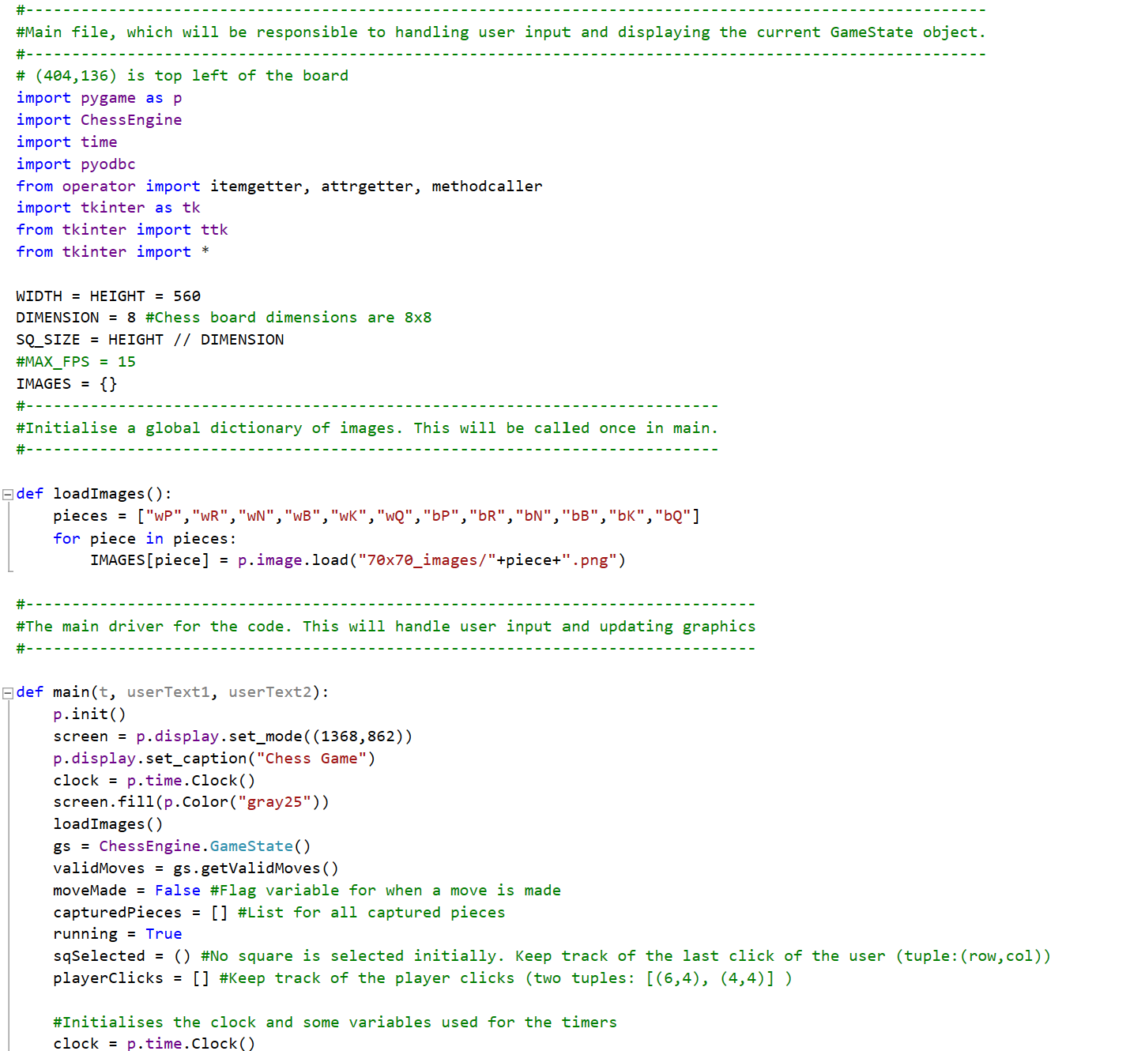

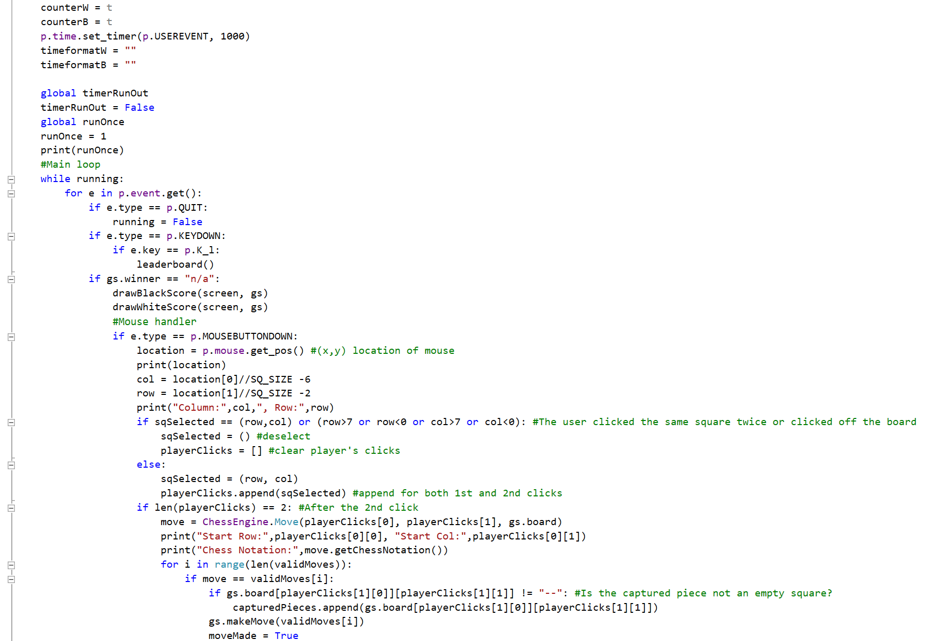

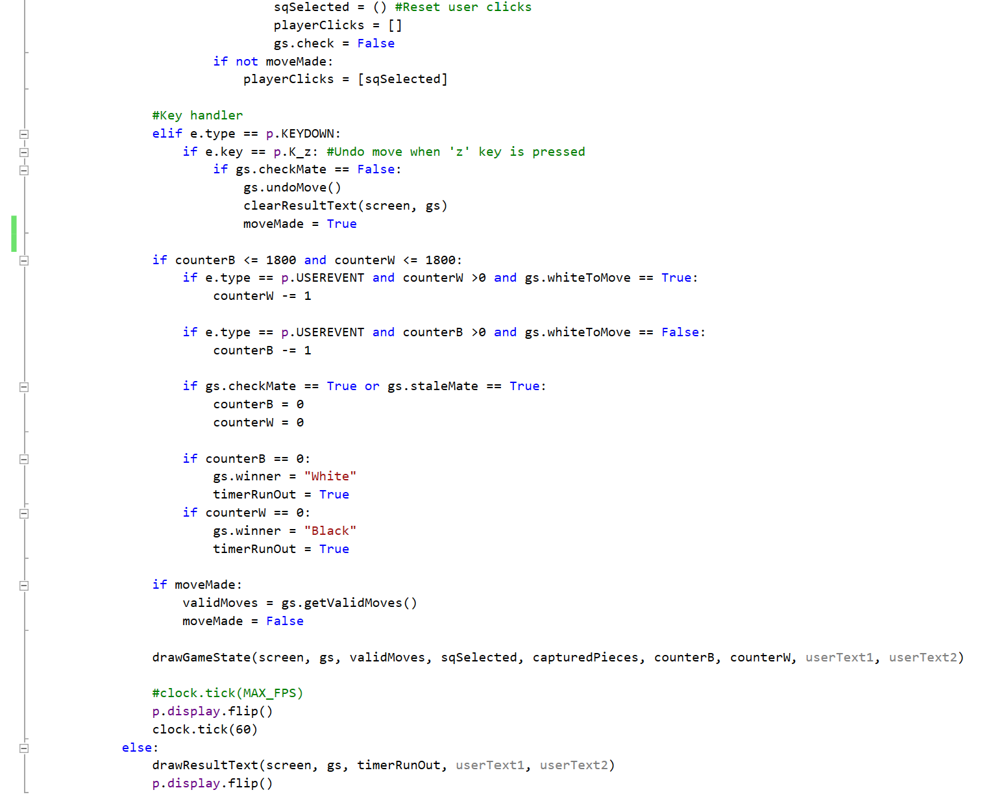

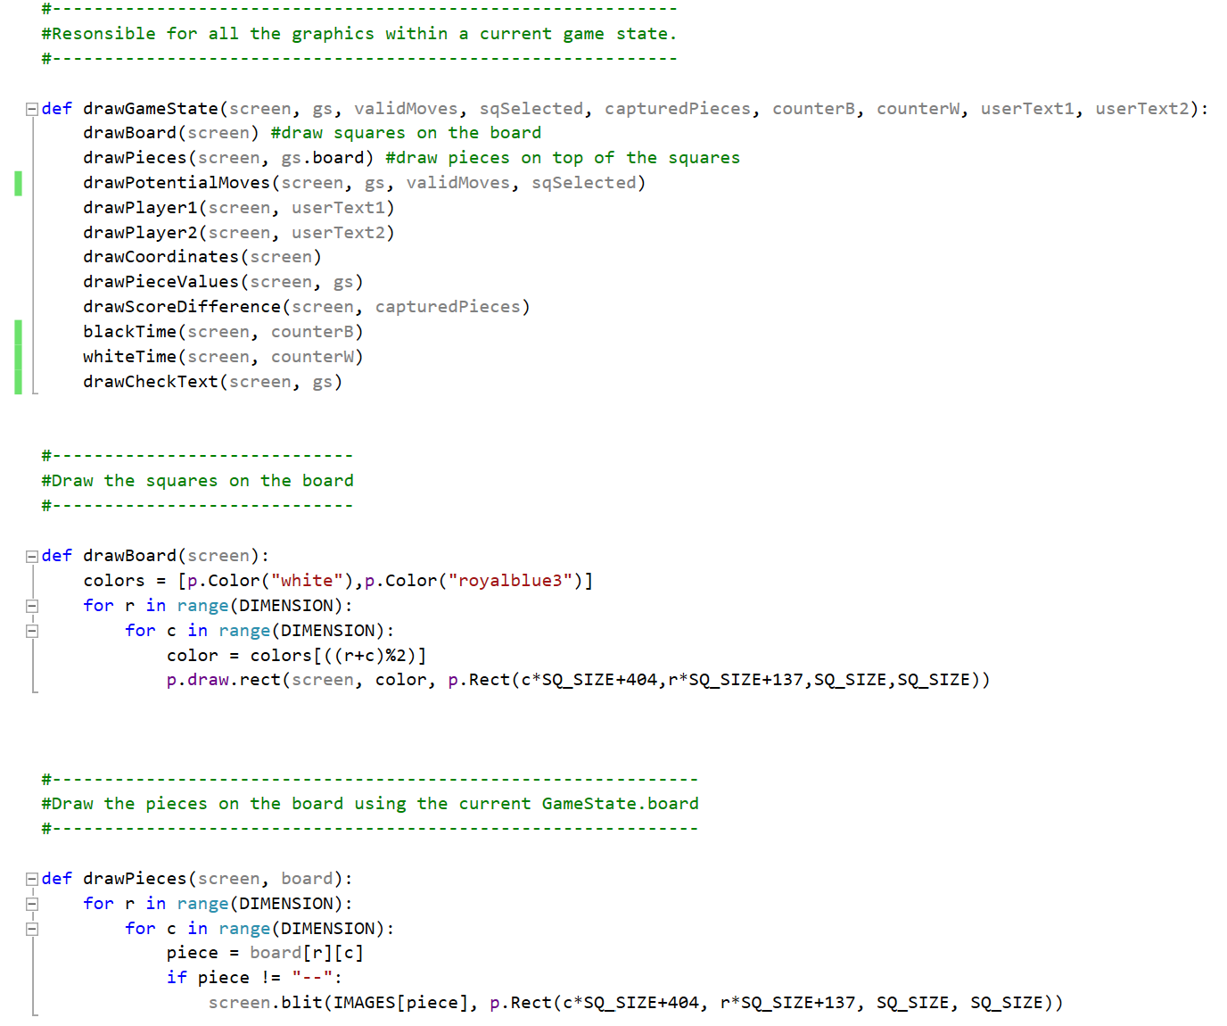

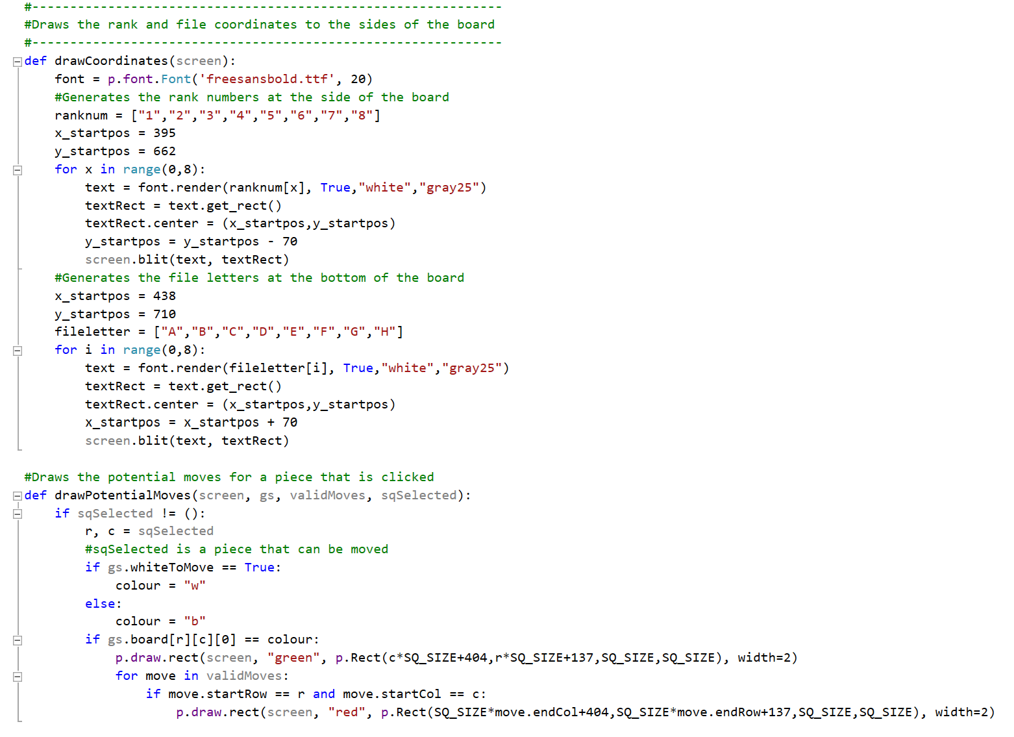

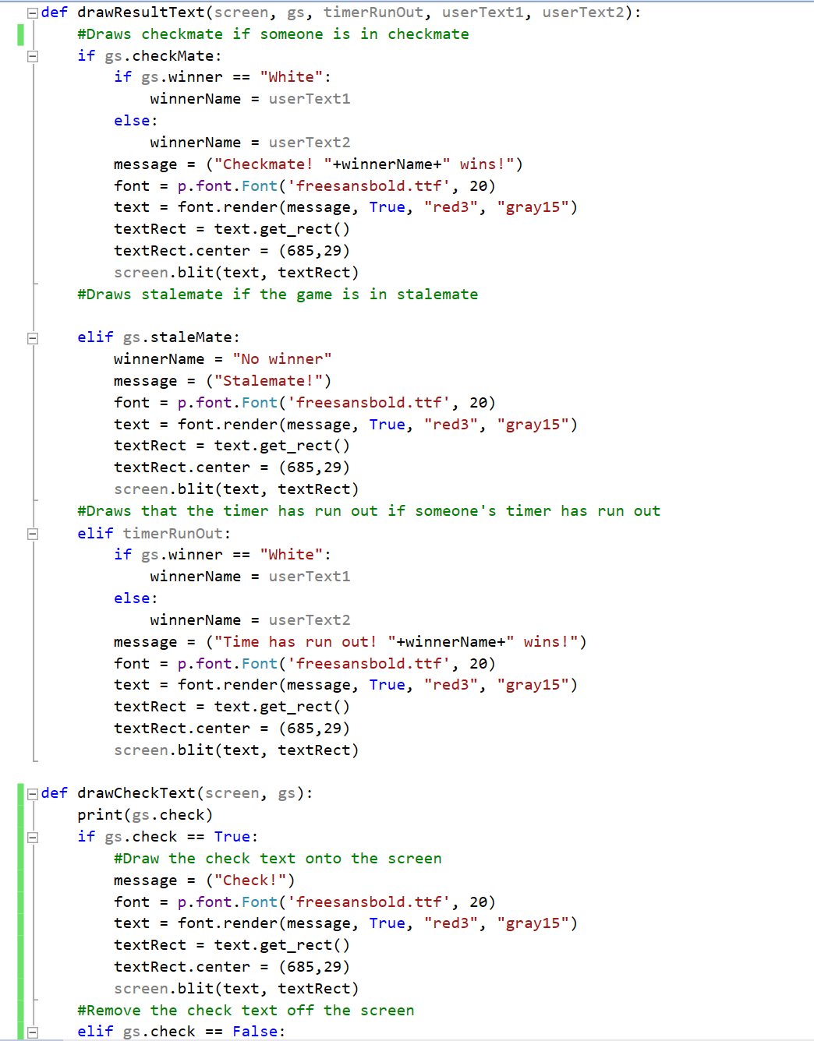

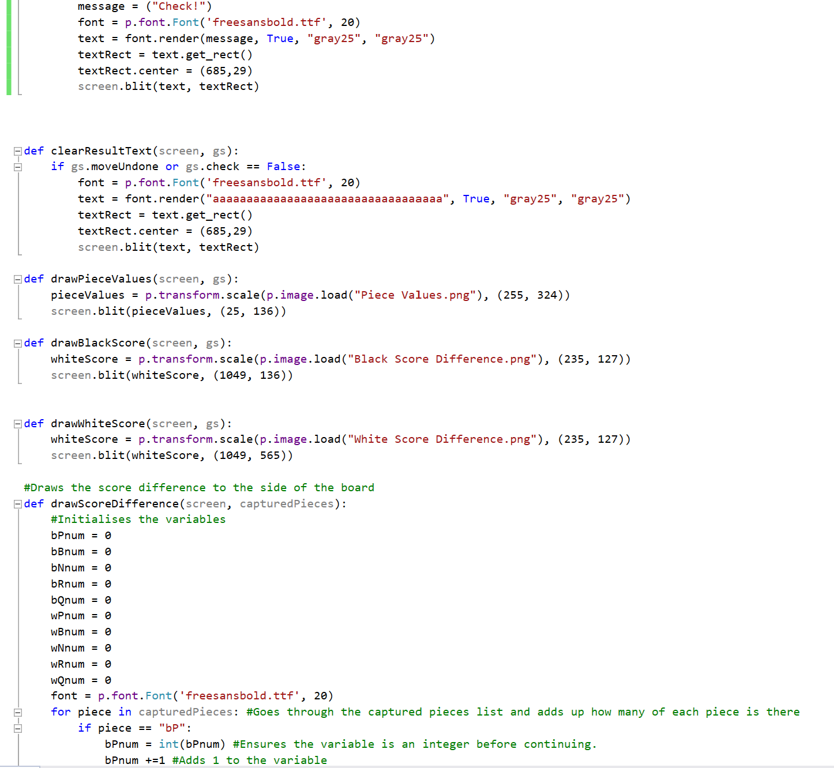

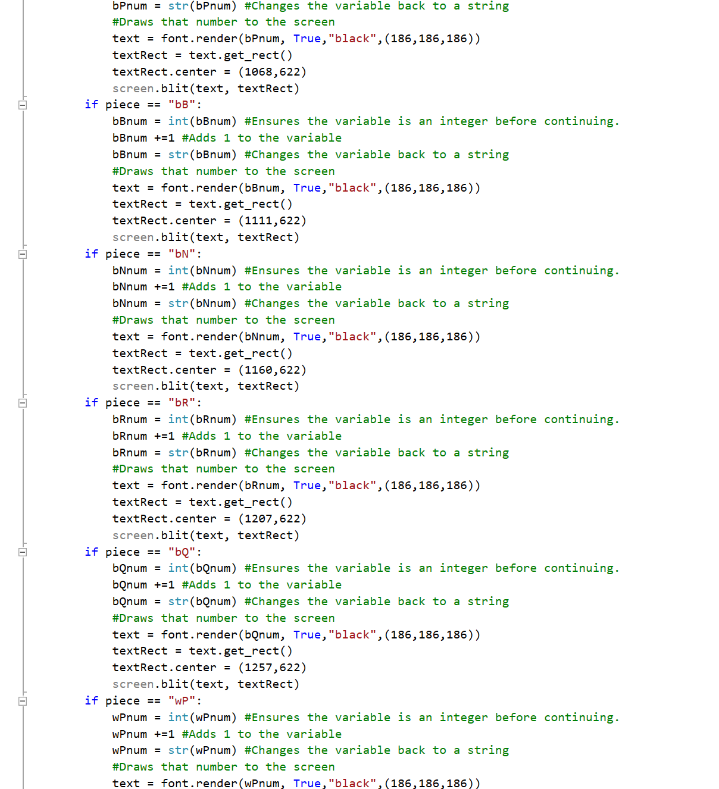

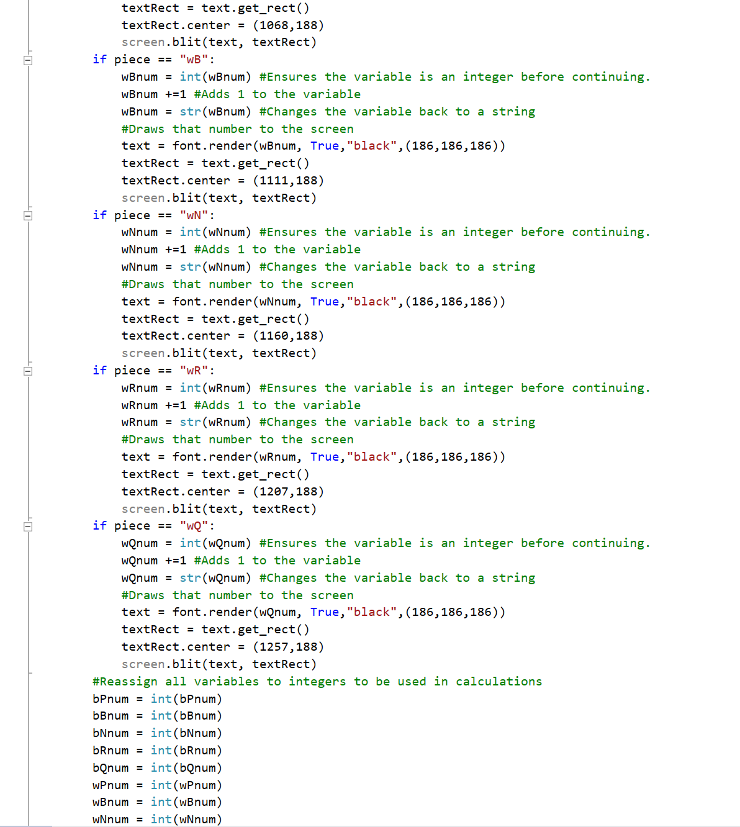

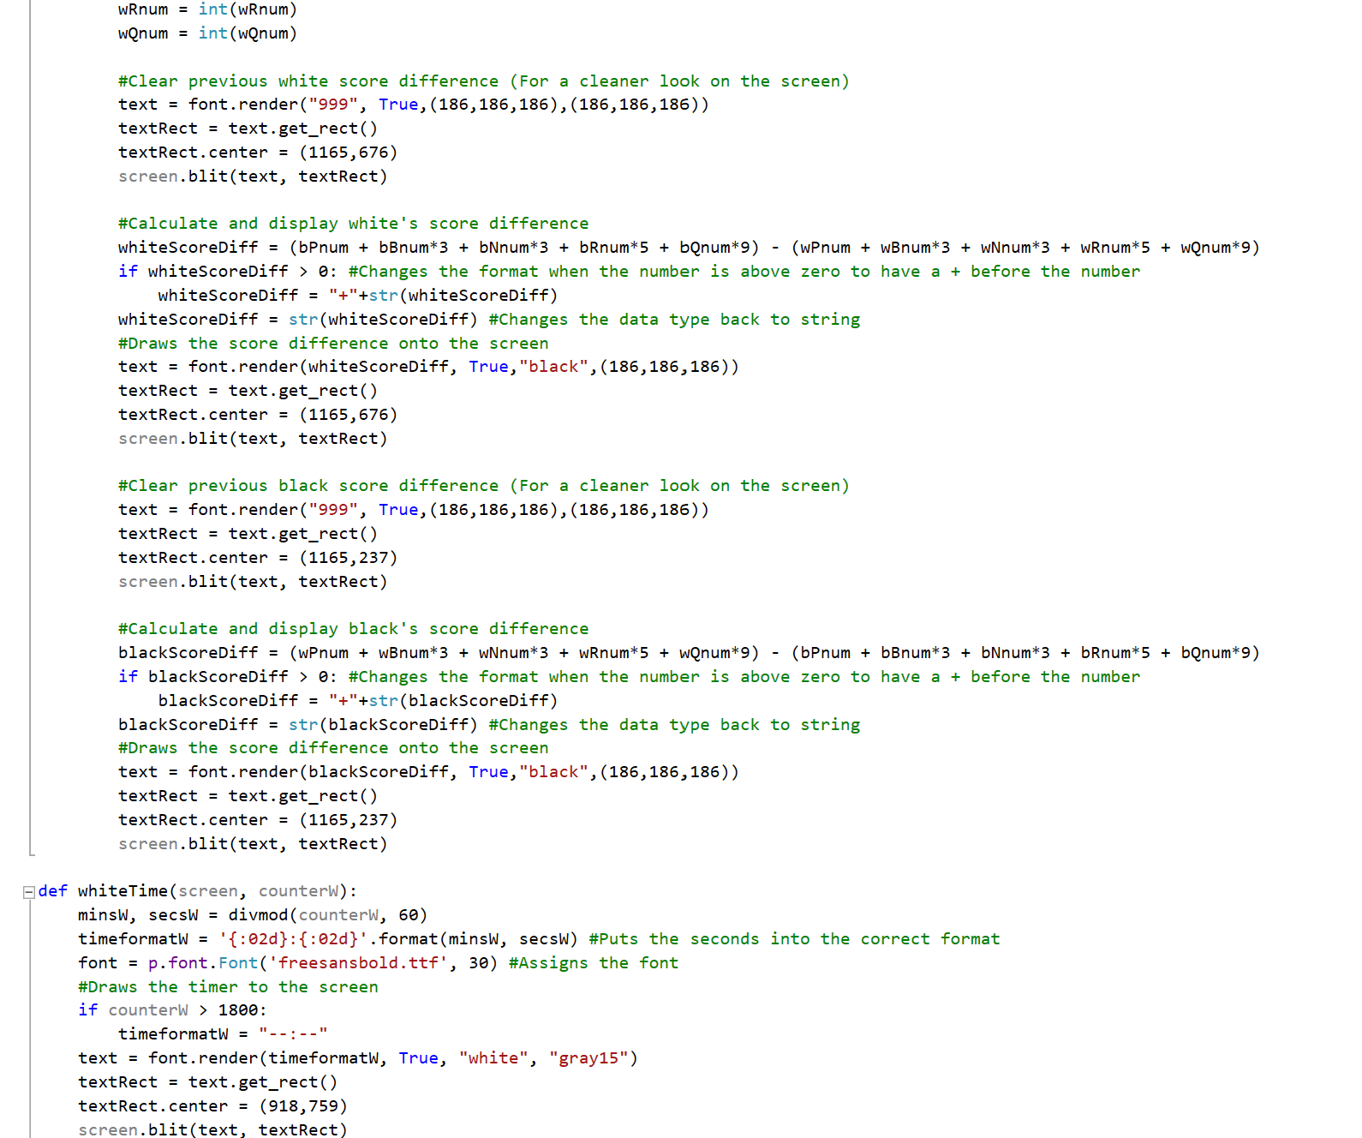

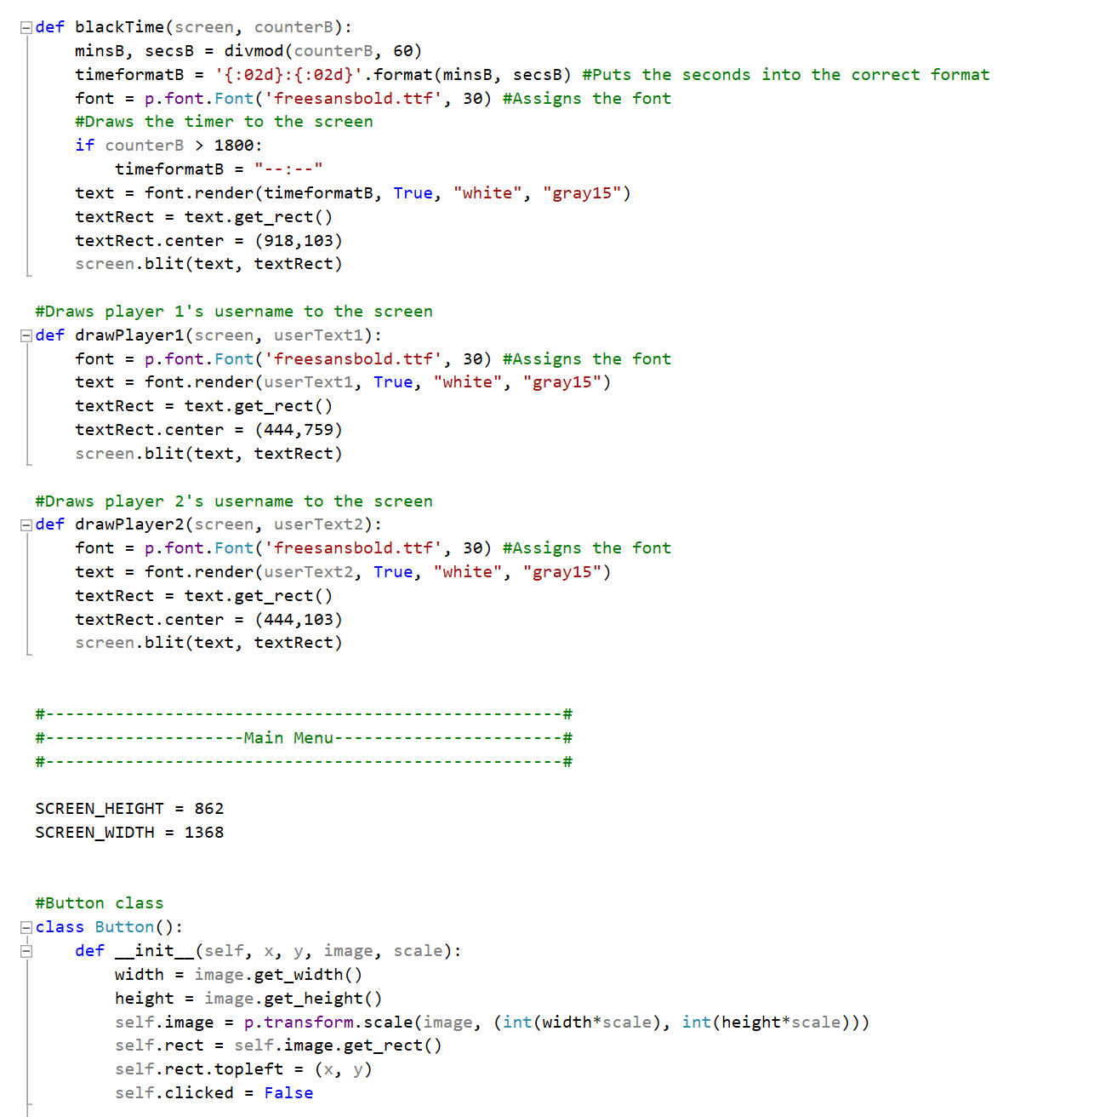

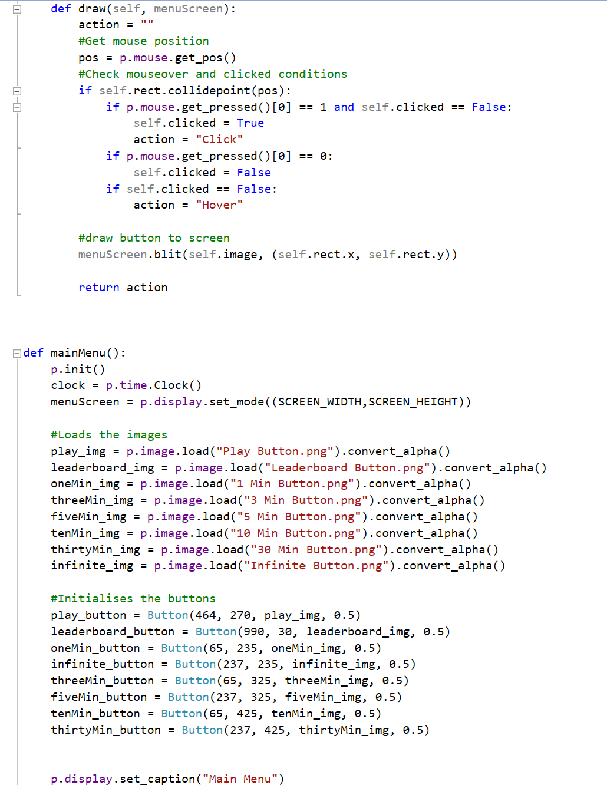

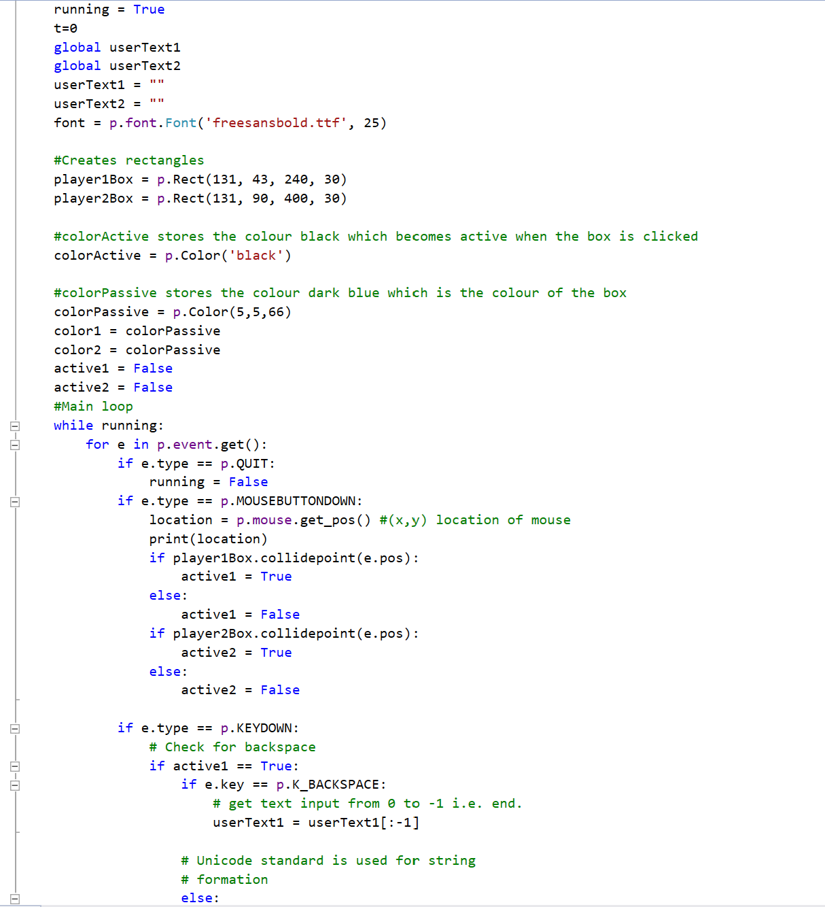

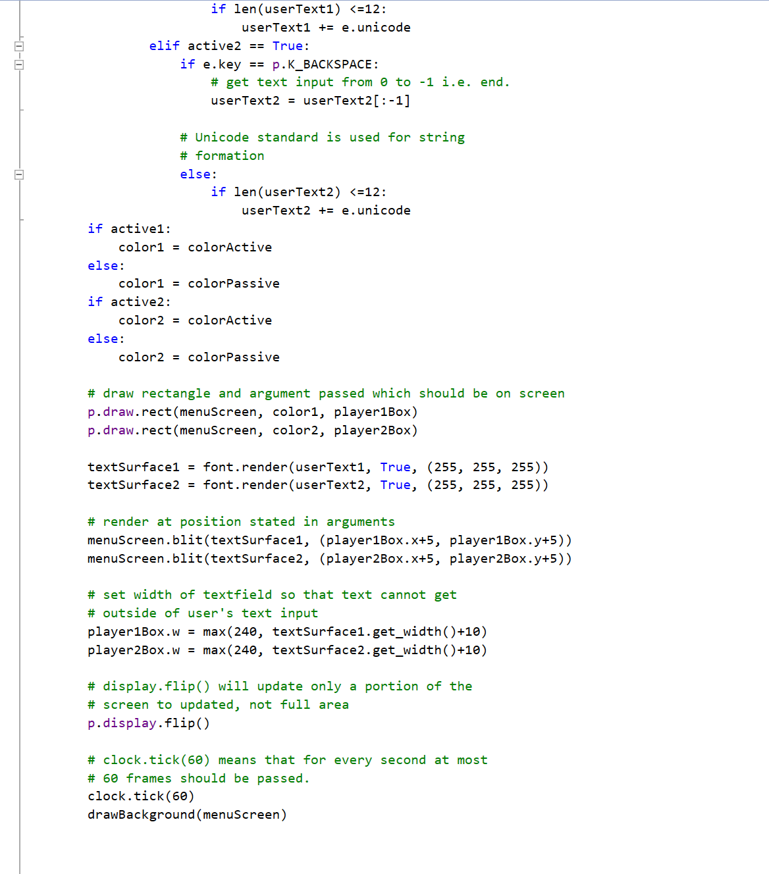

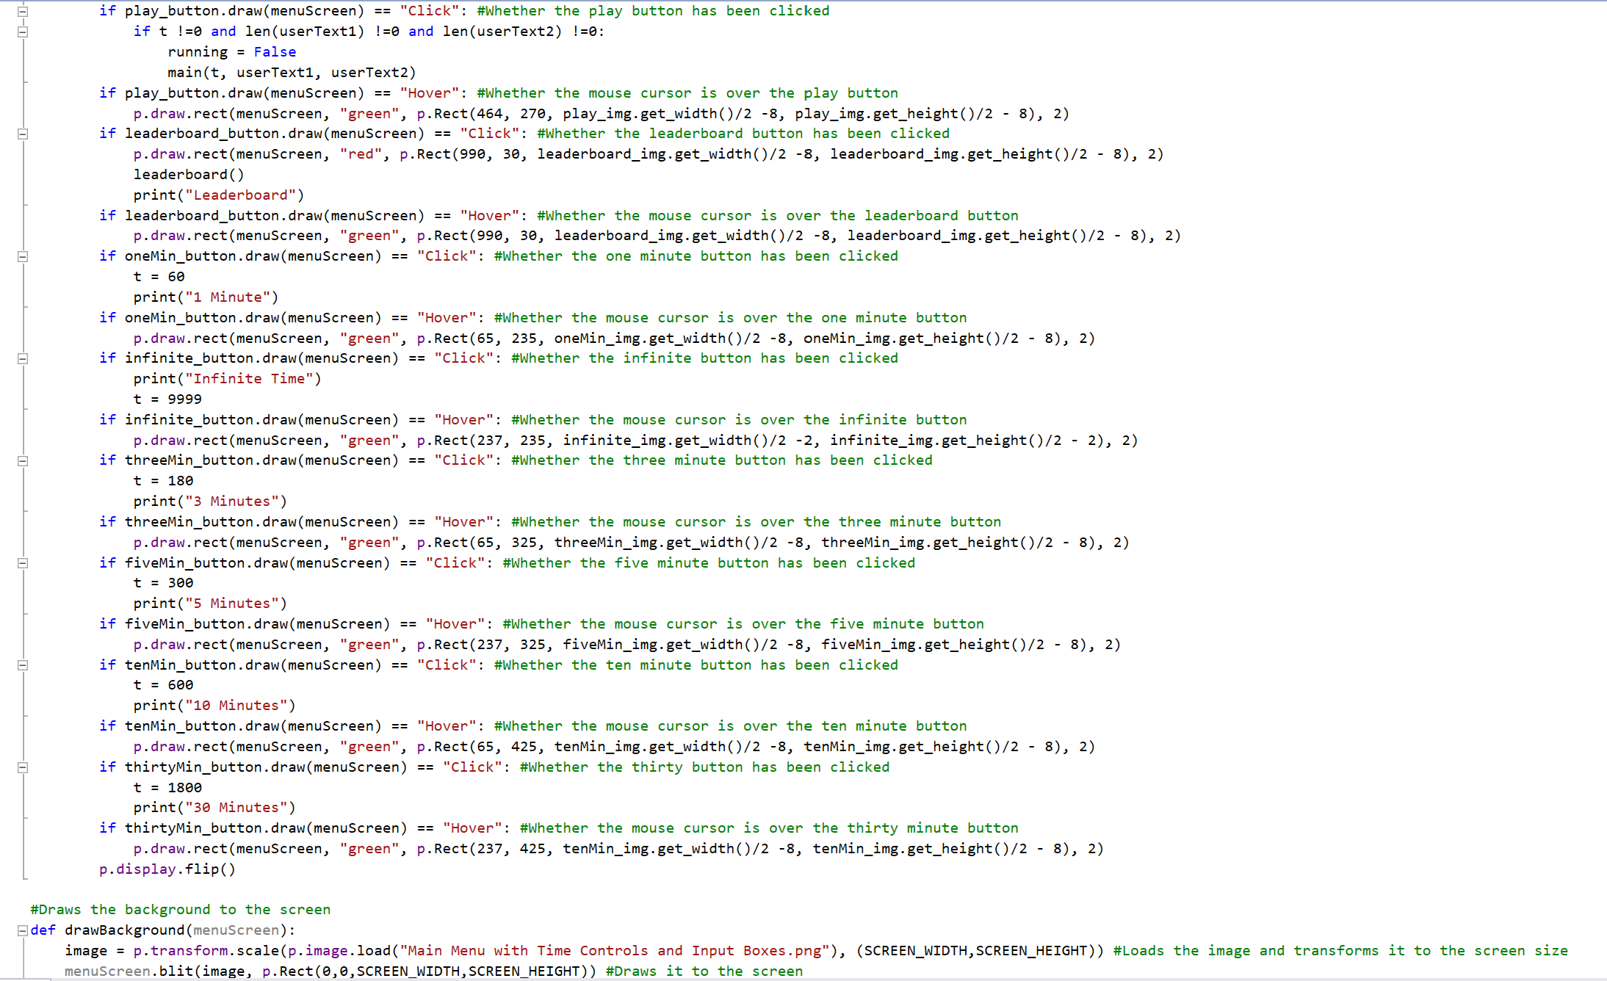

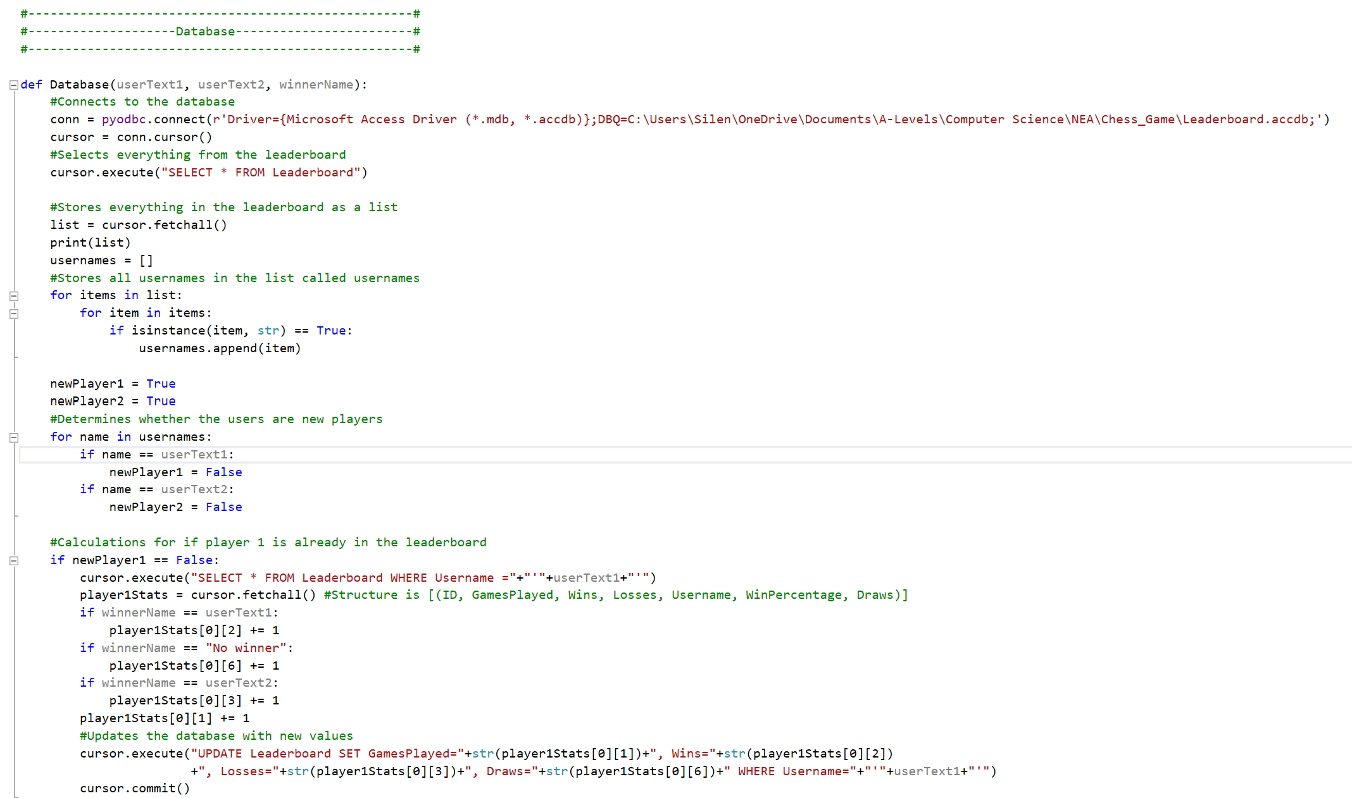

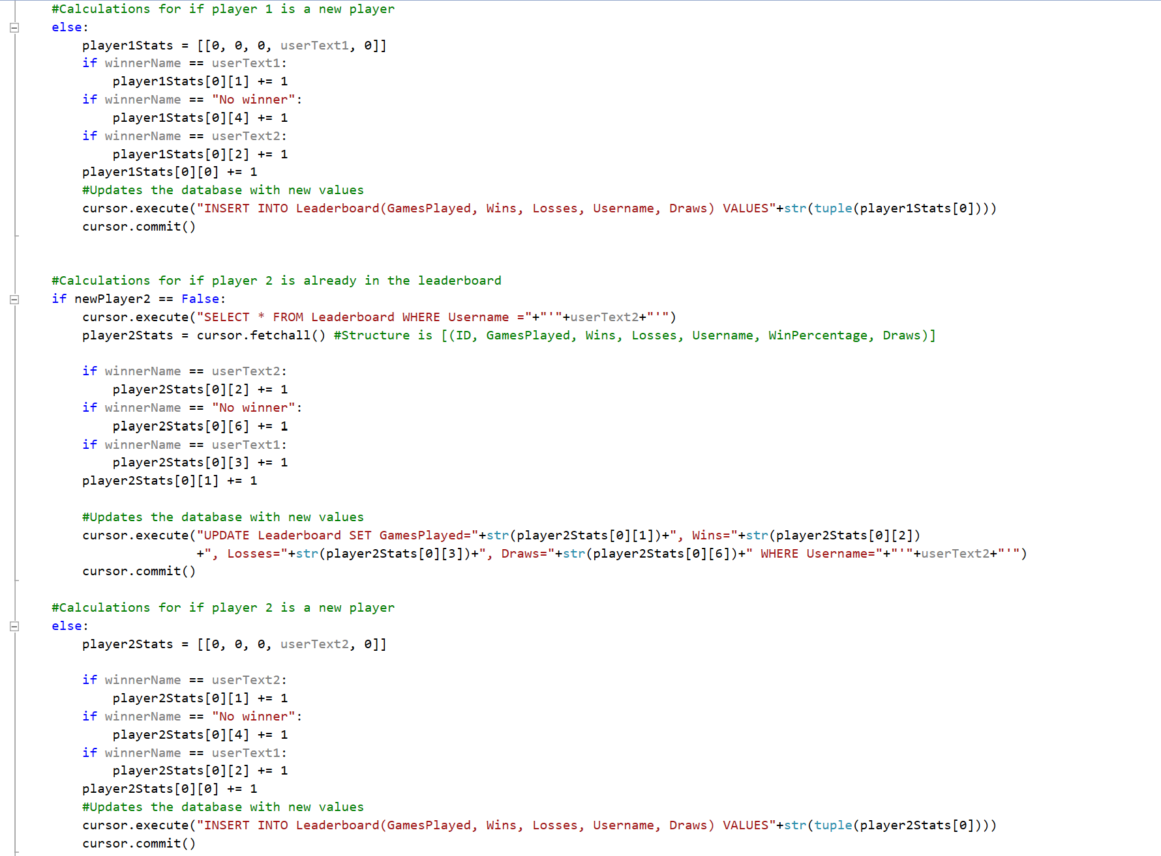

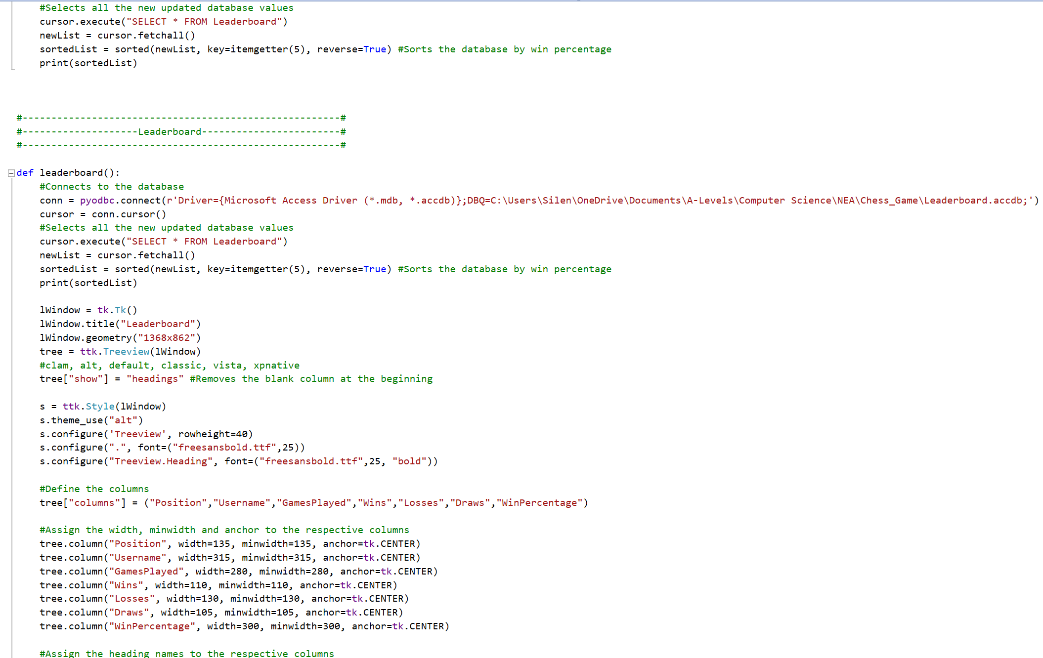

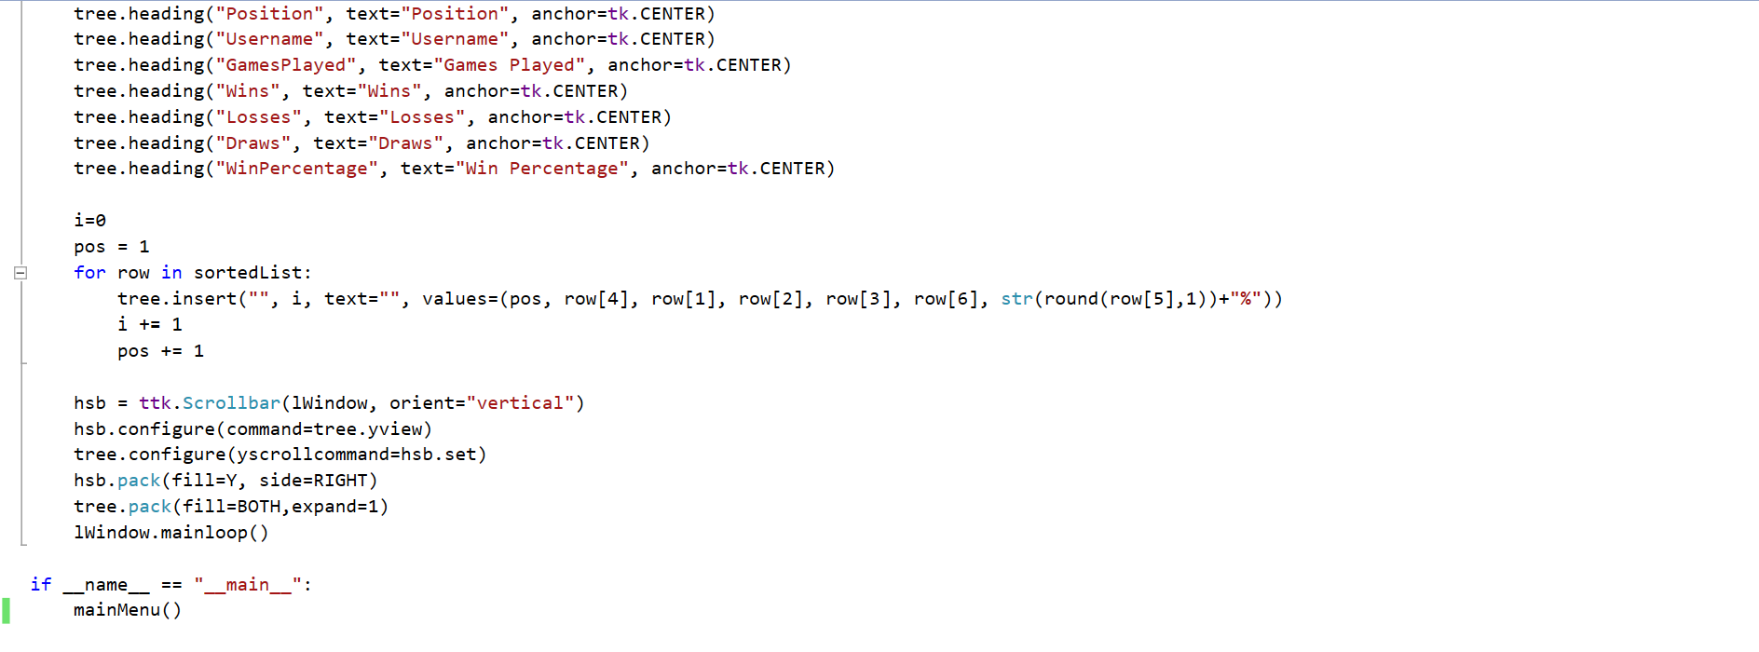

## Chess Engine File

